A Leveled OCR Pipeline for Handwritten Medical Intake Forms
Reading, correcting, and matching twenty fields per form, then routing the uncertain ones to human review
Kemal Sivro
Faculty of Electrical Engineering, University of Sarajevo
Student ID 20015 Supervised by Aida Branković
Courses: Computational Data Analytics; Machine Learning and Pattern Recognition

Abstract—This report describes a system that reads handwritten medical intake forms and turns them into structured patient records. A form carries twenty fields covering patient identity, contact details, insurance information, and the current visit. The strictest fields fail entirely if a single character is wrong, so a single recognition model is not enough. The system pairs each field type with the model that suits it and then corrects the raw reading in stages. Fixed digit cells go to a small convolutional classifier, free text goes to a fine-tuned EasyOCR recognizer, and checkboxes are read by pixel detection. A vocabulary stage snaps text fields to their known choice lists, and a final stage matches the form against a patient database and replaces stored identity fields with their canonical values. On twenty held-out forms the mean field accuracy rises from 20.8 percent at the raw baseline to 92.0 percent after database matching, and to roughly 98 percent once a blank field and the word None are treated as the same answer. Patient matching is correct on all twenty forms.
Index Terms—optical character recognition, handwriting recognition, document understanding, record linkage, human in the loop.
I. INTRODUCTION
Clinics collect patient information on paper intake forms and later copy it into a database by hand. This is slow and error prone. Automating the step is attractive, but handwritten forms are a hard target for optical character recognition. Cursive and print vary between writers, ink bleeds into guide lines, and several fields are unforgiving: a social security number, an insurance number, or a date is only correct when every character is correct.
The approach taken here separates two problems that are usually mixed together. The first is reading the marks on the page as accurately as the handwriting allows. The second is using what we already know about the form and the patient to repair the reading. Treating these separately lets each part use the right tool. A character classifier is well suited to the form's single character digit boxes, a sequence recognizer suits free text, and a database of known patients can supply exact identity values once the right patient is found.
The system is organized as four levels. L0 is the raw pretrained reader. L1 is a hybrid read that routes each field to a specialized model. L2 snaps text fields to a known vocabulary. L3 matches the form to a patient database and fills identity fields from the record. Each level is a small module so a front-end application can run any of them and show the operator the difference.
II. FORM DESIGN AND DATASET
The blank form is generated by a template script so that its geometry is known exactly. It carries three corner finder patterns for registration, comb cells (one printed box per character) for fixed-format fields such as dates and the social security number, checkboxes for gender and blood type, and single light boxes for free text. Labels sit above each entry area, and the guide lines are printed in a light gray that preprocessing can drop out. Knowing the box coordinates in advance means every field can be cropped from the same position on every scan.
A database holds one thousand synthetic patients, each with a static identity and a history of past visits. The first one hundred patients were used to produce real handwritten forms, which were filled in and scanned. The visit written on each of these forms is held out of the database, so the form is the only source for the current visit while the database remains the source for stable identity. A label file records the ground truth for all twenty fields. The forms are split with a fixed seed into eighty for training and twenty held out for evaluation, and every result below is measured on the twenty held-out forms.
III. PREPROCESSING
Each scan is first registered to a canonical canvas of 1654 by 2339 pixels. The three finder patterns are located and used to compute a homography that warps the scan into template space, which corrects skew and scale. This succeeded on all one hundred forms. The page is then converted to grayscale and contrast-equalized, which also removes a yellow cast from the scanner. The light gray guide lines are dropped out, each field is cropped by its known box, and comb fields are further cut into one crop per character. A cleaning pass removes box borders, stray edges, and dust while protecting descenders and the last letters of words. Gender and blood type are read directly from checkbox pixel density. The output is a folder of clean per-field and per-character crops for every form.
IV. RECOGNITION
A. Baseline reader (L0)
The baseline uses a pretrained EasyOCR recognizer with a per-field allow list. The allow list restricts a field to its legal characters, so a digit field can only emit digits and a name field cannot emit numbers. This baseline reaches 20.8 percent mean field accuracy. The checkbox fields are already perfect because they do not rely on recognition, but the comb digit fields read close to zero.
B. A detection failure on single characters
The near-zero digit reading turned out to be a defect rather than a limit of the handwriting. EasyOCR's standard call runs a text-detection stage before recognition, and on the tiny single-character crops the detector frequently found no text box and returned an empty string. Inspection confirmed the cells held clear ink yet came back blank. Because each crop already is the text region, the fix was to call the recognizer directly and skip detection. This single change lifted the digit fields and the text fields together and moved the baseline up across the board.
C. Fine-tuning the text recognizer
The recognizer was then fine-tuned on the form's own handwriting. A first attempt trained on every cropped sample, including the single-character digit cells. Because those cells outnumber the text fields by a wide margin, the model drifted toward reading isolated digits and grew worse at multi-word fields such as the chief complaint. Restricting fine-tuning to the text fields removed this imbalance. The text-only run descended smoothly and selected its best weights at epoch 26 by validation loss (Fig. 5). Fine-tuning the text recognizer gave a small and mixed improvement, which set up the decision to handle digits with a dedicated model instead.
D. A dedicated digit classifier
Because the comb cells are already segmented into single characters, they are a poor fit for a sequence model and a natural fit for an image classifier. A small convolutional network was pretrained on MNIST and then fine-tuned on 4,397 digit cells drawn from the eighty training forms, with every digit class represented by between 329 and 616 examples. On the twenty held-out forms it reaches 97.6 percent per digit, and accuracy is even across the ten classes (Fig. 4). Training from scratch on the same data reached 96.8 percent, so MNIST pretraining helped a little and showed that the form data alone was already sufficient. The effect on whole fields is large: assembling the per-cell predictions raised exact-match on the digit fields from near zero to between 65 and 95 percent (Fig. 3). The three letters of the insurance number stay with EasyOCR under an upper-case allow list, while its eight digits go to the classifier.
V. CORRECTION LEVELS
A. Hybrid base read (L1)
The first level combines the specialized readers into one pass. Digit comb cells go to the classifier, the insurance letters and all free text go to the fine-tuned EasyOCR recognizer, and the checkboxes come from pixel detection. This hybrid read is the foundation for everything above it, and on its own it lifts mean accuracy from 20.8 to 43.2 percent.
B. Vocabulary snapping (L2)
Several text fields are drawn from a finite list: the department, the chief complaint, the allergy and medical-history options, the medications, and, with a list built from the database, the attending doctor. For these fields a noisy reading is matched to the nearest legal entry, so a reading of Rhematology becomes Rheumatology. This stage moves the department from 15 to 100 percent and the chief complaint from 5 to 95, and it raises mean accuracy to 61.0 percent. Names are left for the database stage, since the name lists are large and identity is better supplied by a matched record.
C. Patient-database matching (L3)
The final level matches the form against the thousand-patient database. Every patient is scored by a weighted character similarity over the identity fields, leaning hardest on the social security and insurance numbers because they are close to unique, with name and date of birth as support. The best-scoring patient supplies the canonical identity values, while the current visit stays with the form. Matching is correct on all twenty forms with a wide margin between the best and second-best candidate, and it succeeds even when individual fields are misread, because combining several noisy fields still points to one patient out of a thousand. With identity supplied from the record, mean accuracy reaches 92.0 percent.
D. Validation and review
The system does not accept everything it produces. Each field is checked against its own notion of a valid value: a date must be a real calendar date within a plausible year, a phone number and a social security number must match their formats, and a department or doctor must be a known entry. Database-backed fields are additionally flagged when the form holds a valid value that disagrees with the stored record, which may be a genuine update or a bad match and is left for a person to decide. Fields that pass are accepted automatically, and only the uncertain ones reach the operator.
VI. RESULTS
Table I summarizes the mean field accuracy and the patient-match rate at each level. Fig. 1 shows the same progression, and Fig. 2 breaks it down to every field.
Level | Description | Mean acc. | Match
L0 | Pretrained EasyOCR, allow lists | 20.8% | n/a
L1 | Hybrid: digit CNN + text | 43.2% | n/a
L2 | + vocabulary snapping | 61.0% | n/a
L3 | + patient-DB match | 92.0% | 100%
Table I. Accuracy and match rate by correction level.
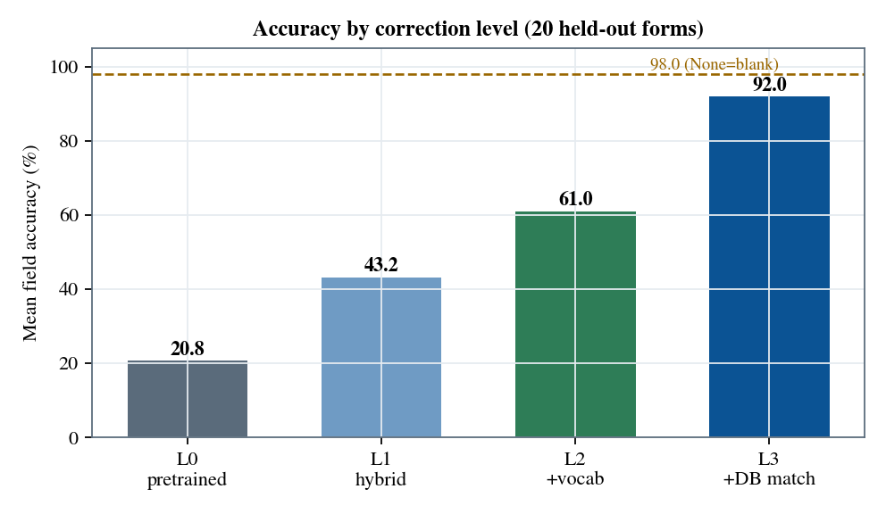
Fig. 1. Mean field accuracy at each level. The dashed line marks the value when a blank field and None score as equal.
Almost every field reaches 100 percent by L3: identity and contact fields come from the matched record, the visit date is read by the digit classifier at 95 percent, and the department and chief complaint are fixed by vocabulary snapping. Fig. 2 shows where each gain comes from.
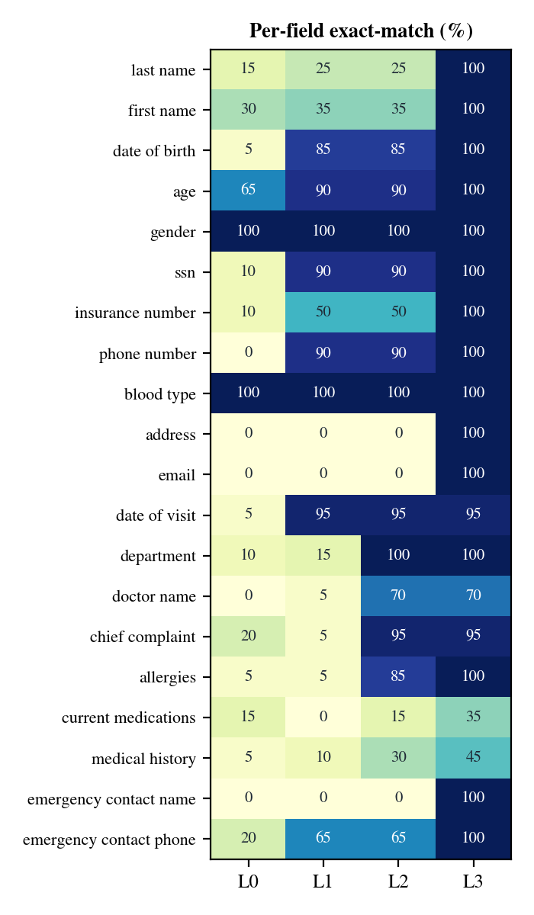
Fig. 2. Exact-match accuracy for every field across the four levels.
A. Digit reading
Table II reports the digit classifier. The contrast between the pretrained MNIST model on the form digits and the fine-tuned model shows why adaptation was needed, and the from-scratch result shows the data was enough on its own.
Setting | Accuracy
MNIST test set | 99.0%
MNIST model on form digits | 63.1%
From scratch on form digits | 96.8%
MNIST pretrained + fine-tuned | 97.6%
Table II. Digit classifier accuracy by training setting.
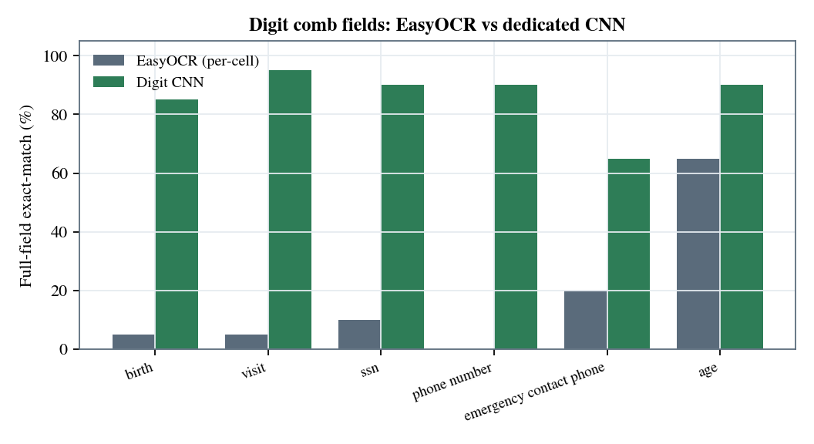
Fig. 3. Whole-field exact-match on the digit fields: per-cell EasyOCR against the dedicated classifier.
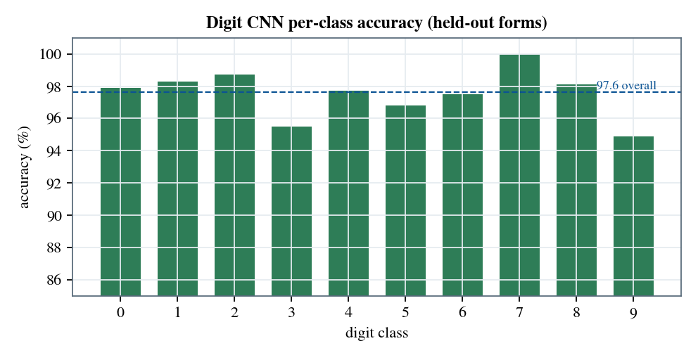
Fig. 4. Per-class accuracy of the digit classifier on the held-out forms.
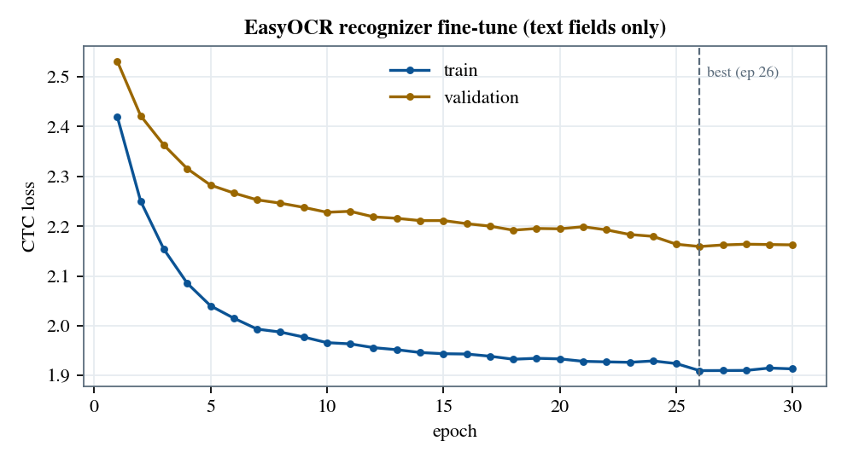
Fig. 5. Fine-tuning the EasyOCR recognizer on text fields only.
VII. DISCUSSION
The largest gains did not come from a better single model. Fine-tuning the general recognizer helped only a little and, before the digit cells were separated out, it hurt the free-text fields. The real progress came from matching each field type to the right tool and then correcting with structured knowledge: a small classifier for the segmented digits, a vocabulary for the constrained text fields, and a patient database for identity.
Two fields stay low. The medical history and the current medications sit at 45 and 35 percent, but most of those misses are a labeling artifact rather than a reading error. When a patient has no history the form was sometimes left blank and sometimes filled with the word None, and the database settled on None, so the strict scorer counts a blank against a None as wrong even though they mean the same thing. Treating the two as equal lifts these fields and brings the mean to about 98 percent. The attending doctor and the emergency contact name are free names with no canonical source on file; vocabulary snapping built from past visits recovered the doctor to 70 percent, while the contact name has no list to fall back on.
The evaluation has clear limits. The forms are synthetic and were written by a small number of hands, so real deployment would face more variety than the held-out twenty. The database-first design for stable fields means that a genuine change a patient writes on the form is surfaced for review rather than applied, which is the safe behavior for a record system but depends on an operator acting on the queue.
VIII. CONCLUSION
A leveled design reads handwritten intake forms far more accurately than any single recognizer reaches on its own. The base read pairs a digit classifier with a fine-tuned text recognizer, vocabulary snapping repairs the constrained text fields, and database matching supplies exact identity values once the patient is found. Mean field accuracy rises from 20.8 percent to about 98 percent, and the patient is matched correctly on every held-out form. Just as important, the system knows what it is unsure about and asks for review rather than guessing. Natural next steps are to fine-tune on a wider set of writers, to add a reconciliation step that can accept genuine updates to mutable fields, and to extend the digit classifier to the insurance letters.
REFERENCES
[1] JaidedAI, EasyOCR: ready-to-use OCR with allow lists and a CRNN recognizer.
[2] Y. LeCun, C. Cortes, and C. Burges, The MNIST database of handwritten digits.
[3] A. Graves, S. Fernandez, F. Gomez, and J. Schmidhuber, Connectionist temporal classification, ICML 2006.
[4] K. Zuiderveld, Contrast limited adaptive histogram equalization, Graphics Gems IV, 1994.

