Vera Poliakova

8/10/2021

IT FDN 110 A

Module 5

## Assignment05 task

Modify starter file so that the “ToDoList” file will contain two columns of data for Task and Priority. Load columns into a python dictionary object.

Figure 1: A screenshot of the script running from a command shell.

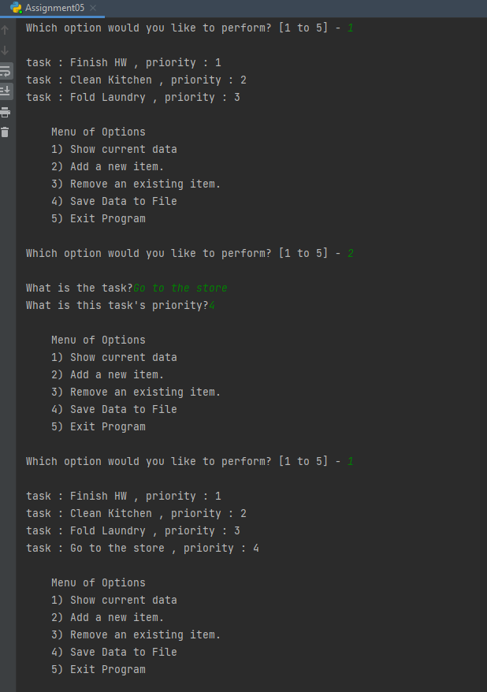

Figure 2: A screenshot of the script running from Pycharm.

Figure 3: A screenshot of the data file

## Knowledge documentation

This assignment used much of the same elements as the previous one, with the addition of reading files and using dictionaries.

### Reading a file

In order to use data from a file, the information must be stored in working memory in python, usually as a list. Strip and Split are useful functions for reading lines from a text file.

Strip removes unwanted carriage returns such as extra spaces or new lines from the ends of a string.

Split will separate a string by the delimiter such as a comma, often this is used as a way to store different data elements from a list.

### Dictionaries

A dictionary is an unordered and mutable python data storage container that is used to map unique keys to values, analogous to a spreadsheet with column headers and data. The homework required that dictionaries were used to store rows of data with the keys (column headers) being task and priority.

# Summary

My main takeaway from this assignment is another way to store data: dictionaries which don’t rely on data position or location but instead can sort by keys.