TIGR MeV through SBEAMS Tutorial

Loading Data Into MeV From SBEAMS

Browse to a normalized data set (as described here:):
- Log in to SBEAMS at http://db/sbeams/cgi/main.cgi
- Go to the Microarray module
- Choose the ‘bmarzolf - Stegmaier Cell Lines’ project 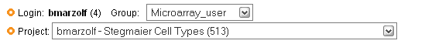
- Go to Data Pipeline 
- Choose Affy Analysis Pipeline at the bottom of the page. (If this link does not exist, you are either on the wrong project, or there are no Affymetrix arrays in this project)
- Go to the Normalized Data tab 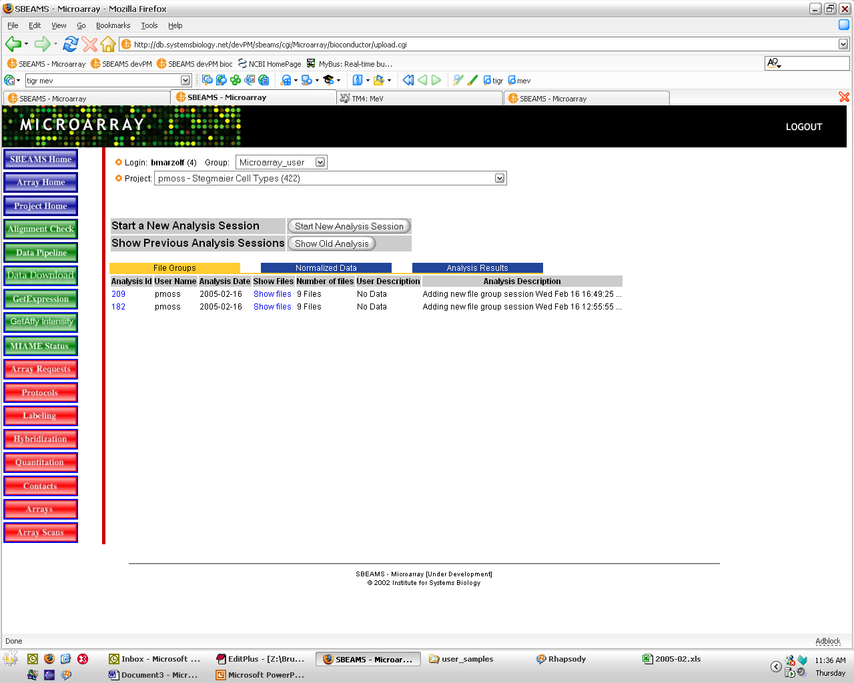
- This should display a list of normalization runs (if not, you need to normalize the data!)
- Choose the Show Files link for the analysis with the User Description of ‘Use this for the analysis demo’

Launch MeV:
- Choose the Start Mev link
- This will take you to a page where you confirm which samples will be loaded. Click the Submit Job button.
- This takes you to another page, where you’ll need to wait several seconds for some processing to occur. After processing is complete, you will need to click the word here
- The next few steps will vary depending upon how your web browser and Java are configured (you need to have Java installed, which can be obtained at java.sun.com).
  - You may get a dialog box asking how to open the JNLP. Choose ‘Open With’ JNLPFile, assuming this is an option that is presented. If JNLPFile isn’t displayed, you’ll need to choose Other… and select the location of the java executable.
  - If Java Web Start begins successfully, you’ll likely get a warning that this package, distributed by Bruz Marzolf, cannot have it’s authenticity verified. Choose Start.

Introduction To MeV

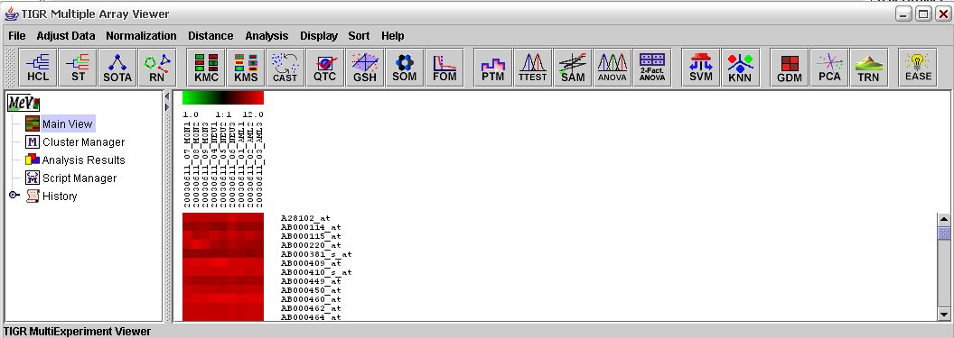
chips
Probe sets
clustering
template
search
statistics

There are four major components to the MeV interface:
- menus – essentially all functionality is available through menus
- toolbar – these are shortcuts to all of the analysis methods, which are also contained in the Analysis menu
- analysis tree – the left pane is organized as a tree, as more analyses are performed, their results become new branches and are accessible here
- data view – the right pane is used to display data in a number of different forms

* Please see documentation at http://www.tigr.org/software/tm4/mev.html for additional information

Statistics

It’s often necessary to use statistics to select a subset of interesting genes for further analysis.

Performing t-test:
- Click the TTEST button 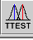
- By default a One-Class test is selected, which would be comparing each probe set signal to a set value, such as 0. We want to compare two groups, so pick Between subjects.
- Some information about sample groups has been passed in from SBEAMS, so click the Load SBEAMS Grouping button—this loads information about which chip is in which group that’s been passed along by SBEAMS.
- Use the default setting for all of the t-test parameters, and click OK.
- This produces a new branch in the analysis tree labeled ‘T Tests (1)’. Open this branch.
- Several different views of the t-test results are available, and are each worth noting as many of the analysis methods have these same views:
- Expression Images – Each group of genes (in this case significant and non-significant) is shown in a separate heat map view.
- Centroid Graphs – For each group of genes, the average expression on each chip with error bars.
- Expression Graphs – A line graph of the expression of each gene in a group is shown
- Table Views – Shows a tabular display with each gene as a separate row, and each column a different attribute of that gene
- Cluster Information – General information about the clustering results
- Volcano Plot – A plot of the difference in mean expression between the groups versus the test statistic (in this case p-value).
- General Information – Information about the input parameters for the method that was performed.

Performing SAM (Statistics Analysis of Microarrays):
- Click the SAM button 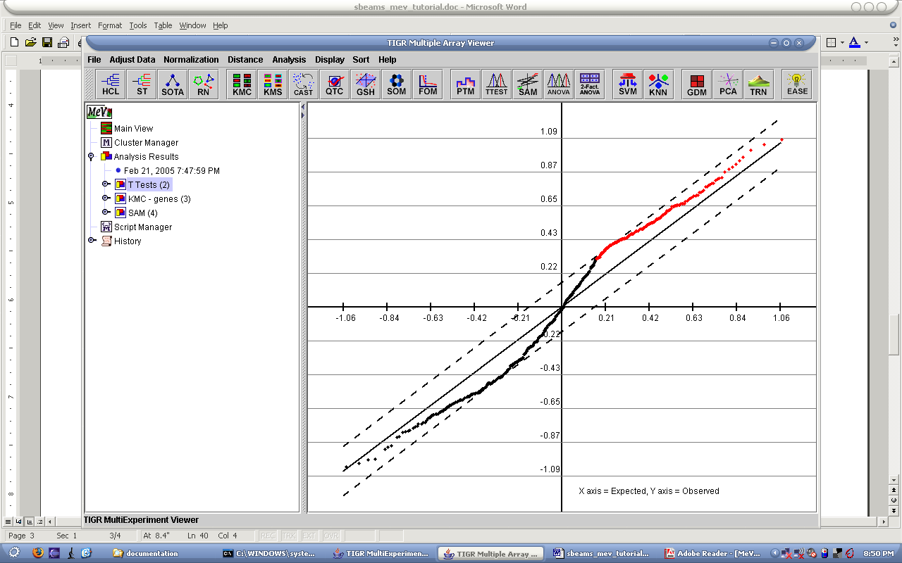
- Several methods are available as tabs across the top of the window, including the two-class unpaired, two-class paired and multi-class. Keep the default of Two-class unpaired since we’re not looking at paired data (e.g. before and after treatment for same individual)
- Click the Load SBEAMS Grouping button to assign groups based on SBEAMS information.
- Use the default setting for all of the SAM parameters, and click OK. Since you selected 100 permutations and not that many are possible, you’ll be prompted to either use 35 or 100. Select Use all of them and click OK.
- Once done processing (it may seem like it freezes at 95% completion, but give it a little time), it’ll present another window with a graph. This graph shows the test statistics of the real data versus the statistics with random permutation. The Delta value can be varied and the resulting significant genes and false positives obseved. Once you’ve chosen a delta value that gives desirable results, click OK.
- The results will appear in a new tab, labeled ‘SAM (2)’. SAM result views differ slightly from t-test in that there isn’t a volcano plot, and there are two additional views, the SAM Graph and Delta table.
- Choose Positive Significant Genes under the Centroid Graphs view. This set of genes can be labeled as a cluster of interest that will show up in other analyses by right-clicking on the centroid view and choosing ‘Store cluster’
- Choose a color for the cluster, and optionally a name (a good idea unless you’re certain you’ll remember what the color means).
- Click OK. These genes will now show up in existing views of your data as well as any new analyses you run.

Performing ANOVA (ANalysis of VAriance):
- Click the ANOVA button
- Since there are three groups in our data set, enter ‘3’ for Number of groups and click the OK button to the right.
- Click the Load SBEAMS Grouping button to assign groups based on SBEAMS information.
- Keep the default settings and click OK.
- This produces a new tab labeling ‘One-way ANOVA (3)’
- Open the Significant Genes under Table Views.
- Right-click on the table view and click Launch new session with entire cluster. This launches a new MEV window with just this data. This is what we’ll be using to performing the next section, clustering!
- Notice the main view is all red? The color scale resets every time a new window is launched, so go to the Display menu and pick Set Ratio Scale. Enter ‘15’ as the Upper value and ‘1’ as the Lower value.

Clustering

Traditional hierarchical clustering:
- Click the HCL button, 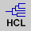
- Stick with the most common settings, Average Linkage and both Cluster Genes and Cluster Experiments
- Click OK – this will take a few minutes to complete
- The results will appear in a new analysis branch labeled ‘HCL (4)’
- Under this branch, there is a new type of view, HCL Tree.
- If you’d like to be able to see the labels beside the tree, go to the Display menu and choose Element Size as 10x10.
- If you’d like to see actual gene symbols or names, go to the Display menu, then Gene Labels and choose what annotation you’d like displayed.
- Clusters of chips and genes can be selected by clicking under the branch you’d like to select:
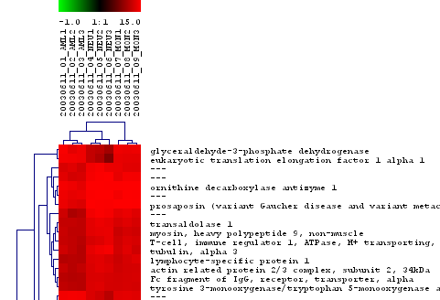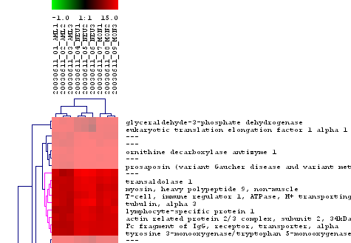

Traditional hierarchical clustering:
- Click the ST button, 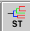
- Under Gene Tree, choose ‘Bootstrap Experiments’ and under Experiment Tree, pick ‘Bootstrap Genes’
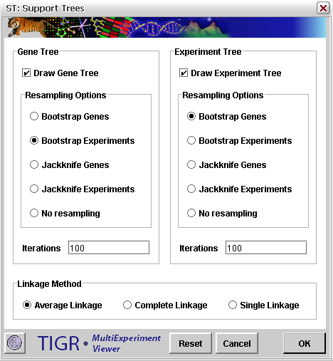

- Change both Iterations fields to ‘10’—this is just to speed things up, and will not offer optimal results.
- Click OK
- This results in a new branch ‘ST (1)’, which contains a Support Tree view similar to the HCL Tree observed in the previous step. The difference is that the branches of the tree are color-coded depending upon how well they withstood the bootstrapping procedure. Color codes can be displayed by going to the Help menu and choosing Support Tree Legend

Template Matching

Using Pavlidis Template Matching:
- Click the PTM button, 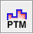
- Either an existing gene can be used as the template, or a template can be created manually. We’ll manually create a template by dragging the slide bars for the AML chips to Max, NEU chips to Min and MON chips to Max
- Under Threshold Parameters, select Use Threshold R and in the Enter R[0,1], type ‘0.95’
- Click OK.
- Genes that show a Pearson correlation greater than 0.95 will be placed in a new analysis branch named ‘PTM’

