Release Notes

These are the release notes for boards with a date of 4/1/2014 in the etch on the component side near the battery holder.

Thank you for purchasing the 32K Omnibus Memory kit. There are a couple of issues you should be aware of before attempting to assemble your kit:

The kit was initially spec'ed for ABT family integrated circuits for IC1, IC2, and IC8. The ABT parts did not work reliably. As a result, ALS245A parts have been substituted for IC1 and IC2, and an LS540 has been substituted for IC8. These parts should be installed where the silkscreen calls for the corresponding ABT parts.

The silkscreen around the DIP switches has a number of issues. First, the "ON" direction is on the wrong side. Secondly, the bank ordering in the silk screen has a non-obvious relationship to reality due to a wiring error at the decoder that feeds the DIP switches. To alleviate this, the switches should be flipped over, and a sticker with the correct bank ordering has been included. Below is a picture of the suggested orientation of the DIP switch module and the corrective label applied. Please be aware of this when installing the DIP switches.

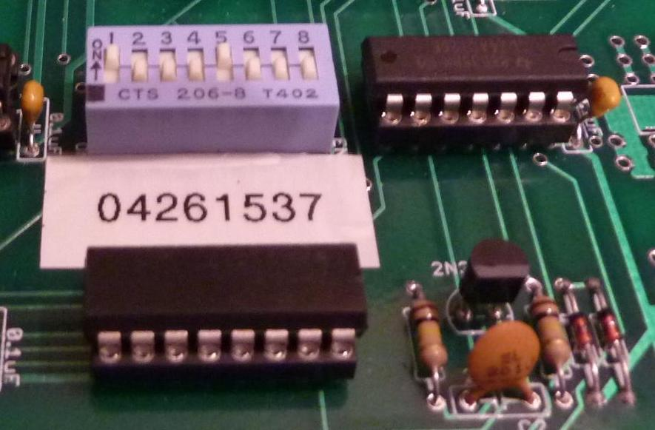
The picture shows banks 0 and 1 disabled. Which banks you want enabled will of course depend on the particulars of your system.

Please visit http://www.so-much-stuff.com/pdp8/32KOmnibus/32KOmnibus.php for more detailed assembly hints.

Vince

