figures

Vienna Saccomanno

1/16/2020

## R Markdown

library(tidyverse)

## -- Attaching packages ------------------------------------------------------------------------------------------------------------------------ tidyverse 1.2.1 --

## v ggplot2 3.2.1 v purrr 0.3.2  
## v tibble 2.1.3 v dplyr 0.8.3  
## v tidyr 0.8.3 v stringr 1.4.0  
## v readr 1.3.1 v forcats 0.4.0

## -- Conflicts --------------------------------------------------------------------------------------------------------------------------- tidyverse_conflicts() --  
## x dplyr::filter() masks stats::filter()  
## x dplyr::lag() masks stats::lag()

library(readr)  
library(viridis)

## Warning: package 'viridis' was built under R version 3.6.2

## Loading required package: viridisLite

library(hrbrthemes)

## Warning: package 'hrbrthemes' was built under R version 3.6.2

## NOTE: Either Arial Narrow or Roboto Condensed fonts are required to use these themes.

## Please use hrbrthemes::import_roboto_condensed() to install Roboto Condensed and

## if Arial Narrow is not on your system, please see http://bit.ly/arialnarrow

library(ggsci)

## Warning: package 'ggsci' was built under R version 3.6.2

library(gridExtra)

## Warning: package 'gridExtra' was built under R version 3.6.2

##   
## Attaching package: 'gridExtra'

## The following object is masked from 'package:dplyr':  
##   
## combine

###Making bar charts on trends

allo_cause <- read.delim("By Cause/Allocation_by_cause.txt")  
allo_region<- read.delim("By Region/Allocation_2019USD_1989-2019.txt")  
  
#Changing legend order  
levels(allo_cause$Cause)

## [1] "" "Anthropogenic" "Combination of both"  
## [4] "Environmental"

allo_cause$Cause<- factor(allo_cause$Cause, levels = c("Anthropogenic", "Environmental", "Combination of both"))  
  
  
#allocation by cause  
cause_p0 <- ggplot(allo_cause, aes(fill= Cause, y=Allocation, x=Year))+  
 geom_bar(position = "stack", stat= "identity")+  
 scale_y_continuous(labels = scales::dollar)+  
 scale_x_continuous(breaks=seq(1995,2018,5))+  
 scale_fill_uchicago()+  
 theme_classic()  
  
cause_p1 <- cause_p0 + labs(x="Years",  
 Y= "Allocation",  
 subtitle= "1.a",  
 caption = "Source: NOAA")  
cause_p1

## Warning: Removed 1369 rows containing missing values (position_stack).

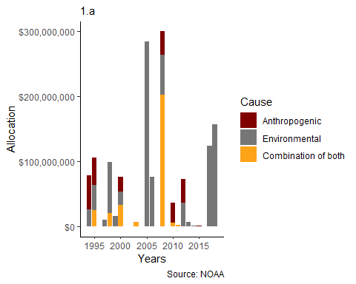

#allocation by region  
region_p0 <- ggplot(allo_region, aes(fill= Region, y=Allocation, x=Year))+  
 geom_bar(position = "stack", stat= "identity")+  
 scale_y_continuous(labels = scales::dollar)+  
 scale_x_continuous(breaks=seq(1994,2018,5))+  
 scale_fill_jama()+  
 theme_classic()  
  
region_p1 <- region_p0 + labs(x="Years",  
 Y= "Allocation",  
 subtitle= "1.b",  
 caption = "Source: NOAA")  
region_p1

## Warning: Removed 121 rows containing missing values (position_stack).

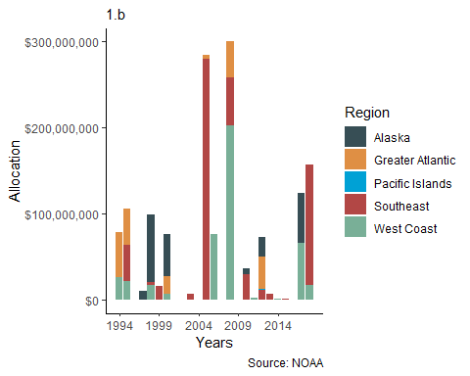

grid.arrange(cause_p1, region_p1)

## Warning: Removed 1369 rows containing missing values (position_stack).

## Warning: Removed 121 rows containing missing values (position_stack).

