
©Journal of the Technical University – Sofia
Plovdiv branch, Bulgaria
“Fundamental Sciences and Applications” Vol. 22, 2016

Type the paper’s title here (use Papertitle style)
name1 family1, name2 family2, style AUTHORS
Abstract: Page size of the papers is A4. Papers must consist of even number of pages. Maximum 6 pages are allowed. Do not use footnotes, page numbering and hyphenation. Papers must be sent in both DOC and PDF versions. Place your abstract here by applying „Abstract“ style from the Styles menu.
Key words: use again “Abstract style”, key word1, key word2

- Basics
Page size of the papers is A4. Papers must consist in even number of pages. Maximum 6 pages are allowed. Do not use footnotes, page numbering and hyphenation. Papers must be sent in both DOC and PDF versions.
- Formatting
Format the papers by using the mark-up styles of the template. Do not change the parameters of the styles. For the main text of the paper use „MainText” (Ctrl+Num 3) style. Do not use blank lines between the paragraphs. The spaces before and after each paragraph are included into the related styles.
First level section headings must be introduced by using „SectionL1”(Ctrl+Num 2) mark-up style from the template.
  - Level2 Sections
For second level of headings use „SectionL2” mark-up style.
    - Level3 Sections
For second level of headings use „SectionL3” mark-up style.
- Equations and symbols
Number equations consecutively with equation numbers in parentheses flush with the right margin, as in (1). First create the equation. Then select the “Equation” (Ctrl+Num 4) mark-up style. Press the tab key before and after the equation. Put the equation number in parentheses after the second tab, as in (1). Is it recommended to use MathType instead of MS Word Equation Editor. To format your equations use the following parameters: Full = 11 pt; Subscript/Superscript = 58%; Sub- Subscript/Superscript = 42%; Symbol = 150%; Sub-symbol = 100%; User 1 = 75%; User 2 = 150%; Smaller/Larger Increment = 1 pt.
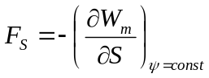 (1)
Refer equations by using the correspondence number in parentheses (1), do not use “Eq. (1)” or “equation (1)”.
- Figures and tables
Place figures and tables centered in the column (“FigPosition” mark-up style). Figure captions (“FigName”(Ctrl + Num 5)) should be below the figures. Just type the captions. Figures number is introducing automatically by the style.
Use the abbreviation “Fig. 1”, even at the beginning of a sentence (See Fig. 1.)
Use 8 pt at least in your graphics.
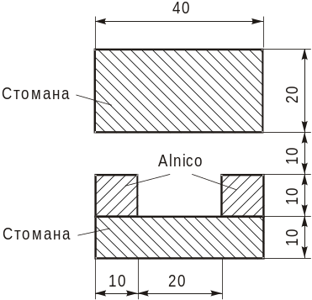
- Figure caption
Table heads should appear above the table. Use „TableName“ (Ctrl + Num 6) to insert the head. Tables numbering is automated.
- Table head
data | data | data
data | data | data

- References and citations
Number citations consecutively within brackets [1]. The sentence punctuation follows the bracket [1]. Refer simply to the reference number, as in [2]. Do not use “Ref. [2]” or “reference [2]”.”
Use Harvard system to create the reference list: http://education.exeter.ac.uk/dll/studyskills/harvard_referencing.htm. For books and articles published in books use the referencing styles presented in [1] and [2] respectively. Papers and journal articles use referencing style as it is done for [3].
- Conclusion
Papers that do not follow the format specified by the template are going to be rejected.
REFERENCES
- Smith, S.E. (2004). Name of book in italics, page or chapter numbers if relevant. Publisher, Place of publication.
- Brown, F., Harris, M.G., and Other, A.N. (1998). Name of paper. In Name(s) of editor(s) (ed.), Name of book in italics, page numbers. Publisher, Place of publication.
- Smith, S.E. and Jones, L.Q. (2008). Name of paper. Name of journal in italics, volume (number), page numbers.
Authors’ contacts – mark-up style „Contacts”
Address:
Phone (optional):
E-mail: vasil_ivanov@abv.bg
E-mail: stanimira@abv.bg
E-mail: ivan_kirilov@abv.b

