Date of publication MMM-22, yyyy, date of current version MMM-dd, yyyy.
www.computingonline.net / computing@computingonline.net
Print ISSN 1727-6209
Online ISSN 2312-5381
DOI 10.47839/ijc.19.3.XX
Designing Microcontroller module with target to use AVR/PIC assembler
Veselin Stanchev ¹
Scientific field: Computer Architectures
1Department ICT, Technical University-Plovdiv Branch, Plovdiv, Bulgaria
Corresponding author: Veselin Stanchev (e-mail: vrstanchev@tu-plovdiv.bg).
ABSTRACT

Assembly languages are very useful for programming of micro-controllers, microprocessors, embedded devices, real-time operating systems. The most natural way for micro-controller programming is to use Assembly languages. For different types of micro-controller families - AVR/PIC-based, there are different assembly languages. For AVR-based micro-controllers such as - ATtiny13,ATtiny85,ATMega32u4 different assembly languages can be used – AVR Assembler or GNU Assembler.

Micro-controllers can be used for micro-controller modules design. This paper describes design and programming of micro-controller module which uses both AVR-based and PIC-based micro-controller. This module can be used for educational purposes. It shows communication between its micro-controllers.

KEYWORDS PCB; MCU; AVR/PIC; Assembly language; Micro-controller module

I. INTRODUCTION Usage of free assembly languages is very important for understanding Computer Architectures. Free assembly languages can be used for university purposes. To explain usage of them for micro-controllers, micro-controller boards can be designed using open-source EDA software such as: Fritzing or LibrePCB. On single micro-controller board can be used micro-controllers together. There are several variants for that – usage of PIC-based micro-controllers, usage of AVR-based micro-controllers or AVR/PIC micro-controllers together. Target of the current project is to use AVR assembler and PIC assembler through custom communication protocol. There are requirements for hardware and software part of the project. ATtiny85 and PIC10F320 are chosen.
For software part of the project are used tools such as: Git, GNU Make [8], GNU GCC [9], GNU PIC Utils[10], avra[11]. Git is used for project version-control. GNU Make is used for automatization of software build. Software of the project is also produced as static Assembly library.
Hardware part is created by using of LibrePCB[7]. LibrePCB is used for schematic design, footprints of micro-controllers and layout of the micro-controller module.

II. MATERIAL AND METHODS Project orientation is scientific-practical and practical. The micro-controller module can be used for university purposes. For realization of the project are used open-source tools. Because of that project can be upgraded easily. The project can be used for: assembly language labs, micro-controller labs, understanding of micro-controller communication, understanding of AVR/PIC programming.

1) Existing micro-controller modules ANAVI MACRO PAD 2, ANAVI LIGHT CONTROLLER, Raspberry Pi Pico[12] and AVR64DD32 Curiosity Nano[11]. For each of them are analyzed: supported micro-controllers, supported communication protocols, supported interfaces, supported assembly languages. Example: ANAVI MACRO PAD 2 and ANAVI LIGHT CONTROLLER [2],[3].
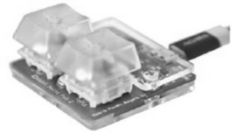
FIGURE 1. ANAVI MACRO PAD 2
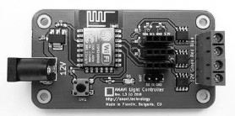
FIGURE 2. ANAVI LIGHT CONTROLLER

Requirements of the project are hardware-based and software-based.

2) For hardware-based requirements:
ATtiny85 and PIC10F320 are chosen.
AVR/PIC-based micro-controllers has to be chosen.

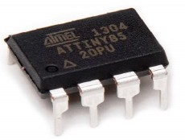
FIGURE 3. ATTiny85

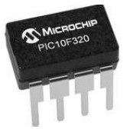
FIGURE 4. PIC10F320

Micro-controller’s features are analyzed. ATTiny85 has features such as: 8kb flash memory, 8-bit timer, communication thought universal serial interface, communication thought I2C. PIC10F320 has features such as: 128 bytes of memory, 8-bit timer, communication thought host and micro-controller. [4],[5]

For design of micro-controller module LibrePCB is chosen. AVR/PIC-based micro-controller’s symbols are created. Footprints for them are created.

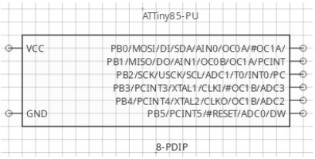
FIGURE 5. Symbol of ATTiny85

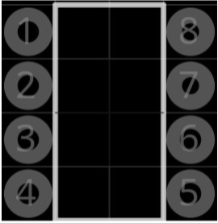
FIGURE 6. Footprint of ATTiny85

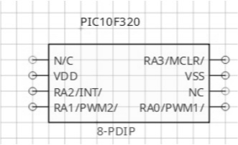
FIGURE 7. Symbol of PIC10F320

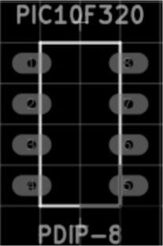
FIGURE 8. Footprint of PIC10F320

USB interface is chosen for power and programming. So micro-controller module block diagram is created.

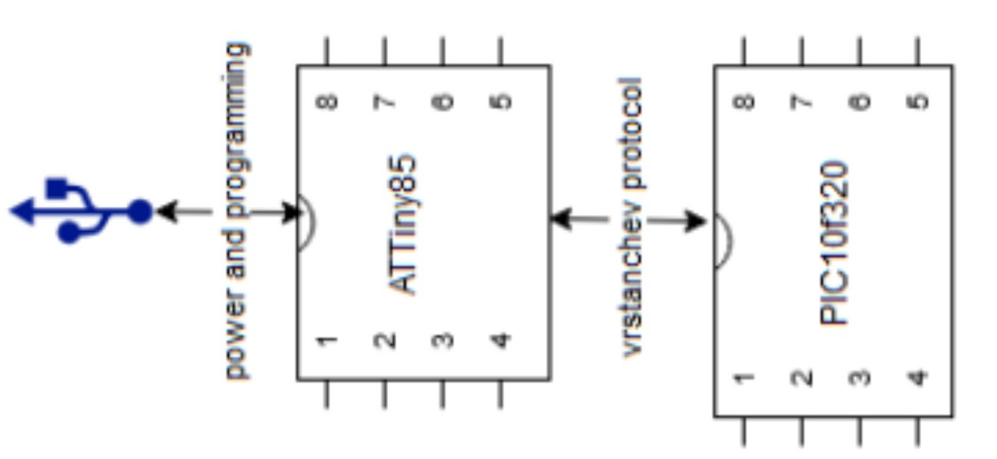
FIGURE 9. Micro-controller module block diagram
[1]

Due to chosen micro-controllers, interfaces and block diagram micro-controller module’s schematic is created. Components are connected directly thought wires or net labels

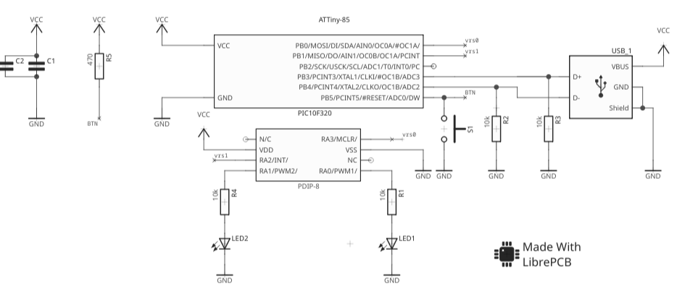
FIGURE 10. Micro-controller module schematic [1]

Interface | Connectivity | Used Pins
USB | Attiny85↔USB | PB3,PB4
Communication protocol  vrstanchev | Attiny85↔PIC10F320 | PB0, PB1 → RA2, RA3

FIGURE 11. Interfaces and used pins table [1]

PIN Type | PIN
output | PB0
output | PB1
input | RA2
input | RA3

FIGURE 12. Pin-type table [1]

Component | Used Pins
ATTiny85 | PB0,PB1
PIC10F320 | RA2,RA3
LED1,LED2 | RA0,RA1

FIGURE 13. Components and used pins [1]

3) For software-based requirements:
Assembly languages for ATtiny85 and PIC10F320 has to be chosen. AVR assembly and PIC assembly languages are chosen. There are given examples for micro-controllers intructions. Custom vrstanchev protocol is implemented. Code for ATTiny85 and PIC10F320 is implemented thought functions. It is chosen for micro-controllers communication. Logic of communication is shown. Build of the code is automated thought GNU Make. Function for ATTiny85 is compiled via avra compiler. Function for PIC10F320 is compiled via gpasm compiler. [1]

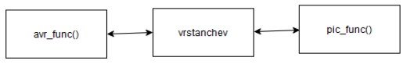
FIGURE 14. Schematic of vrstanchev protocol functions [1]
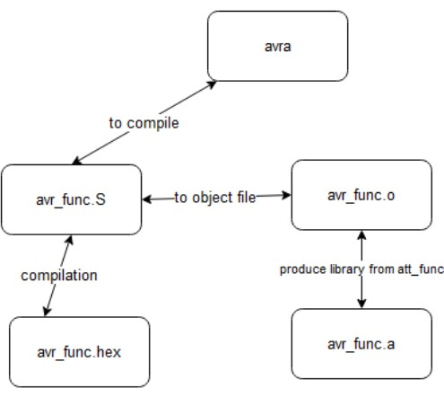
FIGURE 15. Schematic of att_func() Compilation [1]

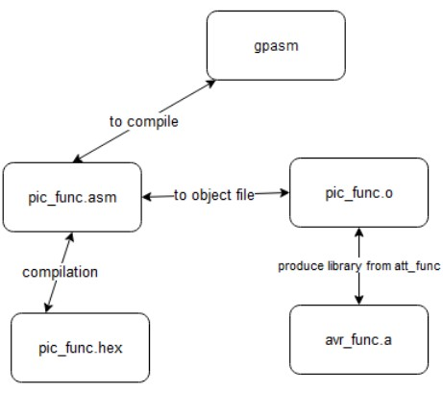
FIGURE 16. Schematic of pic_func() Compilation [1]

Build of att_func()
compile:att_func.S
avra att_func.S
att_func.o:att_func.S
avra -o att_func.o att_func.S

Build of pic_func()
compile:pic_func.asm
gpasm pic_func.asm
pic_func.o:pic_func.asm
gpasm -c pic_func.asm

FIGURE 17. GNU Make Build scripts [1]

Part of source code of the ATTiny85
assembly function:
att_func:
.include “tn85def.inc”
.equ pb0_out=0b0000001
.equ pb1_out=0b0000010
.cseg
.org 0x00
sbi r16, pb0_out
sbi r17, pb1_out

Part of source code of the PIC10F320
assembly function:
.include
“pic10f320.inc”
.org 0
pic_func:
CLRF PORTA
MOVLW B‘00000100’
MOVLW B‘00001000’
MOVLW B‘00000100’
MOVLW B‘00001000’

Part of source code of the vrstanchev communication protocol:
vrstanchev:
mov B‘00000100’, r0
mov B‘00001000’r1
mov B‘00000100’,r3

FIGURE 18. Parts of the source code [1]

Assembly language functions are compiled also as static library. Static libraries are archives of compiled object files(with extension .o). For ATTiny85 function achiever is GNU ar and for PIC10F320 function achiever is GNU PIC Library (gplib). Static library schematic is given below:

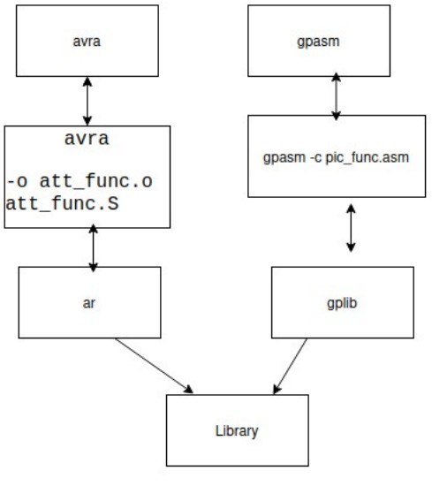
FIGURE 19.Static library schematic

4) Compare of AVR assembler / PIC assembler

5) Vrstanchev protocol simulation

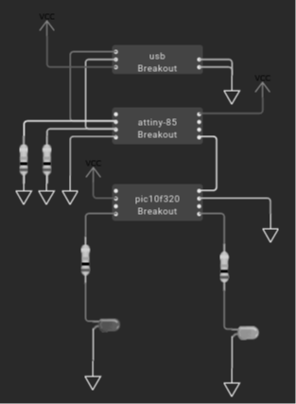

Part of NASM simulation code
;data constants
section .data
STRT_BIT equ 1
INFO equ 101
STPBIT equ 0
;code started
section .text
global _start
_start:
mov eax,1
mov ebx, 0
;compare for communication start
cmp ebx, STRT_BIT
je communicate
communicate:
mov ecx,INFO

FIGURE 20. Part of Netwide assembler simulation code [7]

III. RESULTS Micro-controller module powered by ATTiny85 and PIC10F320 is designed. LibrePCB is used to design the module. Because of using tools that are open-source or are part of the GNU project, micro-controller module’s features are easy to been upgraded. For programming of ATTiny85 is used AVR Assembly and for PIC10F320 is used PIC Assembly. Micro-controllers communicates each other thought implemented vrstanchev protocol. The protocol is available also as static Assembly library. AVR/PIC assembly languages features are compared. Communication protocol vrstanchev is shown.

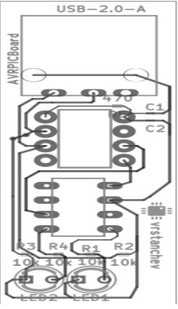
FIGURE 21. Micro-controller module board layout [2]

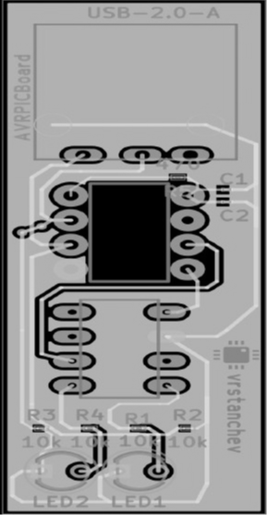
FIGURE 22. Background noise of the module is reduced

IV. CONCLUSIONS AND FUTURE WORK Hardware and software requirements of the project are completed. The target of the project is complete. Module will be used for my PhD thesis theme: “Methods and Tools to develop a assembly-based operating system for embedded devices”. Features of the micro-controller module to been added: interfaces for main module, additional modules for main module, different releases of main module, micro-controller module powered by AVR-AVR or PIC-PIC micro-controllers.

V. License:
This paper is licensed under:
CC BY 4.0
VI. References
Reference to a technical datasheet:
[1] L.Anavi ANAVI Macro Pad 2 DataSheet., Plovdiv, Bulgaria.
Reference to a Master Degree Thesis:
[2] V.Stanchev “Designing Microcontroller module with target to use AVR/PIC assembler” Master Degree Thesis.
Reference to a technical datasheet:
[3] L.Anavi ANAVI Light Controller DataSheet, Plovdiv, Bulgaria.
Reference to a technical datasheet:
[4] Atmel Inc., ATTiny85 Datasheet.
Reference to a technical datasheet:
[5] Microchip Inc., PIC10F320 Datasheet.
Reference to a user manual:
[6] LibrePCB Manual 1.0
Reference to AVR/PIC project simulation code:
[7] Netwide Assembler simulation code
Reference to a user manual:
[8]GNU MAKE
Reference to a user manual:
[9] GNU GCC 13.2
Reference to a user manual:
[10] GNU PIC UTILS
Reference to a technical datasheet:
[11] AVR64DD32-DataSheet
Reference to a technical datasheet:
[12] Raspberry Pi Pico-DataSheet
Reference to a technical datasheet:
[13] Raspberry Pi Pico-DataSheet
Reference to a technical datasheet:
[14] Raspberry Pi Pico-DataSheet
Reference to a technical datasheet:
[15] Raspberry Pi Pico-DataSheet

Veselin Stanchev
Graduate Eng. Master of Science.
Professional Field: Computer Systems,
Complexes and Networks
Scientific field: Computer Architectures



