

School of Computing and Mathematical Sciences

CO7201 Individual Project

Preliminary Report

AI Symptom Tracker - CogniCare

Vrushali Hippargi
vvh2@student.le.ac.uk
249055862

Project Supervisor: Victoria Wright(vrw4)
Principal Marker: Newman Lau(mll28)

Word Count: 1930
27-02-2026
DECLARATION
All sentences or passages quoted in this report, or computer code of any form whatsoever used and/or submitted at any stages, which are taken from other people’s work have been specifically acknowledged by clear citation of the source, specifying author, work, date and page(s). Any part of my own written work, or software coding, which is substantially based upon other people’s work, is duly accompanied by clear citation of the source, specifying author, work, date and page(s). I understand that failure to do this amounts to plagiarism and will be considered grounds for failure in this module and the degree examination as a whole.

Name: Vrushali Hippargi
Date: 27-02-2026

Contents
1. Aims and Objectives 3
2. Requirements 3
3. Technical Specification 4
4. Requirements Evaluation Plan 5
5. Background Research and Reading list 5
6. Time-plan and Risk Plan 10
7. References 11

Aims and Objectives
The goal of this project is to develop “CogniCare”, a supportive health platform designed to alleviate the cognitive burden of medical documentation for individuals with suspected Chronic Traumatic Encephalopathy (CTE) and their care networks. By allowing patients to record unstructured “brain dumps”, the system leverages AI-driven Natural Language Processing (NLP) to automatically categorize symptoms into five key clinical pillars: Mood, Behaviour, Sleep, Physical, and Cognitive. This transition from raw narrative to a structured, collaborative timeline ensures that critical health data is accurately captured for medical consultations while simplifying the user experience for those with cognitive impairments. This is supported by an automated categorization pipeline that leverages Large Language Models to map unstructured narratives into five clinical pillars. To ensure data safety, the architecture incorporates a privacy-first middleware layer designed to scrub personally identifiable information (PII) before external processing. Furthermore, the system utilizes a relational database model to manage complex, many-to-many “Care Circle” permissions, providing patients with granular control over data sharing. Finally, the project implements a reporting engine to synthesize longitudinal data into structured summaries optimized for clinical review.

Requirements

Essential:
- AI-Driven “Brain Dump” Analysis:
Patient Action: Ability to offload raw thoughts or symptoms into a simple, unstructured text interface.
System Action: Automatically parsing and tagging entries into the five health pillars using NLP.
- Collaborative Symptom Tracking:
Patient Action: View a chronological feed of their categorized symptoms to track personal trends.
Carer Action: Ability to view the shared timeline and add “Observation Notes” to provide a second perspective on the patient’s status.
- Granular Access Control:
Patient Action: Use a “Care Circle” dashboard to invite carers and toggle permissions for specific health pillars (e.g., sharing Physical data but keeping Mood private).
System Action: Enforcement of role-based permissions to ensure data privacy and patient-led sharing.
- Clinical Summary Exports:
User Action: Ability to trigger the generation of a structured weekly PDF summary. System Action: Compiling categorized data into a professional format suitable for medical consultations.

Desirable:
- Voice-to-Text Integration:
Patient Action: Ability to record audio “brain dumps” to minimize typing fatigue.
System Action: Converting voice recordings into text for AI analysis.
- Secure Care Circle Messaging: A real-time, text-based chat system for patients and authorized carers to coordinate care using Socket.io.
- Supporting Document Uploads: Secure storage and sharing of medical records, prescriptions, or scan results within the Care Circle.

Optional:
- Accessible Design (WCAG 2.1): Rigorous implementation of simplified UI and navigation standards for users with cognitive impairments.
- NHS Integration Framework: Mapping internal data structures to FHIR standards to demonstrate potential for future NHS system integration.
- Offline Entry: PWA functionality to allow symptom logging without an active internet connection.

Technical Specification

3.1 Core Technology Stack
- Frontend Framework: Next.js 14 (App Router). Used for building a highly responsive React-based interface.
- Mobile Bridge: Capacitor (Ionic). Wraps the Next.js application into a native binary, allowing the use of native mobile features like biometrics and microphone access.
- Backend Runtime: Node.js (Next.js API Routes). The backend logic is handled through serverless functions within the Next.js framework, facilitating secure communication between the frontend and external APIs.
- Database: PostgreSQL. A robust relational database chosen for its ability to handle complex relational queries (essential for the many-to-many “Care Circle” logic) and its strong data integrity features.
- ORM (Object-Relational Mapping): Prisma. Acts as the bridge between Node.js and PostgreSQL. Prisma provides type-safety, ensuring that symptom data and permission settings conform to strict data models.
- Authentication & Identity: NextAuth.js for role-based access control (RBAC) to distinguish between “Patient” and “Carer” accounts.
- AI Integration: OpenAI API (GPT-4o). Utilized for the NLP categorization engine, interfaced via secure server-side environment variables to protect API keys.
- Styling: Tailwind CSS & Shadcn/UI

3.2 Backend Architectural Logic
- Type-Safe Communication: By using TypeScript across both Next.js and Prisma, we ensure that a “Symptom Log” object has the same structure from the moment the user types it to the moment it's stored in PostgreSQL.
- Stateless API Routes: Each request (like saving a “Brain Dump”) is handled by an isolated API route. This improves security as each request must be re-authenticated via the session token before any data is written to the database.
- The Permission Gatekeeper: The backend does not simply “fetch all data”. Every database query is wrapped in a permission check.
  - Example: If a Carer requests a patient's history, the Prisma query uses a where clause that cross-references the CareRelationship table to filter out unauthorized pillars before the response is sent back over the network.

Requirements Evaluation Plan

4.1 Technical Evaluation

Test ID | Requirement | Test Case Description | Expected Outcome
TC-01 | PII Redaction | Input a “Brain Dump” containing a specific name and address. | The logs sent to the AI API must contain [REDACTED] tokens instead of the original text.
TC-02 | NLP Accuracy | Provide 20 synthetic statements mapping to the “Sleep” and “Cognitive” pillars. | The AI must return a JSON object with at least 90% accuracy in pillar mapping.
TC-03 | Native Bridge | Trigger the microphone recording via the Capacitor API on an Android/iOS emulator. | The audio must be successfully captured and converted to a Base64 string for processing.

4.2 Security and Permission Evaluation
To verify the “Care Circle” logic, we will perform Boundary Value Analysis on the database permissions:
- The “Blank Dashboard” Test: A Carer’s account will attempt to access a Patient’s timeline while their relationship status is set to PAUSED in the CareRelationship table. The API must return a 403 Forbidden or an empty array.
- Granular Filtering Test: A Carer with permissions for “Physical” only will attempt to fetch a log containing both “Physical” and “Mood” data. The backend must strip the “Mood” key from the JSON response before delivery.

Background Research and Reading list

According to the Concussion Legacy Foundation UK, Chronic Traumatic Encephalopathy (CTE) is a degenerative brain disease resulting from repetitive brain trauma [10]. The Foundation classifies the clinical presentation of CTE into three primary domains: cognitive (executive function and judgment), mood and behaviour (aggression and depression), and sleep (REM disorders and apnea) [1]. These established categories form the clinical basis for the five-pillar AI categorization logic used in CogniCare.

5.1 Clinical Foundation: CTE and the 5 Pillars of Health
The necessity of this platform is rooted in the complex diagnostic nature of CTE and Traumatic Brain Injury (TBI), which are characterized by long-term, progressive impairments [1].
- The 5 Pillars: This project adopts the “5 Pillars of Health” framework to categorize symptoms effectively [1]. Research into mental health narratives confirms that transformer-based models are highly effective at classifying specific symptom levels within such domains [8].
- The Diagnostic Gap: Traditional diagnostic methods rely heavily on patient-doctor interactions, which can be resource-intensive and hindered by the variability of symptoms [3]. Automated tracking helps bridge this gap by utilizing self-reported data, which provides a high-potential source for health informatics and predictive models [2].
- Direct Project Impact: This research directly dictated the database schema design. By adopting these specific domains, the Prisma models for symptom logging are clinically validated rather than arbitrary.

5.2 Technical Precedent: NLP in Healthcare
The use of Natural Language Processing (NLP) to interpret unstructured text data is a proven method for identifying patterns in chronic disease management [3, 9].
- Symptom-Disease Mapping: Research demonstrates that NLP models can achieve an overall accuracy of 86.5% in mapping free-text symptom descriptions to clinical entities using Named Entity Recognition (NER) [3]. Large Language Model (LLM) platforms further improve this by providing high-accuracy preliminary assessments [9].
- Normalization: A key challenge identified in literature is the ambiguity of patient language [3]. CogniCare utilizes “Normalization”, the process of standardizing colloquial terms (e.g., “feeling faint”) into medical terminology (e.g., “dizziness”) as described in existing healthcare assistant frameworks [3, 7].
- Direct Project Impact: This documented accuracy informed the Requirements Evaluation Plan. The 90% accuracy target in TC-02 was set as a benchmark slightly above this documented baseline to ensure a high-utility tool for users experiencing cognitive fatigue.

5.3 Transcription and Speech Technology
Given the cognitive impairments associated with TBI, voice-first interfaces are critical for usability and data acquisition [4, 6].
- Whisper & T5: Utilizing advanced models like OpenAI’s Whisper for transcription, followed by NLP-based correction (such as T5), ensures high fidelity in capturing user narratives even in cases of slurred speech or neuro-fatigue [4].
- Reducing Friction: Voice-enabled AI systems provide a low-friction entry point for health assessments, facilitating proactive health management for users with physical or cognitive limitations [6].
- Direct Project Impact: This research influenced the Capacitor Mobile Bridge choice. Because native microphone access is essential for high-quality audio capture for Whisper, a native binary wrapper was prioritized over a standard web-only PWA to ensure the highest transcription accuracy possible for users.

5.4 Data Privacy and Ethical Considerations
The sensitivity of medical data requires a “Privacy by Design” approach to foster user reliance and trust [3, 5].
- Security Measures: Research emphasizes that data privacy and encrypted handling are the most significant challenges for health-AI tools [3, 5].
- PII Redaction: This project implements NER-based security layers to identify and redact Personally Identifiable Information (PII) before any data is processed by external APIs, a practice cited as essential for maintaining diagnostic reliability and patient privacy [3].
- Direct Project Impact: This practice is cited as essential for maintaining diagnostic reliability and patient privacy. This research led to the specific inclusion of TC-01 in the test plan to verify that sensitive data is redacted before it reaches the OpenAI API.

5.5 Initial Non-working Prototype:
The working title “Brain Dump” was used during the early UI/UX design phase before being finalized as “CogniCare” to better reflect the clinical 5-pillar framework.
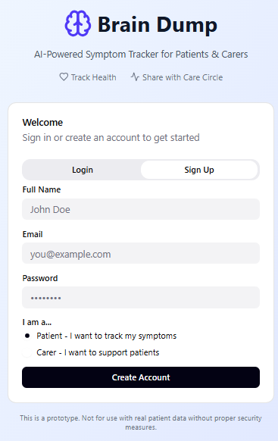 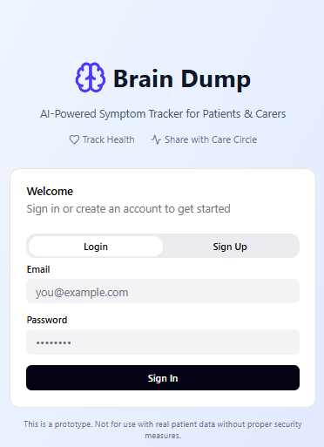
Fig: Signup flow Fig: Login flow

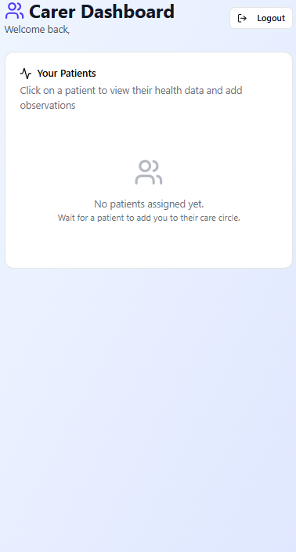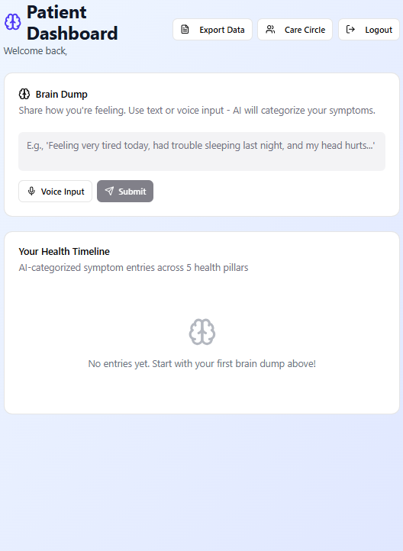

Fig: Carer Dashboard Fig: Patient Dashboard

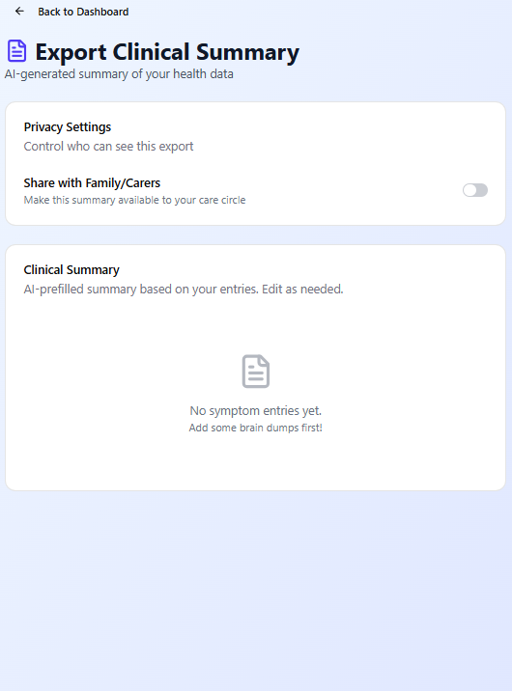

Fig: PDF generation flow

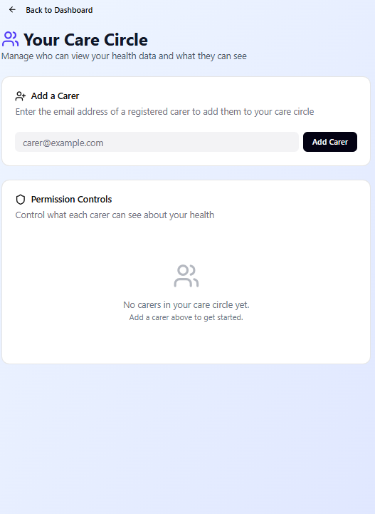

Fig: Care Circle flow

Time-plan and Risk Plan

  - Time-Plan

Phase | Task Name | Start Date | End Date | Technical Complexity & Detail
Design | Initial Project Scope & Documentation | Feb 16 | Feb 22 | Defining “CogniCare” logic & 5 pillars.
Design | Wireframe Implementation | Feb 22 | Feb 25 | Completed (UI/UX blueprints for reference).
Design | User-Role Access & Workflows | Feb 26 | Mar 02 | Mapping permissions and sharing logic.
Setup | Next.js & Capacitor Project Repository | Mar 03 | Mar 06 | Initializing repo & native bridge config.
Setup | Install Prisma & DB (PostgreSQL) Setup | Mar 07 | Mar 11 | Relational schema for logs and roles.
Academic | Interim Report Prep & Submission | Mar 12 | Mar 18 | Drafting progress report & technical update.
Setup | NextAuth.js & Middleware | Mar 19 | Mar 23 | Handling session-based security and RBAC.
Backend | PII Data Scrubbing Utility | Mar 24 | Mar 31 | Logic to strip PII before AI calls.
Backend | OpenAI API Integration (NLP Engine) | Apr 01 | Apr 8 | Prompt engineering for 5-pillar output.
Academic | Principal Marker Interview Prep | Apr 9 | Apr 15 | Preparing technical demo & research defence.
Backend | Build Care Circle Management | Apr 16 | Apr 22 | Invites and permission toggle logic.
Frontend | Build Patient "Brain Dump" View | Apr 23 | April 28 | Text input & Capacitor Voice hooks.
Frontend | Build Collaborative Timeline View | April 29 | May 04 | Visualizing data & observation notes.
Academic | Dissertation Writing & Formatting | May 05 | May 10 | Academic writing and plagiarism checks.
Final | Clinical PDF Summary Generation | May 11 | May 13 | jspdf implementation for weekly logs.
Final | Testing & Project Completion | May 14 | May 15 | Final report delivery and code freeze.
Viva | Project Viva (Oral Exam) | May 18 | May 18 | Final defence of project and software.

6.2 Risk Plan

Risk | Impact | Mitigation Strategy
Capacitor Plugin Conflicts | Medium | Test native microphone and storage plugins on physical devices by Week 5.
PII Data Leakage | Critical | Implement the data scrubber in the Next.js API route before sending payloads to OpenAI.
AI Mapping Errors | High | Use "Symptom Confirmation" UI features so users can correct AI categorization

References

[1] Concussion Legacy Foundation UK, “CTE Support & Resources”, Concussion Legacy Foundation UK. [Online]. Available: https://www.concussionfoundation.org.uk/cte-resources

[2] C. Duncan and T. Nagai, “Characteristics of Symptom Tracking App Data and its Potential Use for XAI”, 2022 IEEE 10th International Conference on Healthcare Informatics (ICHI), Rochester, MN, USA, 2022.

[3] V. Kumar P, A. Selvam N and S. P, “Chronic Disease Symptom Checker with NLP”, 2025 4th International Conference on Sentiment Analysis and Deep Learning (ICSADL), Bhimdatta, Nepal, 2025.

[4] S. Shaikh, A. Naik, N. Veer, D. Borker and K. M. C. Kumar, “An Integrated Approach to Speech Disorder Detection: Whisper Transcription, NLP-Based T5 Correction, and TDNN Analysis”, 2025 IEEE 6th India Council International Subsections Conference (INDISCON), Rourkela, India, 2025.

[5] Y. Mellah, T. Bouchentouf, N. Rahmoun and M. Rahmoun, “Bilingual Chatbot For Covid-19 Detection Based on Symptoms Using Rasa NLU”, 2022 2nd International Conference on Innovative Research in Applied Science, Engineering and Technology (IRASET), Meknes, Morocco, 2022.

[6] V. Khanam, M. Singh and V. Dhote, “An Intelligent Voice-Enabled AI Chatbot for Symptom Detection and Early Health Assessment”, 2025 3rd DMIHER International Conference on Artificial Intelligence in Healthcare, Education and Industry (IDICAIHEI), Wardha, India, 2025.

[7] D. M. D. Preethi, V. Nithyasree S and T. Preethi Sri, “CareConnect – AI-powered Health Assistant”, 2025 Third International Conference on Emerging Applications of Material Science and Technology (ICEAMST), Bengaluru, India, 2025.
[8] C. A. Frantzidis, A. S. Stravoravdi, A. I. Ladas and G. Papazisis, “SYMPTOM: SYMptom-Level Prediction of Target Outcomes in Major Depressive Disorder (MDD) Using Transformers on Mental Health Narratives”, 2025 IEEE 25th International Conference on Bioinformatics and Bioengineering (BIBE), Athens, Greece, 2025.

[9] J. K. A, S. G. P, T. A. K, Shivlinga and N. B. Chittaragi, “Virtual Health Assist: An LLM-Powered AI Platform for Symptom Diagnosis and Healthcare Assistance”, 2025 Third International Conference on Networks, Multimedia and Information Technology (NMITCON), BENGALURU, India, 2025.

[10] Counseling@Northwestern, “How Counselling Can Help After a Concussion”, Northwestern University, [Online]. Available: https://counseling.northwestern.edu/blog/how-counseling-can-help-after-concussion/

