**Exhibit 4.3**

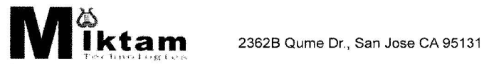

**PROMISSORY NOTE**

FOR VALUE RECEIVED, Mitkam Technologies, Inc., the borrower, promises to pay to the order of Eugene Cheng, the note holder, the principal amount of Fifty Thousand Dollars ($50,000.00), together with simple interest on the unpaid principal balance from the date of this note until the date this note is paid in full, at the annual rate of Eight (8%). Payments shall be made at the address or the account designated by the note holder.

The tern of this note shall be Six (6) Months from the date of receiving the total loan amount. Principal and interest shall be paid in full by August 19, 2009. However, the tern could be renewable with the consent of both parties. If the note is renewed for additional terms, the interest payment shall be paid at each maturity date of said term.Each payment on this note shall be applied first to

accrued but unpaid interest and the remainder shall be applied to unpaid principal.

This note may be prepaid by the borrower in whole or in part at any time without penalty. This note is not assumable without the written consent of the note holder, which consent shall not be unreasonably withheld. This note is nontransferable by the note holder.

If any payment due under this note is not received by the note holder within 30 days of its due date, the entire amount of unpaid principal and accrued but unpaid interest of the loan shall, at the option of the note holder, become immediately due and payable with written notice by the note holder to the borrower. In the event of a default, the borrower shall be responsible for the costs of collection, including, in the event of a lawsuit to collect on this note, the note holder's reasonable attorney fees as determined by a court hearing the lawsuit.

Date: February 19, 2009

BORROWER:

MITKAM TECHNOLOGIES, INC.

2362-B Qume Drive

San Jose, CA 95131

*/s/ Thomas Chao*

Thomas Chao, President

www.miktamusa.corn  Tel: 408-392-0668 FAX: 408-392-0662