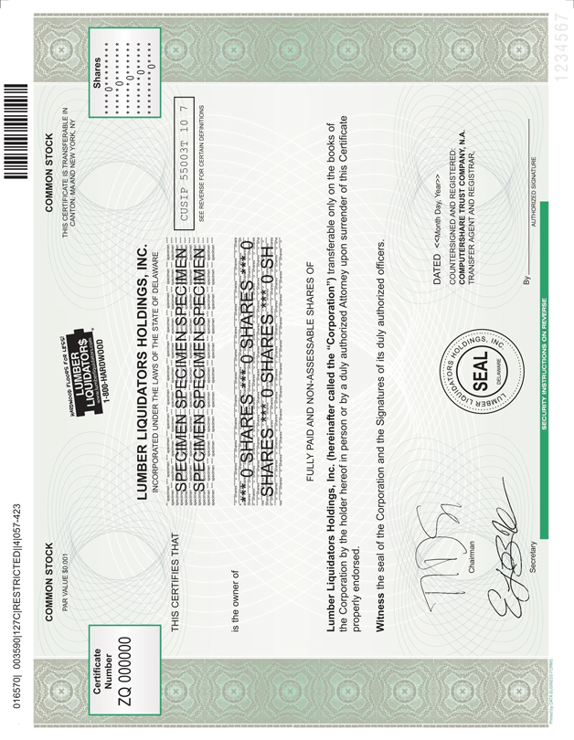

LUMBER LIQUIDATORS HOLDINGS, INC.

|  |  |  |  |  |  |  |  |  |  |  |  |  |
| --- | --- | --- | --- | --- | --- | --- | --- | --- | --- | --- | --- | --- |
|  |  |  |  |  |  |  |  |  |  |  |  |  |
|  |  | The following abbreviations, when used in the inscription on the face of this certificate, shall be construed as though they were written out in full according to applicable laws or regulations: | | | | | | | | | | |
|  |  | TEN COM |  | - as tenants in common |  |  |  | UNIF GIFT MIN ACT- |  | Custodian | | |
|  |  |  |  |  |  |  |  |  |  | (Cust)                                  (Minor) | | |
|  |  | TEN ENT |  | - as tenants by the entireties |  |  |  |  |  | under Uniform Gifts to Minors Act | | |
|  |  |  |  |  |  |  |  |  |  | (State) | | |
|  |  | JT TEN |  | - as joint tenants with right of survivorship and not as tenants in common |  |  |  | UNIF TRF MIN ACT |  | Custodian (until age     ) | | |
|  |  |  |  |  |  |  |  |  | (Cust)                                          (Minor) | | |
|  |  |  |  |  |  |  |  |  | under Uniform Transfers to Minors Act | | |
|  |  |  |  |  |  |  |  |  | (State) | | |
|  |  |  |  | Additional abbreviations may also be used though not in the above list. | | | | | | | | |

|  |  |  |
| --- | --- | --- |
|  |  |  |
|  |  | PLEASE INSERT SOCIAL SECURITY OR OTHER IDENTIFYING NUMBER OF ASSIGNEE |
| For value received,                  hereby sell, assign and transfer unto |  |  |

(PLEASE PRINT OR TYPEWRITE NAME AND ADDRESS, INCLUDING POSTAL ZIP CODE, OF ASSIGNEE)

|  |  |  |
| --- | --- | --- |
|  |  |  |
|  |  | Shares |
| represented by the within Certificate, and do hereby irrevocably constitute and appoint |  |  |
|  |  | Attorney |
| to transfer the said Shares on the books of the within named Corporation with full power of substitution in the premises. |  |  |

|  |  |  |  |  |  |  |  |  |  |  |  |  |
| --- | --- | --- | --- | --- | --- | --- | --- | --- | --- | --- | --- | --- |
|  |  |  |  |  |  |  |  |  |  |  |  |  |
| Dated: |  |  | | |  | 20 |  |  |  |  |  | Signature(s) Guaranteed: Medallion Guarantee Stamp  THE SIGNATURE(S) SHOULD BE GUARANTEED BY AN ELIGIBLE GUARANTOR INSTITUTION (Banks, Stockbrokers, Savings and Loan Associations and Credit Unions) WITH MEMBERSHIP IN AN APPROVED SIGNATURE GUARANTEE MEDALLION PROGRAM, PURSUANT TO S.E.C. RULE 17Ad-15. |
| Signature: |  |  | | | | | | |  |  |
| Signature: |  |  | | | | | | |  |  |
|  |  | Notice: |  | The signature to this assignment must correspond with the name as written upon the face of the certificate, in every particular, without alteration or enlargement, or any change whatever. | | | | |  |  |

