**Exhibit 4.14**

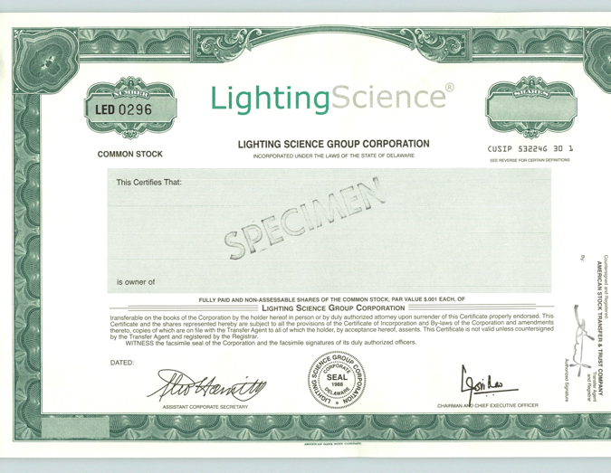

LightingScience®

COMMON STOCK

LIGHTING SCIENCE GROUP CORPORATION

INCORPORATED UNDER THE LAWS OF THE STATE OF DELAWARE

CUSIP 532246 3D 1

SEE REVERSE FOR CERTAIN DEFINITIONS

This Certifies That:

is owner of FULLY PAID AND NON-ASSESSABLE SHARES OF THE COMMON STOCK, PAR VALUE $.001 EACH, OF

Lighting Science Group Corporation

transferable on the books of the Corporation by the holder hereof in person or by duly authorized attorney upon surrender of this Certificate properly endorsed. This Certificate and the shares represented hereby are subject to all the provisions of the Certificate of Incorporation and By-laws of the Corporation and amendments thereto, copies of which are on file with the Transfer Agent to all of which the holder, by acceptance hereof, assents. This Certificate is not valid unless countersigned by the Transfer Agent and registered by the Registrar.

WITNESS the facsimile seal of the Corporation and the facsimile signatures of its duly authorized officers.

DATED:

ASSISTANT CORPORATE SECRETARY

CHAIRMAN AND CHIEF EXECUTIVE OFFICER

Countersigned and Registered:

AMERICAN STOCK TRANSFER & TRUST COMPANY

Transfer Agent and Registrar

By:

Authorized Signature