**Exhibit 4.17**

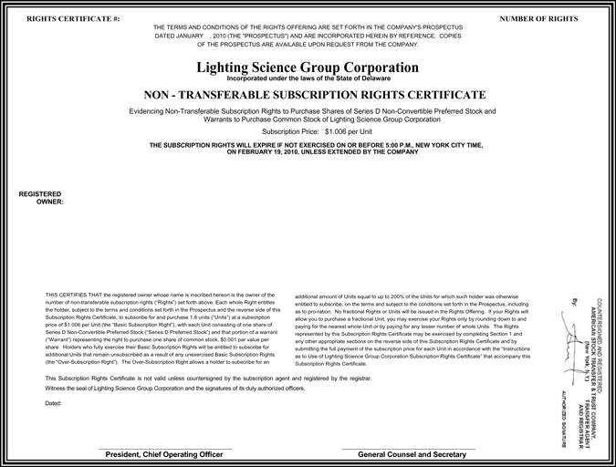

RIGHTS CERTIFICATE #: NUMBER OF RIGHTS

THE TERMS AND CONDITIONS OF THE RIGHTS OFFERING ARE SET FORTH IN THE COMPANY’S PROSPECTUS

DATED JANUARY , 2010 (THE “PROSPECTUS”) AND ARE INCORPORATED HEREIN BY REFERENCE. COPIES

OF THE PROSPECTUS ARE AVAILABLE UPON REQUEST FROM THE COMPANY.

Lighting Science Group Corporation

Incorporated under the laws of the State of Delaware

NON—TRANSFERABLE SUBSCRIPTION RIGHTS CERTIFICATE

Evidencing Non-Transferable Subscription Rights to Purchase Shares of Series D Non-Convertible Preferred Stock and Warrants to Purchase Common Stock of Lighting Science Group Corporation

Subscription Price: $1.006 per Unit

THE SUBSCRIPTION RIGHTS WILL EXPIRE IF NOT EXERCISED ON OR BEFORE 5:00 P.M., NEW YORK CITY TIME,

ON FEBRUARY 19, 2010, UNLESS EXTENDED BY THE COMPANY

REGISTERED

OWNER:

THIS CERTIFIES THAT the registered owner whose name is inscribed hereon is the owner of the

number of non-transferable subscription rights (“Rights”) set forth above. Each whole Right entitles the holder, subject to the terms and conditions set forth in the Prospectus and the reverse side of this Subscription Rights Certificate, to subscribe for and purchase 1.8 units (“Units”) at a subscription price of $1.006 per Unit (the “Basic Subscription Right”), with each Unit consisting of one share of Series D Non-Convertible Preferred Stock (“Series D Preferred Stock”) and that portion of a warrant (“Warrant”) representing the right to purchase one share of common stock, $0.001 par value per share. Holders who fully exercise their Basic Subscription Rights will be entitled to subscribe for additional Units that remain unsubscribed as a result of any unexercised Basic Subscription Rights (the “Over-Subscription Right”). The Over-Subscription Right allows a holder to subscribe for an

[GRAPHIC APPEARS HERE]

additional amount of Units equal to up to 200% of the Units for which such holder was otherwise entitled to subscribe, on the terms and subject to the conditions set forth in the Prospectus, including as to pro-ration. No fractional Rights or Units will be issued in the Rights Offering. If your Rights will allow you to purchase a fractional Unit, you may exercise your Rights only by rounding down to and paying for the nearest whole Unit or by paying for any lesser number of whole Units. The Rights represented by this Subscription Rights Certificate may be exercised by completing Section 1 and any other appropriate sections on the reverse side of this Subscription Rights Certificate and by submitting the full payment of the subscription price for each Unit in accordance with the “Instructions as to Use of Lighting Science Group Corporation Subscription Rights Certificate” that accompany this Subscription Rights Certificate.

This Subscription Rights Certificate is not valid unless countersigned by the subscription agent and registered by the registrar. Witness the seal of Lighting Science Group Corporation and the signatures of its duly authorized officers.

Dated:

President, Chief Operating Officer General Counsel and Secretary

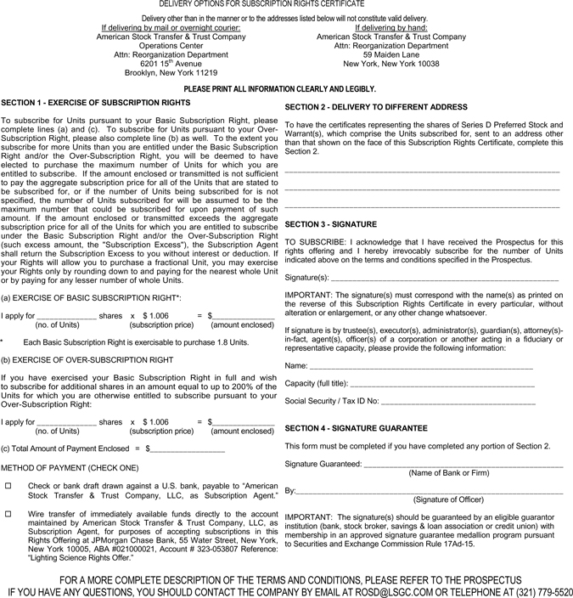

DELIVERY OPTIONS FOR SUBSCRIPTION RIGHTS CERTIFICATE

Delivery other than in the manner or to the addresses listed below will not constitute valid delivery.

If delivering by mail or overnight courier:

American Stock Transfer & Trust Company

Operations Center

Attn: Reorganization Department

6201 15th Avenue

Brooklyn, New York 11219

If delivering by hand:

American Stock Transfer & Trust Company

Attn: Reorganization Department

59 Maiden Lane

New York, New York 10038

PLEASE PRINT ALL INFORMATION CLEARLY AND LEGIBLY.

SECTION 1—EXERCISE OF SUBSCRIPTION RIGHTS

To subscribe for Units pursuant to your Basic Subscription Right, please complete lines (a) and (c). To subscribe for Units pursuant to your Over-Subscription Right, please also complete line (b) as well. To the extent you subscribe for more Units than you are entitled under the Basic Subscription Right and/or the Over-Subscription Right, you will be deemed to have elected to purchase the maximum number of Units for which you are entitled to subscribe. If the amount enclosed or transmitted is not sufficient to pay the aggregate subscription price for all of the Units that are stated to be subscribed for, or if the number of Units being subscribed for is not specified, the number of Units subscribed for will be assumed to be the maximum number that could be subscribed for upon payment of such amount. If the amount enclosed or transmitted exceeds the aggregate subscription price for all of the Units for which you are entitled to subscribe under the Basic Subscription Right and/or the Over-Subscription Right (such excess amount, the “Subscription Excess”), the Subscription Agent shall return the Subscription Excess to you without interest or deduction. If your Rights will allow you to purchase a fractional Unit, you may exercise your Rights only by rounding down to and paying for the nearest whole Unit or by paying for any lesser number of whole Units.

|  |  |  |
| --- | --- | --- |
| (a) |  | EXERCISE OF BASIC SUBSCRIPTION RIGHT*: |

I apply for shares x $ 1.006 = $

(no. of Units) (subscription price) (amount enclosed)

|  |  |  |
| --- | --- | --- |
| * |  | Each Basic Subscription Right is exercisable to purchase 1.8 Units. |

|  |  |  |
| --- | --- | --- |
| (b) |  | EXERCISE OF OVER-SUBSCRIPTION RIGHT |

If you have exercised your Basic Subscription Right in full and wish to subscribe for additional shares in an amount equal to up to 200% of the Units for which you are otherwise entitled to subscribe pursuant to your Over-Subscription Right:

I apply for shares x $ 1.006 = $

(no. of Units) (subscription price) (amount enclosed)

|  |  |  |
| --- | --- | --- |
| (c) |  | Total Amount of Payment Enclosed = $ |

METHOD OF PAYMENT (CHECK ONE)

Check or bank draft drawn against a U.S. bank, payable to “American Stock Transfer & Trust Company, LLC, as Subscription Agent.”

Wire transfer of immediately available funds directly to the account maintained by American Stock Transfer & Trust Company, LLC, as Subscription Agent, for purposes of accepting subscriptions in this Rights Offering at JPMorgan Chase Bank, 55 Water Street, New York, New York 10005, ABA #021000021, Account # 323-053807 Reference: “Lighting Science Rights Offer.”

SECTION 2—DELIVERY TO DIFFERENT ADDRESS

To have the certificates representing the shares of Series D Preferred Stock and Warrant(s), which comprise the Units subscribed for, sent to an address other than that shown on the face of this Subscription Rights Certificate, complete this Section 2.

SECTION 3—SIGNATURE

TO SUBSCRIBE: I acknowledge that I have received the Prospectus for this rights offering and I hereby irrevocably subscribe for the number of Units indicated above on the terms and conditions specified in the Prospectus.

Signature(s):

IMPORTANT: The signature(s) must correspond with the name(s) as printed on the reverse of this Subscription Rights Certificate in every particular, without alteration or enlargement, or any other change whatsoever.

If signature is by trustee(s), executor(s), administrator(s), guardian(s), attorney(s)-in-fact, agent(s), officer(s) of a corporation or another acting in a fiduciary or representative capacity, please provide the following information:

Name:

Capacity (full title):

Social Security / Tax ID No:

SECTION 4—SIGNATURE GUARANTEE

This form must be completed if you have completed any portion of Section 2.

Signature Guaranteed:

(Name of Bank or Firm)

By:

(Signature of Officer)

IMPORTANT: The signature(s) should be guaranteed by an eligible guarantor institution (bank, stock broker, savings & loan association or credit union) with membership in an approved signature guarantee medallion program pursuant to Securities and Exchange Commission Rule 17Ad-15.

FOR A MORE COMPLETE DESCRIPTION OF THE TERMS AND CONDITIONS, PLEASE REFER TO THE PROSPECTUS

IF YOU HAVE ANY QUESTIONS, YOU SHOULD CONTACT THE COMPANY BY EMAIL AT ROSD@LSGC.COM OR TELEPHONE AT (321) 779-5520