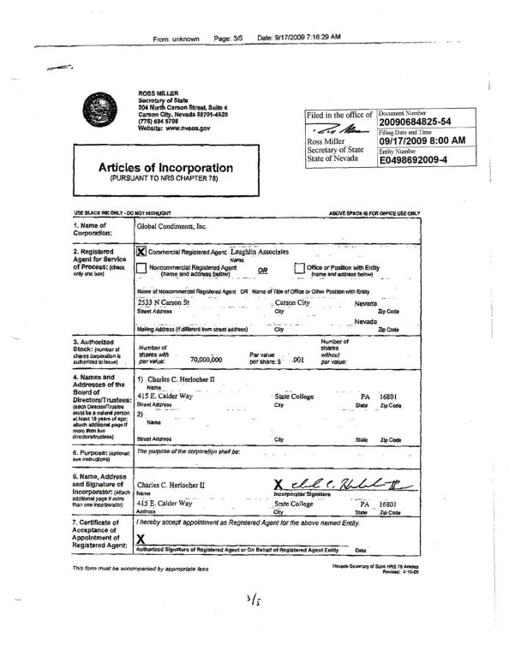

**GLOBAL CONDIMENTS, INC.**

**Articles of Incorporation (con’t)**

**ARTICLE 3 (Expanded)**

Common Stock: The amount of the total authorized capital stock of this corporation is Fifty Million (50,000,000) shares with a par value of $0.001 each, amounting to Fifty Thousand Dollars ($50,000.00).

Preferred Stock: The amount of the total authorized capital stock of this corporation is Twenty Million (20,000,000) shares with a par value of $0.001 each, amounting to Twenty Thousand Dollars ($20,000.00), with the Board of Directors having authority to attach such terms as they deem fit.

**ARTICLE 8**           Elimination or Limitation of Liability of Directors

No director shall be liable to the corporation or its stockholders for monetary damages for breach of fiduciary duty as a director: provided, however, that nothing contained herein shall eliminate or limit the liability of a director (i) for any breach of the director's duty of loyalty to the corporation or its stockholders, (ii) for acts or omissions not in good faith or which involve intentional misconduct or a knowing violation of law, (iii) for any transaction from which the director derived an improper personal benefit, or (iv) for any act or omission occurring prior to their directorship.

**ARTICLE 9**            Indemnification of Directors and Officers

The corporation shall indemnify the directors and officers of the corporation, and of any subsidiary of the corporation, to the full extent provided by the laws of the State of Nevada.

Expenses incurred by a director or officer in defending a civil or criminal action, suit or proceeding shall be paid by the corporation in advance of the final disposition of such action, suit or proceeding upon receipt of an undertaking by or on behalf of such director or officer to repay such amount if it shall ultimately be determined that he is not entitled to be indemnified by the corporation. In addition, the corporation may advance expenses of such nature on any other terms and/or in any other manner authorized by law.