Supplement
Figure S: Principle component analysis based on 9 annual climate variables. Insert shows vector loadings of each variable along the first two PC axis which explained most of the variance in weather patterns across years. Main plot shows the location of each cycle in the climatePC space, with numbers and color indicating the individual cycle (1-24). Max.Temp = Mean daily maximum temperature, Min.Temp = Mean daily minimum temperature, Hot.Days = Days above 35ºC, Mean.Preccip= Average daily precipitation, No.Preccip = Cummulative days without rain, Max.Drought = Highest drought index, Mean.Drougt=Average drought index, Rain.event.T = Average interevent times between rain events, Burstiness.Rain = Burstiness of Rain events,
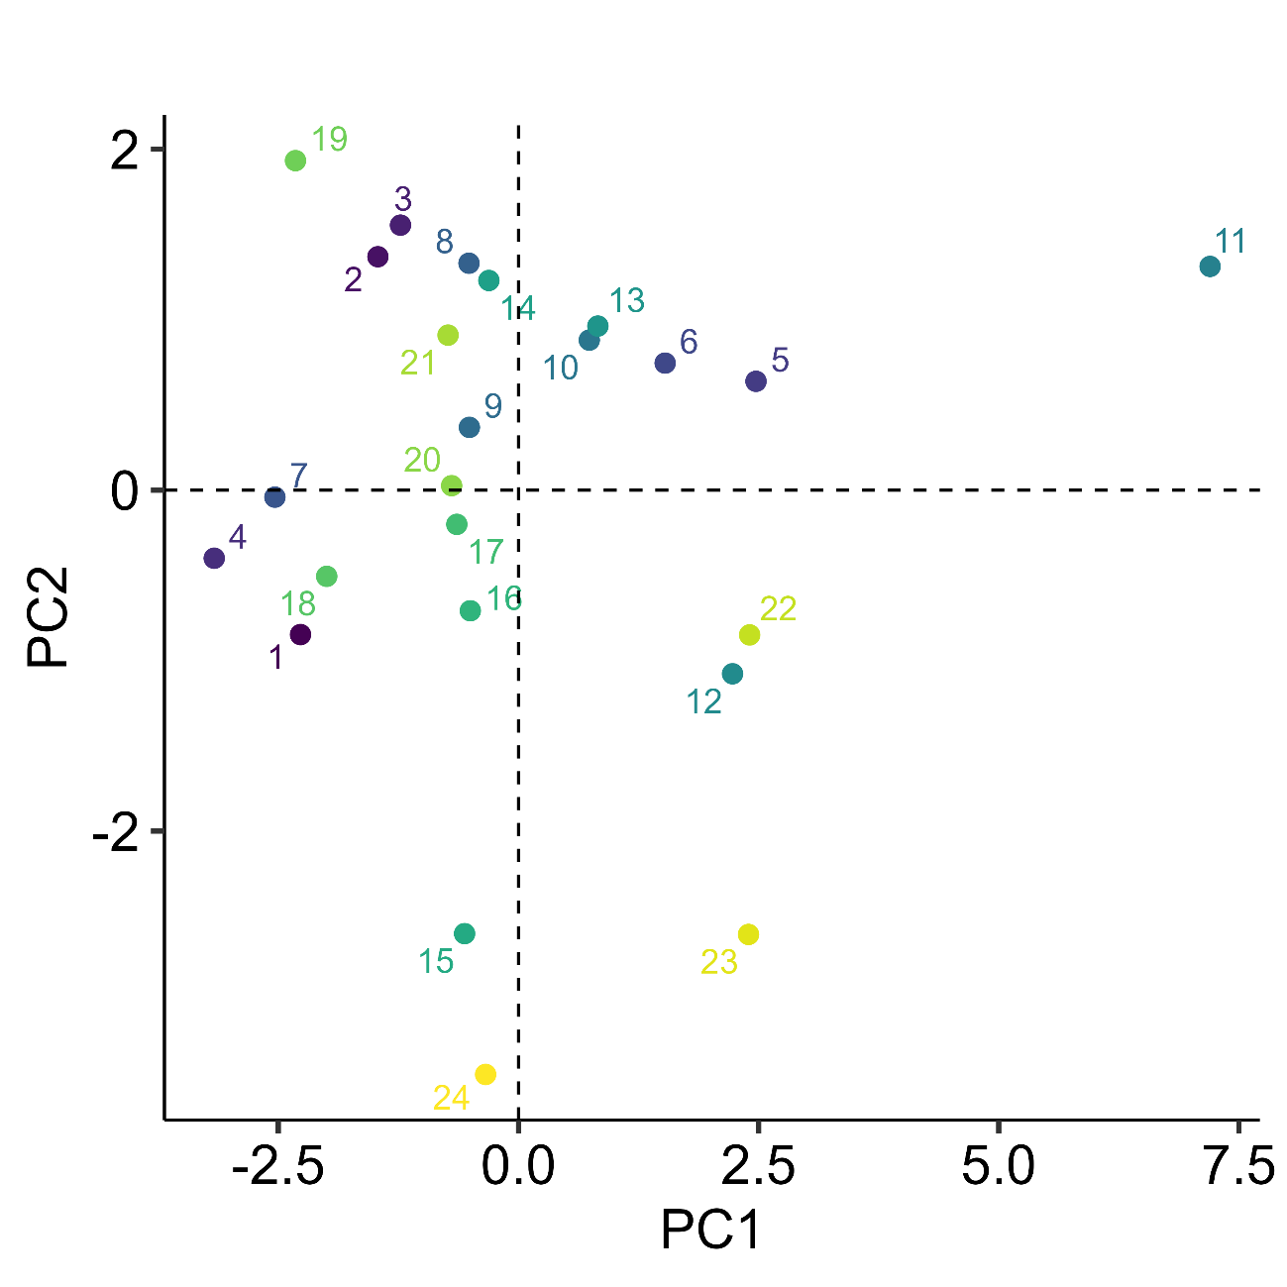
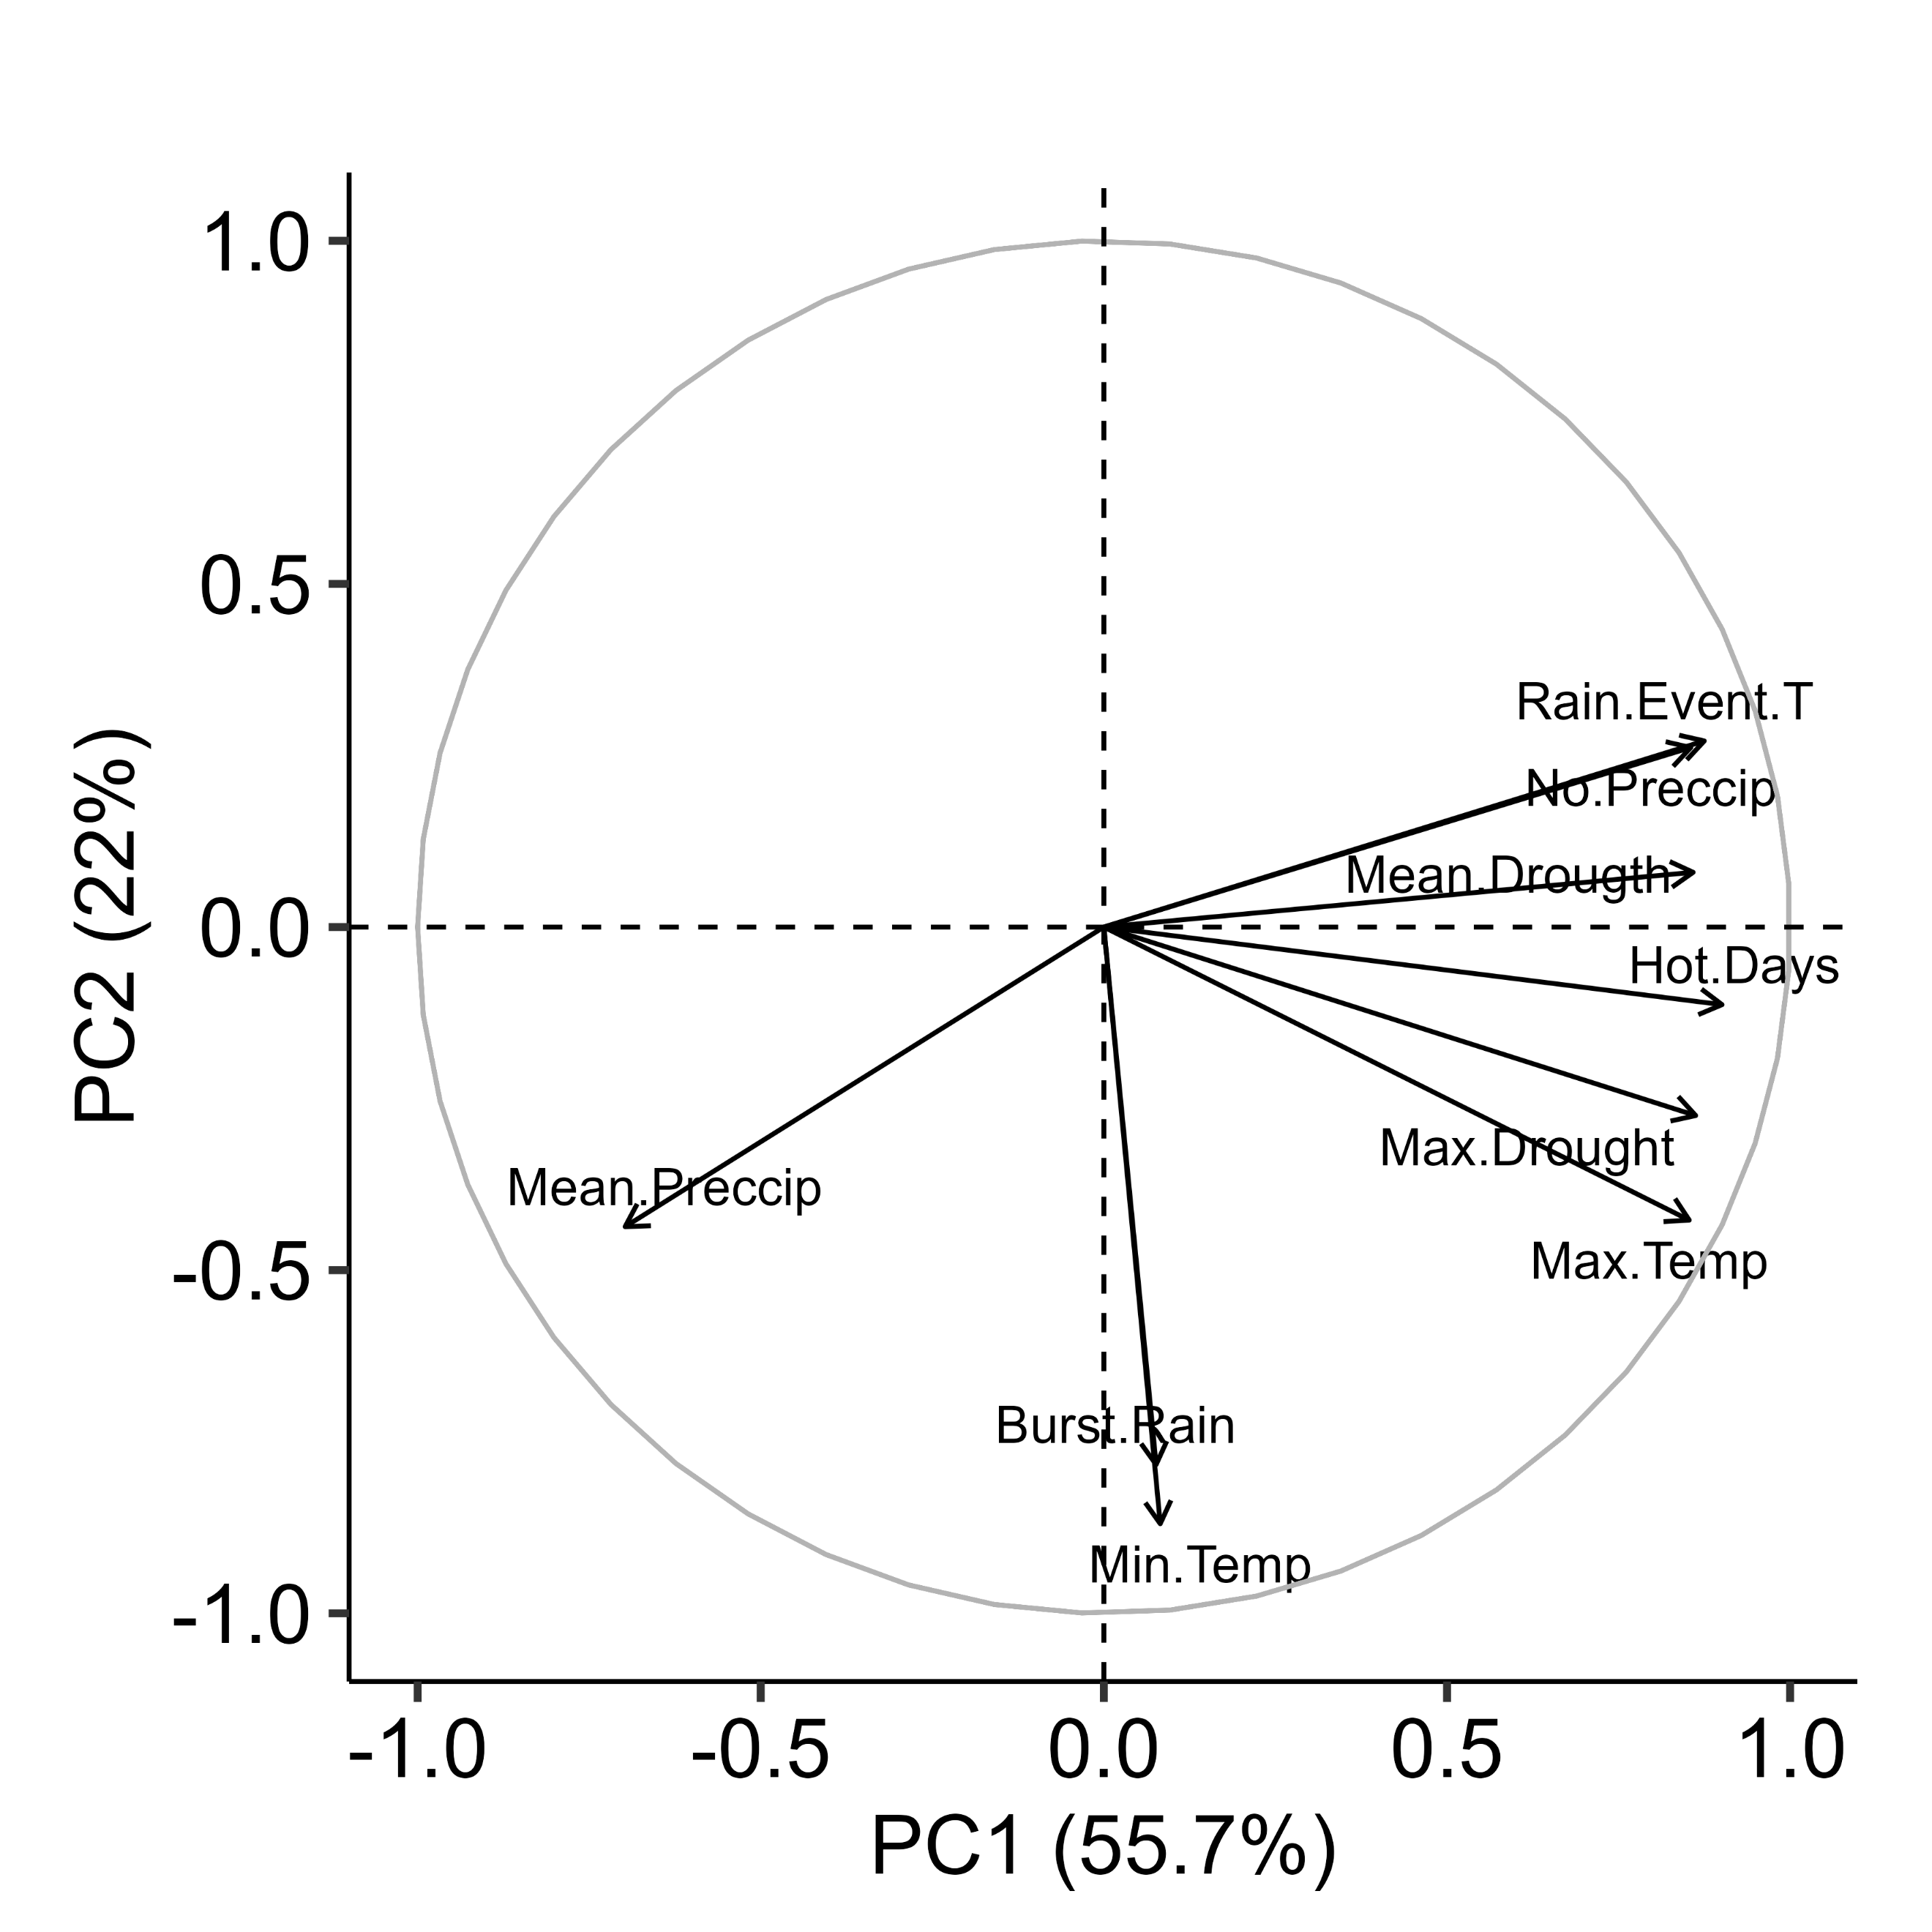
Figure SX: Daily maximum temperature and precipitation average per reproductive cycle, total number of very hot days (daily maximum temperature >35ºC) and days without precipitation. Dashed horizontal lines indicate the average across all 24 years and grey band $±$1 SE. Red indicates extreme years for the respective variable. 