Supplementary Materials for
Climatic extremes erode the temporal architecture of seasonal communities
Volker H. W. Rudolf^{1*}, Daniel Saenz²
*Corresponding author: Volker.rudolf@rice.edu
The file includes:
Materials and Methods
Supplementary Text
Figs. S1 to S8
Tables S1 to S8

Figures and tables overview:
Figure S1: Principal component analysis indicating annual differences in climatic variables
Figure S2: The duration and frequency of a state are positively correlated.
Figure S3: Frequency of node durations follows a negative exponential probability density function.
Figure S4: Correlation among network metrics across all ponds and time periods.
Fig. S5: Temporal (seasonal) structure of community transitions varies across sites (ponds) and years, while ignoring 1-day gap in calling activity
Fig. S6: Temporal (seasonal) structure of community transitions varies across sites (ponds) and years, while ignoring 2-day gap in calling activity.
Fig. S7: Temporal (seasonal) structure of community transitions varies across sites (ponds) and years, while ignoring 3-day gap in calling activity.
Fig. S8: Temporal structure of community transition networks changes in years with extreme climatic events.
Table S1: Effect of pond identity and cycle on network metrics.
Table S2: Effect of pond identity and cycle on network metrics after accounting for variation in species number.
Table S3: Weather PCA effect on network metrics.
Table S4: Same as Table S3 but including Species Richness as a covariate
Table S5: Effect of years with extreme HOT or Drought conditions on network metrics.
Table S6: Same as Table S5 but including Species Richness as a covariate
Table S7: Effect of pond identity and cycle on network metrics while ignoring 1-day gap in calling
Table S8: Effect of pond identity and cycle on network metrics while ignoring 2-day

Methods
Quantifying temporal community structure with transition networks
We used time-explicit transition networks based on daily observations to capture the temporal structure of communities within a year (6). This approach treats each unique combination of species (also called a community state) as a node, and links between nodes indicate a change in community structure when species enter or leave a community. This basic structure is similar to transition graphs used to study community assembly (44, 45), but it adds additional temporal information. Specifically, each node and link has one or more associated timestamps indicating the time intervals during which a specific community state or link was active. The structure of such a time-explicit transition network thus depends on the exact sequence and timing of changes in community structure. For instance, if states only occur once, we obtain a simple linear network structure, whereas repeating nodes would result in a more complex interconnected network structure (Fig. 1). Importantly, any difference in how a given community changes over time is mirrored in a concurrent change in the structure of these time-explicit transition networks, which we can capture by comparing network metrics (6).
Study system & phenology data collection
Amphibians are an excellent system to study the link between the temporal structure of communities and climate. The timing and duration of breeding activity vary across species (46-49), resulting in intra-annual changes in calling communities. Because their breeding activity is closely tied to temperature and rainfall, their phenology is significantly influenced by year-to-year variations in weather conditions (25). Furthermore, because species use different climate cues, they also vary in their phenological responses (23), which can reshuffle the temporal structure of amphibian communities across years (31, 49). Finally, Amphibians exhibit some of the strongest phenological responses to climate change (50), and they are the most threatened vertebrates globally (24). Identifying how amphibian communities are affected by climate change and extreme events should therefore be a high priority.
We collected high-resolution data on the calling activities (reflecting their respective breeding phenologies) of 12 amphibian species at eight different sites (ponds) in South-East Texas for 24 years (2001-2024). Details of pond characteristics and data collection methods are provided in Carter et al. (2019). Briefly, ponds are clustered in two geographic areas: the Davy Crockett National Forrest and the Stephen F. Austin Experimental Station, with an average distance of 7 km and a maximum distance of 34 km between ponds. We recorded calls each night for six consecutive 1-minute periods during peak calling time (hourly from 21:00 to 3:00) using an automated audio recorder at each site. We processed recordings manually with sonogram references to identify 12 species (Acris crepitans, Gastrophryne caroliensis, Hyla versicolor, Hyla cineria, Incilius (Bufo) valliceps, Anaxyrus (Bufo) woodhousii, Lithobates catesbeiana Lithobates clamitans, Lithobates sphenocephala, Lithobates palustris, Pseudacris crucifer, Pseudacris triseriata). These species interact locally, either via acoustic interference or competition for common resources in the adult or larval stage. To quantify annual changes in community structure, we converted the hourly calling data to nightly presence/absence data of each species and divided the data into annual breeding cycles (“frog years”), which we based on the activities of all species across all years and started on December 7th (see supplemental file).
Climate Data
Amphibian breeding activity in temperature regions is primarily driven by temperature and precipitation patterns (25, 30). We obtained daily weather data on both data types from the closest public local weather station situated between both pond clusters (Lufkin, Angelina Co. Airport, TX, 31.23593, -94.75468), including daily precipitation (mm), and daily maximum (Tmax) and minimum (Tmin) temperature. In addition, we obtained daily integrated drought severity metrics from the National Integrated Drought Information System (drought.gov), which considers a range of variables to indicate the amount of “missing” rain in an area. We converted the daily five categorical drought indices into a single metric by weighing each category relative to its severity and summing across all categories.
The daily weather was then binned into annual reproductive cycles (“frog years”) to calculate summary statistics for each cycle, including average highest and lowest daily temperature (meanTmax, meanTmin), the sum of extreme hot days (HotDays, i.e. daily Tmax > 35ºC), average daily precipitation (meanPrec), the burstiness of daily rainfall (BurstRain) to capture variation in the number of days between rainfall events, and cumulative number of days without rain (DaysNoRain). These annual weather metrics differed substantially across the 24-year period: The average daily temperature low (meanTmin) and high (meanTmax) per cycle ranged from 8.59 -15.23ºC and 19.30-27.78ºC respectively, with 6-99 days above a maximum temperature of 35ºC per year, and cumulative precipitation from 758.7-1990.1. Finally, we identified years with “extreme” climatic events as those falling outside ±1 SD of the mean over the past 50 years for each metric. We created two different sets of extreme years based on temperature versus precipitation: extreme hot years (years with 1 SD above the average mean Tmax or HotDays) and extreme dry years (years with 1 SD below the average meanPrec or above the average number of DaysNoRain). This approach ensured that we only picked the most extreme years during the study period, while providing enough statistical power to compare metrics across extreme vs normal years. Note that this includes the 5 hottest years recorded in the past 100 years, and 5 driest years recorded in the past 50 years. Thus, the years represent true climate extremes.
Data analysis
We converted species phenologies to transition networks of communities for each pond and cycle, resulting in total of 192 individual community transition networks (24 years x 8 sites). We focused on different aspects of the temporal structure by calculating a range of key network metrics falling into four broad categories (Table 1). First, we used a time-explicit daily transition network to quantify the durations and frequencies of occurrences of each state, and how these two are correlated. We also calculated burstiness, memory, and the rate of state transitions to determine the temporal spacing patterns of events and the time intervals between events. Burstiness determines whether transitions occur randomly, evenly spaced, or aggregated in time. Memory indicates how intervals between events are correlated. Event rate quantifies the average speed at which transitions cumulate over time. To further quantify the transition patterns between community states, we converted the daily transition networks into an annual Markov transition network, where each link is directed and weighted by its frequency of occurrence. For each network, we calculated several key metrics to quantify network structure (the number of unique nodes, connectance, modularity, mean distance, and betweenness weighted by edge frequency), nodes (average number of node occurrence, average and skewness of node duration), and edges (total number of edges; average and skewness of edge frequency). Together, these four groups of metrics (Table 1) provide a detailed picture of how the temporal structure of communities changes over a cycle at a given site and year.
Burstiness (B) was calculated using mean (µ) and the standard deviation (σ) of the inter-event times as $B=\frac{σ-μ}{σ+μ}$, where B=1 indicates high clustering with long inter-event times, B=0 random/neutral, and -1 complete regular spacing. Memor measures was based on the length of the state, and calculated as $M=\frac{\sum_{i-1}^{n-1}{(d_{i}-\overline{x})(d_{i+1}-\overline{y})}}{\sqrt{\sum_{i-1}^{n-1}{{(d_{i}-\overline{x})}^{2}}\sum_{i-1}^{n-1}{{(d_{i+1}-\overline{y})}^{2}}}}$, where D gives the vector of durations (d₁,d₂,d₃, …d_{n}) and x and y indicate vectors of durations with all durations except the last or first, respectively. A positive value indicates long events are followed by long events, 0 indicates independence, (no correlation), and negative values indicate compensation, i.e. long events are followed by short and vice versa. We calculated event rate by fitting a linear model to the cumulative sum of events over time, with the regression coefficient indicating the event rate. The linear model was the best and most parsimonious fit. Network metrics were calculated with the igraph package in R. Connectance was calculated using a directed graph formula excluding self-loops as $C=\frac{L}{N(N-1)}$, with L= unique directed edges between pairs, and N=total number of states. Weighted connectance was calculated as $C_{w}=\frac{\sum{w}}{V(V-1)/2}$, with w= sum of all edge weights and v is the number of vertices. Since both metrics were almost perfectly correlated, we only include unweighted connectance for ease of comparison. Modularity (Q) was calculated with the Walktrap Community Detection Algorithm in the modularity function igraph. Mean distance, or Average Path Length, was calculated using standard default function of igraph (mean_distance) but includes the inverse of edge weights to convert high frequency into higher proximity. Betweenness centrality was calculated as Freeman’s Group Centralization of Betweenness with “centr_betw” function in igraph.
When analyzing how variation in climate affected the community transition patterns, we first standardized all climate and network metrics using a z-score transformation (each variable has a mean of 0 and a standard deviation of 1). We then used a PCA analysis on these standardized metrics to mitigate issues of variance inflation caused by the inherent collinearity among climate metrics. The PCA analysis showed that 78% of the variation in the metrics could be captured by just the first two principal components (PC1= 54.3% & PC2 =23.8%) and any subsequent principal component added <7.6% (Supplement Fig on Axis, see Supplement Fig x for axis loading). We used general linear mixed models and the respective standardized network metrics as response variables, the first two weather principal components as predictors, and pond (site) as a random effect to account for non-independence of repeated observations across years. We also tested how network metrics differ across extreme climate years, using GLMs with extreme heat and drought years each as bimodal predictors, and pond as a random effect. All models fit best with normally distributed errors, except for Connectance and mean Distance, which were log-transformed to improve model fit and meet error distribution assumptions.
We tested how sensitive the results are to small gaps in calling activity by repeating the analysis in four ways: the original raw data, which treated all days without calling as absence, and three separate analyses that assumed species were still present when gaps (breaks) between calls were only either one (g1), two (g2), or three days (g3). So, if a species is called on days 1 and 3 but not on day 2, it would be considered absent in the raw data, whereas it would be considered present for all three days in the other scenarios. Overall, we found that ignoring small gaps did not qualitatively alter any patterns and only weakened or strengthened some effects, indicating that our results are robust. Consequently, we present only the results based on raw calling data in the main text (see the supplement for additional analyses).

Robustness to calling gaps
We tested how sensitive the results are to small gaps in calling activity by repeating the analysis in four ways: the original raw data, which treated all days without calling as absence, and three separate analyses that assumed species were still present when gaps (breaks) between calls were only either one (g1), two (g2), or three days (g3). So, if a species is called on days 1 and 3 but not on day 2, it would be considered absent in the raw data, whereas it would be considered present for all three days in the other scenarios. Overall, we found that while ignoring small gaps inherently increased or decreased metrics, it did not qualitatively change the general patterns and only slightly weakened or strengthened some responses, indicating that our results are robust. Consequently, we present only the results based on raw calling data in the main text and the results for the other three data sets assumption in the supplement.

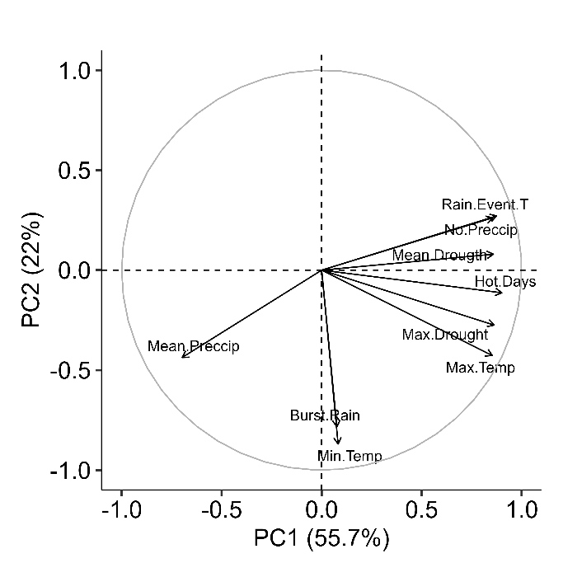
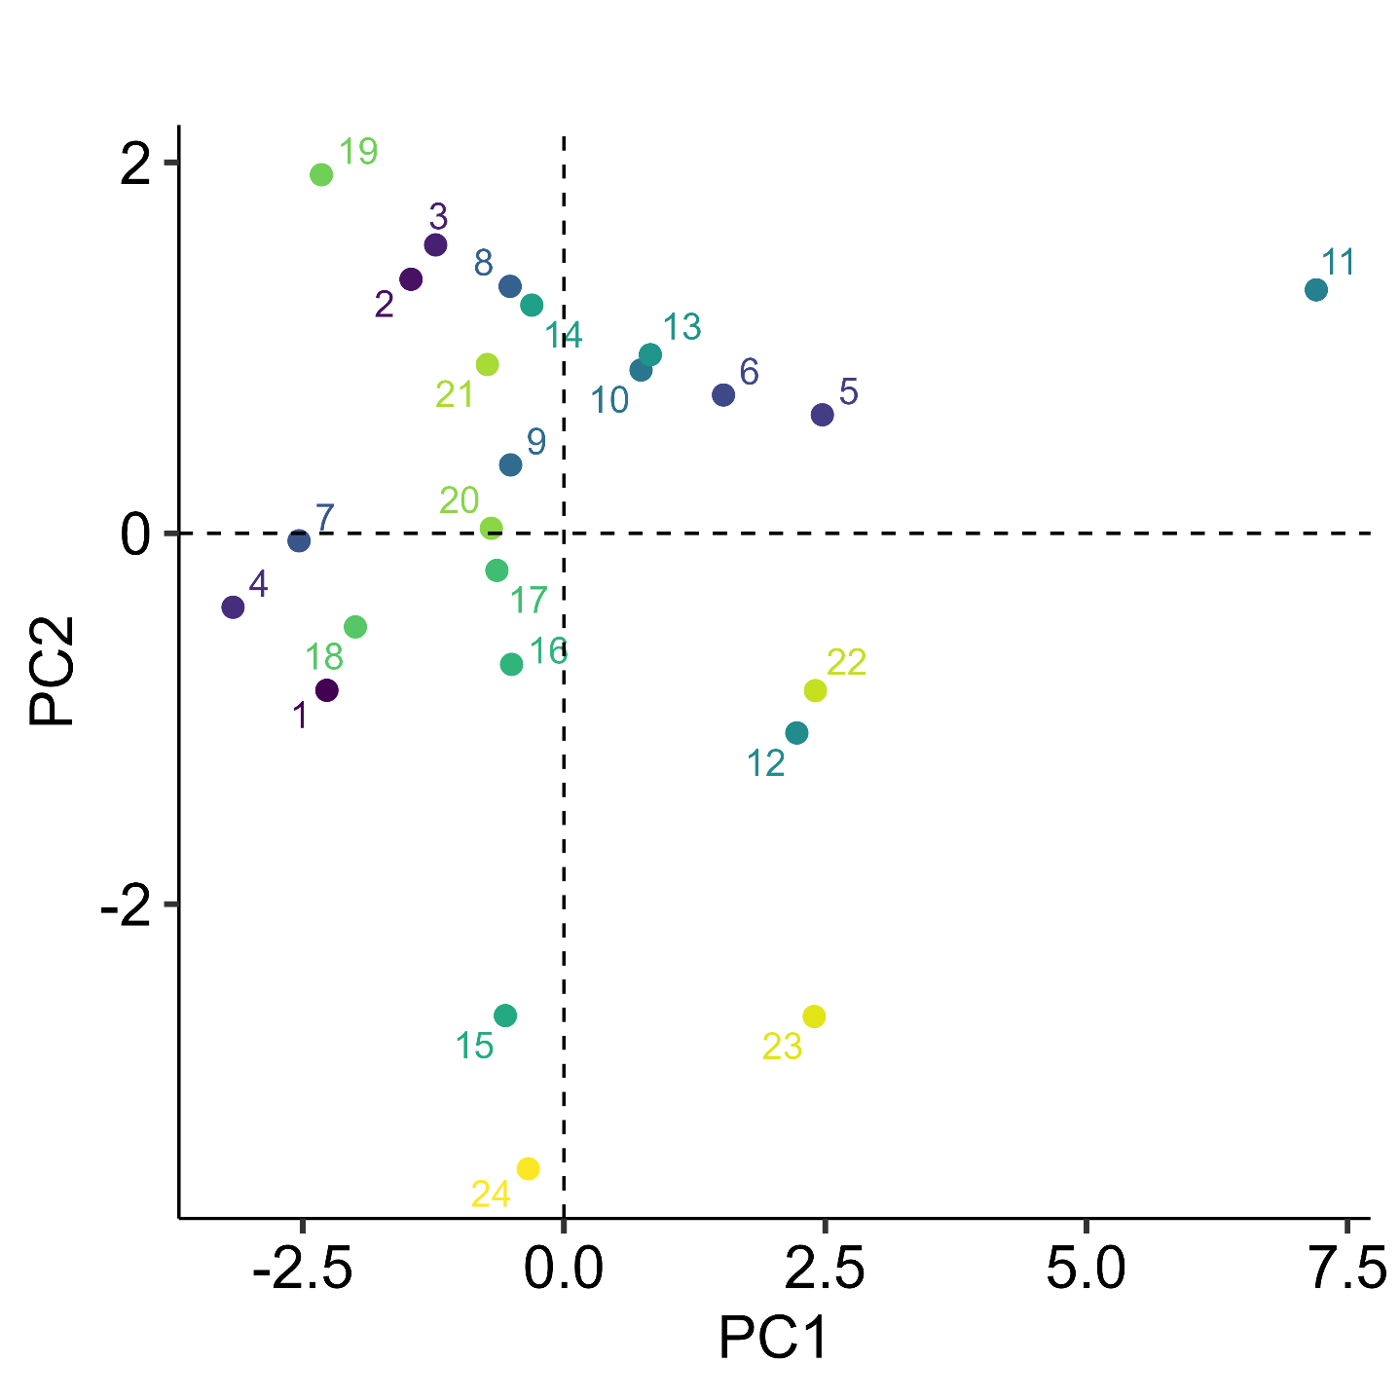
Figure S1: Principal component analysis indicating annual differences in climatic variables. The left side shows the loading of the nine different annual weather metrics. The right panel shows the location of each year in two-dimensional space, and the color indicates the values for each annual cycle from 2001 to 2024. Max.Temp = Average daily maximum temperature, Min.Temp = Average daily minimum temperature, Hot.Days = Number of days above 35ºC, Mean.Preccip= Average daily precipitation, No.Preccip = Number of days without rain, Max.Drought = Highest drought index, Mean.Drougt= Average drought index, Rain.event.T = Average interevent times between rain events, Burstiness.Rain = Burstiness of Rain events.

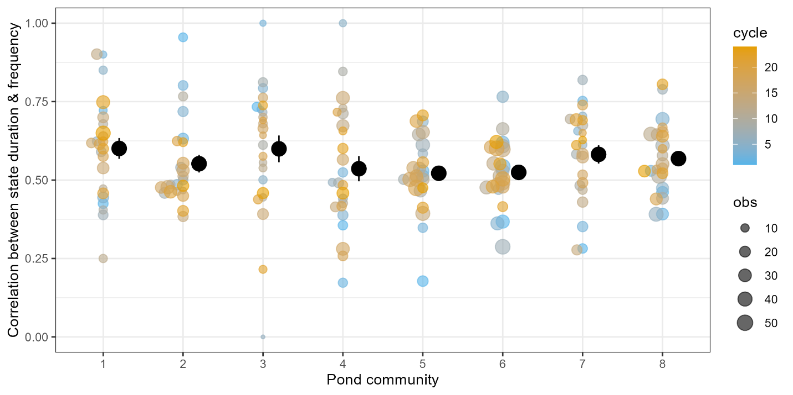Figure S2: The duration and frequency of a state are positively correlated. Small points indicate the correlation coefficient (r²) between the frequency and duration of a community state averaged across a given year and pond, with the size of the point indicating the number of community states observed during a given year and color indicating the annual cycle. Large black points indicate mean ±1SE across years for a given pond community.

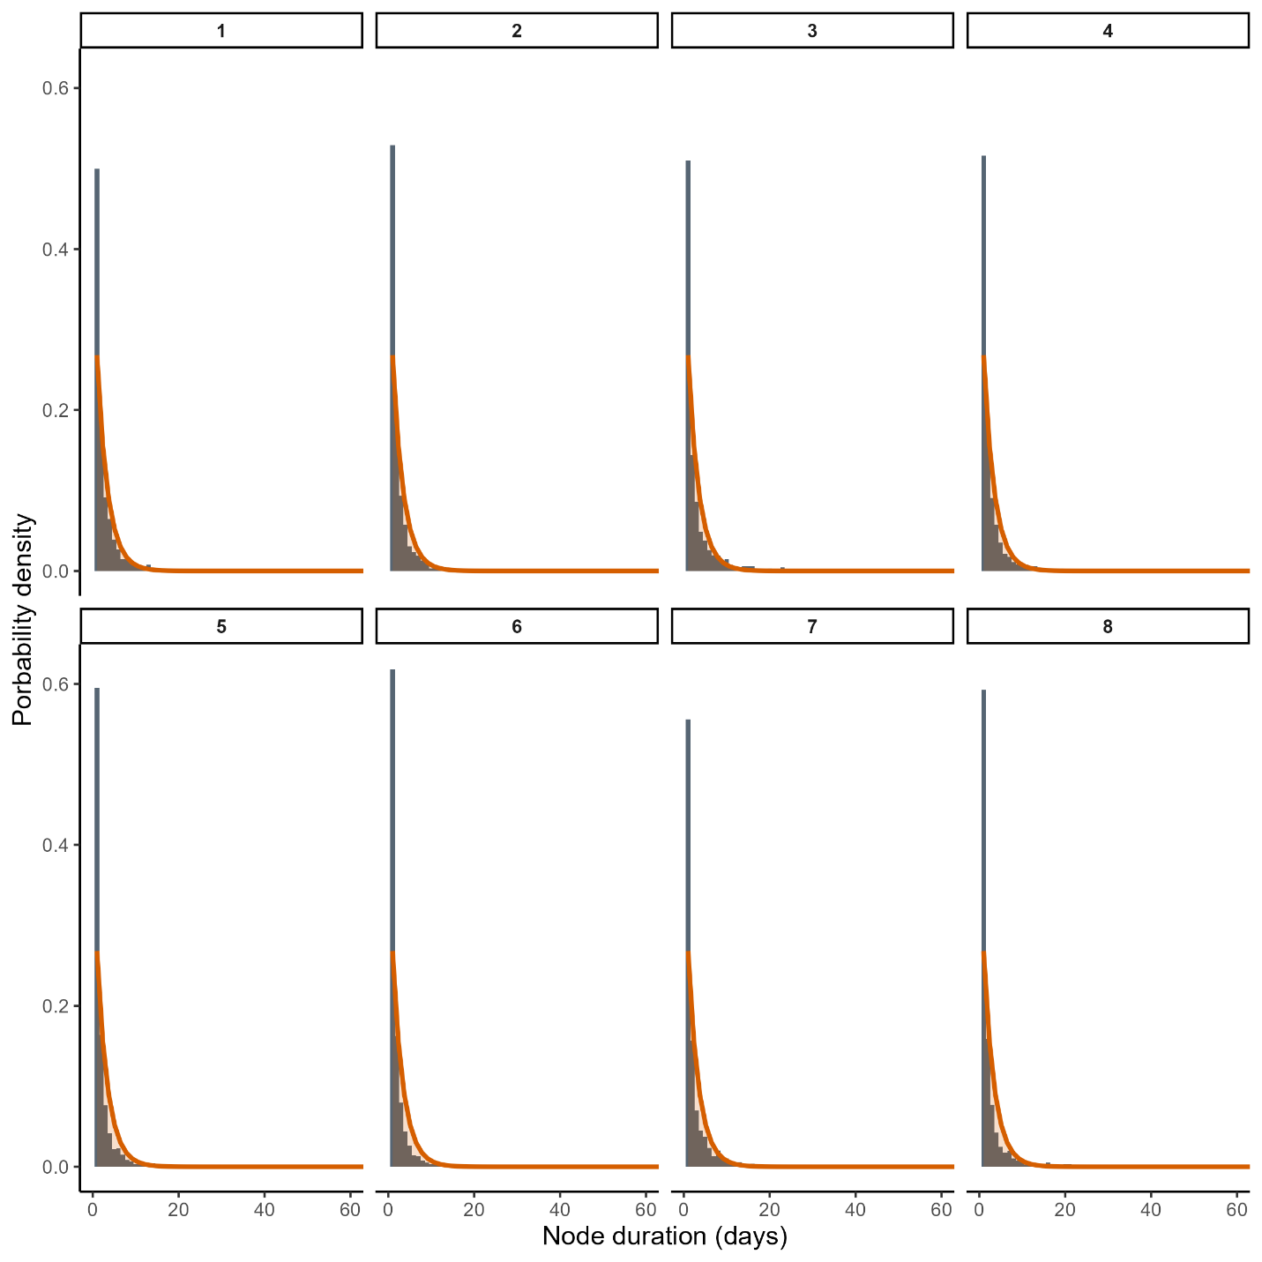Figure S3: Frequency of node durations follow negative exponential probability density function. Black bars indicate density of node durations, with a fitted negative exponential function $P\left(d\right)\sim e^{-λd}$(green line). Each panel represents a given pond (1-8), including all 24 years. Note that a very small number of longer state durations were omitted for clarity.

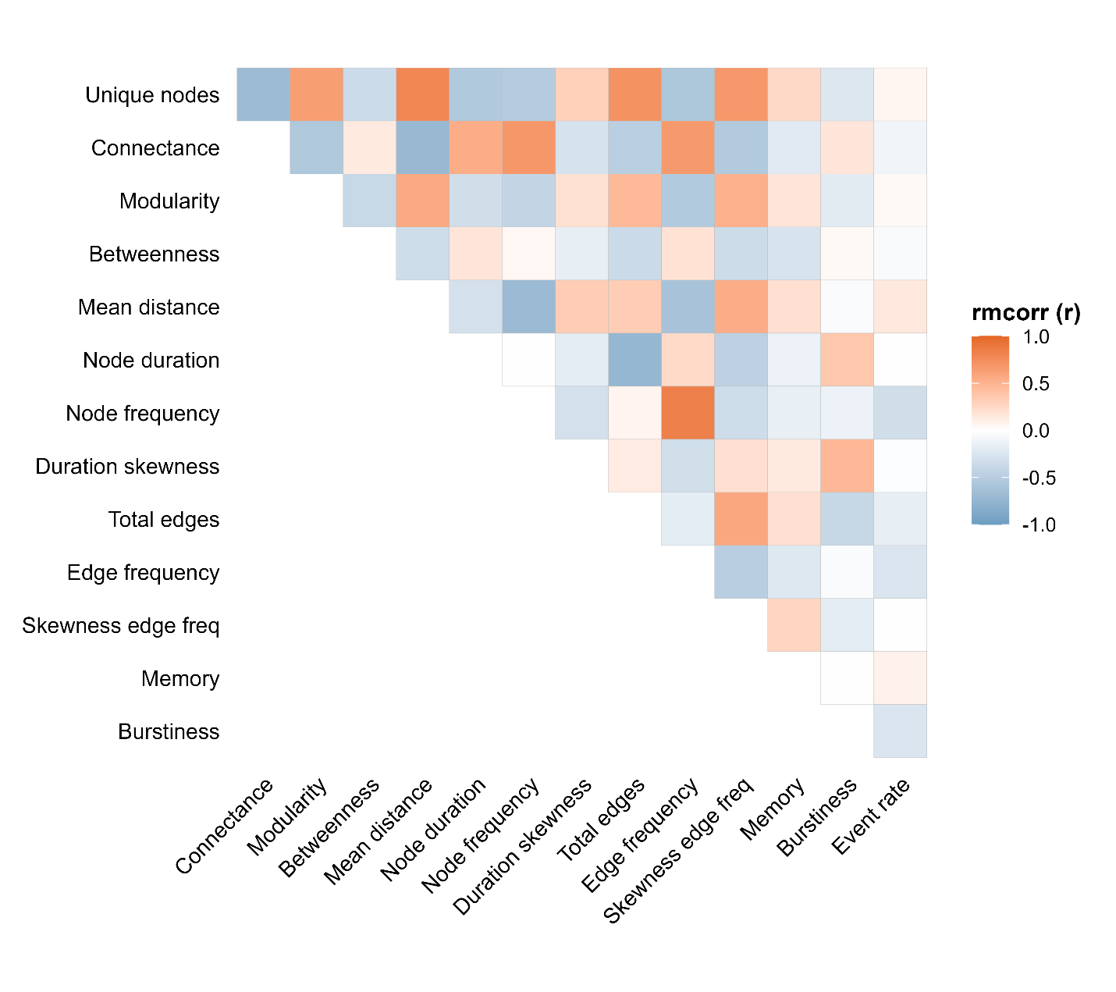Figure S4: Correlation among network metrics across all ponds and time periods. Correlations, rmcorr (r), were calculated with the rmcorr package in R and account for repeated observations of the same pond. For reference, the highest observed (and expected) correlation value here is 0.83, between Node frequency and Edge frequency.
Fig. S5: Temporal (seasonal) structure of community transitions varies across sites (ponds) and years while ignoring 1-day gap in calling activity. Note Fig. 2 in the main text did not ignore gaps. Solid black points indicate pond means ±1SE across annual cycles, and small points indicate the respective metric for a given year, with color indicating the respective annual cycle. 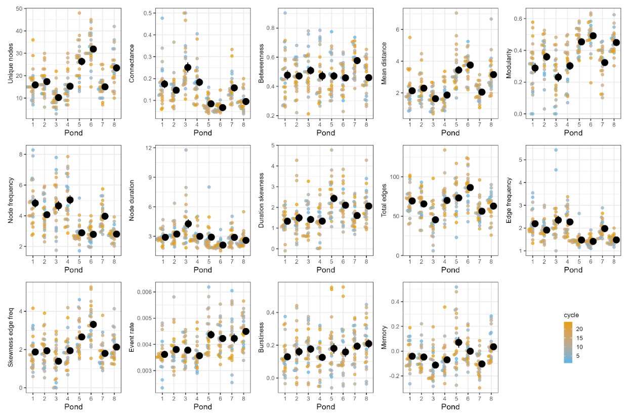
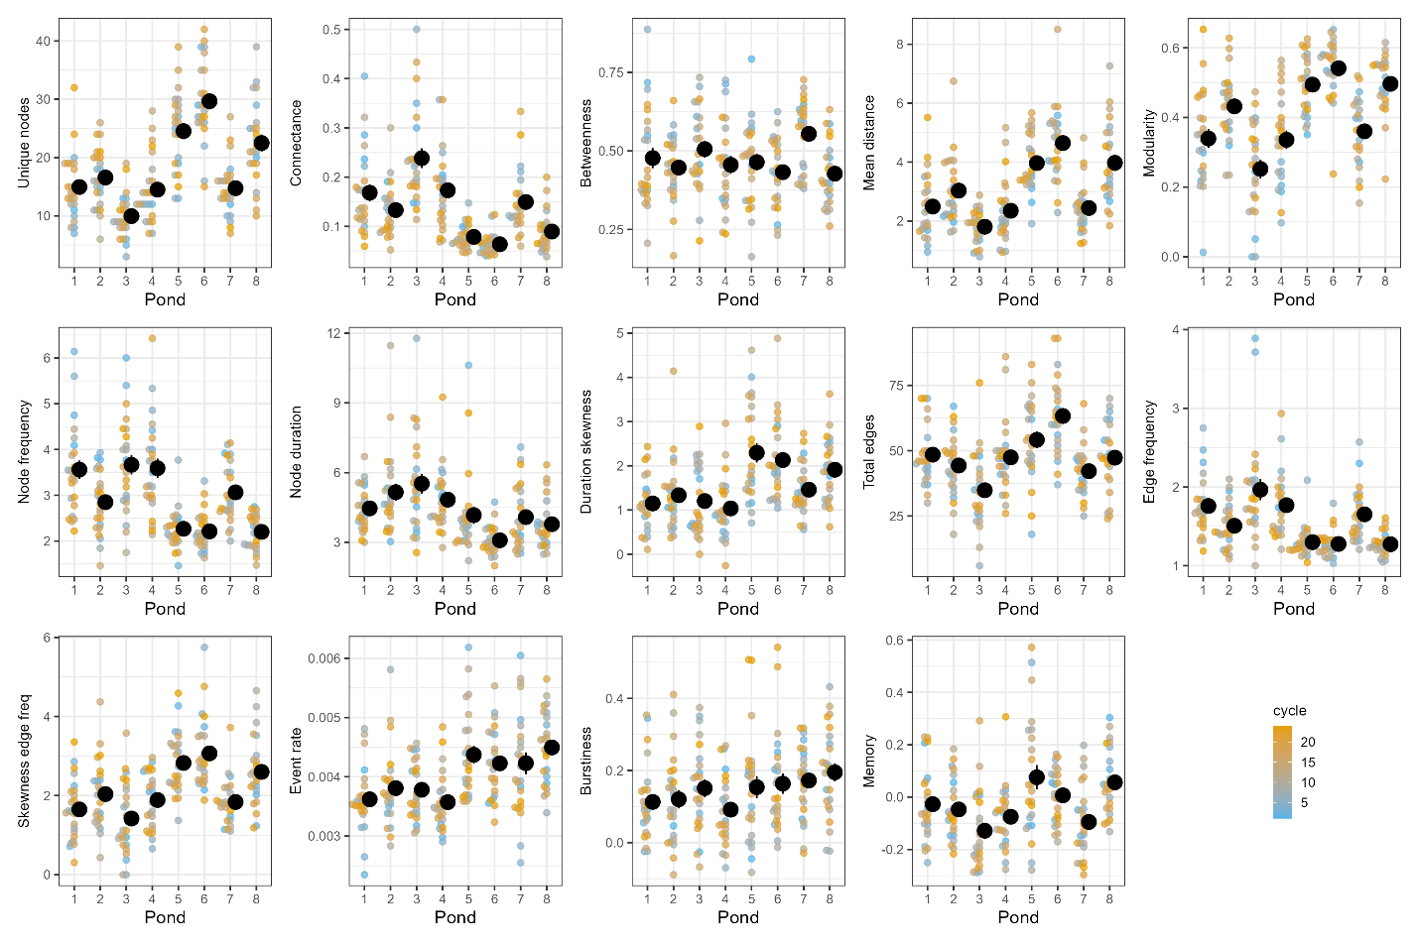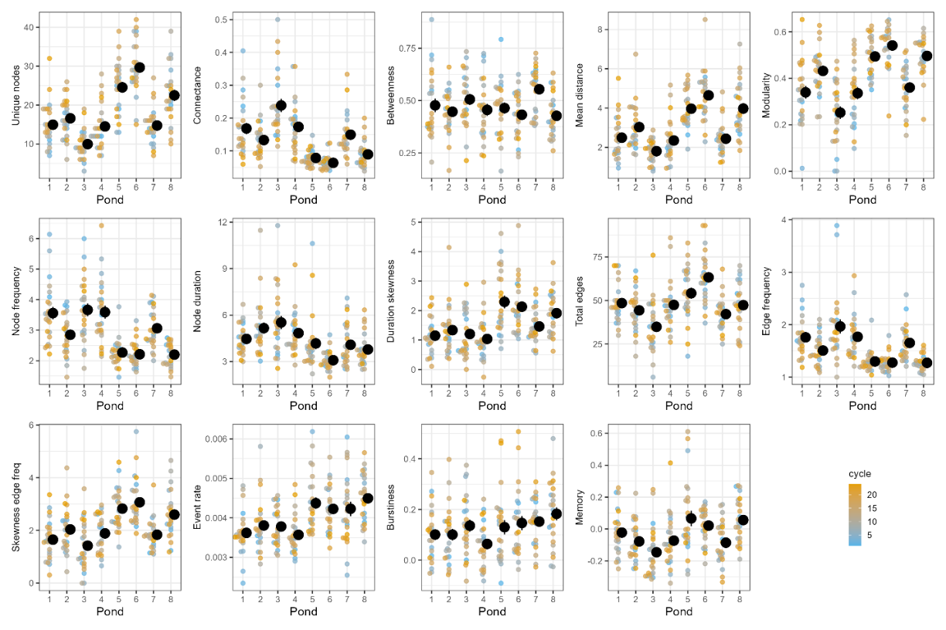
Fig. S6: Same S5 Fig. 5 but ignoring 2-day gap in calling activity. Fig. S7: Same as Fig. S5 but ignoring 3-day gap in calling activity.
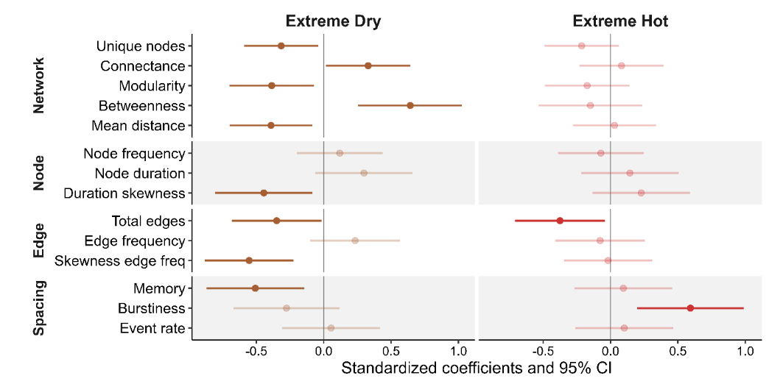
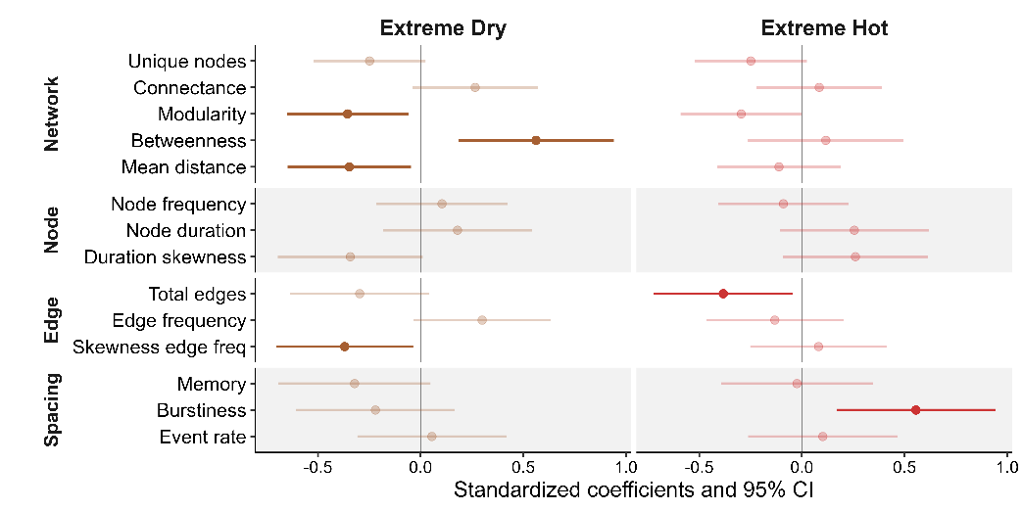
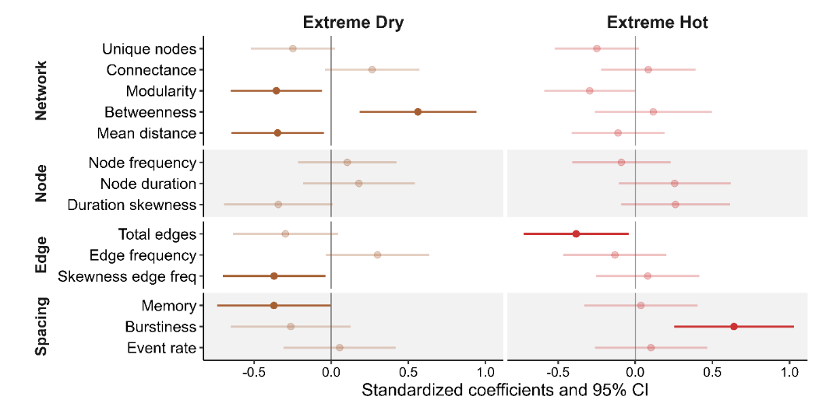
Fig. S8: Temporal structure of community transition networks changes in years with extreme climatic events. Same as Fig. 4 in the main text, but ignoring 1-day (top), 2-day (middle), or 3-day gap (bottom) in calling. Changes in network metrics reflect temporal shifts in seasonal community structure under extreme dry (low cumulative rainfall and long dry periods) or hot conditions (high daily maximum temperatures and total number of hot days).

Table S1: Effect of pond identity and cycle on network metrics. Test statistic from a generalized additive model (GAM) fitted to each response variable to test the effect of pond, (annual) cycle, and their potential interactive effect (pond: cycle). The interactive effect was inferred from a lack-of-fit test and indicates whether adding a pond-specific smoothing term significantly improves the fit of the respective GAM. Cycle was fitted as a smoothing term to identify if there is a general temporal trend that is shared across all ponds.
response | pond |  | cycle |  | pond:cycle
response | F | p | F | p | F | p
Node diversity | 35.61 | 0.0000 | 2.84 | 0.0939 | 2.16 | 0.0000
Connectance | 19.12 | 0.0000 | 2.04 | 0.1552 | 0.28 | 0.0561
Modularity | 19.71 | 0.0000 | 2.84 | 0.1108 | 1.09 | 0.0001
Betweenness | 2.24 | 0.0332 | 2.39 | 0.1236 | 0.92 | 0.0013
Mean distance | 26.14 | 0.0000 | 2.38 | 0.1246 | 0.87 | 0.0085
Node duration | 8.00 | 0.0000 | 3.62 | 0.0586 | 0.69 | 0.0085
Node frequency | 24.03 | 0.0000 | 0.55 | 0.4600 | 1.18 | 0.0000
Duration skewness | 7.53 | 0.0000 | 1.39 | 0.2405 | 0.35 | 0.1138
Total edges | 11.07 | 0.0000 | 3.92 | 0.0493 | 1.28 | 0.0009
Edge frequency | 19.39 | 0.0000 | 2.43 | 0.1350 | 0.61 | 0.0068
Skewness edge freq | 13.73 | 0.0000 | 4.28 | 0.0400 | 0.68 | 0.0146
Memory | 8.76 | 0.0000 | 0.63 | 0.4291 | 0.22 | 0.0966
Burstiness | 1.24 | 0.2844 | 3.26 | 0.0729 | 1.16 | 0.0007
Event rate | 9.09 | 0.0000 | 3.01 | 0.0259 | 0.25 | 0.1368

Table S2: Effect of pond identity and cycle on network metrics after accounting for variation in species number. Same as Table S1, but the analysis included the total number of active species observed at a pond each year as a covariate.
response | pond |  | cycle |  | pond:cycle
response | F | p | F | p | F | p
Node diversity | 9.72 | 0.0000 | 4.71 | 0.0313 | 1.06 | 0.0045
Connectance | 1.14 | 0.3373 | 3.60 | 0.0592 | 0.11 | 0.1766
Modularity | 3.41 | 0.0019 | 3.88 | 0.0504 | 0.52 | 0.0089
Betweenness | 2.13 | 0.0430 | 2.34 | 0.1282 | 0.90 | 0.0013
Mean distance | 6.53 | 0.0000 | 3.93 | 0.0489 | 0.22 | 0.1941
Node duration | 4.39 | 0.0002 | 1.38 | 0.2418 | 0.88 | 0.0036
Node frequency | 7.74 | 0.0000 | 0.61 | 0.4377 | 0.85 | 0.0005
Duration skewness | 2.54 | 0.0165 | 1.02 | 0.3138 | 0.45 | 0.0569
Total edges | 9.39 | 0.0000 | 2.50 | 0.1158 | 1.19 | 0.0003
Edge frequency | 2.83 | 0.0080 | 6.46 | 0.0119 | 0.35 | 0.0757
Skewness edge freq | 6.21 | 0.0000 | 2.70 | 0.1024 | 0.64 | 0.0214
Memory | 4.26 | 0.0002 | 0.74 | 0.3921 | 0.22 | 0.1075
Burstiness | 1.82 | 0.0859 | 3.97 | 0.0478 | 0.94 | 0.0032
Event rate | 6.00 | 0.0000 | 2.95 | 0.0270 | 0.23 | 0.1467

Table S3: Weather PCA effect on network metrics. This table gives test statistics and p-value of general linear mixed models for the respective response metric with PC1 and PC2 as fixed predictors (reflecting the annual weather metrics) and pond ID as random effect.
 | PC1 |  | PC2
response | t-statistic | P | t-statistic | P
Node diversity | -2.64 | 0.0091 | -1.78 | 0.0766
Connectance | 2.43 | 0.0163 | 2.55 | 0.0116
Modularity | -2.90 | 0.0042 | -2.72 | 0.0072
Betweenness | 2.57 | 0.0109 | 2.95 | 0.0036
Mean distance | -1.83 | 0.0694 | -2.49 | 0.0138
Node frequency | 0.49 | 0.6238 | 2.28 | 0.0240
Node duration | 1.27 | 0.2062 | 1.05 | 0.2952
Duration skewness | -0.31 | 0.7548 | -2.19 | 0.0297
Total edges | -2.82 | 0.0054 | -0.94 | 0.3491
Edge frequency | 1.24 | 0.2175 | 2.17 | 0.0310
Skewness edge freq | -2.58 | 0.0107 | -2.41 | 0.0171
Memory | -1.84 | 0.0677 | -0.48 | 0.6312
Burstiness | 1.51 | 0.1335 | -2.72 | 0.0071
Event rate | 2.29 | 0.0233 | 1.54 | 0.1259

Table S4: Same as Table S3 but including Species Richness (total number of species active in a year at a pond) as a covariate.
 | PC1 |  | PC2 |  | Species richness
response | t-statistic | P | t-statistic | P | t-statistic | P
Node diversity | -1.06 | 0.2898 | -1.43 | 0.1547 | 13.73 | 0.0000
Connectance | 0.56 | 0.5736 | 2.46 | 0.0148 | -20.32 | 0.0000
Modularity | -1.70 | 0.0913 | -2.43 | 0.0162 | 8.85 | 0.0000
Betweenness | 2.43 | 0.0160 | 2.90 | 0.0042 | -0.67 | 0.5042
Mean distance | -0.39 | 0.6955 | -2.23 | 0.0273 | 9.63 | 0.0000
Node duration | -0.97 | 0.3346 | 1.98 | 0.0498 | -8.51 | 0.0000
Node frequency | -0.16 | 0.8737 | 0.60 | 0.5519 | -9.86 | 0.0000
Duration skewness | 0.39 | 0.6976 | -1.94 | 0.0542 | 4.30 | 0.0001
Total edges | -1.76 | 0.0809 | -0.50 | 0.6173 | 8.06 | 0.0000
Edge frequency | -0.41 | 0.6847 | 1.83 | 0.0684 | -11.28 | 0.0000
Skewness edge freq | -1.52 | 0.1299 | -2.14 | 0.0333 | 7.37 | 0.0000
Memory | -1.42 | 0.1569 | -0.32 | 0.7465 | 2.22 | 0.0279
Burstiness | 1.13 | 0.2611 | -2.94 | 0.0037 | -2.57 | 0.0138
Event rate | 2.60 | 0.0100 | 1.67 | 0.0958 | 1.99 | 0.0482

 | Hot |  | Drought
response | t-statistic | P | t-statistic | P
Node diversity | 0.15 | 0.8841 | -2.95 | 0.0036
Connectance | -0.71 | 0.4811 | 2.83 | 0.0051
Modularity | 0.73 | 0.4639 | -3.48 | 0.0006
Betweenness | -1.38 | 0.1697 | 4.52 | 0.0000
Mean distance | 0.99 | 0.3245 | -3.04 | 0.0027
Node duration | -1.06 | 0.2905 | 1.65 | 0.1007
Node frequency | -0.24 | 0.8110 | 2.00 | 0.0465
Duration skewness | 2.14 | 0.0333 | -2.99 | 0.0032
Total edges | -0.55 | 0.5804 | -2.32 | 0.0217
Edge frequency | -1.22 | 0.2257 | 2.79 | 0.0059
Skewness edge freq | 1.70 | 0.0914 | -4.12 | 0.0001
Burstiness | 3.79 | 0.0002 | -1.54 | 0.1265
Memory | 0.57 | 0.5667 | -2.23 | 0.0270
Event rate | -0.68 | 0.4944 | 1.09 | 0.2785
Table S5: Effect of years with extreme HOT or Drought conditions on network metrics. Test statistics and p-value of general linear mixed models for the respective response metric with Hot and Drought category as fixed predictors (reflecting the annual weather metrics) and pond ID as random effect.
Table S6: Same as Table S5 but including Species Richness (total number of species active in a year at a pond) as covariate.

 | Hot |  | Dry |  | Species Richness
response | t-statistic | p | t-statistic | p | t-statistic | p
Node diversity | 1.40 | 0.1625 | -3.61 | 0.0004 | 14.29 | 0.0000
Connectance | -2.37 | 0.0189 | 3.53 | 0.0005 | -21.04 | 0.0000
Modularity | 1.56 | 0.1199 | -3.64 | 0.0004 | 9.41 | 0.0000
Betweenness | -1.45 | 0.1497 | 4.49 | 0.0000 | -0.98 | 0.3326
Mean distance | 2.00 | 0.0466 | -3.28 | 0.0013 | 10.01 | 0.0000
Node frequency | -1.92 | 0.0559 | 1.59 | 0.1143 | -8.66 | 0.0000
Node duration | -1.07 | 0.2839 | 2.10 | 0.0368 | -9.98 | 0.0000
Duration skewness | 2.52 | 0.0127 | -2.90 | 0.0042 | 4.48 | 0.0000
Total edges | 0.05 | 0.9610 | -2.40 | 0.0173 | 8.32 | 0.0000
Edge frequency | -2.34 | 0.0203 | 2.98 | 0.0033 | -11.55 | 0.0000
Skewness edge freq | 2.56 | 0.0112 | -4.38 | 0.0000 | 7.94 | 0.0000
Burstiness | 3.69 | 0.0003 | -1.63 | 0.1054 | -2.27 | 0.0288
Memory | 0.77 | 0.4438 | -2.15 | 0.0329 | 2.41 | 0.0173
Event rate | -0.57 | 0.5727 | 1.13 | 0.2593 | 1.41 | 0.1606

Table S7: Same as Table S1, but for networks built while ignoring 1-day gap in calling activity (see methods for details).
response | pond |  | cycle |  | pond:cycle
response | F | p | F | p | F | p
Node Diversity | 36.04 | 0.0000 | 2.52 | 0.1143 | 1.94 | 0.0000
Connectance | 18.84 | 0.0000 | 1.80 | 0.1819 | 0.22 | 0.0842
Betweenness | 2.29 | 0.0293 | 4.87 | 0.0286 | 0.26 | 0.1263
Modularity | 19.88 | 0.0000 | 2.44 | 0.1477 | 1.12 | 0.0004
Mean distance | 22.64 | 0.0000 | 3.51 | 0.0625 | 1.11 | 0.0023
Node duration | 7.59 | 0.0000 | 1.01 | 0.3167 | 0.61 | 0.0126
Node frequency | 19.82 | 0.0000 | 1.11 | 0.4667 | 0.60 | 0.0051
Duration skewness | 6.93 | 0.0000 | 0.78 | 0.3786 | 0.06 | 0.2960
Total edges | 11.99 | 0.0000 | 3.58 | 0.0602 | 1.18 | 0.0014
Edge frequency | 15.34 | 0.0000 | 1.92 | 0.1681 | 0.65 | 0.0192
Skewness edge freq | 13.12 | 0.0000 | 1.91 | 0.1685 | 0.52 | 0.0420
Burstiness | 1.45 | 0.1877 | 2.09 | 0.1499 | 0.98 | 0.0033
Event rate | 8.36 | 0.0000 | 4.66 | 0.0039 | 0.21 | 0.1231
Memory | 6.19 | 0.0000 | 0.11 | 0.7453 | 0.10 | 0.3123

Table S8: Same as Table S1, but for networks built while ignoring 2-day gap in calling activity (see methods for details).
response | pond |  | cycle |  | pond:cycle
response | F | p | F | p | F | p
Node diversity | 36.65 | 0.0000 | 2.29 | 0.1323 | 1.52 | 0.0004
Connectance | 21.67 | 0.0000 | 2.66 | 0.1613 | 0.31 | 0.0506
Betweenness | 2.85 | 0.0076 | 3.75 | 0.0543 | 0.33 | 0.1077
Modularity | 26.16 | 0.0000 | 2.77 | 0.1372 | 1.41 | 0.0001
Mean distance | 23.93 | 0.0000 | 7.75 | 0.0060 | 0.79 | 0.0094
Node duration | 7.58 | 0.0000 | 0.00 | 0.9696 | 0.83 | 0.0037
Node frequency | 20.29 | 0.0000 | 3.83 | 0.0118 | 0.44 | 0.0206
Duration skewness | 9.29 | 0.0000 | 4.38 | 0.0377 | 0.16 | 0.2569
Total edges | 10.80 | 0.0000 | 1.32 | 0.2525 | 1.02 | 0.0035
Edge frequency | 15.82 | 0.0000 | 2.68 | 0.1035 | 1.17 | 0.0009
Skewness edge freq | 13.65 | 0.0000 | 1.00 | 0.3194 | 0.41 | 0.0555
Burstiness | 2.08 | 0.0476 | 2.04 | 0.1551 | 0.64 | 0.0251
Event rate | 8.36 | 0.0000 | 4.66 | 0.0039 | 0.21 | 0.1231
Memory | 6.09 | 0.0000 | 0.03 | 0.8617 | 0.19 | 0.1799

