>>> Question.objects.get(pub_date__year=current_year)

Username: adminvrl
Password: 12345v
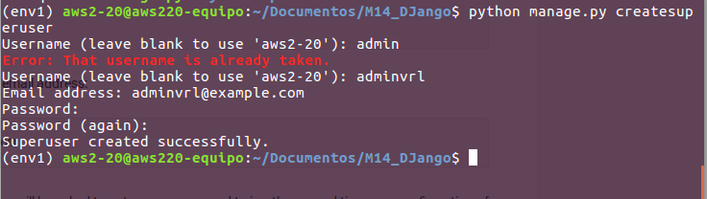

Pasos a seguir:
- virtualenv
- django -admin startproyect
- python manage.py startapp
- urls
- models.py
- settings +app
- admin.py

