CYBERSECURITY ASSESSMENT REPORT
Security Assessment Report
Target | https://thezenithindia.in
Assessment Type | Authorized Security Assessment (Internship Assignment)
Assessment Status | Phase 1 – Reconnaissance & Initial Security Review  Phase 2 – Client-Side Code & Authentication Review
Report Classification | Confidential – For Internal / Authorized Use Only
Analyse and made by | Vrunal Pramod Patil and Junaid Rafique
Testing Methodology
- Passive Reconnaissance
- Manual Testing
- Browser Developer Tools
- Burp Suite Community Edition
- Gobuster
- Nikto
- Wappalyzer
- Client-Side JavaScript Bundle Analysis (Static Keyword Review)

1. Executive Summary
A security assessment was performed on thezenithindia.in to identify publicly observable security issues, understand the application's technology stack, and evaluate its initial security posture.
The assessment focused on reconnaissance, technology identification, directory enumeration, HTTP security configuration, authentication behavior, and publicly accessible resources. This revision extends the original assessment with a static review of the deployed client-side JavaScript bundle, which surfaced additional areas warranting attention around token storage, exposed configuration, and client-side route protection.
The website demonstrates several positive security practices, including HTTPS, Cloudflare protection, restricted access to sensitive server files, and a modern frontend architecture. However, the assessment also identified several areas where security can be strengthened, including missing HTTP security headers, authentication controls, visible login enumeration behavior, browser-side token storage, and leftover development configuration in the production bundle.
Of particular note, the login page's user-enumeration behavior and its lack of rate limiting combine into a single, more serious risk: the organization's own registered email address (zenithindia0007@gmail.com) can be confirmed as valid through differing error messages, after which an attacker faces no throttling, lockout, or CAPTCHA when attempting to brute-force its password. See the chained finding in Section 11.
All findings in this report are based on non-destructive, passive, and manual testing consistent with an authorized reconnaissance-phase engagement. Several items are flagged as “requires further testing” rather than confirmed vulnerabilities, and are marked accordingly.

2. Assessment Scope
Target
https://thezenithindia.in
Assessment included:
- Website Reconnaissance
- Technology Fingerprinting
- Directory Enumeration
- robots.txt Analysis
- Sitemap Analysis
- HTTP Security Header Review
- Authentication Review
- Initial Security Configuration Review
- Client-Side JavaScript Bundle Analysis (keyword-based static review)
No destructive testing or exploitation was performed.

3. Website Purpose
Based on manual analysis of the website, sitemap, social media pages, and publicly accessible content, the website appears to be designed as an AI-focused business platform.
Primary objectives include:
- AI Automation Solutions
- AI Chatbots
- Generative AI & LLM Services
- Prompt Engineering
- Agentic AI
- AI Training Models
- Product Insights
- Domain Intelligence
- Internship Program
The platform primarily functions as a marketing, portfolio, and lead-generation website for AI-based services, and also runs a public internship application intake.

4. Technology Stack
Component | Technology
Frontend | React
Routing | React Router 7.18.0
CSS Framework | Tailwind CSS
Animation | Framer Motion
Animation Library | AOS
Icons | Lucide
HTTP Client | Axios
Fonts | Google Font API
CDN | Cloudflare / Unpkg
Web Server | LiteSpeed
Hosting | Hostinger
Protocol | HTTP/3
Metadata | Open Graph

Observation
The application uses a modern React-based frontend architecture with Cloudflare acting as the CDN and reverse proxy. The web server is LiteSpeed hosted on Hostinger infrastructure. Authenticated requests are issued via an Axios instance pointed at https://api.thezenithindia.in/api.

5. Directory Enumeration

Tool Used
Gobuster

Findings
The following application directories were discovered and returned HTTP 301 redirects:
Path | Result
/assets | 301 – static assets
/css | 301
/js | 301
/static | 301
/pages | 301
/news | 301 – flagged for manual follow-up
/interview | 301 – flagged for manual follow-up
/religion | 301
/smm | 301
/judge | 301
robots.txt | 200

Additional Observation – Duplicate Asset Directories
Two separate, live asset paths were identified: /assets and /assests (transposed character, likely a typo introduced in a reference/link somewhere in the codebase). The files served under each path do not match, confirming these are two distinct directories rather than a redirect/alias of one another — i.e. the misspelled /assests path is a genuinely wrong path that is still being referenced and served, rather than harmless dead weight. This should be corrected to point all references to the single intended /assets directory to avoid serving stale or inconsistent content.

Additional Observation – Default Web-Server User Directories
A large number of standard Apache-style user-directory paths (e.g. ~admin, ~root, ~www, ~ftp, ~sysadmin, ~test) all returned HTTP 301 redirects to their own path. This pattern is typical of a catch-all rewrite rule rather than the presence of real per-user directories, and is recorded here as reconnaissance evidence rather than a confirmed exposure. No content was retrievable via these paths.

Security Observation
The discovered directories appear to contain public application resources and static content. No immediate exposure of sensitive data was observed during enumeration. The /news and /interview endpoints returned broken/unexpected behavior (“bug”) during manual verification — the underlying cause appears to be an incorrect or mismatched path/route configuration for these two sections rather than a data-exposure issue, and is recommended for follow-up testing in the next assessment phase to confirm root cause.

6. Sensitive File Exposure
The following sensitive files were tested during directory enumeration:
- .git
- .git/HEAD
- .htaccess
- .htpasswd
- .svn
Response:
HTTP 403 Forbidden

Risk
No direct exposure was observed.

Observation
The server correctly prevents public access to sensitive configuration and version-control files.
Severity: Informational

7. robots.txt Analysis
robots.txt was publicly accessible.

Important Findings
Disallow: /admin/ Disallow: /api/

Additional Observations
The website blocks several AI crawlers including:
- GPTBot
- ClaudeBot
- Google-Extended
- Bytespider
- CCBot
The sitemap location is also declared.

Risk
No direct security issue identified.
Severity: Informational

8. Sitemap Analysis
The sitemap exposed several publicly accessible pages including:
- /
- automation-workflow
- ai-chatbots
- training-models
- domain-insights
- product-insights
- generative-ai-llms
- prompting
- agentic-ai
- internship
- login
- signup

Observation
The sitemap references login and signup endpoints. During manual verification, these routes did not behave as expected (e.g., /login returned 404 when accessed directly). This may indicate outdated sitemap entries or client-side routing that requires a client-rendered entry point.
Severity: Informational

9. HTTP Security Headers

Verified via Burp Suite
Present:
Content-Security-Policy: upgrade-insecure-requests
Missing:
- Strict-Transport-Security
- Referrer-Policy
- X-Content-Type-Options
- Permissions-Policy

Finding 1: Missing HTTP Strict Transport Security (HSTS)
Severity: Medium

Risk
Without HSTS, browsers are not instructed to always use HTTPS, increasing the potential exposure to protocol downgrade attacks in certain network scenarios.

Recommendation
Strict-Transport-Security: max-age=31536000; includeSubDomains; preload

Finding 2: Missing Referrer-Policy
Severity: Low

Risk
Sensitive URL information may be unnecessarily disclosed to external websites through the HTTP Referer header.

Recommendation
Referrer-Policy: strict-origin-when-cross-origin

Finding 3: Missing X-Content-Type-Options
Severity: Low

Risk
Browsers may attempt MIME-type sniffing, which can increase the risk of certain content interpretation attacks.

Recommendation
X-Content-Type-Options: nosniff

Finding 4: Missing Permissions-Policy
Severity: Low

Risk
Modern browser features such as camera, microphone, and geolocation are not explicitly restricted through response headers.

Recommendation
Configure an appropriate Permissions-Policy based on application requirements.

Observation
A Content Security Policy header is present but currently contains only the upgrade-insecure-requests directive. A more comprehensive policy could further strengthen client-side security.

10. Nikto Scan Summary
Nikto identified:
- Cloudflare
- LiteSpeed
- Hostinger
- HTTP/3
- HTTP Compression
- Missing Security Headers
These observations were manually verified where applicable. No critical server-side vulnerabilities were confirmed during the scan.

11. Authentication Assessment

Observation
Repeated authentication attempts were performed during testing.

Finding
No visible rate limiting was observed during multiple failed authentication attempts.

Evidence
- Approximately 10–20 consecutive failed login attempts were accepted.
- No CAPTCHA challenge appeared.
- No temporary account lockout was observed.
- No HTTP 429 (Too Many Requests) response was observed.

Finding 5: Missing Visible Rate Limiting
Severity: Medium

Risk
An attacker may perform automated password guessing or credential stuffing attacks with fewer obstacles.

Recommendation
- Implement per-account and per-IP rate limiting.
- Introduce temporary account lockout after repeated failures.
- Enable CAPTCHA after multiple failed login attempts.
- Monitor repeated authentication failures.

Finding 6: Potential User Enumeration via Login Responses
Severity: Low

Observation
During testing, a known/registered email address consistently returned an “Invalid credentials” response when an incorrect password was used, while multiple random, non-existent email addresses consistently returned “User not found”. This difference in application responses may allow an attacker to infer whether an email address is registered.
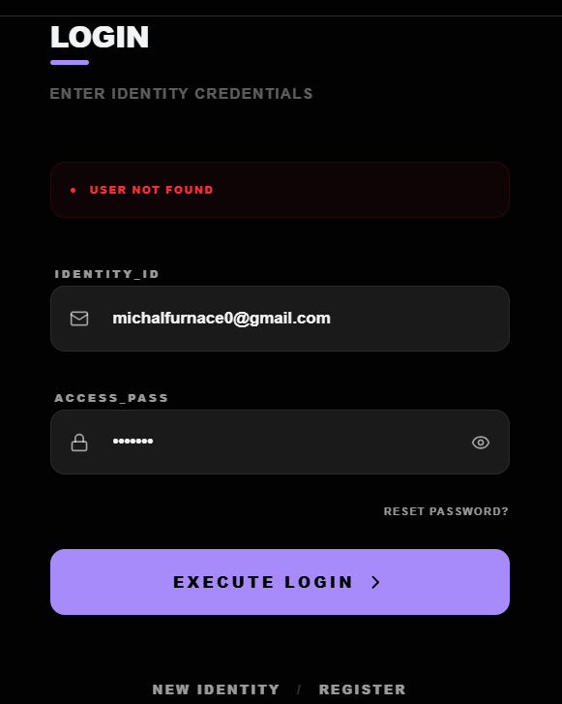
Figure 1 — Login response for a non-existent account (“User not found”).
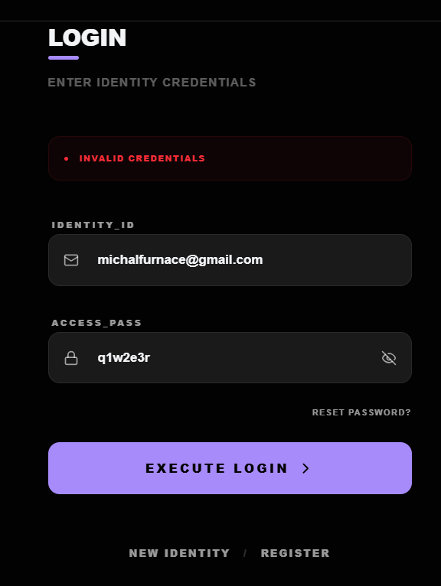
Figure 2 — Login response for a registered account with an incorrect password (“Invalid credentials”).
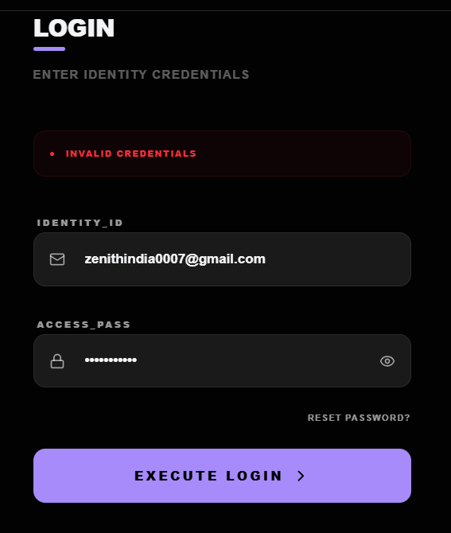
Figure 3 — The organization's own public contact address returns “Invalid credentials” rather than “User not found”, confirming the address is registered — demonstrating the enumeration behavior.

Impact
Different authentication error messages can assist attackers in identifying valid accounts, enabling more targeted password attacks or phishing attempts.

Recommendation
Return a generic authentication failure message such as “Invalid email or password” and avoid revealing whether a supplied email address exists.

Finding 5+6 (Chained): User Enumeration Combined with Missing Rate Limiting – Targeted Credential Brute-Force
Severity: Medium

Observation
Findings 5 and 6 combine into a more severe chained risk. The login form's differing error messages (“Invalid credentials” vs. “User not found”) confirm that zenithindia0007@gmail.com is a registered account (Figure 3). Because no rate limiting, account lockout, or CAPTCHA was observed on the login endpoint (Finding 5), an attacker who has confirmed this address is valid can proceed directly to an automated password-guessing (brute-force) attack against that specific, known-valid account with no throttling in place.

Risk
This chain removes the main obstacle to credential attacks: instead of guessing both a valid email and its password, an attacker only needs to guess the password for an account already confirmed to exist. This meaningfully increases the practical likelihood of a successful account takeover compared to either issue in isolation.

Recommendation
- Treat Findings 5 and 6 as a single priority remediation: fixing only one does not fully mitigate the risk.
- Return identical, generic responses for both “wrong password” and “unknown email” cases.
- Enforce per-account and per-IP rate limiting and progressive delays on the login endpoint.
- Add CAPTCHA or equivalent challenge after a small number of failed attempts.

Finding 5+6 (Chained): User Enumeration Combined With Missing Rate Limiting — Targeted Brute Force
Severity: High

Observation
Findings 5 and 6 combine into a materially higher-risk attack path. The login form confirms that zenithindia0007@gmail.com is a registered account (it returns “Invalid credentials” rather than “User not found”), and no rate limiting, CAPTCHA, or lockout was observed even after 10–20 consecutive failed attempts. Individually these are a Low and a Medium finding; together they mean an attacker does not need to guess which addresses are valid before starting a brute-force attack — the enumeration behavior hands them a confirmed, high-value target (an organizational account) up front, and the missing rate limiting removes the main practical obstacle to attempting large numbers of password guesses against it.

Risk
This is treated as High rather than the sum of its parts because the two weaknesses are complementary: enumeration removes the attacker's uncertainty about the target, and the lack of throttling removes the time/attempt cost of attacking it. An attacker could run an automated password-guessing or credential-stuffing attack directly against this one confirmed account with no visible feedback loop (no CAPTCHA, lockout, or HTTP 429) to slow them down.

Recommendation
- Treat this as the priority remediation item: implement per-account and per-IP rate limiting on /auth/login before addressing the two underlying issues separately.
- Return identical, generic responses for both “user not found” and “wrong password” cases (Finding 6 remediation) — this alone breaks the attacker's ability to select the target with confidence.
- Add lockout/backoff or CAPTCHA after a small number of failed attempts on any single account, independent of IP.
- Consider proactively rotating credentials on the zenithindia0007@gmail.com account and enabling MFA, since its validity has been observably confirmed through this response difference.

12. Client-Side JavaScript Bundle Analysis
The main production bundle (index-eZN3Gom.js) was reviewed using a static keyword scan (613 keyword matches across api, token, key, secret, password, bearer, auth, jwt, and axios terms, plus URL/endpoint extraction). This is a static, non-invasive review of publicly shipped client code — it does not by itself confirm exploitable vulnerabilities such as SQL Injection, Remote Code Execution, XSS, Command Injection, or file-upload flaws. Findings below are indicators that warrant further dynamic/manual testing in a subsequent phase, and are labelled accordingly.

Finding 7: Authentication Token (JWT) Stored in Browser localStorage
Severity: Medium

Observation
The bundle stores and retrieves the authentication token using localStorage (localStorage.getItem("token") / setItem("token", ...)), and an Axios request interceptor automatically attaches it to outgoing requests as an Authorization: Bearer <token> header.

Risk
Tokens held in localStorage are readable by any JavaScript executing in the page context. If a Cross-Site Scripting (XSS) vulnerability exists anywhere on the origin, an attacker could exfiltrate the token and achieve account takeover until the token expires. This finding describes a design/defense-in-depth weakness in token storage; it is not itself evidence of an existing XSS vulnerability, none was identified during this assessment.

Recommendation
- Store authentication tokens in HttpOnly, Secure, SameSite cookies rather than localStorage.
- Implement a strict Content-Security-Policy to reduce the impact of any future XSS.
- Apply short token lifetimes with refresh-token rotation.

Finding 8: Development/Localhost Endpoints Present in Production Bundle
Severity: Low

Observation
The shipped bundle still references development endpoints:
http://localhost:5000/api/auth/forgot-password http://localhost:5000/api/auth/reset-password
This indicates development configuration was not fully removed prior to the production build.

Risk
Not independently exploitable, but it may reveal internal service structure (host, port, framework conventions) useful to an attacker during reconnaissance.

Recommendation
Use environment-based configuration so build tooling strips development URLs from production bundles, and add a pre-release check for hardcoded localhost references.

Finding 9: Admin Route Gated Only by Client-Side Token Check (Requires Backend Verification)
Severity: Medium (Unconfirmed – Recommend Verification)

Observation
The bundle redirects users to /admin after login when the account is flagged as an administrator, and a client-side route guard permits rendering the /admin route whenever a token is present in localStorage, regardless of the token's role claims.

Risk
Client-side route guards are a UX convenience, not a security boundary. If the corresponding backend admin APIs do not independently re-validate the caller's authorization on every request, a standard authenticated (non-admin) user could potentially reach admin functionality by calling the underlying API directly. This was not tested during this phase (robots.txt explicitly disallows crawling /admin/ and /api/, and no exploitation was attempted), so this is recorded as a recommendation for targeted testing rather than a confirmed vulnerability.

Recommendation
- Confirm that every /admin/* backend endpoint independently enforces role-based authorization server-side.
- Do not rely on frontend routing/redirect logic as an access-control mechanism.
- Add authorization tests (as a normal authenticated user) against admin-only API routes.

Finding 10: OTP-Based Signup / Password-Reset Flow – Recommended for Further Testing
Severity: Informational

Observation
The application implements OTP-based email verification for signup and for forgot-password / reset-password flows. These mechanisms were identified via static review only and were not exercised during this phase.

Recommendation – areas to test in a follow-up phase
- OTP brute-force resistance
- Rate limiting on OTP requests
- OTP reuse / replay
- OTP expiration handling
- Password-reset token validation

Note – String Observed in Vendor Library Code
The keyword scan also surfaced a single unusual literal string inside a third-party/vendor portion of the bundle (not application code) resembling an internal placeholder comment rather than a real credential or secret. It does not correspond to any application secret, API key, or credential, and no further action is required beyond noting it for completeness.

13. File Upload Handling – Internship Application Form
Severity: Low (Recommendation)

Observation
The public internship application form accepts a PDF resume upload with no visible client-side indication of server-side file validation, virus/malware scanning, or content-type verification beyond the file picker's PDF filter (which is trivially bypassable client-side).

Figure 4 — Public internship application form accepting a PDF resume upload.

Risk
PDF files can carry embedded scripts, malformed structures, or embedded malicious payloads. Without server-side validation, an uploaded file could pose a risk to staff opening submitted resumes, or could be used to store/host malicious content on the server.

Recommendation
- Validate uploaded files by inspecting actual file content/magic bytes, not just the file extension or MIME type reported by the browser.
- Scan uploads with an antivirus/malware engine before storage or review.
- Store uploads outside the web root, or in a location with execution disabled.
- Enforce a strict file-size limit and rate-limit submissions.
This item was not exploited or tested for bypass; it is a hardening recommendation based on the observed form behavior.

14. Positive Security Practices
The assessment also identified several positive security measures:
- HTTPS enabled.
- Cloudflare used as CDN and reverse proxy.
- LiteSpeed web server.
- HTTP/3 support.
- Sensitive files (.git, .svn, .htaccess) protected with HTTP 403.
- robots.txt present and blocks known AI crawlers.
- Sitemap available.
- Modern React-based frontend architecture.
- A Content-Security-Policy header is present (though minimal).

15. Risk Summary
Finding | Severity
Chained: Enumeration + No Rate Limit → Targeted Brute-Force | Medium
JWT Stored in Browser localStorage | Medium
Missing HSTS | Medium
Missing Rate Limiting | Medium
Admin Route Gated Only by Client-Side Check (unconfirmed) | Medium
Potential User Enumeration | Low
Development/Localhost Endpoints in Production Bundle | Low
File Upload Validation Not Verified (Internship Form) | Low
Missing Referrer-Policy | Low
Missing X-Content-Type-Options | Low
Missing Permissions-Policy | Low
Minimal CSP Configuration | Low
OTP Flow Requires Further Testing | Informational
Duplicate Asset Directories (/assets vs /assests) | Informational
Sensitive Files Protected | Informational
HTTPS Enabled | Informational
Cloudflare Protection | Informational

16. Conclusion & Disclaimer
This engagement was performed as an authorized reconnaissance and initial security review under an internship assignment. All testing was passive or manual in nature; no destructive testing, exploitation, or unauthorized access was attempted at any stage, including during the client-side bundle review documented in Section 12.
Several items in this report are explicitly marked as requiring further testing rather than confirmed vulnerabilities. It is recommended that a follow-up engagement, scoped and authorized separately, be used to validate server-side enforcement of the items flagged in Sections 9, 11, 12, and 13 before any findings are treated as confirmed exploitable issues.
This report is confidential and intended solely for the authorized recipient(s) associated with this assessment.

