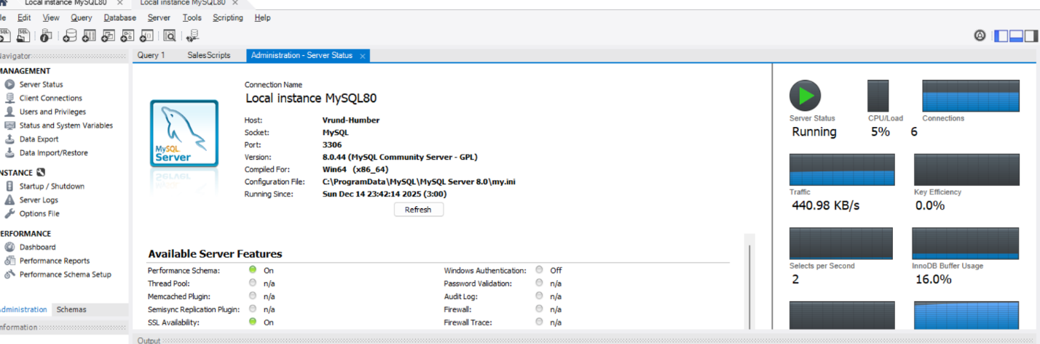
- SERVER INFORMATION:

- DATABASE INFORMATION:
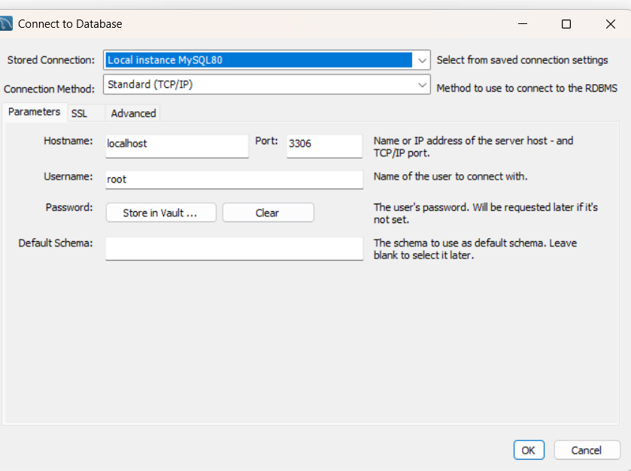

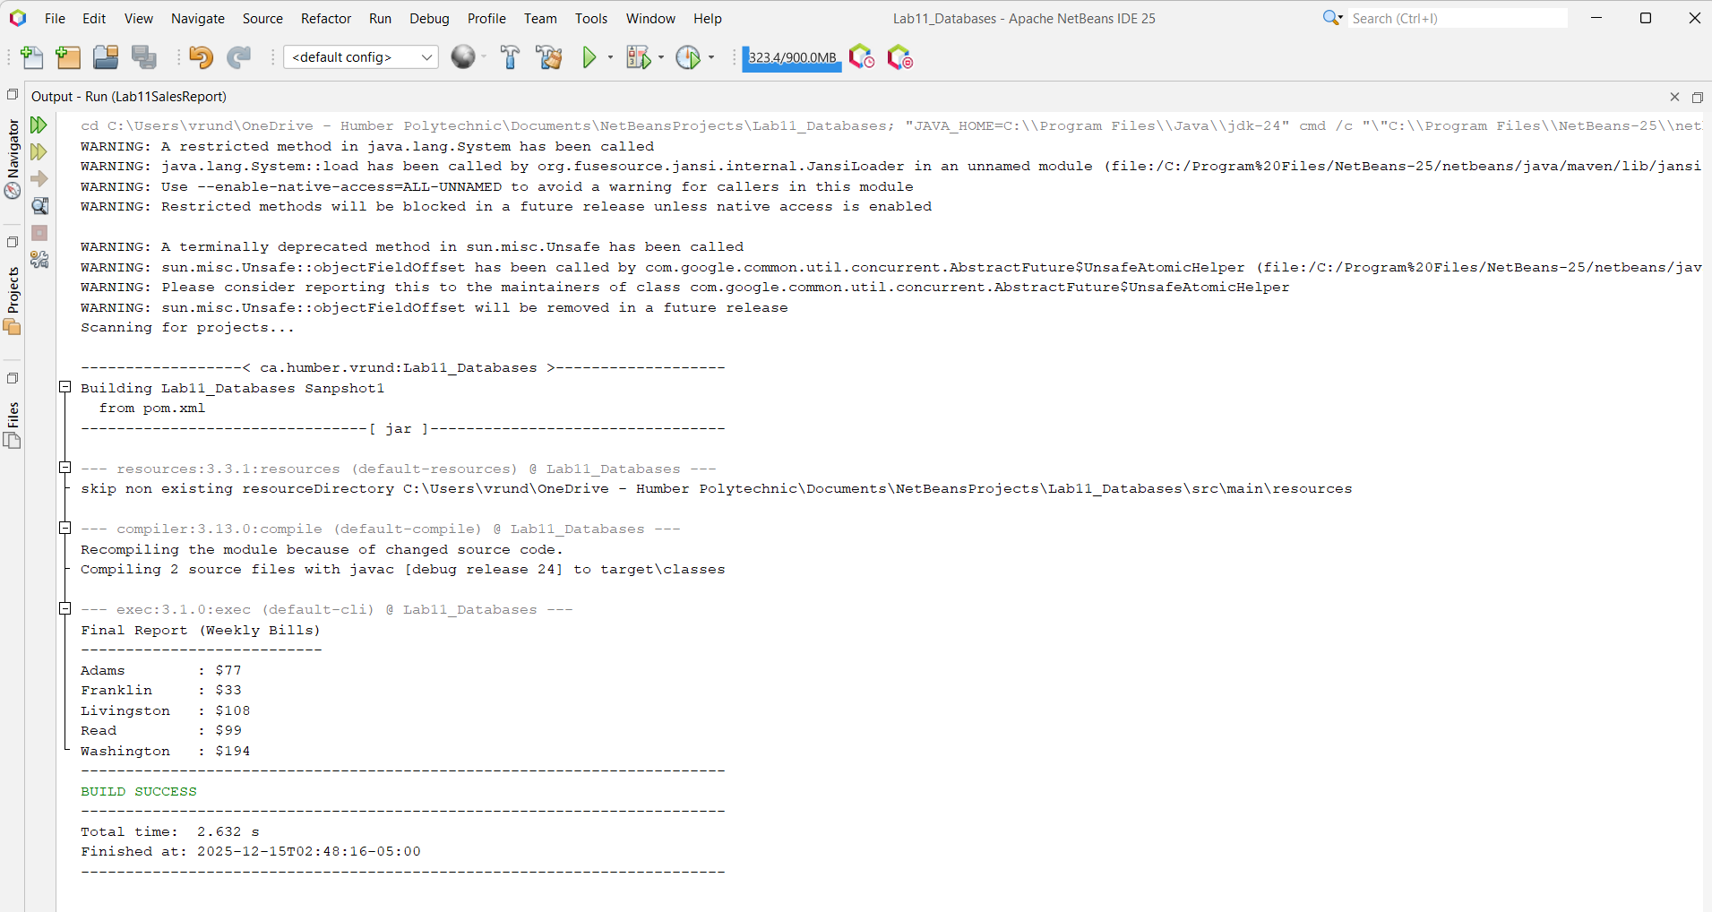
- OUTPUT:

