# **3. Requirement Analysis**

**3.1 Feasibility Study**

* **Economical Feasibility**

In This project, we will require to have a internet connection for better online application. Such at the developer end it needs the good server with high capacity of RAM and CPU processors so can it can handle lots of members at time online communications, but as it will be web-enabled we do not have any extra cost of setting up a network. This is also feasible economically.

* **Technical Feasibility**

This application does require that much of higher & advanced technology. It requires database interaction and it also requires to be accessed via any browser and also required internet on that particular device. This can be easily done. Also these should be a facility of online order for particular service online. We are sending all the service information with the all service attributes so the members can have reliable navigation and make proper decision for order service. It must be developed within the 40 days of period excluding the time period for the testing and validation, verification. Thus it seems that the project is technically feasible to do.

* **Operational Feasibility**

The new system can be beneficial only if it satisfies the organization requirements; in such a way that resource utilization and optimum outcome is justified. A new system should not only be robust but should also be able to work simultaneously with other systems. Operational feasibility means that new system should not affect any existing system during the development phase or even in the implementation phase. Following are some points underlying the operational feasibility of the system- As the development proceeded many doubts got cleared out.

Efforts were made to optimize the human efforts in data collection, storage, retrieval, security and presentation.

The proposed system made best efforts in achieving necessary function and performance, as required by the user and keeping in mind some infrastructure constraints.

**3.2 User of the System**

* Admin
* Customer
* Provider

**3.3 Modules of the System**

Login

Registration

Customer Management

Provider Management

Order Management

Service Management

Feedback Management

**3.4 Process Model**

Spiral Model Spiral Model may be a combination of a body of water model and unvarying model. [1] every introduce spiral model begins with a style goal and ends with the consumer reviewing the progress. [2]

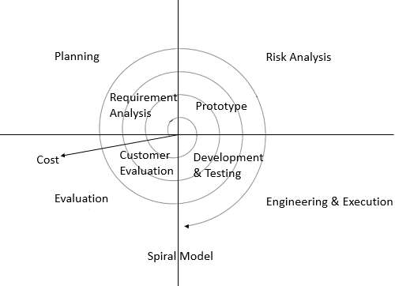

Figure 1 Spiral Model

**Why Spiral Model is used?**

* Project is massive.
* Risk and prices analysis square measure vital.
* Changes could need at any time.
* important changes square measure expected within the product throughout the event cycle. [3]

**3.5 Hardware and Software Requirements**

* **Server Side**
* Hardware Requirements
  + Processor - Intel Core i5 6th Gen
  + Memory – 4.00 Gb
  + OS(Window 10)
  + Hard disk(1.00 Tb)
* Software Requirements
  + Visual Studio code
  + Postman
  + Dbever
  + Web Browser(Mozilla Firefox,Google Chrome)
  + MS Word
  + MS Power Point
  + E-Draw
* **Cilent Side**
  + Internet enabled device with web-browser

**3.6 Use Case**

1. Customer
2. Admin

**3.6 Use Case Diagram**

Customer:

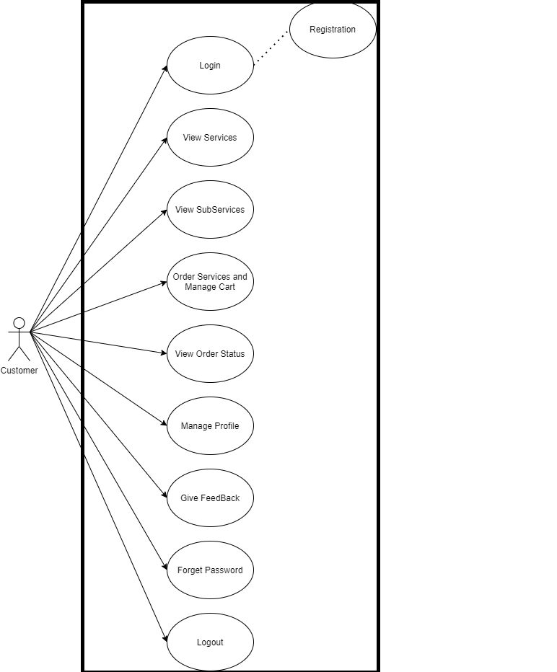

Figure 2 Customer usecase diagram

Admin:

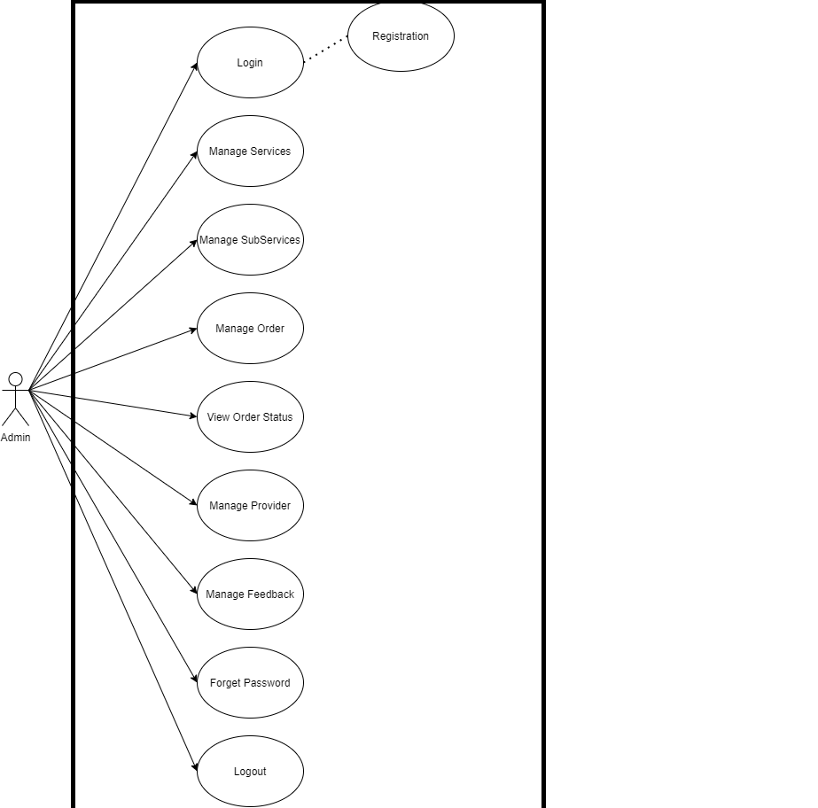

Figure 3 Admin usecase diagram