**4. Design**

**4.1 Use Case Scenarios**

1. Admin Login

|  |  |
| --- | --- |
| Use Case ID | UC01 |
| Use Case Name | Login |
| Primary Actor | Admin |
| Pre-Condition | Admin must be registered |
| Basic Flow Of System | The website can be accessed through email id and password |
| Alternative Way | There is not any alternative way for login |

2. Manage Provider

|  |  |
| --- | --- |
| Use Case ID | UC02 |
| Use Case Name | Manage Provider |
| Primary Actor | Admin |
| Pre-Condition | Admin must be logged in |
| Basic Flow Of System | Admin can add Provider, update the provider details and delete the provider |
| Alternative Way | There is not any alternative way for login |

3. View Customer

|  |  |
| --- | --- |
| Use Case ID | UC03 |
| Use Case Name | View Customer |
| Primary Actor | Admin |
| Pre-Condition | Admin must be logged in |
| Basic Flow Of System | Admin can view all the customer which are enroll in this website |
| Alternative Way | There is not any alternative way for login |

4. Manage Order

|  |  |
| --- | --- |
| Use Case ID | UC04 |
| Use Case Name | Manage Order |
| Primary Actor | Admin |
| Pre-Condition | Admin must be logged in |
| Basic Flow Of System | Admin can view order, confirm and reject the order and also view the status of the order |
| Alternative Way | There is not any alternative way for login |

5. Manage Feedback

|  |  |
| --- | --- |
| Use Case ID | UC05 |
| Use Case Name | Manage Feedback |
| Primary Actor | Admin |
| Pre-Condition | Admin must be logged in |
| Basic Flow Of System | Admin can view feedback ,give response of that particular feedback |
| Alternative Way | There is not any alternative way for login |

6. Manage Services and Subservices

|  |  |
| --- | --- |
| Use Case ID | UC06 |
| Use Case Name | Manage services and subservices |
| Primary Actor | Admin |
| Pre-Condition | Admin must be logged in |
| Basic Flow Of System | Admin can add, update and delete the services and subservices |
| Alternative Way | There is not any alternative way for login |

7. Customer Login

|  |  |
| --- | --- |
| Use Case ID | UC07 |
| Use Case Name | Login |
| Primary Actor | Customer |
| Pre-Condition | Customer must be registered |
| Basic Flow Of System | The website can be accessed through email id and password |
| Alternative Way | There is not any alternative way for login |

8. View Services and Subservices

|  |  |
| --- | --- |
| Use Case ID | UC08 |
| Use Case Name | View services and subservices |
| Primary Actor | Customer |
| Pre-Condition | There is not any pre-condition |
| Basic Flow Of System | Customer can view all services and subservices |
| Alternative Way | There is not any alternative way for login |

9. Add to cart and place order

|  |  |
| --- | --- |
| Use Case ID | UC09 |
| Use Case Name | AddTocart |
| Primary Actor | Customer |
| Pre-Condition | User must be logged in |
| Basic Flow Of System | Customer can place their order by add service into cart |
| Alternative Way | There is not any alternative way for login |

10. View Order

|  |  |
| --- | --- |
| Use Case ID | UC10 |
| Use Case Name | View Order |
| Primary Actor | Customer |
| Pre-Condition | User must be logged in |
| Basic Flow Of System | Customer can view their order and order status |
| Alternative Way | There is not any alternative way for login |

**4.2 UML Diagram**

**4.2.1 Class Diagram:**

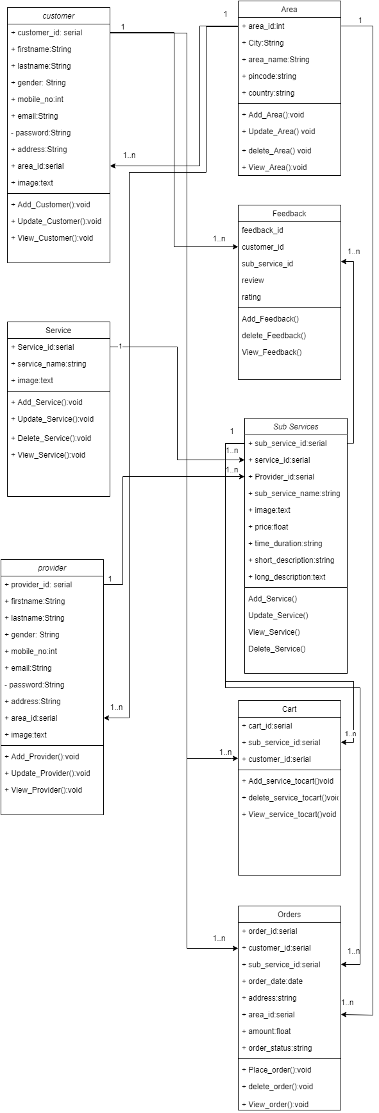

Figure 4 class diagram

**4.2.2 Sequence Diagram:**

**1. Admin**

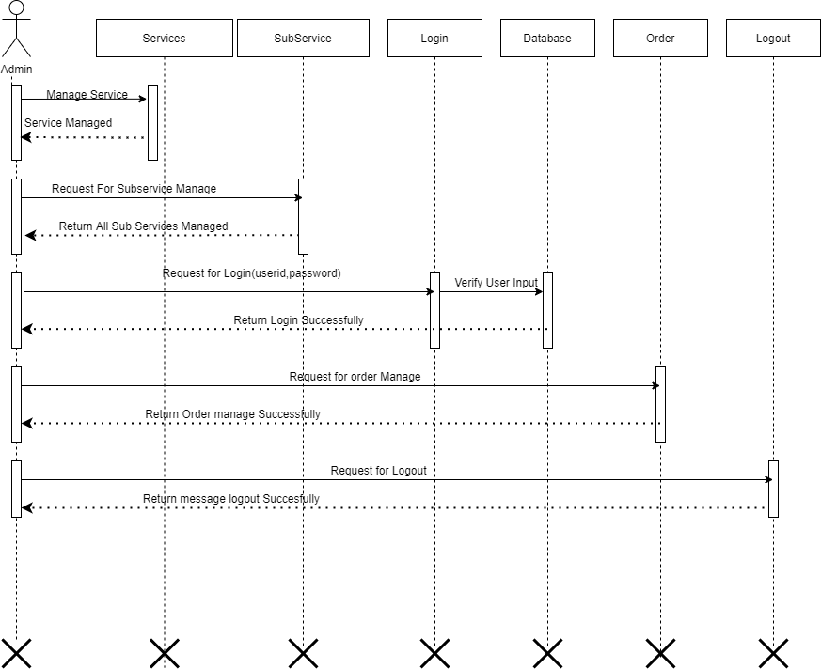

Figure 5 Admin sequance diagram

**2. Customer**

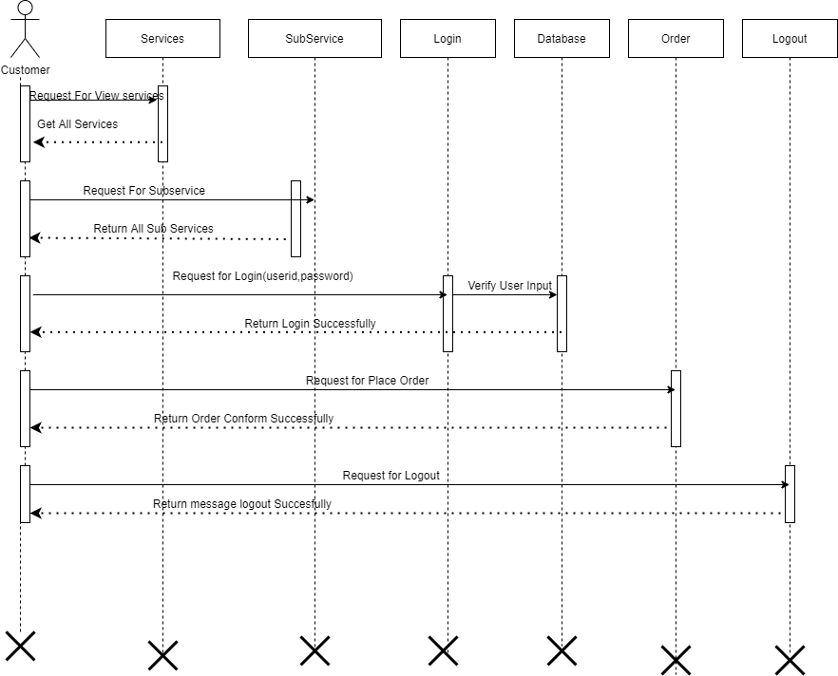

Figure 6 Customer sequance diagram

**4.2.3 Activity Diagram:**

**1. Admin**

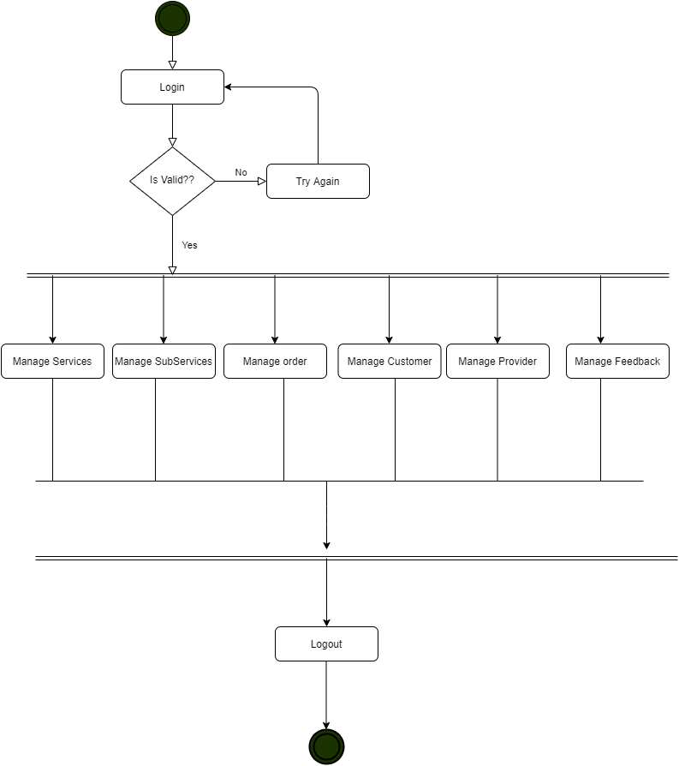

Figure 7 Admin Activity diagram

**2. Customer**

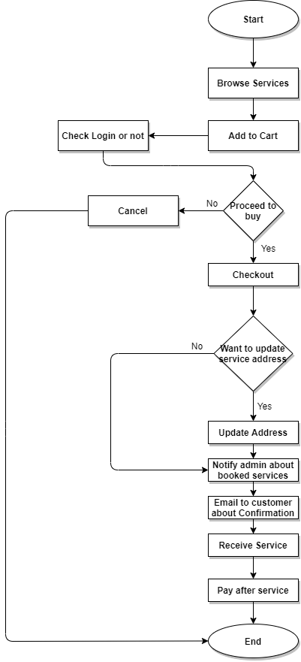

Figure 8 Customer activity diagram

**4.2.4 Collaboration Diagram**

**1. Admin** 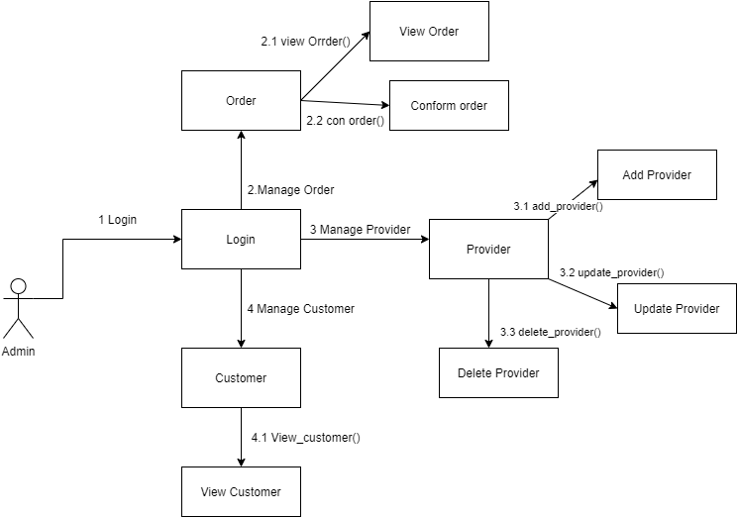

Figure 9 Admin collaboration diagram

**2. Customer**

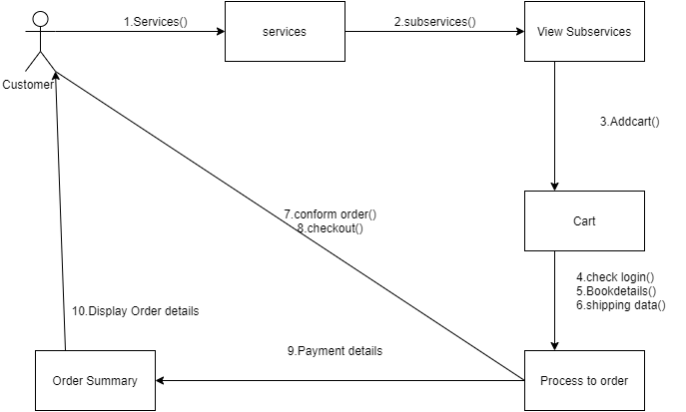

**4.2.5 Package Diagram**

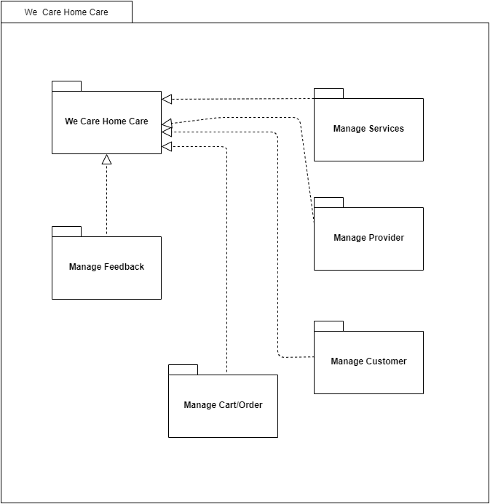

Figure 10 Package diagram

**4.3 Entity Relationship Diagram**

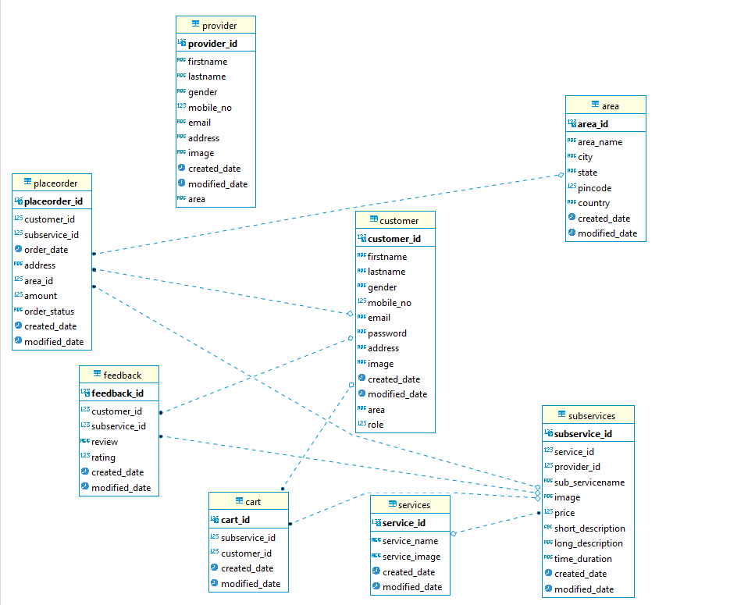

Figure 11 Entity Relationship diagram

**4.4 Data Dictionary**

**1. Customer**

|  |  |  |  |
| --- | --- | --- | --- |
| **Field** | **Data Type** | **Constraints** | **Description** |
| ID | Alpha-Numeric | Primary key | Store unique id of customer |
| Firstname | Text | Required | Store firstname of customer |
| lastname | Text | Required | Store lastname of customer |
| Gender | Text | Required | Store gender of customer |
| Mobileno | Float | Required | Store mobileno of customer |
| Email | Text | Required | Store email of customer |
| Password | Text | Required | Store password of customer |
| Address | Text | Required | Store address of customer |
| Image | Text | Required | Store image of customer |
| Area | Text | Required | Store area of customer |
| Created_date | Date | Required | Store date of customer registration |
| Modified_date | Date | Required | Store date of customer update their details |

**2. Provider**

|  |  |  |  |
| --- | --- | --- | --- |
| **Field** | **Data Type** | **Constraints** | **Description** |
| ID | Alpha-Numeric | Primary key | Store unique id of provider |
| Firstname | Text | Required | Store firstname of provider |
| lastname | Text | Required | Store lastname of provider |
| Gender | Text | Required | Store gender of provider |
| Mobileno | Float | Required | Store mobileno of provider |
| Email | Text | Required | Store email of provider |
| Address | Text | Required | Store address of provider |
| Image | Text | Required | Store image of provider |
| Area | Text | Required | Store area of provider |
| Created_date | Date | Required | Store date of provider registration |
| Modified_date | Date | Required | Store date of provider update their details |

**3. Services**

|  |  |  |  |
| --- | --- | --- | --- |
| **Field** | **Data Type** | **Constraints** | **Description** |
| ID | Alpha-Numeric | Primary key | Store unique id of Services |
| Service_name | Text | Required | Store service name |
| Image | Text | Required | Store image of service |
| Created_date | Date | Required | Store date |
| Modified_date | Date | Required | Store date of service update |

**4. SubServices**

|  |  |  |  |
| --- | --- | --- | --- |
| **Field** | **Data Type** | **Constraints** | **Description** |
| ID | Alpha-Numeric | Primary key | Store unique id of SubServices |
| Provider_id | Alpha-Numeric | Foreign key(provider) |  |
| Service_id | Alpha-Numeric | Foreign key(service) |  |
| SubService_name | Text | Required | Store subservice name |
| Image | Text | Required | Store image of subservice |
| Price | Number | Required | Store price of subservice |
| Short_description | Text | Required | Store short description |
| long_description | Text | Required | Store long description |
| Time_duration | Text | Required | Store time |
| Created_date | Date | Required | Store date |
| Modified_date | Date | Required | Store date of sub service update |

**5. Cart**

|  |  |  |  |
| --- | --- | --- | --- |
|  | **Data Type** | **Constraints** | **Description** |
| ID | Alpha-Numeric | Primary key | Store unique id of cart |
| customer_id | Alpha-Numeric | Foreign key(customer) |  |
| subService_id | Alpha-Numeric | Foreign key(subservice) |  |
| Created_date | Date | Required | Store date |
| Modified_date | Date | Required | Store date of cart update |

**6. PlaceOrder**

|  |  |  |  |
| --- | --- | --- | --- |
| **Field** | **Data Type** | **Constraints** | **Description** |
| ID | Alpha-Numeric | Primary key | Store unique id of order |
| customer_id | Alpha-Numeric | Foreign key(customer) |  |
| subService_id | Alpha-Numeric | Foreign key(subservice) |  |
| Order_date | Date | Required | Store the order date |
| Address | Text | Required | Store deliver address |
| Area | Text | Required | Store area |
| Amount | Number | Required | Store price of service |
| Order_status | Text | Required | Store the order status |
| Created_date | Date | Required | Store date |
| Modified_date | Date | Required | Store date of order update |

**7. Feedback**

|  |  |  |  |
| --- | --- | --- | --- |
| **Field** | **Data Type** | **Constraints** | **Description** |
| ID | Alpha-Numeric | Primary key | Store unique id of feedback |
| customer_id | Alpha-Numeric | Foreign key(customer) |  |
| subService_id | Alpha-Numeric | Foreign key(subservice) |  |
| Review | Text | Required | Store the review |
| Rating | Number | Required | Store the rating |
| Created_date | Date | Required | Store date |
| Modified_date | Date | Required | Store date of feedback update |