SHREE RAMKRISHNA INSTITUTE OF COMPUTER EDUCATION AND APPLIED SCIENCES

VEER NARMAD SOUTH GUJARRT UNIVERSITY

BECHERAL OF COMPUTER SCIENCE

CERIFICATE

This is certified that___________________ (B.Sc computer science with semester

Exam No:-________) has successfully completed his work entitled______________

At ______________ as a partial requirement of degree of bechlore of computer

Application during academic year 2013-14

________________

Lecturer, in charge I/C principal

Date : place : Athwagate

SHREE RAMKRISHNA INSTITUTE OF COMPUTER EDUCATION AND APPLIED SCIENCES

VEER NARMAD SOUTH GUJARRT UNIVERSITY

BECHERAL OF COMPUTER SCIENCE

PROJECT REPORT

ON

PROJECT NAME

Student Enrollment System

AS PARTIAL REQUIREMENT FOR THE DEGREE

BECHERAL OF COMPUTER SCIENCE

(B.Sc. Computer Science)

SUBMITED:-

::: ORGANIZATION :::

NAME OF ORGANIZATION

No | Description | Page No.
1 | Introduction  1.1 project profile
2 | System Introduction  - System Objectives, Defination and Scope  - Hardware/Software Requirements  - Software Enviornment description  - Technology used
3 | Requirement Analysis  - System Requiments  - DFD  - Process Specification  - Risk Management  - Data Dictionary
4 | Design  - Database Design  - System Architacture  - System Flowchart  - Form And Report layout with Description
5 | Software Testing  - Test cases and Test Results
6 | Future Enhacement and Opportunities

INTRODUCTION

Introduction Of Project

PROJECT PROFILE:

Project Name: | Student Enrollment System
Organization: | SHREE RAMKRISHNA INSTITUTE
Technology: | VB.Net with SQL Server
Front End: | Visual Basic Studio
Back End: | SQL Server
Developed by: | Mr Kaushik j. Ajudiya
Miss Vrunda H. Ankoliya
Miss Palak A. Gabani

PROJECT DEFINATION:
- The Student Enrollment System is based on the procedure of admission of students.
- The Student Enrollment System is an Extensive and Powerful script written in vbscript.

FEATURED:
- FEATURES
- Projects are categorized into various menus so convenient user navigation.
- Front page display all the categories for document that admin wants to show and features that can be added by the admin.
- All the documents are provided by admin
- documents display order can be switched on/off from a admin panel by admin.
- User can also report a document from Report

PROPOSED

SYSTEM
s

Scope
- Main aim of the system
System provides a way for enroll management and admission procedure.
- Scope of System
  - Our Proposed System – Student Enrollment System performs different type of fundamental operations to address basic needs for enroll students.
  - Project is able to introduce new Colleges, Faculties that are newly added in University.
  - Our system provides the facility to Admin to add, update & delete Student entry and forums. System also provides the facility to user to generate report of students. Admin have overall control of system.

Objectives

- The system allows the owner to manage all kind of categories and maintain students.
- Add new subjects and Faculties by owner.

- Provides reports using report section of system.

Advantages

- High Security
There is high security mechanism provided by the proposed system. No unauthorized person can make change in the data those are stored in System. Only authorized person can change & also can make login.
- Less Time Required
In our system, all the processes are carried out by computer so obviously it will require time than traditional inventory system and in that sense; in will require less time to complete transactions and can process data very fast.
- High Amount of Accuracy
In our desktop system there are less amount of human activities are involved in that case it will have less effect in our accounts. The system will perform all calculation and manipulation automatically; in that case the data that you receive will be accurate and much more reliable than the data that generated previously.
- Easy to use

The main advantage of Student Enrollment system is that it allows owner to manage students and reports with easy to user tools.

ENVIRONMENT

DESCRIPTION

System Hardware And Software Requirement
The efficient hardware and software configuration requires to run the system is as suggest below. The configuration suggested is for better performance. Same functionality or higher configuration will always better.

Software | Visual Basic Studio 2008
Operating System | Linux or windows or any above version.
Database | SQL Server 2005
Microprocessor | Any but latest is good for performance
Memory | 2 GB
Hard Disk Space | 80 GB
DFD

0 Level DFD :
Student Enrollment System

User
User
Request
Access

1.1Level DFD:
Login
1.1 Level
User
UserName/Password
If Valid
TblUser
Not Match
Error Message

Entries
1.1.1 Level
Update/ Delete
1.1.2
Report Generate
1.1.3
User
Enter the Data
Saved
Update Data
Data Updated Message
tblEnrollment
tblEnrollment
Report Generating
Error Message
Report
Request
tblCourse
tblCollege
tblFaculty

1.2 Level Diagram:

SYSTEM

PLANNING

Software Engineering Model
- Process Model
INCREMENTAL MODEL
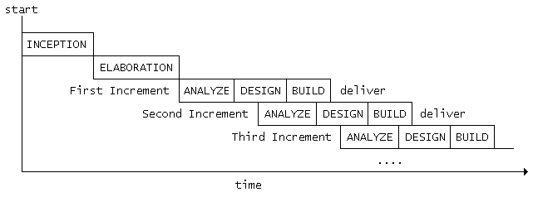
The incremental approach attempts to combine the waterfall sequence with some of the advantages of prototyping. This approach is favored by many object-oriented practitioners. It basically divides the overall project into a number of increments. Then it applies the waterfall model to each increment. The system is put into production when the first increment is delivered. As time passes additional increments are completed and added to the working system. This approach is favored by many object-oriented practitioners.
→Incremental Phases

- Inception
During the inception phase, the purpose, business rationale, and scope of the project is determined. This is similar to the feasibility analysis that is done in other life cycles.

- Elaboration
During the elaboration phase, more detailed requirements are collected, high level analysis is performed, and a general architecture is determined. This phase divides the requirements into increments that can be built separately. As we will see, each increment consists of a subset of high level use cases that capture the user's requirements.
- Construction
The construction phase builds increments of the system. Each increment is developed using a waterfall approach. This includes detailed analysis and design for the use cases in the increment and coding and testing of the event processors that implement the sequence of events defined by the use cases. The result is production quality software that satisfies a subset of the requirements and is delivered to the end users. Work on different increments may be done in parallel.

- Transition
The transition phase (not shown in the figure) is the last phase in the project. This may include such things a performance tuning and rollout to all users.

Project Schedule

- Task Dependency Diagram

Delivery Confirmation
Testing
Documentation
Designing
Estimation
Scheduling
Requirement Analysis

Requirement Gathering

- Time Line Chart
Task | Month1 |  |  |  | Month2
1) Requirement analysis
Collected requirement from our guide
Analyze gathered information
Determine scope of the system
Milestone: req. Analysis complete
2) Planning and risk analysis
Analyze data for possible risks
Identify technical risks
Determine different modules
Milestone: Planning completed
3) Designing
Design basic interface of the site
Design database tables
Design web form for modules
Milestone: designing completed
4) Coding and integrating modules
Implement logic for different modules
Implement database connectivity
Integrate different modules
Implement Report
Milestone: coding completed
5) testing
Validate input control and check accuracy of Reports
Milestone: testing in progress
6) Documentation
Milestone: testing completed

SYSTEM

ANALYSIS

Detailed SRS

- Member ( Modules )

Modules related to members are
  - Add New College
  - Add New Faculty, Course and Subject
  - Add New Enrollment
  - Modifying and deleting Enrollment
  - Modifying and deleting College
  - Modifying and deleting Faculty,Course and Subject
  - Reporting

Add New College:

Members can add new colleges that are newly introduced.
Add New Faculty:

Member can add new faculty that are newly introduced.
Add New Course:
Member can add new corurse that are newly introduced.
Add New Enrollment:
Member can add new student entry from the form that student had filled.
Modifying & Deleting Enrollment:
Members can modify student entry that is already exists.

Modifying & Deleting college:
Member can modify and delete college information of particular college.
Modifying & DeletingFaculty:
Member can modify and delete faculty information of particular faculty.
Modifying & Deleting Course:
Member can modify and delete course information of particular course.
Reporting:
Member can generate report as per need.

UML Diagrrams

Use Case Diagram User side
Login
New User
Registration

User
Add Faculty
Add Student Entry
Product

Modify &Delete College

Modify &Delete Faculty

Modify &Delete Student

Project

Add College

Exit

SOFTWARE

DESIGN

Database Design
Tables
tblUser:
Primary key –UserID
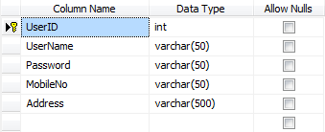

tblCollege:
Primary Key -CollegeID
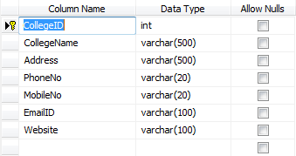

tblCourse:
Primary Key –CourseID
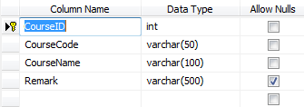

tblFaculty:
Primary Key –FacultyID
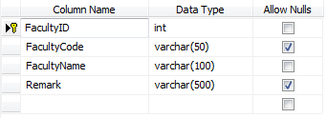
tblSubject:
Primary Key –SubjectID
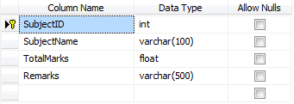

tblMarks:
Primary Key –MarksID
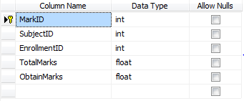
tblEnrollment:
Primary Key –EnrollmentID
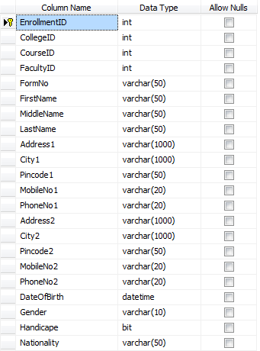

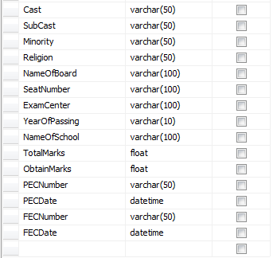

Interface Desgin

- Login Page :-

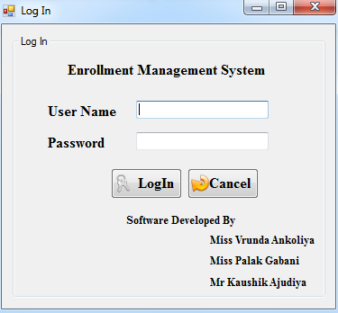

- User_Page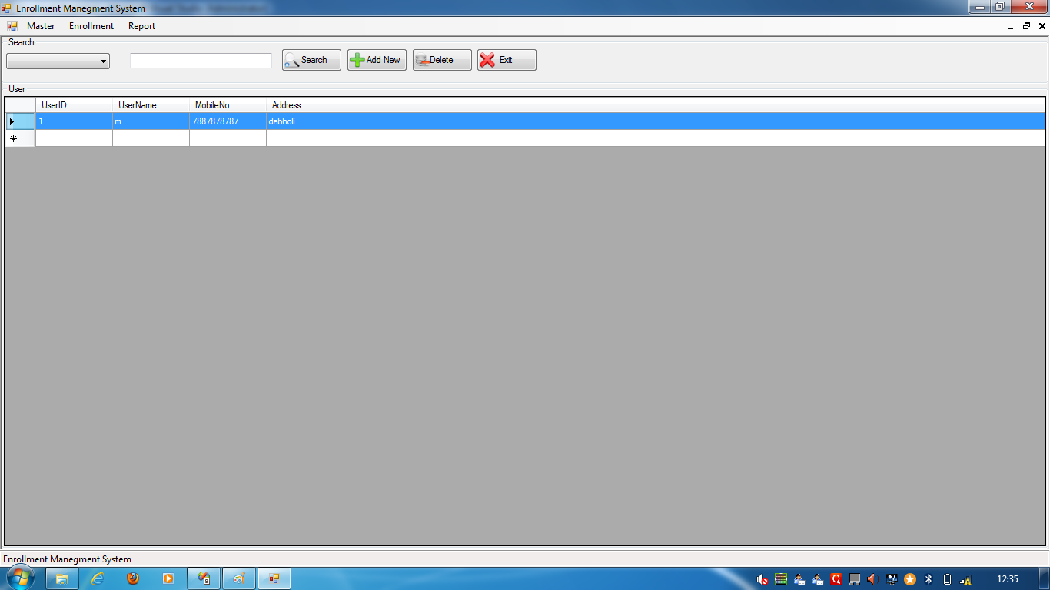

Add User :-

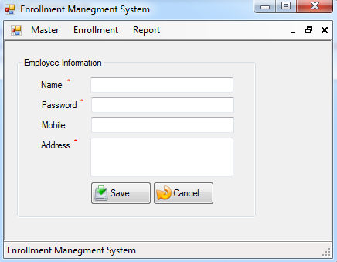

College Information and Modify Form :-
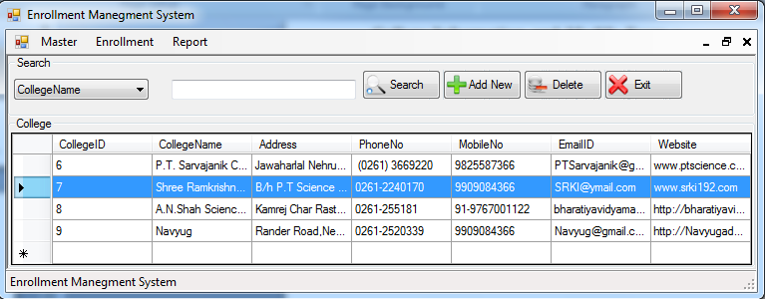
Add College Form:
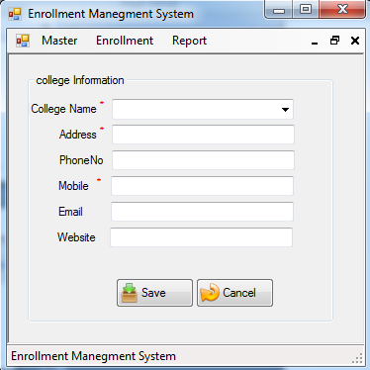
Course Information & Modify Form:
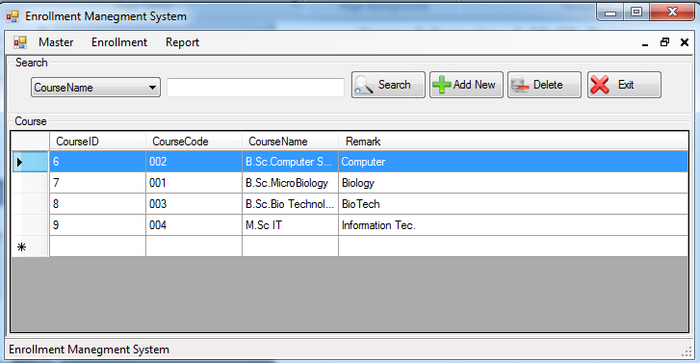
Add New Course:-

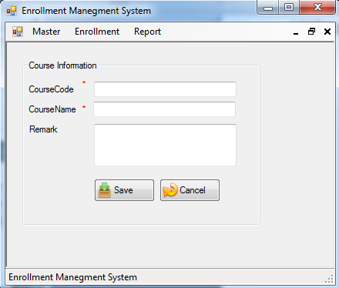
Faculty Information &Modify Form:-
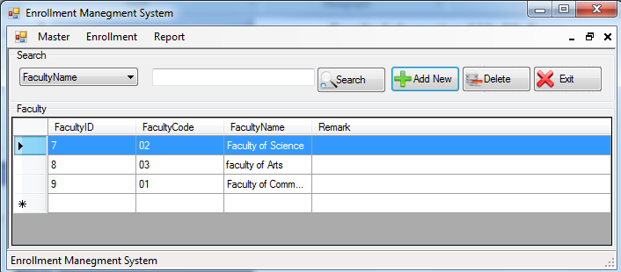
Add Faculty:
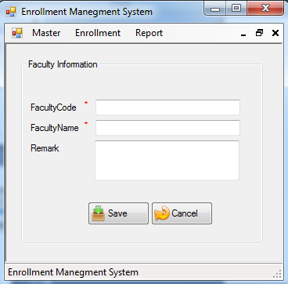
Student Enrollment & Modify Form:-
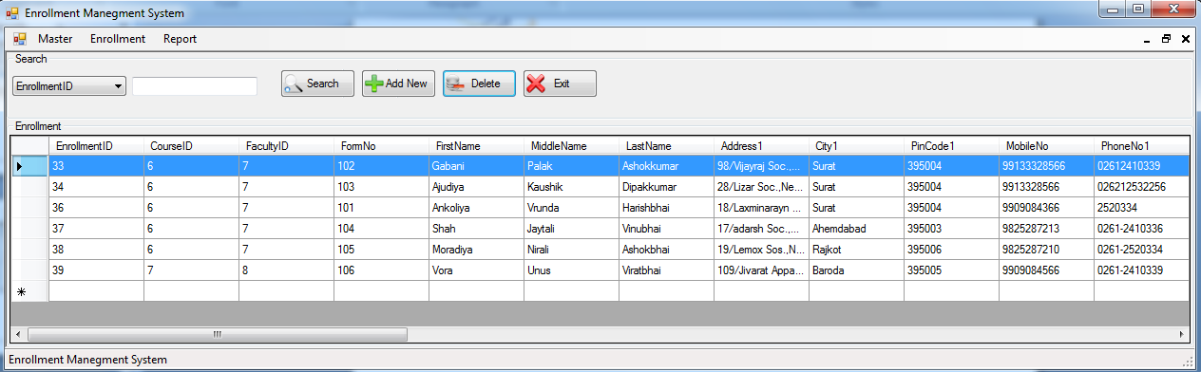
Add New Student:-
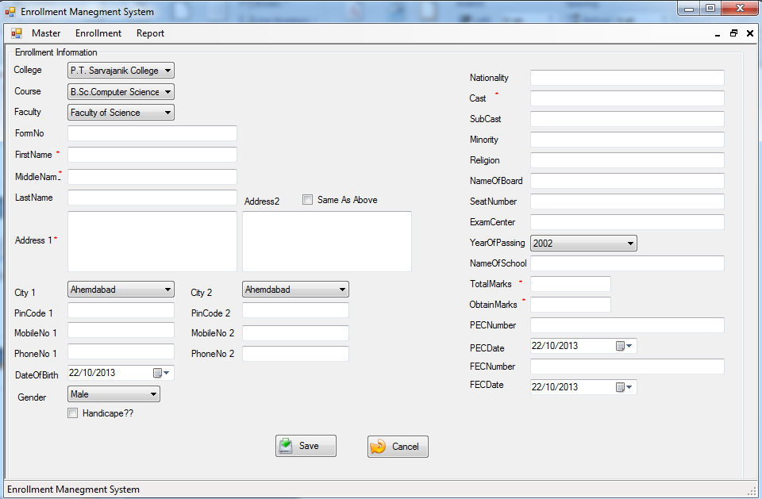

Report page:-
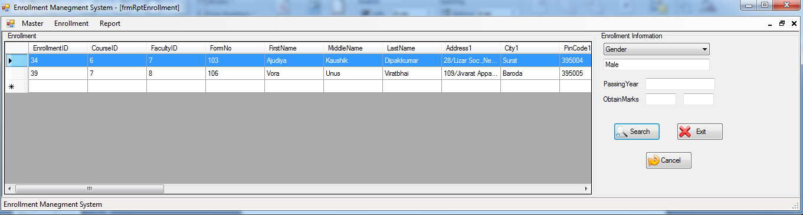

SOFTWARE
TESTING

Software Testing

- During development process of this project we did testing along with developing small modules.

- As new module or its major part is developed, we try to give input to it and check whether it gives desired output or not. It applies to all data structures, interface behavior and validity of data entered.

- When we integrate two or more modules, we check whether they give desired output when executed after integrating and compare results with previous tests results.

- As this system is meant to be used by multiple users simultaneously , we also checked website by accessing it from two different client machines using different users and checked whether both users get desired output without any problem or not.

- Testing is very vital for any system to be successfully implemented. The common view is that it is performed to prove that there is no error in a program. Therefore the most useful and practical approach is with the understanding that testing is the process of executing a program with the explicit intention of finding errors. The system is tested experimentally to ensure that the S/W does not fall. The system is run according to its Specifications and in the way user expects. Preparation of test-sample data the system will process as normal input.

Following testing practices are used.

1. Unit Testing:
During the programming stage each and every module treated unit has been put into the test using the test data. Every module is tested independently. The steps are follows:
1. Manually code is tested like spelling checks, logical error and other errors.
2. Once the manual checking is over the complication has been done. Syntactical errors if any have to be corrected.
3. After the clean compilation of the program, some dummy data, as specifications, has been used for testing of that module to see if it works as specified.

2. System Testing:
After completing the sub-system testing, all the interconnected modules should be tested. The system testing will start only after the first testing is over. The necessary data as per specifications will be entered and system as a whole will be tested.

REFERENCES

- WEBSITES:
www.vbdotnetforum.com

- BOOKS:
- Black Book and SQL Server.
- Software Engineering by Roger Pressman

