

**MAHARASHTRA STATE BOARD OF TECHNICAL EDUCATION,**

**Mumbai**.

A MICRO PROJECT PROPOSAL ON

# “Band Website”

UNDER THE SUBJECT

##### “Client-Side Scripting”

(**22519)**

COMPUTER ENGINEERING DEPARTMENT ACADEMIC YEAR

2023-2024

#### UNDER THE GUIDANCE OF

Prof. P. V. Toraskar.

**GOVERNMENT POLYTECHNIC, MIRAJ.**

# Certificate

This is to certify that, as part of the partial fulfilment of the Third Year Diploma Course for the semester fifth, the Bonafide students studying in Third Year Diploma (Computer), I Scheme **Miss. Srushti Pancham Mane** have completed the project report titled as “Fort Conservation Website”– CSS (Client-Side Scripting) under the guidance of Prof. P. V. Toraskar and submitted it to Government Polytechnic, Miraj. The information presented in this project report has not been submitted earlier.

Place: Govt. Polytechnic, Miraj Date: / / 2023

|  |  |  |
| --- | --- | --- |
| Prof P. V. Toraskar | Dr. Prof. V.R. Falmari | Capt. Dr. N. P. Sonje |
| **(GUIDE)** | **( HOD )** | **(PRINCIPAL)** |

## ACKNOWLEDGEMENT

We take it is an opportunity to thank all those who have directly and indirectly inspired, directed and assisted us towards successful completion of this project report. We express our sincere thanks to the Prof. Nitin Sonje & the Head of Department, Prof. Dr. V. R. Falmari for having us allowed to submit this report as part of our academics learning. We express our sincere thanks to Prof. P. V. Toraskar, Lecturer in Computer Department, Government Polytechnic, Miraj for encouragement throughout the project report and guideline in designing & working out this project.

Place: Govt. Polytechnic, Miraj Date: / / 2023

Yours Sincerely -

**Srushti Pancham Mane**

Part A Annexture-I

## Micro-Project Proposal

#### **Title**: “Band Website”.

1. **Aim of the micro-project**
   * The project's goal is to create a website that provides information of Musical Bands.
   * In this website, display the concerts and m.
   * It also include , Some more details about Band Strategy.
   * The goal of this project is to provide information of Mouse Events and Musical Band.
2. **Course Outcomes addressed.**
   * Make use of the programme flow control structure to create interactive web pages.
   * Use JavaScript to create web pages that are event-based.
   * Make navigation and menus for web pages.
   * Develop secure web sites.
3. **Proposed Methodology**
4. Selection of Topic:

First Step in website development is to select the topic. I will develop the website of Musical Band.

1. Gather Information about the Musical Bands:

It contains the information gathering like Musical Band Videos and their information.

1. Creation of Home page:

Home page contains the navbar having the options like about, music and work.

1. Creation of Contact section:

This section is specially included for the user interaction with website. here, user can enter their name, email-id and gives the suggestions on fort conservation.

1. Creation of Project Pages :

This web page contains the information about organizations that is works for Band Website. It also contains the some photos of events that is done by that organization. These photos shows the appreciable work of organizations.

1. **Action Plan**

|  |  |  |  |  |
| --- | --- | --- | --- | --- |
| **Sr. No** | **Details of activity** | **Planned start date** | **Planned finish date** | **Name of responsible team member** |
| 1. | Deciding the topic for microproject | 24/07/2023 | 31/07/2023 | Srushti Pancham Mane |
| 2. | Gathering information related to topic | 31/07/2023 | 07/08/2023 |
| 3. | Gathering various resources. | 07/08/2023 | 14/08/2023 |
| 4. | Formulation of the content. | 14/08/2023 | 28/08/2023 |
| 5. | Implementing core logic | 28/08/2023 | 18/09/2023 |
| 6. | Creation of various webpages. | 18/09/2023 | 16/10/2023 |
| 7. | Preparing the final report. | 16/10/2023 | 19/10/2023 |
| 8) | Checking of microproject  with the help of teachers. | 19/10/2023 | 23/10/2023 |

1. **Resources Required**

|  |  |  |  |  |
| --- | --- | --- | --- | --- |
| **Sr No.** | **Name of resource** | **Specifications** | **Qty** | **Remarks** |
| 1. | Computer System | Processor- i5 RAM- 8 GB | 1 | – |
| 2. | Operating System | Windows 11 |
| 3. | Development Software | Visual studio code/ Notepad++ | 1 | _ |

**Part B Annexure II**

**Micro-Project Report**

##### Title of micro-project:

**1.0 Rationale:**

### “Band Website”

##### A musical ensemble, also known as a music group or musical group, is a group of people who perform [instrumental](https://en.wikipedia.org/wiki/Instrumental_music) and/or [vocal music](https://en.wikipedia.org/wiki/Vocal_music), with the ensemble typically known by a distinct name. Some music ensembles consist solely of instrumentalists, such as the [jazz quartet](https://en.wikipedia.org/wiki/Jazz_quartet) or the [orchestra](https://en.wikipedia.org/wiki/Orchestra). Other music ensembles consist solely of singers, such as [choirs](https://en.wikipedia.org/wiki/Choir) and [doo wop](https://en.wikipedia.org/wiki/Doo_wop) groups. In both [popular music](https://en.wikipedia.org/wiki/Popular_music) and [classical music](https://en.wikipedia.org/wiki/Classical_music), there are ensembles in which both instrumentalists and singers perform, such as the [rock band](https://en.wikipedia.org/wiki/Band_(rock_and_pop)) or the Baroque chamber group for [basso continuo](https://en.wikipedia.org/wiki/Basso_continuo) ([harpsichord](https://en.wikipedia.org/wiki/Harpsichord) and [cello](https://en.wikipedia.org/wiki/Cello)) and one or more singers. In [classical music](https://en.wikipedia.org/wiki/Classical_music), trios or quartets either blend the sounds of [musical instrument](https://en.wikipedia.org/wiki/Musical_instrument) families (such as [piano](https://en.wikipedia.org/wiki/Piano), [strings](https://en.wikipedia.org/wiki/Strings_(music)), and [wind instruments](https://en.wikipedia.org/wiki/Wind_instrument)) or group together instruments from the same instrument family, such as string ensembles (e.g., [string quartet](https://en.wikipedia.org/wiki/String_quartet)) or wind ensembles (e.g., [wind quintet](https://en.wikipedia.org/wiki/Wind_quintet)). Some ensembles blend the sounds of a variety of instrument families, such as the [orchestra](https://en.wikipedia.org/wiki/Orchestra), which uses a [string section](https://en.wikipedia.org/wiki/String_section), [brass instruments](https://en.wikipedia.org/wiki/Brass_instrument), [woodwinds](https://en.wikipedia.org/wiki/Woodwind) and [percussion instruments](https://en.wikipedia.org/wiki/Percussion_instrument), or the [concert band](https://en.wikipedia.org/wiki/Concert_band), which uses brass, woodwinds and percussion.

##### 2.0Benefits of the micro-project:

Some of the Benefits of the micro-project are as follows:

* + - The project's goal is to create a website that provides information on importance of musical bands
    - Nexa is a dynamic and responsive band website which engages with users and take recommendations or any doubt about the images taken by the photographer.
    - The goal of this project is to provide information on musical websites.
    - It Provides facility to interact with User’s Creativity.

##### Course outcomes related micro-project:

* + - Make use of the programme flow control structure to create interactive web pages.
    - Use JavaScript to create web pages that are event-based.
    - Make navigation and menus for web pages.
    - Develop secure web sites.

##### Literature review:

##### Music ensembles typically have a leader. In jazz bands, rock and pop groups and similar ensembles, this is the [band leader](https://en.wikipedia.org/wiki/Band_leader). In classical music, orchestras, concert bands and choirs are led by a [conductor](https://en.wikipedia.org/wiki/Conducting). In orchestra, the [concertmaster](https://en.wikipedia.org/wiki/Concertmaster) (principal first violin player) is the instrumentalist leader of the orchestra. In orchestras, the individual sections also have leaders, typically called the "principal" of the section (e.g., the leader of the viola section is called the "principal viola"). Conductors are also used in [jazz](https://en.wikipedia.org/wiki/Jazz) [big bands](https://en.wikipedia.org/wiki/Big_band) and in some very large rock or pop ensembles (e.g., a rock concert that includes a [string section](https://en.wikipedia.org/wiki/String_section), a [horn section](https://en.wikipedia.org/wiki/Horn_section) and a [choir](https://en.wikipedia.org/wiki/Choir) which are accompanying a rock band's performance).

##### 5.0 Actual methodology followed-

* **Home Module:**
  + Modules include Navbar with 4 buttons.
  + If you click on **About** then it displays information about the band studio website.
  + If you Click on **Contact,** then it redirects you to the form.
  + If you click on **Work,** it displays works of Band Website.

##### Band Information module:

* + It displays the All information about Band website and on rollover of mouse it shows various types of animations.

##### Work Module:

* + All photos of Band Studio Website.
  + It Displays the Attractive and Beautifull Collection of Photos.

##### Contact Module:

* + It displays the form with fields with name, email and Suggestions for Band Website.

##### 6.0 Output Of our Micro-Project:

* **Home page:**

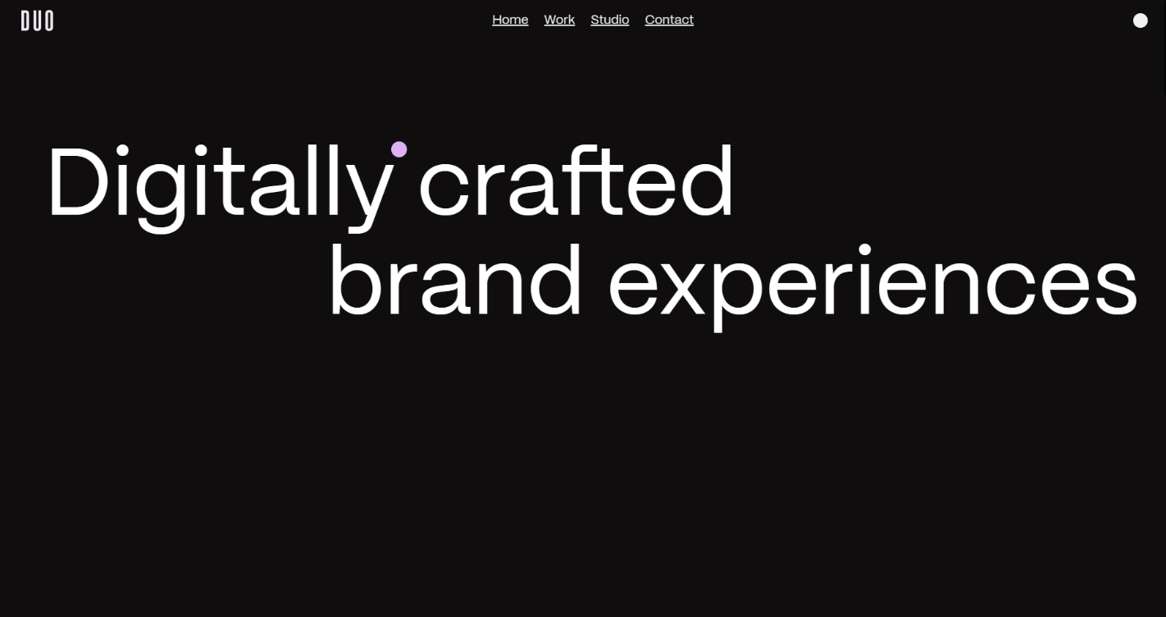

##### A screenshot of a website Description automatically generatedAbout Page:

* **A person with long hair and a picture of a city

  Description automatically generatedWork Page:**

##### Contribute Module :

**7 .0 Skill developed /learning outcomes:**

* + - The concept of project understood.
    - Implementation of the self-development process.
    - Understanding the structural base of popular websites and recreating them.
    - Understand the principles of Creating responsive and dynamic web page.
    - Develop skills in analysing the usability of a web site.
    - Understand how to plan and conduct user research related to web usability.

##### 0 Conclusion of Micro-Project:

* + Fort conservation website is more than a documentation process it is more, it is an art form and should be treated with the same respect to our heritage and culture
  + Via this JavaScript project, we provide the overall information attractiveness to the website
  + We can make websites more dynamic and responsive using the JavaScript.

**9..0 Actual Resources Used:**

|  |  |  |
| --- | --- | --- |
| **Sr No.** | **Software** | **Hardware** |
| 1) | Visual Studio Code | Device name LAPTOP- |
|  |  | Hp 15-fq 155202TU |
|  |  | Processor:12th Gen Intel(R) |
|  |  | Core (TM) i5- |
|  |  | Installed RAM:8.00 GB (7.75 GB usable) |
| 2) | Microsoft word |

* 1. **Reference:**
     1. https://www.maharashtratourism.gov.in
     2. <https://shivdurg.org>
     3. https://www.w3schools.com

## Micro-project Evaluation Sheet

**Name of Student:** Srushti Pancham Mane

**Enrolment no:** 2101310153. **Program:** Computer Engineering **Semester:** 5th

**Course Title:** Client-Side Scripting (CSS)

**Course code:** 22519

**Title of Micro-project:** Fort Conservation Website.

* Make use of the programme flow control structure to create interactive web pages.
* Use JavaScript to create web pages that are event-based.
* Make navigation and menus for web pages.
* Make interactive web pages by validating them with regular expressions.
* Develop secure web sites.

|  |  |  |  |  |  |  |
| --- | --- | --- | --- | --- | --- | --- |
| **Sr.No.** | **Characteristics to be assessed** | **Poor Marks**  (1 – 3) | **Average**  (Marks 4-  5) | **Good** (Marks 9-10) | **Excellent**  (Marks 9-  10) | **Sub total** |

**(**A)Process and Product Assessment (Convert above total marks out of 6 marks)

|  |  |  |  |  |  |  |
| --- | --- | --- | --- | --- | --- | --- |
| **1.** | Relevance to the course |  |  |  |  |  |
| **2.** | Literature Review/information  collection |  |  |  |  |  |
| **3.** | Completion of Target as per project proposal |  |  |  |  |  |
| **4.** | Analysis of Data and representation |  |  |  |  |  |
| **5.** | Quality of Prototype/Model |  |  |  |  |  |
| **6.** | Report Preparation |  |  |  |  |  |

|  |  |  |  |
| --- | --- | --- | --- |
| **Roll No.** | **(A)**  **Process and Product assessments (6 marks)** | **(B)**  **Individual Presentation or viva (4 marks)** | **Total Marks 10** |
| 21342 |  |  |  |

**Comments/Suggestions about team work/leadership/inter-personal communication:**

**---------------------------------------------------------------------------------------------**

##### ------------------------------------------------------------------------------------

**Name and designation of the Teacher: -**

##### ---------------------------------------------------------------------------------------------

**------------------------------------------------------------------------------------**

##### Dated Signature:

**--------------------------------------------------------------------------------------------**