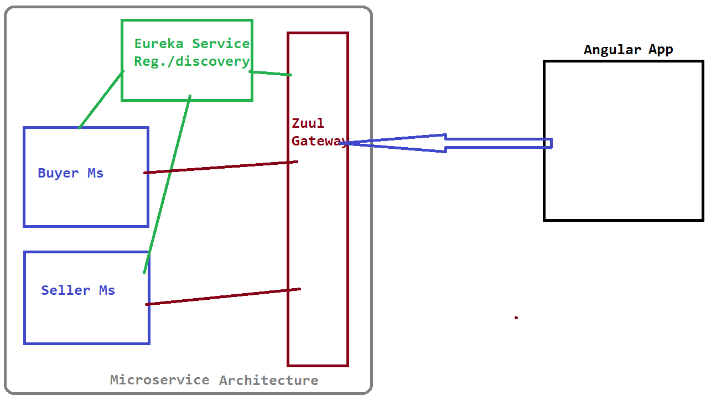

1. Data fields

Product:

id -

name -

model -

make -

category id -

sub category id -

price -

quantity -

image -

specifications -

seller id -

status(active/inactive) -

Buyer:

id -

username -

password -

emailid -

Seller:

id -

username -

password -

emailid -

company name -

company description -

Shopping Cart:

id -

product id -

purchase quantity -

buyer id -

Purchase History:

id -

product id -

purchase quantity -

buyer id -

purchase date/time -

2. REST APIs

Buyer:

searchProduct:

addToCart:

getCart:

Seller:

addProduct i/p - Product o/p - Product with id which got created

3. Entity class relationship

4. UI Screens

