# FINAL OUTPUTS RESULTS:

## 1. EXECUTION WHEN BUTTON IS PRESSED ONCE FOR 2 SECONDS:

Ignition mode and Car in ON

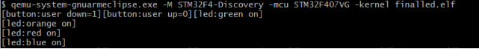

## 2. EXECUTION WHEN BUTTON IS PRESSED ONCE AGAIN FOR 2 SECONDS:

ACC mode and Car is OFF

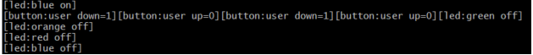

## 3. EXECUTION WHEN BUTTON IS PRESSED FOR SECOND TIME:

Turning ON the wiper

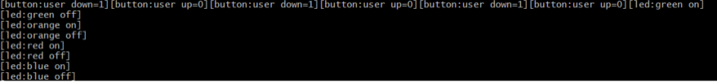

## 4. EXECUTION WHEN BUTTON IS PRESSED FOR THIRD TIME:

Turning OFF the wiper

