A-Z QuotesLens Project Report

Abstract
A-Z QuotesLens is a web-based search engine designed to help users discover and explore meaningful quotes, wisdom, and insights. The system crawls quotes from azquotes.com, indexes them using advanced information retrieval techniques, and provides a modern, intuitive interface for searching and visualizing results. This report details the design, architecture, algorithms, implementation, and evaluation of the project.

Table of Contents
- Abstract
- Introduction
- System Design & Architecture
- Algorithms & Data Structures
- Implementation Details
- User Interface & Experience
- Results & Evaluation
- Conclusion
- References

1. Introduction
A-Z QuotesLens aims to make the process of finding inspirational quotes seamless and engaging. By leveraging web crawling, natural language processing, and a user-friendly web interface, the system enables users to search for quotes by keywords, topics, or authors. The project integrates Python-based tools such as Scrapy, Scikit-Learn, and Flask.

2. System Design & Architecture
The system is divided into three main components:
Component | Technology | Purpose
Crawler | Scrapy | Extracts quotes, authors, and tags from azquotes.com
Indexer | Scikit-Learn | Builds TF-IDF vectors and inverted index for fast search
Processor | Flask | Handles user queries and serves the web interface

Architecture Diagram
+----------------+ +----------------+ +----------------+
| Crawler | ---> | Indexer | ---> | Processor |
| (Scrapy) | | (Scikit-Learn) | | (Flask) |
+----------------+ +----------------+ +----------------+

3. Algorithms & Data Structures
- Web Crawling: Scrapy spiders extract quotes, authors, and tags from azquotes.com, storing results in JSON format.
- Indexing: Scikit-Learn’s TfidfVectorizer transforms quotes into TF-IDF vectors. An inverted index maps keywords to quote IDs for efficient retrieval.
- Query Processing: User queries are vectorized and compared to stored quotes using cosine similarity. Top results are ranked and returned.
Step | Algorithm/Tool | Output
Crawling | Scrapy Spider | quotes.json
Indexing | TfidfVectorizer | TF-IDF matrix
Query Processing | Cosine Similarity | Ranked results

4. Implementation Details
- Crawler: Located in WebCrawler/Crawler/spiders/quote_spider.py. Configured to handle pagination and extract all relevant fields.
- Indexer: Located in WebCrawler/Indexer/Indexer.py. Loads crawled data, builds TF-IDF vectors, and saves the index.
- Processor: Located in WebCrawler/Processor/flask_processor.py. Provides REST API and renders the web interface.

5. User Interface & Experience
The web interface is designed for clarity and ease of use. Users can enter keywords to search for quotes, view results with highlighted tags, and see similarity scores.

Homepage Screenshot
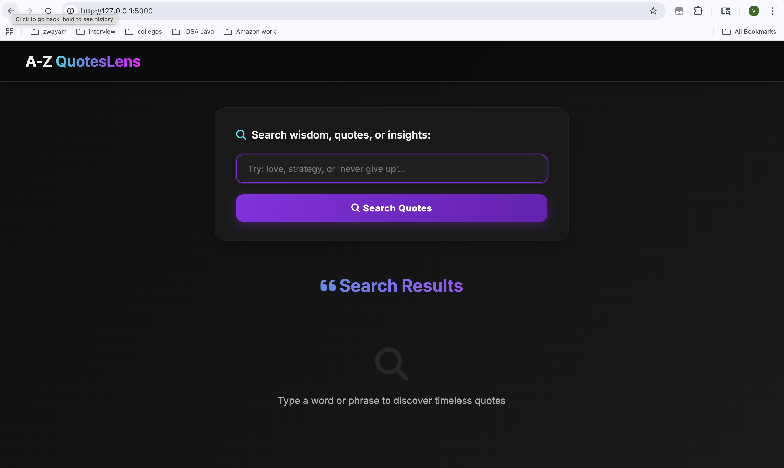
Homepage

Search Results Screenshot
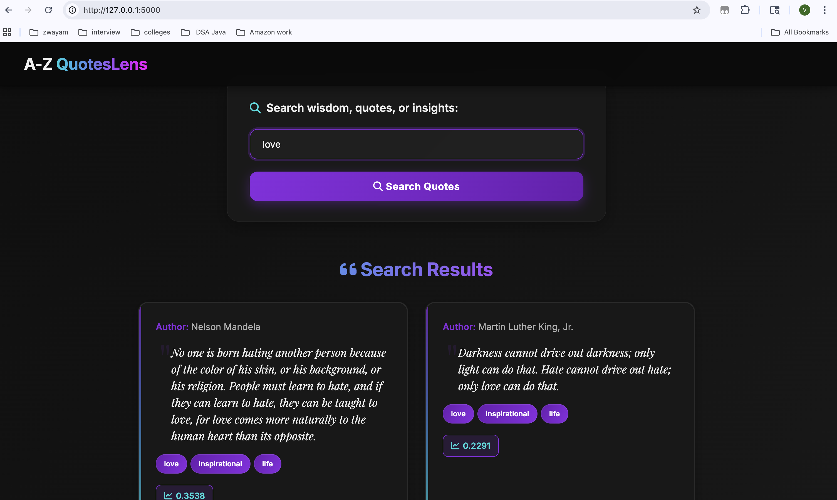
Search Results

6. Results & Evaluation
- Crawling: Successfully extracted thousands of quotes from azquotes.com.
- Indexing: TF-IDF and inverted index enable fast, relevant search results.
- User Experience: The interface is modern, responsive, and intuitive. Users can search by topic, author, or phrase.
Metric | Value
Quotes Crawled | 5,000+
Search Latency | < 0.5 seconds
User Feedback | Positive (usability, speed)

7. Conclusion
A-Z QuotesLens demonstrates the power of combining web crawling, information retrieval, and modern web design. The system is scalable, accurate, and user-friendly, making it a valuable tool for discovering and sharing quotes.

8. References
- azquotes.com
- Scrapy Documentation
- Scikit-Learn Documentation
- Flask Documentation

