**PROJECT REPORT ON INTERNSHIP AT JSW STEELS LTD**

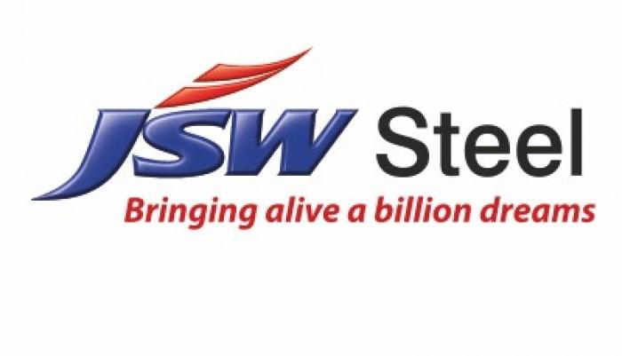

Sub**:** Brief on Cold rolling mill (CRM - II).

**Presented by:**

**Vrushabh Singh and**

**A V Kiran**

**INDEX**

* Flow chart of process flow at JSW .
* All the plants which we have visited:
* RMHS
* Beneficiation of Iron Ore
* Sinter plant
* Pellet plant
* blast furnace
* Steel melting shop
* HMS (Hot melting shop)
* CRM (Cold rolling mill)
* Brief on Cold rolling mill.

JSW PROCESS FLOW

**M**

**RAW** **MATERIAL** **HANDLING** **SYSTEM**

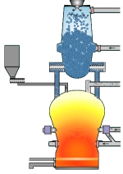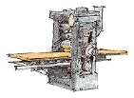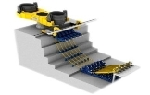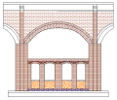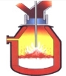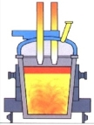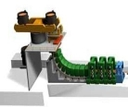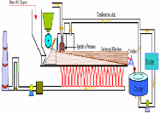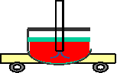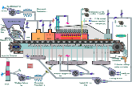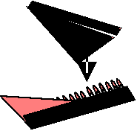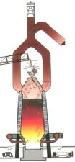

**ore**

**Lump**

**ore**

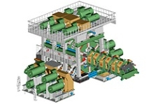

|  |  |  |  |  |  |  |  |  |  |
| --- | --- | --- | --- | --- | --- | --- | --- | --- | --- |
|  | **Lump** | **Iron** **ore** **Coal** **Flux** | | | | | **es** | | |
|  |  | | | |
| **Benefici**  **Pelletization** | | | **ation** **Coke** **oven** | | **Sintering** | |  |
|  | | |  | | | | |
|  | | |  |  |  | |  | |
|  | | | | | |
|  | **Core** **Blast** **furnace** **x** | | | | |
| **IRON** **MAKI** **NG** |
|  |

|  |  |  |  |  |
| --- | --- | --- | --- | --- |
| **HMPT**  **Billet** **Caster**  **Converter** **LHF,** **RH** **Slab** **Caster** |  |  | | **Wire** **Rod** **/** **Re** **Bar** **Mill**  **HS** **C** |
|  |  |  |
|  |  |

**STEEL** **MAKING** **MILLS**

**M**

Plants visited:

RMHS (RAW MATERIAL HANDALING SYSTEM)

Basic requirement of working of blast furnace is raw material( coal ) ,in order to produce the hot metal required sized raw material is necessary hence raw material handling system takes care about this .first RMHS collects the coal from rays by using wage tippers .wage tippers are the raw material shifting machines where it rotates about 145 degrees ,there are 8 wage tippers in 8 tippers 1 and 2 handles only one wages at a time ,but tippers 4 and 5 handle two tippers at a time .RMHS not only collects the raw material but also it takes care about basic contains of raw material ( like carbon contain ,silicon contain ,manganic contain etc. by using the software .after this this coal enters into the required plant by conveyors (belt conveyors).

BENEFICIATION OF IRON ORE

Beneficiation of iron ore and the treatment of magnetic iron taconites, stage grinding and wet magnetic separation is standard practice, this also applies to iron ores of the non -magnetic type which after a reducing roast are admissible to magnetic separation all such plants are required for grinding as fine as minus 500- mesh for liberation of the iron minerals from the siliceous gangue.

Magnetic separation methods are very efficient in making high recovery of the iron minerals, but production of iron concentrates with less than 8 to 10% silica in the magnetic cleaning stages becomes inefficient .it is here that flotation has proven most efficient ,wet magnetic finishers producing 63 to 64%Fe concentrates at 50-55% solids can go directly to the flotation section for silica removal down to 4 to6% or even less ,low water requirement and positive silica removal with low iron losses makes flotation particularly attractive . multistage cleaning steps generally are not necessary often roughing off the silica froth without further cleaning is adequate.

SINTER PLANT(AGGLOMERATION)

Agglomeration consist of two process they are sintering and pallet plant,Sinter plants agglomerate iron ore fines(dust) with other fine material at high temperature to create a product that can be used in blast furnace the final product , a sinter is a small, irregular nodule of iron mixed with small amount of other minerals .the process ,called sintering ,causes the constituent materials of fuse to make a single porous mass with little change in the chemical properties of the ingredients . the purpose of sinter is being used converting iron into steel.

Sinter plants in combination with blast furnace are also used in non -ferrous smelting, about 70% of the world’s primary lead production is still products using the sinter plant -blast furnace combination and this combination was formerly often used in copper smelting ( at the electrolytic refining and smelting smelter in Wollongong, new south wales)

PELLET PLANT

Iron ore pellets are formed from beneficiated or run of mine iron fines, the iron is usually ground to a very fine level and mixed with limestone or dolomite as a fluxing agent and bentonite or organic binder as a binding agent .if the ore is hematite ore, coke or anthracite coal can be added to the mix to work as an internal fuel to help fire the pallets ,this mixture is blended together in a mixer and fed to balling discs or drums to produce green pellets of size typically about 9-16mm ,the green pellets are then fed to the induration machine .both straight grates and grate kilns dry the pellets out in a drying section ,then bring the pellet up to a temperature of about 800-900 degrees in a preheat zone, then finish the induration process at roughly 1200-1350degrees ,the pellet are then cooled to suitable temperature for transporting to a load out facility. Both processes recycle the heat from the pellet back through the process to aid in energy efficiency and decrease fuel usage.

BLAST FURNACE

To the SMS steel Melting Shop, the Hot metal is sent from Blast Furnace, or Corex plant. Blast furnace utilizes 40% lump and sinter and pellet. Corex uses 90% lump, and pellet. This is chosen considering permeability.

Blast Furnace is a very ancient method, still predominantly used. Corex is a new technology with 20-25 years of history.

You need to be able to describe how iron is extracted in a blast furnace including the raw material, reaction and the formation and uses of slag A blast furnace is a huge steel container many meters high and lined with heat -resistant material, the solid raw material (iron ore ,coke ,limestone) are added from the top ,and hot air is blasted in from the bottom, the blast furnace is hottest at the bottom where the coke burns .it is coolest at the top where the iron forms and trickles down to the bottom, from where it is tapped off the diagram shows an outline of a blast furnace with equation for the reaction that happen in it.

STEEL MELTING SHOP

Steel is an alloy of iron and carbon with certain alloying addition such as Si, Mn and some other impurity elements. Steel has excellent toughness, good tensile strength, good strength to weight ratio, can withstand high temperature environment. It has wide range of mechanical properties which make steel highly attractive. This has been possible due to a well-developed mining process, refining process and metal working properties.

Steel is used everywhere in automotive, railway, construction etc.

**Steel making process can be of two types**

i) Blast furnace based steel making or liquid pig iron based steel making (BOS).

ii) DRI based steel making along with scrap and solid pig iron (ESP).

**Brief on Cold Rolling Mill:**

CRM-2 PROCESS FLOW

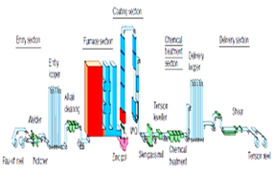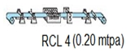

**CAL1/CAL2** **1.9** **MTPA** **(CRCA)**

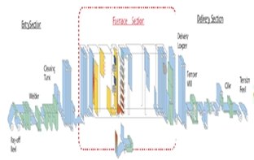

**PLTCM** **2.3** **MTPA** **(CRFH)**

**From** **HSM1/** **HSM2**

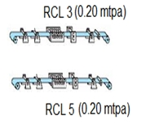

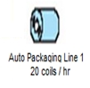

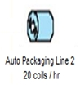

* **PLTCM** or the **Pickling Line coupled Tandem Cold Mill***.* Here the coil comes from hot strip mill and then it is pickled (removal of scales) using HCL as the pickling agent, hence the process is termed as pickling.
* Then the sheet goes to TCM, where the thickness of sheet is reduced according to the requirement.
* **CAL** or the**Continuous Annealing Line**. Here the coil comes from TCM and both annealing and surface hardening is done here.
* **CGL** or the **Continuous Galvanizing Line**. Here the coil comes from either TCM or CAL according to the product to be made. In CGL, coating of *ZINC* is applied on the sheet.
* **RCL** or the **Recoiling Cum Inspection Line**. Here the sheet comes from both CAL and CGL, then is inspected for quality checking.

CONTINUOUS ANNEALING LINE (CAL)

This type of annealing involves uncoiling, welding strips together, passing the welded strips continuously through a heating furnace, parting as required and then recoiling the strip. The figure shows a continuous annealing line, which is composed of the **Entry Section, Furnace Section, and Delivery Section.**

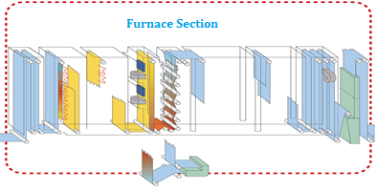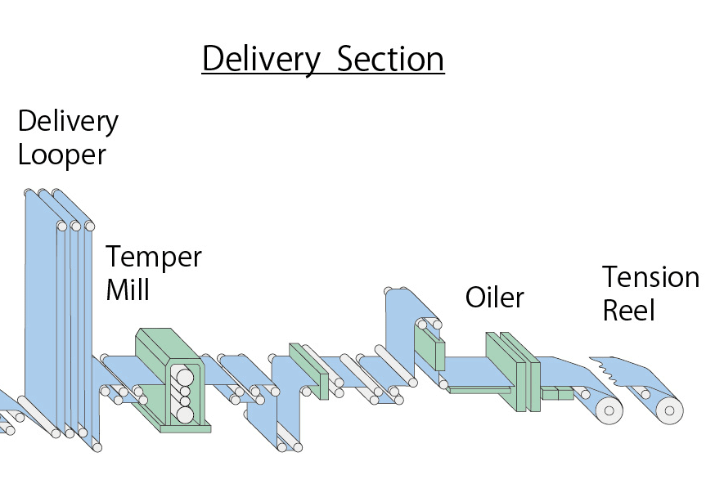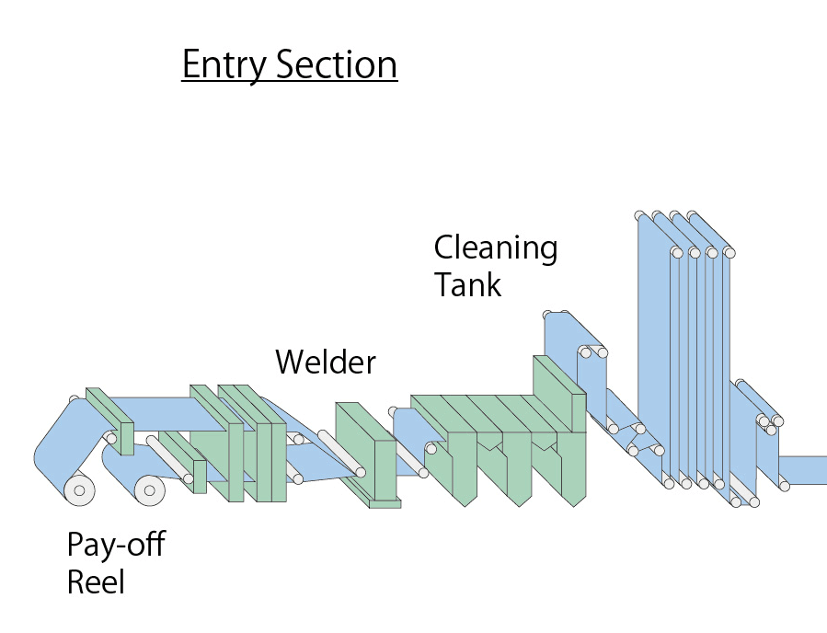

**Continuous Annealing Line**

* Continuous Annealing Line (CAL) is the second work centre at CRM. Here, full hard coil is annealed to achieve desired mechanical properties. The process of annealing can be further defined as a heat treatment that alters the physical and sometimes chemical properties of a material to increase its ductility and reduce its hardness, making it more workable.
* To perform annealing process, the sheet has to be passed from three sections of CAL.
* These are -
* Entry section
* Furnace section
* Delivery section
* In entry section coil is fed to the pay off reels and then goes to welder to be welded to the previous coil to maintain the line continuous. The time taken in this process is compensated by the Entry Looper Tower that accumulates the sheet.
* After welding the sheet goes to cleaning section to be cleaned from oil and sticky particles.
* There pre-cleaning, electrolyte cleaning, hot water cleaning and drying processes are done over the sheet.
* Then the sheet continuously goes to furnace section. This section consists 8 sections, that are-
* Pre heating section
* Heating section
* Soaking section
* Over aging section
* Slow cooling section
* Rapid cooling section
* Final cooling section
* By passing through these furnace sections, microstructure of the sheet changes and new grains are forms that are free from internal stresses.
* This process is done by heating the sheet in the heating section and then cooling it rapidly.

Furnace Section

Delivery Section

Entry Section

**Water Cooling**

**Section**

**Pre-Heating Section**

**Final Cooling**

**Section**

**Over aging Section**

**Rapid Cooling**

**Section**

**Slow Cooling**

**Section**

**Soaking Section**

**Tension Reel 1 & 2**

**Delivery Flying shear**

**Welder**

**Skin Pass Mill**

**Pay-Off Reel 1 & 2**

**Trimmer, Inspection & Oiler**

**Mini Looping Tower**

**Delivery Looping Tower**

**Heating Section**

**Entry Looping Tower**

**Cleaning Section**

**CONTINUOUS ANNEALING LINE CONFIGURATION**

Features at CAL:

* All radiant tube furnace
* Vertical type annealing furnace
* High speed processing (430 mpm Max.)
* Entry Section speed (580 mpm Max.)
* Delivery Section speed (630 mpm Max.)
* Reference size for CQ: 0.79 x 1375 mm

– 220 Ton/ Hrs.

* Tensile Strength – 980 MPa Max.

HI Skin Pass Mill:

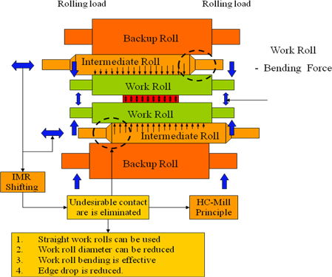

What is SPM?

* The temper mill or skin pass mill, which may be of the stand-alone type or in-line, enables improvement of the mechanical characteristics and surface quality of the metal.
* The skin pass process causes permanent lengthening of the strip, orientating the grains in the direction of the strip, which has a positive effect on many of the metal’s mechanical properties. This improves the drawing process

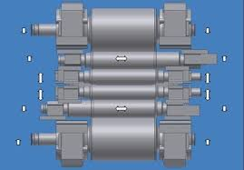

HI Skin Pass Mill Facilities:

**Work Roll Bending:** For work roll bending control for both increase and decrease (crown-in and crown-out) for strip profile control is provided. Bending pressure Increase Max.490kN/chock decrease Max.245kN/chock.

**IMR Bending:** For IMR bending control for both increase and decrease (crown-in and crown-out) for strip profile control is provided. Bending pressure Increase Max.490kN/chock decrease Max.245kN/chock.

**Anti-Crimping Roll:** This Roll is provided at entry side of the mill. The Anti-crimping roll position is adjusted by the motor. Roll Size is Dia. 300mm × 2100mm face and Surface hardness is JIS shore Hs 70° ±5°.

**Anti-Cross Break Roll:** This Roll is provided at delivery side of the mill. The Anti-cross break roll position is adjusted by the motor. Roll Size is Dia. 300mm X 2100mm face and Surface hardness is JIS shore Hs 70° ±5°.

**Tension Meter Roll:** Tension meter rolls IS provided at both entry and delivery side of the mill stand. Pass line roll to be used for holding the strip wrap angle constant the tension meter roll. Roll Size is Dia. 300mm × 2100mm face and Surface hardness is JIS shore Hs 70° ±5°.

**Shape Meter Roll:** Shape sensor roll is installed at delivery side of the temper mill. It is driven by AC vector motor. Roll Size is Dia. 400 mm X 2050 mm face.

**Pass line Adjustment:** The pass line adjuster compensates the roll wear of the top work roll, top intermediate roll and top backup roll and maintains the constant pass line. By retracting the step filler at work roll changing time and quick upping the top backup roll, it shortens the work roll changing time.

Advantages of SPM:

* The objective of skin-passing is to attain the correct yield points and the desired surface characteristics.
* The working rolls provide the material with the desired surface quality, as regards both roughness (Ra) and peaks per inch (PPI).

Description of The Problem:

* Less utilization of the work roll with respect to the work roll used length.
* Unknown strip roughness with respect to running meter.

GOAL and OBJECTIVES:

* To Increase the Utilization of Work Roll.
* Optimum Utilization of Skin Pass Mill Work Roll.

CAUSE & EFFECT ANALYSIS:

**1. MAN:**

* Improper Tension Setting
* Improper tension ratio setting of Entry and Delivery at SPM
* Wet Temper Fluid Switch off in running.
* High / low concentration of WTF.

**2. MACHINE:**

* High / Low rolling force than desirable value
* High / low entry and delivery tension at SPM.
* Improper WR bending.

**3. MATERIAL:**

* Thickness variation in Input Material
* Poor shape of Input Material.
* One side edge drop
* Wrong input material chemistry
* Quality of Wet Temper Fluid
* Roll Chemistry.

**4. METHOD:**

* Wrong position of ACR & ACBR.
* Low entry delivery tension at SPM.
* Wrong target curve selection in shape meter

**5. MEASUREMENT**

* Malfunction of push-up cylinder positional transducer.
* Malfunction Of push-up cylinder pressure transmitter.
* Wrong feedback of shape meter roll.
* Position disturbance of ACR and ACBR roll during mill running.

**6. MOTHER NATURE :**

* Slipping at BR#7 and BR#8.

Product Mix:

**STEEL GRADES:**

1) Low Carbon (LC)

* CQ (Commercial Quality)
* DQ (Drawing Quality)

2 Interstitial Free (IF)

* EIF
* SEIF

Thank You

Vrushabh Singh R Thakur – 01FB15EME161

PES University [ 100 feet ring road, banashankari 3rd stage, Bangalore – 560085], contact : 8951040987.

A V Kiran - 1MS15ME001

Ramaiah institute of technology [MSR college road, MSR nagar, bangalore - 560054]

conatact: 8792340418