A

PROJECT DAIRY ON

“Agricultural Management System”

Submitted by,

DARKUNDE VRUSHAL SHIVAJI

ROLL NO - 22

MCA - I

IN PARTIAL FULLFILLMENT OF

MASTER OF COMPUTER APPLICATION

For

INSTITUTE OF MANAGEMENT STUDIES AND CARRER DEVELOPMENT AND RESEARCH.

NAAC RE-ACCREDITED: A+ GRADE

Affiliated To

SAVITRIBAI PHULE PUNE UNIVERSITY

ACADEMIC YEAR (2021-22)

|  |  |  |
| --- | --- | --- |
| **Chap No** |  | **Details** |
| **1** |  | **Introduction** |
|  | **1.1** | Abstract |
|  | **1.2** | Scope of System |
|  | **1.3** | Operating Environment - Hardware and Software |
|  | **1.4** | Brief Description of Technology Used  Operating systems used (Windows or Unix)  RDBMS/No Sql used to build database (mysql/ oracle, Teradata, etc.) |
| **2** |  | **Proposed System** |
|  | **2.1** | Study of Similar Systems ( If required research paper can be included) |
|  | **2.2** | Users of System |
| **3** |  | **Analysis and Design** |
|  | **3.1** | System Requirements (Functional and Non-Functional requirements) |
|  | **3.2** | Entity Relationship Diagram (ERD) |
|  | **3.3** | Table Structure |
|  | **3.4** | Use Case Diagrams |
|  | **3.5** | Class Diagram |
|  | **3.6** | Activity Diagram |
|  | **3.7** | Sample Input and Output Screens (Screens must have valid data. All  reports must have at-least 5 valid records.) |
| **4** |  | **Coding** |
|  | **4.1** | Algorithms |
|  | **4.2** | Code snippets |
| **5** |  | **Testing** |
|  | **5.1** | Test Strategy |
|  | **5.2** | Unit Test Plan |
|  | **5.3** | Test Case / Test Script |
|  | **5.4** | Defect report / Test Log |
| **6** |  | **Limitations of Proposed System** |
| **7** |  | **Proposed Enhancements** |
| **8** |  | **User Manual (All screens with proper description/purpose Details  about validations related to data to be entered.)** |

1. **Introduction**

# **Abstract**

Agricultural Management System is built using JSP, Servlet, and MYSQL. Agricultural Management System project in java is a web application where a user can search and view the Information using this system. Users can search the Information of their choice according to the requirement online so it will be easy for users.

This Project is performing all the crud operations like EDIT/UPDATE/DELETE functions. Following the MVC architecture to manage the view part in JSP and handling the Server-side request, it’s using servlet and MYSQL as backend.

Agricultural Management System project in java is a web application where a user can search and view the Information using this system. Users can search the Information of their choice according to the requirement online so it will be easy for users. The complete process of Agricultural Management will be managed online. There is no need to maintain the record manually.

# **Scope of System**

This system provides security.

It also helps to maintain records.

It helps to update Crop, Insecticides, Pesticides, Equipement details quickly & easily.

It helps to maintain the database accurately.

Since the proposed system is computerized, so fast calculation is done.

It is time-saving since it maintains records accurately.

It does the manual task of the existing system automatically effectively and efficiently.

It provides a user-friendly GUI.

Through this system, it is possible to print various reports required for the organization.

For all of this clear information and understanding should have been done regarding the system. The proper documentation should be necessary proper normalization and creating of database files should have been done properly also various designing should have been done.

Finally, the system should have been tested properly by tally reports that can be giving much experience in system development.

# **Operation Environment - Hardware and Software**

**Hardware Requirements: -**

* Operating System: - Windows/ Linux
* RAM: - 4 GB or more
* Hard Disk: - 256 GB or more

**Software Requirement: -**

* **Browser:** Any Standard Browser (Chrome, Mozilla Firefox)
* **Front – End:** Html, CSS, JavaScript, Java [JSP (Java Server Pages) Servlet]
* **Back – End:** MYSQL
* **IDE Tools:** Eclipse IDE
* **Server:** Apache Tomcat (9, 10 or later), Xampp (for MYSQL)

# **Brief Description of Technology**

**HTML:**

The Hyper Text Mark-up Language or HTML is the standard mark-up language for documents designed to be displayed in a web browser. It can be assisted by technologies such as Cascading Style Sheets (CSS) and scripting languages such as JavaScript. Web browsers receive HTML documents from a web server or from local storage and render the documents into multimedia web pages. HTML describes the structure of a web page semantically and originally included cues for the appearance of the document. HTML elements are the building blocks of HTML pages. With HTML constructs, images and other objects such as interactive forms may be embedded into the rendered page. HTML provides a means to create structured documents by denoting structural semantics for text such as headings, paragraphs, lists, links, quotes and other items. HTML elements are delineated by tags, written using angle brackets. Tags such as <img /> and <input /> directly introduce content into the page. Other tags such as <p> surround and provide information about document text and may include other tags as sub-elements. Browsers do not display the HTML tags but use them to interpret the content of the page.

**CSS: -**

Cascading Style Sheets (CSS) is a stylesheet language used to describe the presentation of a document written in HTML or XML (including XML dialects such as SVG, MathML or XHTML). CSS describes how elements should be rendered on screen, on paper, in speech, or on other media.

**JavaScript: -**

JavaScript is a dynamic computer programming language. It is lightweight and most commonly used as a part of web pages, whose implementations allow client-side script to interact with the user and make dynamic pages. It is an interpreted programming language with object-oriented capabilities.

**Bootstrap:** -

To use some prebuilt layouts and designs. Bootstrap is the most popular HTML, CSS and JavaScript framework for developing a responsive and mobile friendly website. It includes HTML and CSS based design templates for typography, forms, buttons, tables, navigation, modals, image carousels and many others. It can also use JavaScript plug-ins. It facilitates you to create responsive designs. It is compatible on most of browsers like Chrome, Firefox, Internet Explorer, Safari and Opera etc.

**JSP: -**

Java Server Pages (JSP) is a technology for developing Webpages that supports dynamic content. This helps developers insert Java code in HTML pages by making use of special JSP tags, most of which start with <% and end with %>. A Java Server Pages component is a type of Java servlet that is designed to fulfil the role of a user interface for a Java web application. Web developers write JSPs as text files that combine HTML or HTML code, XML elements, and embedded JSP actions and commands. Using JSP, you can collect input from users through Webpage forms, present records from a database or another source, and create Webpages dynamically. JSP tags can be used for a variety of purposes, such as retrieving information from a database or registering user preferences, accessing Java Beans components, passing control between pages, and sharing information between requests, pages etc.

**Servlet:**

Servlets are protocol and platform-independent server-side software components written in Java. Servlets run on a Web server machine inside a Java-enabled server, that is, a server able to start the Java Virtual Machine(JVM) in order to support the use of Java servlets.

They dynamically extend the capabilities of the server because they provide services over the Web using the request-response paradigm. Servlets were initially supported in the Java Web Server from Java Soft. Since then, several other Java-based Web servers have supported the standard servlet API. Servlets were introduced to interactively view and modify data and to generate dynamic Web content. From a high-level perspective, the process flow would be: The client sends a request to the server. The server sends the request information to the servlet. The servlet builds a response and passes it to the server. That response is dynamically built and the contents of the response usually depend on the client’s request. The server sends the response back to the client.

**MYSQL: -**

MySQL is a relational database management system (RDBMS) developed by Oracle that is based on structured query language (SQL). A database is a structured collection of data. It may be anything from a simple shopping list to a picture gallery or a place to hold the vast amounts of information in a corporate network.

**XAMPP Server**: -

XAMPP is one of the widely used cross-platform web servers, which helps developers to create and test their programs on a local webserver. It was developed by the Apache friends, and its native source code can be revised or modified by the audience. It consists of Apache HTTP Server, MariaDB, and interpreter for the different programming languages like PHP and Perl. It is available in 11 languages and supported by different platforms such as the IA-32 package of Windows & x64 package of macOS and Linux.

**Eclipse:** -

Eclipse (software) Eclipse is an integrated development environment (IDE) used in computer programming, and is the most widely used Java IDE. It contains a base workspace and an extensible plug-in system for customizing the environment. Eclipse is written mostly in Java and its primary use is for developing Java applications.

1. **Proposed System**

# **Study of Similar System**

The existing system is built with innumerable excel sheets that are created by each user. These sheets may be collated by an alumni organization and shared with all the alumni but this activity may not be frequent. E – Mail ID’s may be freely shared and can lead to excessive spam mails. This apparent lack of privacy will force many alumni to avoid sharing their details with fellow alumni. The system is difficult to maintain on a regular basis by a small group of students.

# **User of System**

There are two types of actors in the application

1. **ADMIN / Buyer**

ADMIN can manage all the Information

1. **Customer**

Customer/Farmer who can view Information and Sale crop to buyer or admin.

1. **Analysis and Design**

# **System Requirements**

* + 1. **Functional Requirements**

1. **Admin:**

* Admin can Manage Information of Crops.
* Admin can Manage Information of Insecticide.
* Admin can Manage Information of Pesticide.
* Admin can Manage Information of Equipment.
* Admin can update its Password.
* Admin can view its Profile.
* Buy Customers Corps
* Generates Reports: -
* All Customers details
* All Pesticides details
* All Insecticide details
* All Equipment details

1. **Customer**

* Customer can View/Search Information on Crops.
* Customer can View/Search Information about insecticides.
* Customer can View/Search Information on Pesticides.
* Customer can View/Search Information on Equipment.
* Customer can change their password.
* Customer can view their own Profiles.
* Customer can Sale their crops to specified Buyers
  + 1. **Non-Functional Requirements**

It describes aspects of the system that are concerned with how the system provides the functional requirements. They are-

1. **Security:** The subsystem should provide a high level of security and integrity of the data held by the system, only authorized personnel of the company can gain access to the company's secured page on the system; and only users with valid password and username can login to view user's page.
2. **Error handling:** Error should be considerably minimized and an appropriate error message that guides the user to recover from an error: should be provided. Validation of user's input is highly essential. Also the standard time taken to recover from an error should be 15 to 20 seconds.
3. **Availability**: This system should always be available for access at 24 hours, 7 days a week. Also in the occurrence of any major system malfunctioning, the system should be available in 1 to 2 working days. so that the business process is not severely affected.
4. **Ease of use**: Considered the level of knowledge possessed by the users of this system, a simple but quality user interface should be developed to make it easy to understand and required less training.
5. **Privacy:**

Privacy policy, terms, and condition policies to encourage user to post more freely and gain trust.

# **Entity Relationship Diagram**

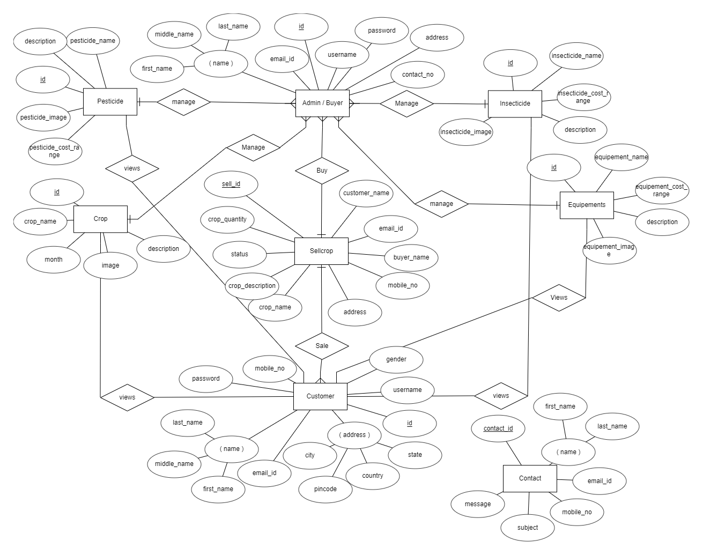

# **Table Structure**

1. **tbladmin(buyer)**

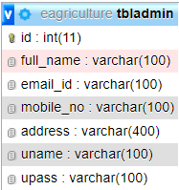

1. **tblpesticide**

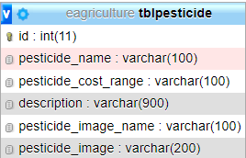

1. **tblinsecticide**

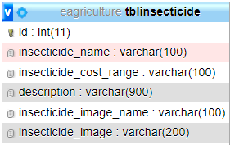

1. **tblequipements**

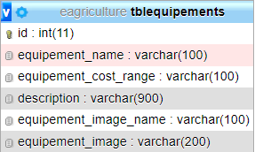

1. **tblcrop**

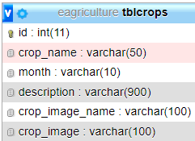

1. **tblcustomer**

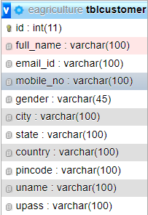

1. **tblsellcrops**

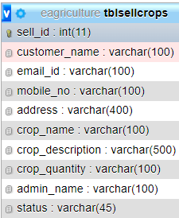

1. **tblcontact**

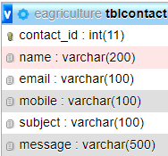

# **Use Case Diagram**

1. **Admin / Buyer Use Case Diagram**
2. **Customer Use Case Diagram**



1. **Global Use Case Diagram**



# **Class Diagram**



# **Activity Diagram**

1. **Login Activity Diagram**



1. **Change Password Activity Diagram**



1. **Logout Activity Diagram**
2. **Admin / Buyer Registration Activity Diagram**



1. **Customer Registration Activity Diagram**
2. **Update Profile Activity Diagram**

# **Sample Input / Output Screen**

1. **Home Page**

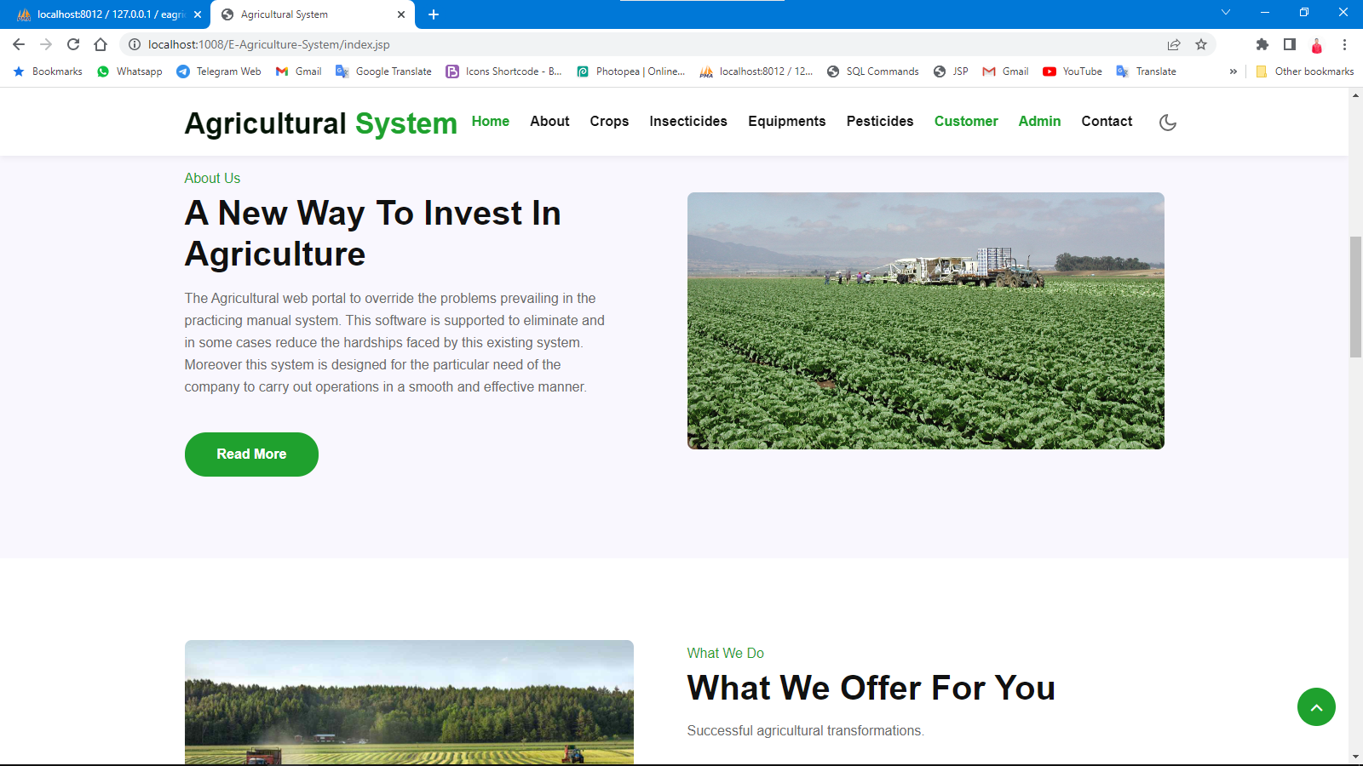

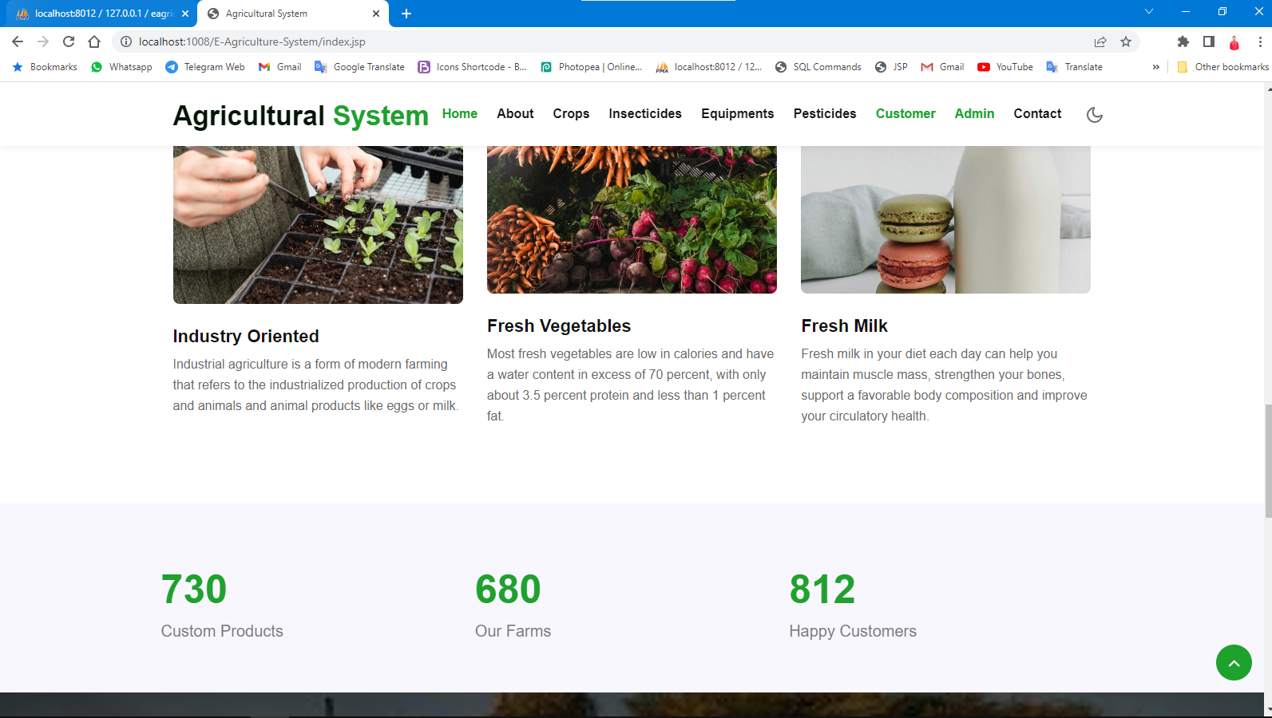

1. **Admin / Buyer** 
   1. **Login Page**

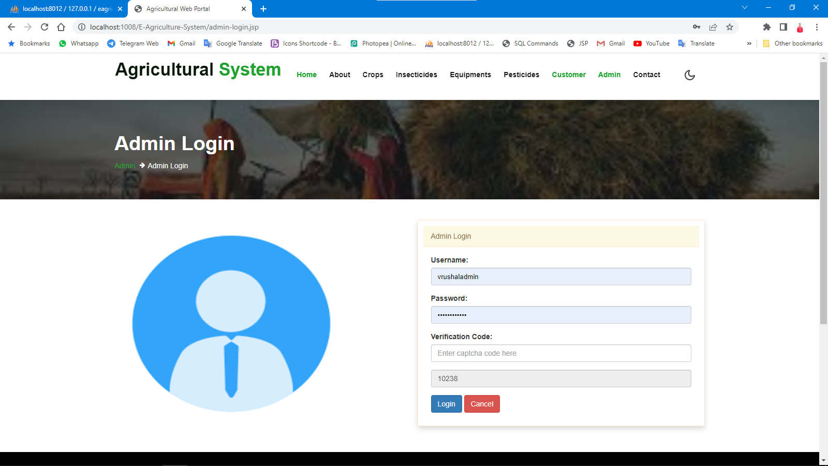

* 1. **Registration Page**

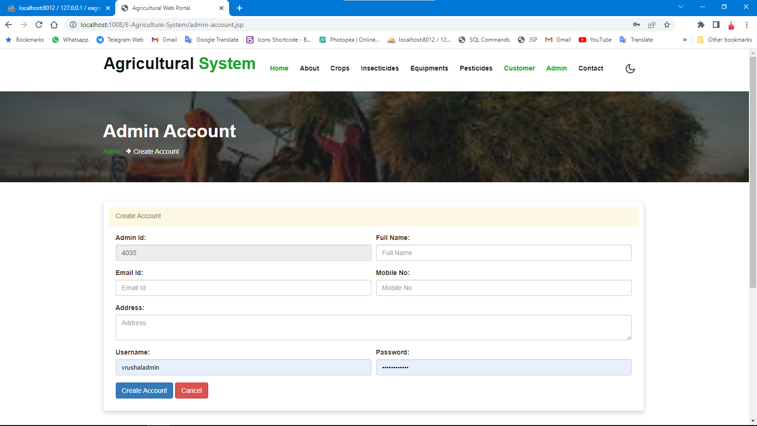

* 1. **Dashboard**

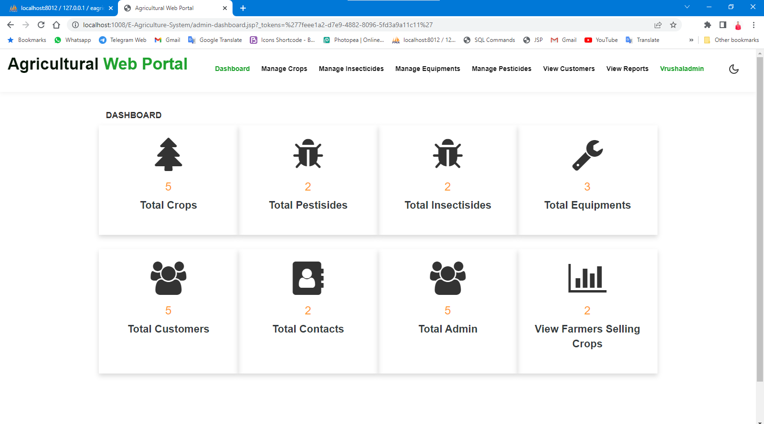

* 1. **Manage Crops**

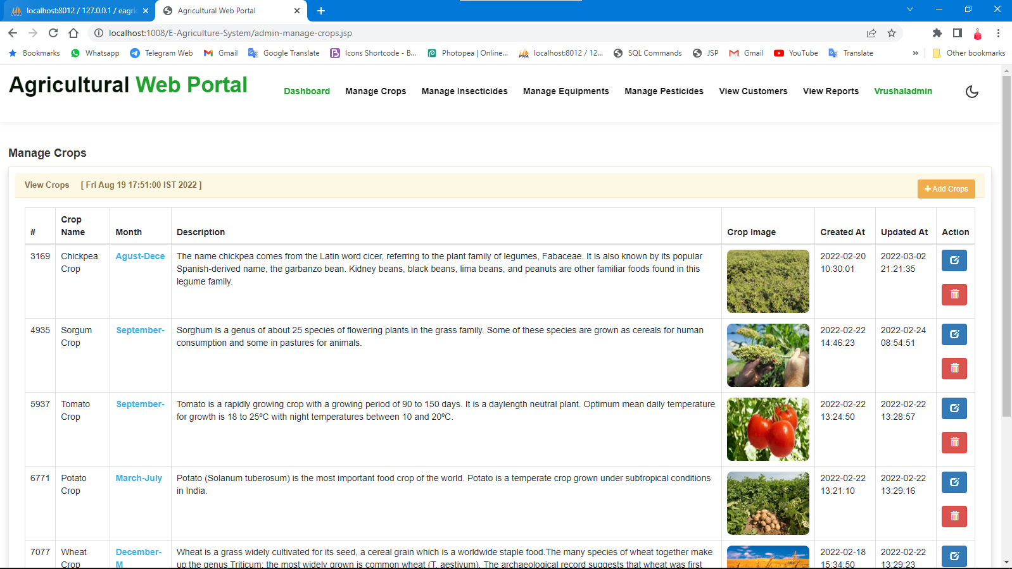

* 1. **Manage Insecticide**

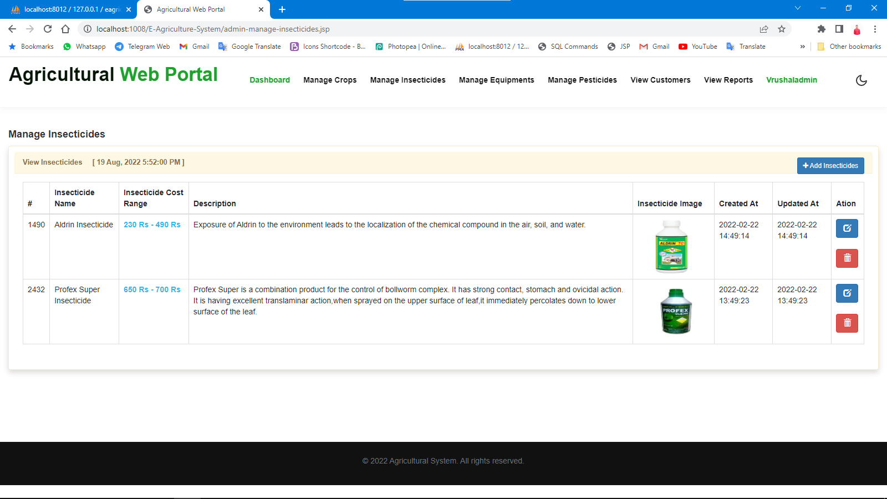

* 1. **Manage Pesticide**

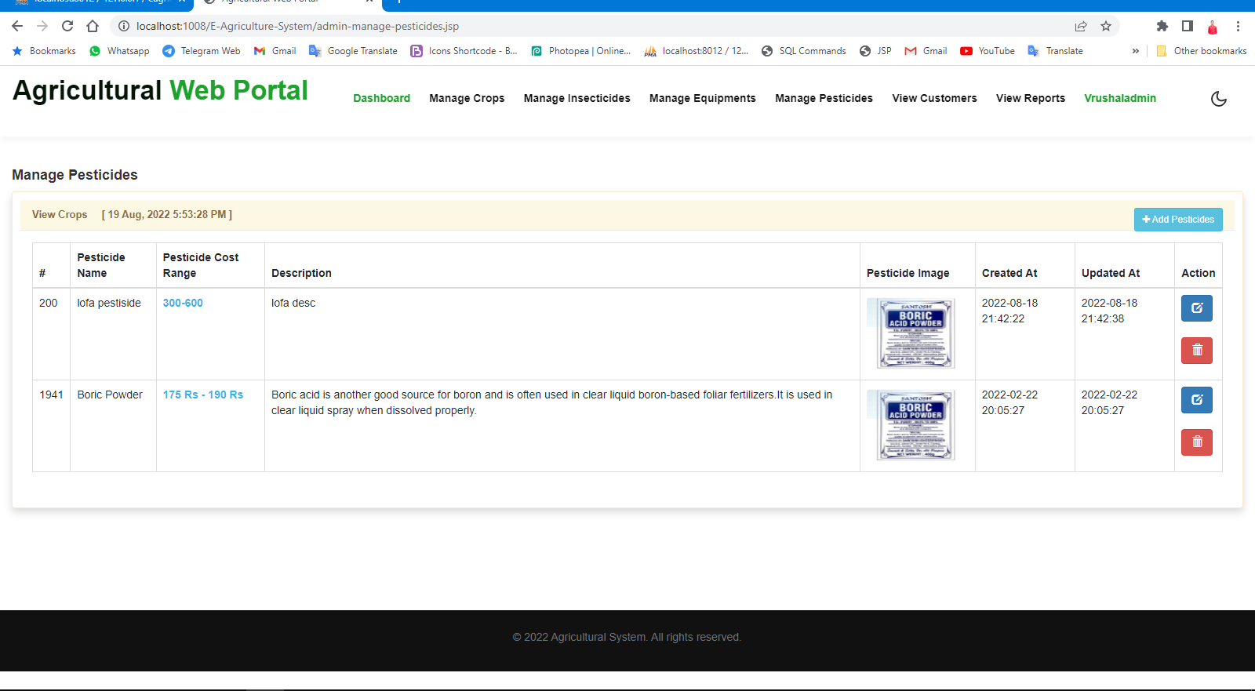

* 1. **Manage Equipment’s**

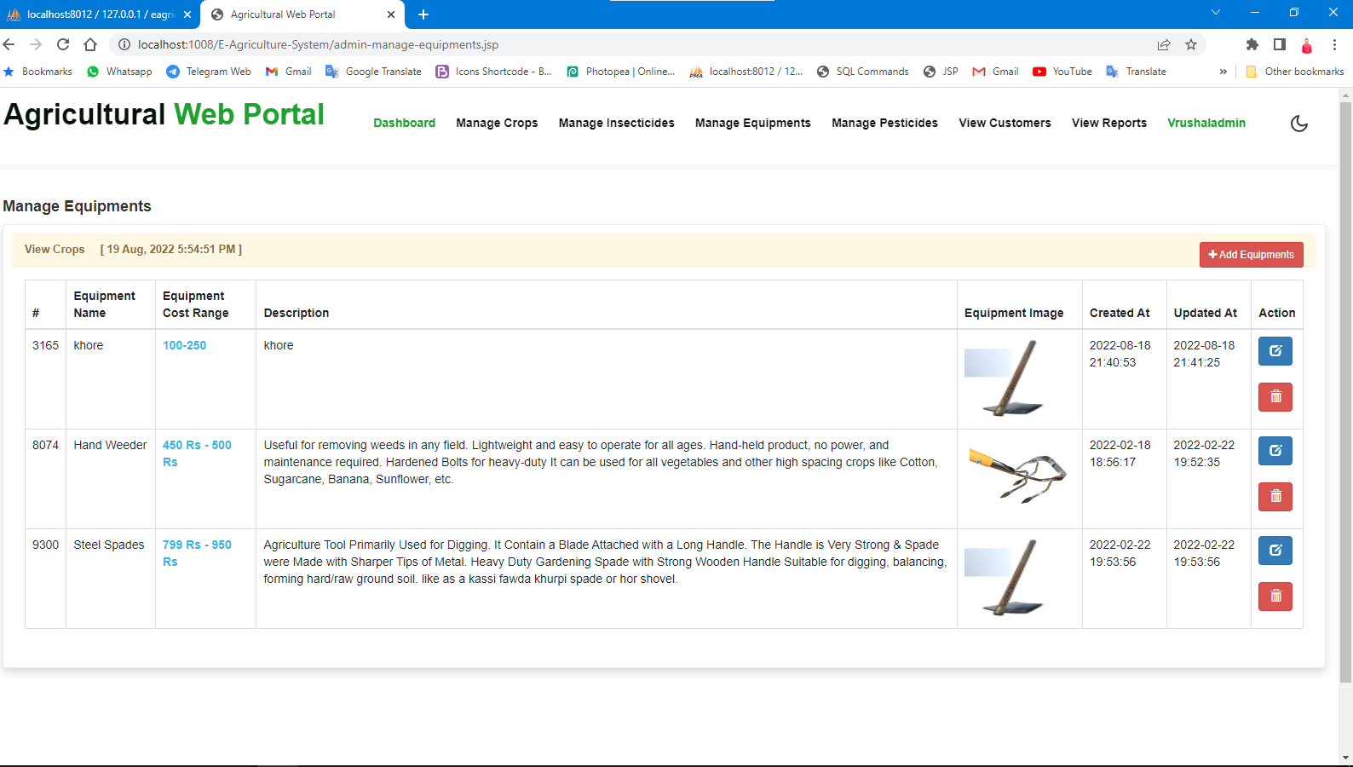

* 1. **View Customers**

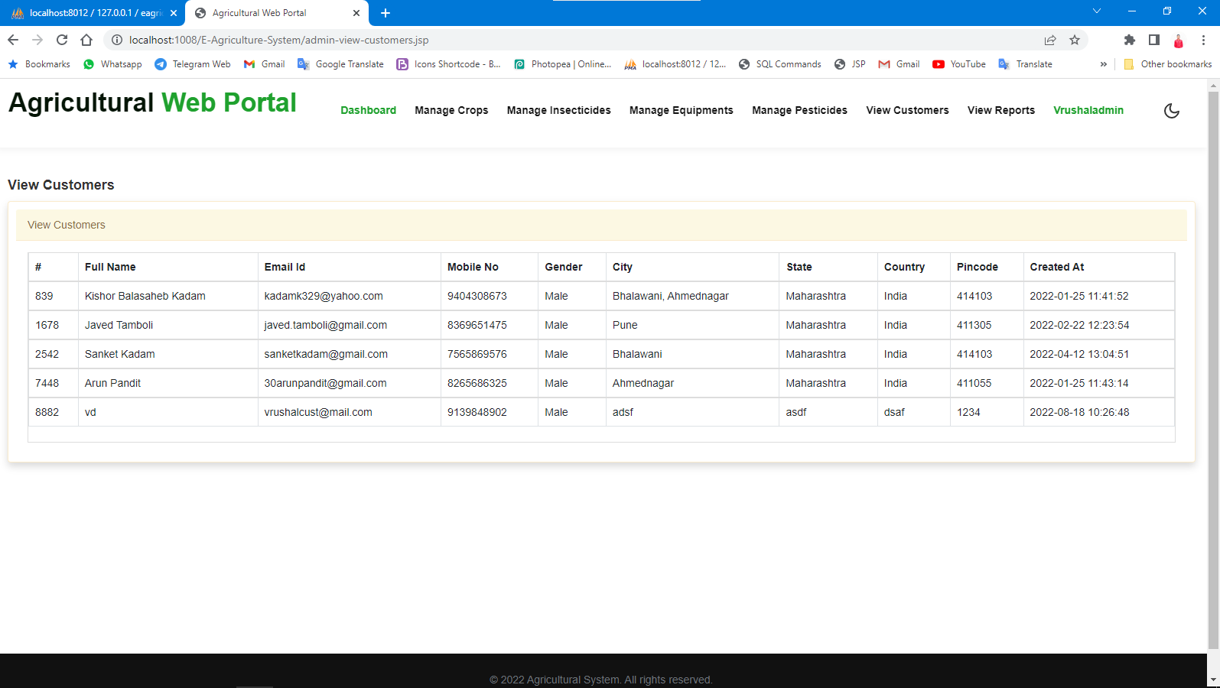

* 1. **View Reports**

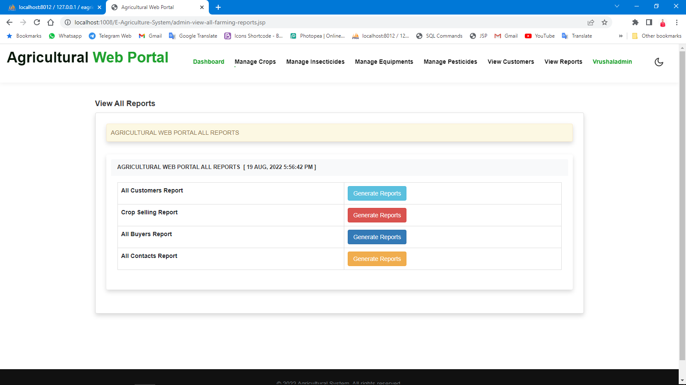

* 1. **View Profile**

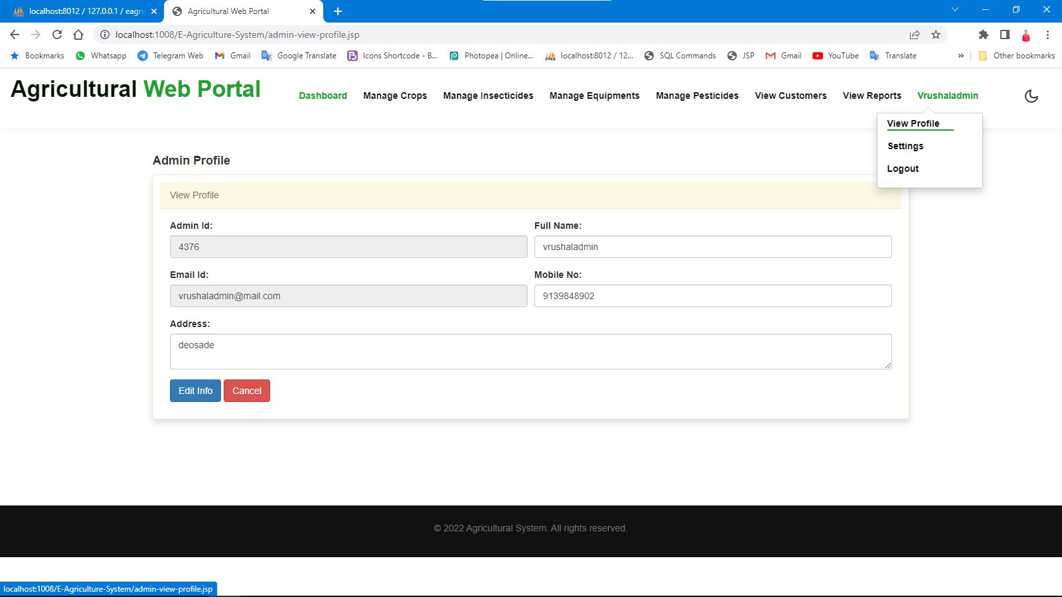

**4. Coding**

<%@ page language=*"java"* contentType=*"text/html; charset=ISO-8859-1"*

pageEncoding=*"ISO-8859-1"*%>

<!doctype html>

<html lang=*"zxx"*>

<head>

<!-- Required meta tags -->

<meta charset=*"utf-8"*>

<meta name=*"viewport"*

content=*"width=device-width, initial-scale=1, shrink-to-fit=no"*>

<title>Agricultural System</title>

<!-- google fonts -->

<link

href=*"//fonts.googleapis.com/css2?family=Poppins:wght@300;600;700&display=swap"*

rel=*"stylesheet"*>

<!-- google fonts -->

<!-- Template CSS -->

<link rel=*"stylesheet"* href=*"assets/css/style-starter.css"*>

<!-- Template CSS -->

</head>

<body>

<!--header-->

<header id=*"site-header"* class=*"fixed-top"*>

<div class=*"container"*>

<jsp:include page=*"design-side-header.jsp"*></jsp:include>

</div>

</header>

<!-- //header -->

<!-- main-slider -->

<section class=*"w3l-main-slider"* id=*"home"*>

<div class=*"companies20-content"*>

<div class=*"owl-one owl-carousel owl-theme"*>

<div class=*"item"*>

<li>

<div class=*"slider-info banner-view bg bg2"*>

<div class=*"banner-info"*>

<div class=*"container"*>

<div class=*"banner-info-bg text-left"*>

<p>Good Food</p>

<h6>Bringing growth, ingenuity, and experience to market.</h6>

</div>

</div>

</div>

<div class=*"banhny-w3grids"*>

<div class=*"banhny-w3grids-1"*>

<img src=*"assets/images/banner1.jpg"*

class=*"img-curve img-fluid"* alt=*""* />

<h4>

<a href=*"#"* class=*"hnys-title"*>Organic Fertilizers</a>

</h4>

</div>

<div class=*"banhny-w3grids-1"*>

<img src=*"assets/images/banner2.jpg"*

class=*"img-curve img-fluid"* alt=*""* />

<h4>

<a href=*"#"* class=*"hnys-title"*>Expert & Professional Farm</a>

</h4>

</div>

</div>

</div>

</li>

</div>

<div class=*"item"*>

<li>

<div class=*"slider-info banner-view banner-top1 bg bg2"*>

<div class=*"banner-info"*>

<div class=*"container"*>

<div class=*"banner-info-bg text-left"*>

<p>Good Food</p>

<h6>Feeding the world, caring for the Earth.</h6>

</div>

</div>

</div>

<div class=*"banhny-w3grids"*>

<div class=*"banhny-w3grids-1"*>

<img src=*"assets/images/banner3.jpg"*

class=*"img-curve img-fluid"* alt=*""* />

<h4>

<a href=*"#"* class=*"hnys-title"*>Agricultural Products</a>

</h4>

</div>

<div class=*"banhny-w3grids-1"*>

<img src=*"assets/images/banner4.jpg"*

class=*"img-curve img-fluid"* alt=*""* />

<h4>

<a href=*"#"* class=*"hnys-title"*>Fresh Dairy Products</a>

</h4>

</div>

</div>

</div>

</li>

</div>

<div class=*"item"*>

<li>

<div class=*"slider-info banner-view banner-top2 bg bg2"*>

<div class=*"banner-info"*>

<div class=*"container"*>

<div class=*"banner-info-bg text-left"*>

<p>Good Food</p>

<h6>Food, water, and energy for a hungry world</h6>

</div>

</div>

</div>

<div class=*"banhny-w3grids"*>

<div class=*"banhny-w3grids-1"*>

<img src=*"assets/images/banner1.jpg"*

class=*"img-curve img-fluid"* alt=*""* />

<h4>

<a href=*"#"* class=*"hnys-title"*>Organic Fertilizers</a>

</h4>

</div>

<div class=*"banhny-w3grids-1"*>

<img src=*"assets/images/banner2.jpg"*

class=*"img-curve img-fluid"* alt=*""* />

<h4>

<a href=*"#"* class=*"hnys-title"*>Expert & Professional Farm</a>

</h4>

</div>

</div>

</div>

</li>

</div>

<div class=*"item"*>

<li>

<div class=*"slider-info banner-view banner-top3 bg bg2"*>

<div class=*"banner-info"*>

<div class=*"container"*>

<div class=*"banner-info-bg text-left"*>

<p>Good Food</p>

<h6>Experience them real agricultural</h6>

</div>

</div>

</div>

<div class=*"banhny-w3grids"*>

<div class=*"banhny-w3grids-1"*>

<img src=*"assets/images/banner3.jpg"*

class=*"img-curve img-fluid"* alt=*""* />

<h4>

<a href=*"#"* class=*"hnys-title"*>Organic Fertilizers</a>

</h4>

</div>

<div class=*"banhny-w3grids-1"*>

<img src=*"assets/images/banner4.jpg"*

class=*"img-curve img-fluid"* alt=*""* />

<h4>

<a href=*"#"* class=*"hnys-title"*>Expert & Professional Farm</a>

</h4>

</div>

</div>

</div>

</li>

</div>

</div>

</div>

</section>

<!-- /main-slider -->

<!--/grids-->

<section class=*"w3l-grids-3 py-5"* id=*"about"*>

<div class=*"container py-md-5"*>

<div class=*"row bottom-ab-grids align-items-center"*>

<div class=*"col-lg-6 bottom-ab-left pr-lg-5"*>

<h6 class=*"sub-title"*>About Us</h6>

<h3 class=*"hny-title"*>A New Way To Invest In Agriculture</h3>

<p class=*"my-3 pr-lg-4"*>The Agricultural web portal to override

the problems prevailing in the practicing manual system. This

software is supported to eliminate and in some cases reduce the

hardships faced by this existing system. Moreover this system is

designed for the particular need of the company to carry out

operations in a smooth and effective manner.</p>

<a href=*"about.jsp"* class=*"btn btn-style btn-secondary mt-4"*>Read

More</a>

</div>

<div class=*"col-lg-6 bottom-ab-right mt-lg-0 mt-5"*>

<img src=*"assets/images/banner1.jpg"* class=*"img-curve img-fluid"*

alt=*""* />

</div>

</div>

</div>

</section>

<!--//grids-->

<!--/services-->

<section class=*"w3l-services1"*>

<div id=*"content-with-photo4-block"* class=*"py-5"*>

<div class=*"container py-md-5"*>

<div class=*"cwp4-two row"*>

<div class=*"cwp4-image col-lg-6 pr-lg-5 mb-lg-0 mb-5"*>

<img src=*"assets/images/banner2.jpg"* class=*"img-fluid"* alt=*""* />

</div>

<div class=*"cwp4-text col-lg-6"*>

<h6 class=*"sub-title"*>What We Do</h6>

<h3 class=*"hny-title"*>What We Offer for You</h3>

<p>Successful agricultural transformations.</p>

<ul class=*"cont-4"*>

<li><span class=*"fa fa-check"*></span> Prioritized and

differentiated strategies</li>

<li><span class=*"fa fa-check"*></span> Market-driven

opportunities for farmers</li>

<li><span class=*"fa fa-check"*></span> Change agents

identified and mobilized</li>

<li><span class=*"fa fa-check"*></span> Finding the right

starting points for scale</li>

<li><span class=*"fa fa-check"*></span> Progress on enabling

policies</li>

</ul>

</div>

</div>

</div>

</div>

</section>

<!--//services-->

<!--/grids-->

<!--//grids-->

<!--/grids2-->

<section class=*"w3l-how-grids-3 py-5"* id=*"how"*>

<div class=*"container py-md-5"*>

<div class=*"w3l-header mb-md-9 mb-9"*>

<h6 class=*"sub-title"*>Healthy food</h6>

<h4>We provide high-quality organic products</h4>

</div>

<br>

<div class=*"row bottom-ab-grids align-items-center"*>

<div class=*"col-lg-4 bottom-ab-left"*>

<div class=*"grdhny-info"*>

<img src=*"assets/images/g1.jpg"* class=*"img-curve img-fluid"* alt=*""* />

<h4>

<a href=*"#"* class=*"hnys-title"*>Industry Oriented</a>

</h4>

<p class=*"mt-2"*>Industrial agriculture is a form of modern

farming that refers to the industrialized production of crops and

animals and animal products like eggs or milk.</p>

</div>

</div>

<div class=*"col-lg-4 bottom-ab-right my-lg-0 my-5"*>

<div class=*"grdhny-info"*>

<img src=*"assets/images/g2.jpg"* class=*"img-curve img-fluid"* alt=*""* />

<h4>

<a href=*"#"* class=*"hnys-title"*>Fresh Vegetables</a>

</h4>

<p class=*"mt-2"*>Most fresh vegetables are low in calories and

have a water content in excess of 70 percent, with only about 3.5

percent protein and less than 1 percent fat.</p>

</div>

</div>

<div class=*"col-lg-4 bottom-ab-right"*>

<div class=*"grdhny-info"*>

<img src=*"assets/images/g3.jpg"* class=*"img-curve img-fluid"* alt=*""* />

<h4>

<a href=*"#"* class=*"hnys-title"*>Fresh Milk</a>

</h4>

<p class=*"mt-2"*>Fresh milk in your diet each day can help you

maintain muscle mass, strengthen your bones, support a favorable

body composition and improve your circulatory health.</p>

</div>

</div>

</div>

</div>

</section>

<!--//grids2-->

<!-- stats -->

<section class=*"w3l-stats py-5"* id=*"stats"*>

<div class=*"gallery-inner container py-lg-0 py-3"*>

<div class=*"row stats-con pb-lg-3"*>

<div class=*"col-lg-4 col-6 stats_info counter_grid"*>

<p class=*"counter"*>730</p>

<h4>Custom Products</h4>

</div>

<div class=*"col-lg-4 col-6 stats_info counter_grid1"*>

<p class=*"counter"*>680</p>

<h4>Our Farms</h4>

</div>

<div class=*"col-lg-4 col-6 stats_info counter_grid mt-lg-0 mt-5"*>

<p class=*"counter"*>812</p>

<h4>Happy Customers</h4>

</div>

</div>

</div>

</section>

<!-- //stats -->

<!--/w3l-bottom-->

<section class=*"w3l-bottom py-5"*>

<div class=*"container py-md-4 py-3 text-center"*>

<div class=*"row my-lg-4 mt-4"*>

<div class=*"col-lg-9 col-md-10 ml-auto"*>

<div class=*"subscribe ml-auto"*>

<div class=*"header-section text-left"*>

<h3 class=*"hny-title two"*>

Agricultural <span> System</span>

</h3>

</div>

</div>

</div>

</div>

</div>

</section>

<!--//w3l-bottom-->

<!-- testimonials -->

<section class=*"w3l-clients"* id=*"clients"*>

<!-- /grids -->

<div class=*"cusrtomer-layout py-5"*>

<div class=*"container py-lg-4 py-md-3 pb-lg-0"*>

<div class=*"heading text-center mx-auto"*>

<h3 class=*"hny-title mb-md-5 mb-4"*>Our customers do the

talking</h3>

</div>

<!-- /grids -->

<div class=*"testimonial-width mt-5"*>

<div id=*"owl-demo1"* class=*"owl-two owl-carousel owl-theme"*>

<div class=*"item"*>

<div class=*"testimonial-content"*>

<div class=*"testimonial"*>

<blockquote>

<span class=*"fa fa-quote-left"* aria-hidden=*"true"*></span>

Thank you for fantastic information web-portal for the

farmers. Would definately recommend to anyone.

</blockquote>

<div class=*"testi-des"*>

<div class=*"test-img"*>

<img src=*"assets/images/c1.jpg"* class=*"img-fluid"*

alt=*"client-img"*>

</div>

<div class=*"peopl align-self"*>

<h3>Sunil Pawar</h3>

</div>

</div>

</div>

</div>

</div>

<div class=*"item"*>

<div class=*"testimonial-content"*>

<div class=*"testimonial"*>

<blockquote>

<span class=*"fa fa-quote-left"* aria-hidden=*"true"*></span> The

platform was great with for the farmers.

</blockquote>

<div class=*"testi-des"*>

<div class=*"test-img"*>

<img src=*"assets/images/c2.jpg"* class=*"img-fluid"*

alt=*"client-img"*>

</div>

<div class=*"peopl align-self"*>

<h3>Adi Pawar</h3>

</div>

</div>

</div>

</div>

</div>

<div class=*"item"*>

<div class=*"testimonial-content"*>

<div class=*"testimonial"*>

<blockquote>

<span class=*"fa fa-quote-left"* aria-hidden=*"true"*></span> Now

a days, changing the farmers view of farming.

</blockquote>

<div class=*"testi-des"*>

<div class=*"test-img"*>

<img src=*"assets/images/c3.jpg"* class=*"img-fluid"*

alt=*"client-img"*>

</div>

<div class=*"peopl align-self"*>

<h3>Kishor Kadam</h3>

</div>

</div>

</div>

</div>

</div>

</div>

</div>

</div>

<!-- /grids -->

</div>

<!-- //grids -->

</section>

<!-- //testimonials -->

<!--/w3l-footer-29-main-->

<jsp:include page=*"./footer.jsp"*></jsp:include>

<section class=*"w3l-footer-29-main w3l-copyright"*>

<div class=*"container"*>

<div class=*"bottom-copies"*>

<p class=*"copy-footer-29 text-center"*>© 2022 Agricultural

System. All rights reserved. | Developed By- Darkunde Vrushal</p>

</div>

</div>

<!-- move top -->

<button onclick="topFunction()" id=*"movetop"* title=*"Go to top"*>

<span class=*"fa fa-angle-up"*></span>

</button>

<script>

// When the user scrolls down 20px from the top of the document, show the button

window.onscroll = **function**() {

scrollFunction()

};

**function** scrollFunction() {

**if** (document.body.scrollTop > 20

|| document.documentElement.scrollTop > 20) {

document.getElementById("movetop").style.display = "block";

} **else** {

document.getElementById("movetop").style.display = "none";

}

}

// When the user clicks on the button, scroll to the top of the document

**function** topFunction() {

document.body.scrollTop = 0;

document.documentElement.scrollTop = 0;

}

</script>

<!-- /move top -->

</section>

<!-- //footer-29 block -->

<!-- disable body scroll which navbar is in active -->

<script>

$(**function**() {

$('.navbar-toggler').click(**function**() {

$('body').toggleClass('noscroll');

})

});

</script>

<!-- disable body scroll which navbar is in active -->

<!-- Template JavaScript -->

<script src=*"assets/js/jquery-3.3.1.min.js"*></script>

<script src=*"assets/js/theme-change.js"*></script>

<script src=*"assets/js/owl.carousel.js"*></script>

<!-- script for banner slider-->

<script>

$(document).ready(**function**() {

$('.owl-one').owlCarousel({

loop : **true**,

margin : 0,

nav : **false**,

responsiveClass : **true**,

autoplay : **true**,

autoplayTimeout : 5000,

autoplaySpeed : 1000,

autoplayHoverPause : **false**,

responsive : {

0 : {

items : 1,

nav : **false**

},

480 : {

items : 1,

nav : **false**

},

667 : {

items : 1,

nav : **true**

},

1000 : {

items : 1,

nav : **true**

}

}

})

})

</script>

<!-- //script -->

<!-- script for tesimonials carousel slider -->

<script>

$(document).ready(**function**() {

$("#owl-demo1").owlCarousel({

loop : **true**,

margin : 20,

nav : **false**,

responsiveClass : **true**,

responsive : {

0 : {

items : 1,

nav : **false**

},

736 : {

items : 2,

nav : **false**

},

1000 : {

items : 3,

nav : **false**,

loop : **true**

}

}

})

})

</script>

<!-- //script for tesimonials carousel slider -->

<!-- stats number counter-->

<script src=*"assets/js/jquery.waypoints.min.js"*></script>

<script src=*"assets/js/jquery.countup.js"*></script>

<script>

$('.counter').countUp();

</script>

<!-- //stats number counter -->

<!--/MENU-JS-->

<script>

$(window).on("scroll", **function**() {

**var** scroll = $(window).scrollTop();

**if** (scroll >= 80) {

$("#site-header").addClass("nav-fixed");

} **else** {

$("#site-header").removeClass("nav-fixed");

}

});

//Main navigation Active Class Add Remove

$(".navbar-toggler").on("click", **function**() {

$("header").toggleClass("active");

});

$(document).on("ready", **function**() {

**if** ($(window).width() > 991) {

$("header").removeClass("active");

}

$(window).on("resize", **function**() {

**if** ($(window).width() > 991) {

$("header").removeClass("active");

}

});

});

</script>

<!--//MENU-JS-->

<script src=*"assets/js/bootstrap.min.js"*></script>

</body>

</html>