MINI PROJECT REPORT
on
DIGITAL WALLET MANAGEMENT SYSTEM

Subject: C++ Programming (Object-Oriented Programming)
Course: Electronics and Computer Engineering (Second Year)

1. Project Title and Description
Project Title | Digital Wallet Management System
Subject | C++ Programming
Course | Electronics and Computer Engineering (Second Year)
College | Walchand Institute of Technology
Guided by | Prof. Meenakshi Shreegandhi

Project Description
- The Digital Wallet Management System is a menu-driven C++ console application that simulates an online e-wallet.
- The user can create a Normal Wallet or a Premium Wallet with an opening balance.
- Money can be added directly or from a source such as a bank account or card.
- Payments can be made to a receiver; the system checks for sufficient balance, and the Premium Wallet gives 2% cashback on every successful payment.
- The current balance can be checked at any time.
- A complete transaction history (type, amount and balance after each transaction) can be displayed.
- A wallet summary shows the wallet ID, owner name, balance and total wallets created.
- Real-life use: such systems are the basis of popular digital payment applications like Paytm, PhonePe, Google Pay, Amazon Pay and mobile banking wallets, used for recharges, bill payments, online shopping and money transfers.

Concepts Used in the Project

Classes and Objects
A class is a user-defined blueprint that bundles data members and member functions; an object is an instance of that class created in memory.
Used in this project: The class Wallet holds the owner name, wallet ID, balance and transaction arrays together with functions such as addMoney(), makePayment() and showTransactions(). PremiumWallet is a second class, and objects of both are created when the user creates a wallet.

Encapsulation (protected members)
Encapsulation wraps data and the functions that operate on it into one unit and restricts direct access to the data using access specifiers. The protected specifier hides members from outside code but keeps them accessible to derived classes.
Used in this project: The data members owner, walletId, balance, the transaction arrays, tCount and the helper function record() are declared protected in Wallet, so main() cannot change the balance directly; it must use public functions. PremiumWallet can still access them.

Constructor
A constructor is a special member function with the same name as the class that runs automatically when an object is created and is used to initialise its data.
Used in this project: Wallet(string name, double initial) sets the owner, balance and transaction count, increments totalWallets, assigns walletId and records the opening balance. PremiumWallet(string, double) calls the base-class constructor through an initialiser list.

Virtual Destructor
A destructor is called when an object is destroyed. When a base-class pointer refers to a derived-class object, the destructor must be virtual so that the correct destructor chain executes during delete.
Used in this project: virtual ~Wallet() {} is declared in Wallet, so delete w in main() safely destroys either a Wallet or a PremiumWallet object through the base-class pointer.

Static Data Member and Static Member Function
A static data member is shared by all objects of a class and exists once per class, not once per object. A static member function can be called without an object and can access only static members.
Used in this project: static int totalWallets counts the wallets created and is defined outside the class as int Wallet::totalWallets = 0;. The static function getTotalWallets() returns this value and is called as Wallet::getTotalWallets() in the wallet summary.

Function Overloading
Function overloading allows several functions with the same name but different parameter lists in the same scope; the compiler selects the correct one from the arguments supplied.
Used in this project: addMoney(double amt) adds money directly, while addMoney(double amt, string source) adds money from a source such as a bank or card and records the source in the transaction history.

Inheritance
Inheritance lets a new (derived) class acquire the properties and behaviour of an existing (base) class, promoting code reuse and extension.
Used in this project: PremiumWallet is publicly derived from Wallet (class PremiumWallet : public Wallet). It reuses all wallet features and adds only the cashback behaviour.

Polymorphism / Virtual Function
Polymorphism means "many forms". With a virtual function, the version of the function that is called is decided at run time from the actual type of the object, not from the pointer type (run-time polymorphism / function overriding).
Used in this project: makePayment() is virtual in Wallet and overridden in PremiumWallet. The call w->makePayment(amt, to) in main() runs the normal version for a Normal wallet and the premium version, which adds 2% cashback, for a Premium wallet.

Friend Function
A friend function is not a member of a class but is allowed to access its private and protected members when declared with the friend keyword.
Used in this project: friend void showSummary(Wallet &w); can read walletId, owner and balance directly, and is used to print the wallet summary (option 6 of the menu).

Inline Function
An inline function asks the compiler to substitute the function body at the call site, which avoids call overhead for short functions.
Used in this project: inline double getBalance() returns the balance and is used for the "Check Balance" option.

Arrays (transaction history)
An array stores a fixed number of elements of the same type in contiguous memory, accessed using an index.
Used in this project: The arrays tType[100], tAmt[100] and tBal[100] store the type, amount and resulting balance of up to 100 transactions, and tCount keeps the number of entries. A for loop in showTransactions() displays them.

Dynamic Memory Allocation (new / delete) and Base-class Pointer
The new operator allocates memory at run time and delete releases it. A base-class pointer can hold the address of a derived-class object, which is the basis for run-time polymorphism.
Used in this project: Wallet *w = NULL; is declared in main(). Depending on the user's choice, w = new PremiumWallet(name, initial) or w = new Wallet(name, initial) is executed, and delete w; frees the memory before the program ends.

Control Structures (do-while loop, switch-case, if-else)
Control structures decide the order in which statements execute: if-else for decisions, switch-case for multi-way selection and do-while for loops that execute at least once.
Used in this project: A do-while loop keeps the menu running until the user chooses 7 (Exit); a switch-case handles the seven menu options; if-else statements check for insufficient balance, wallet type, add-money mode and whether a wallet has already been created.

Input/Output Streams (cin / cout)
The iostream library provides cin for reading input from the keyboard and cout for displaying output on the screen using the extraction (>>) and insertion (<<) operators.
Used in this project: cout prints the menu, messages and transaction details, while cin reads the menu choice, owner name, amounts, receiver name and source name.

2. Objectives
- To enhance programming skills in C++.
- To build a real-world project that tests the concepts learnt in the subject.
- To apply Object-Oriented Programming principles: encapsulation, inheritance, polymorphism and abstraction.
- To improve logical thinking and problem-solving ability.
- To understand modular and reusable code design.
- To learn menu-driven program development.
- To gain hands-on experience in debugging and testing.
- To understand how dynamic memory, pointers and virtual functions work together in a larger program.
- To practise writing clean, readable and well-structured code.
- To develop teamwork, planning and documentation skills.
- To prepare for advanced software development.

3. Methodology / Working
The program follows the step-by-step flow shown below. The user repeatedly chooses options from the main menu until Exit is selected.

Program Flow
1 | Start | The program begins execution and the wallet pointer is set to NULL (no wallet exists yet).
↓
2 | Main Menu | A do-while loop displays the seven-option menu and reads the user's choice.
↓
3 | Create Wallet (Normal / Premium) | The user enters name, initial amount and type; a Wallet or PremiumWallet object is created with new.
↓
4 | Add Money | Money is added directly or from a source (bank/card) using the overloaded addMoney() function.
↓
5 | Make Payment | Balance is checked first; on success the amount is deducted, and a Premium wallet adds 2% cashback.
↓
6 | Check Balance | The inline getBalance() function displays the current balance.
↓
7 | Transaction History | All recorded transactions with their amounts and running balance are listed.
↓
8 | Wallet Summary | The friend function showSummary() prints wallet ID, owner, balance and total wallets.
↓
9 | Exit | The loop ends, the wallet object is deleted and a thank-you message is shown.

Normal Wallet vs Premium Wallet
Feature | Normal Wallet | Premium Wallet
Class used | Wallet (base class) | PremiumWallet (derived class)
Created by choosing | Wallet type 1 | Wallet type 2
Add money / balance / history | Supported | Supported (inherited)
Payment with balance check | Yes | Yes
Cashback on payment | No cashback | 2% cashback on every successful payment
makePayment() version | Wallet::makePayment() | PremiumWallet::makePayment() (overrides)
Example (pay Rs. 400) | Balance reduces by Rs. 400 | Balance reduces by Rs. 400, then Rs. 8 is credited

4. Source Code
#include <iostream>
#include <string>
using namespace std;

class Wallet {
protected:
string owner;
int walletId;
double balance;
string tType[100];
double tAmt[100];
double tBal[100];
int tCount;
static int totalWallets; // static member

void record(string type, double amt) {
if (tCount < 100) {
tType[tCount] = type;
tAmt[tCount] = amt;
tBal[tCount] = balance;
tCount++;
}
}

public:
// Constructor
Wallet(string name, double initial) {
owner = name;
balance = initial;
tCount = 0;
totalWallets++;
walletId = 1000 + totalWallets;
if (initial > 0)
record("Opening Balance", initial);
}

virtual ~Wallet() {}

// Function overloading
void addMoney(double amt) {
balance += amt;
record("Added Money", amt);
cout << "Rs. " << amt << " added successfully.\n";
}

void addMoney(double amt, string source) {
balance += amt;
record("Added from " + source, amt);
cout << "Rs. " << amt << " added from " << source << " successfully.\n";
}

// Virtual function (polymorphism)
virtual bool makePayment(double amt, string to) {
if (amt > balance) {
cout << "Insufficient balance! Payment failed.\n";
return false;
}
balance -= amt;
record("Paid to " + to, amt);
cout << "Payment of Rs. " << amt << " to " << to << " successful.\n";
return true;
}

// Inline function
inline double getBalance() {
return balance;
}

void showTransactions() {
if (tCount == 0) {
cout << "No transactions yet.\n";
return;
}
cout << "\n--- Transaction Details ---\n";
for (int i = 0; i < tCount; i++) {
cout << i + 1 << ". " << tType[i]
<< " | Amount: Rs. " << tAmt[i]
<< " | Balance: Rs. " << tBal[i] << endl;
}
}

static int getTotalWallets() {
return totalWallets;
}

// Friend function
friend void showSummary(Wallet &w);
};

int Wallet::totalWallets = 0;

// Inheritance: Premium wallet gives 2% cashback on payments
class PremiumWallet : public Wallet {
public:
PremiumWallet(string name, double initial) : Wallet(name, initial) {}

bool makePayment(double amt, string to) {
if (Wallet::makePayment(amt, to)) {
double cashback = amt * 0.02;
balance += cashback;
record("Cashback", cashback);
cout << "Cashback of Rs. " << cashback << " received.\n";
return true;
}
return false;
}
};

void showSummary(Wallet &w) {
cout << "\n--- Wallet Summary ---\n";
cout << "Wallet ID : " << w.walletId << endl;
cout << "Owner : " << w.owner << endl;
cout << "Balance : Rs. " << w.balance << endl;
cout << "Total Wallets Created: " << Wallet::getTotalWallets() << endl;
}

int main() {
Wallet *w = NULL;
int choice;

do {
cout << "\n===== DIGITAL WALLET MANAGEMENT SYSTEM =====\n";
cout << "1. Create Wallet\n";
cout << "2. Add Money\n";
cout << "3. Make Payment\n";
cout << "4. Check Balance\n";
cout << "5. Display Transaction Details\n";
cout << "6. Wallet Summary\n";
cout << "7. Exit\n";
cout << "Enter choice: ";
cin >> choice;

if (choice >= 2 && choice <= 6 && w == NULL) {
cout << "Please create a wallet first!\n";
continue;
}

switch (choice) {
case 1: {
if (w != NULL) {
cout << "Wallet already created.\n";
break;
}
string name;
double initial;
int type;
cout << "Enter owner name: ";
cin >> name;
cout << "Enter initial amount: ";
cin >> initial;
cout << "Wallet type (1. Normal 2. Premium): ";
cin >> type;
if (type == 2)
w = new PremiumWallet(name, initial);
else
w = new Wallet(name, initial);
cout << "Wallet created successfully!\n";
break;
}
case 2: {
double amt;
int opt;
string source;
cout << "Enter amount: ";
cin >> amt;
cout << "1. Add directly 2. Add from a source (bank/card): ";
cin >> opt;
if (opt == 2) {
cout << "Enter source name: ";
cin >> source;
w->addMoney(amt, source);
} else {
w->addMoney(amt);
}
break;
}
case 3: {
double amt;
string to;
cout << "Enter receiver name: ";
cin >> to;
cout << "Enter amount: ";
cin >> amt;
w->makePayment(amt, to);
break;
}
case 4:
cout << "Current Balance: Rs. " << w->getBalance() << endl;
break;
case 5:
w->showTransactions();
break;
case 6:
showSummary(*w);
break;
case 7:
cout << "Thank you for using Digital Wallet!\n";
break;
default:
cout << "Invalid choice!\n";
}
} while (choice != 7);

delete w;
return 0;
}

5. Output / Results

Output 1: Normal Wallet
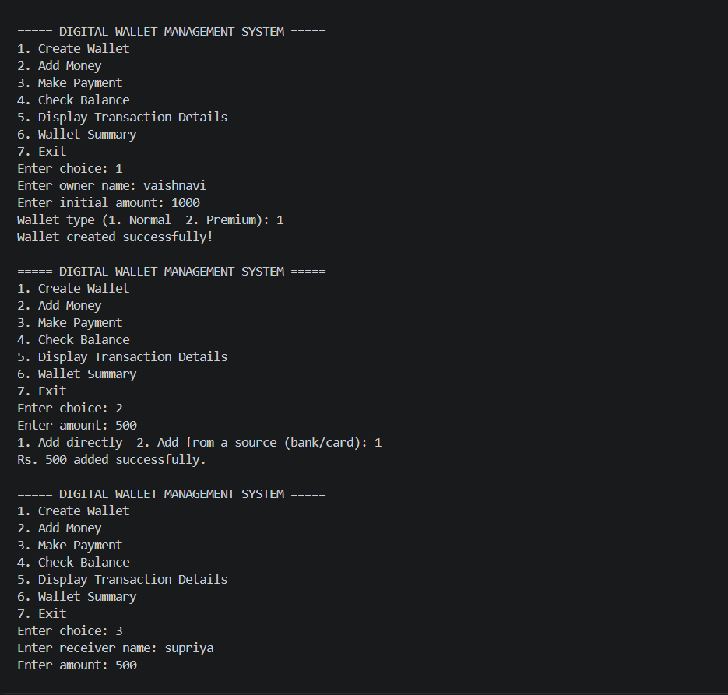
Figure 1: Creating a Normal wallet, adding money and starting a payment
A Normal wallet (type 1) is created for "vaishnavi" with an initial amount of Rs. 1000. Rs. 500 is then added directly, and a payment of Rs. 500 to "supriya" is requested from the menu.
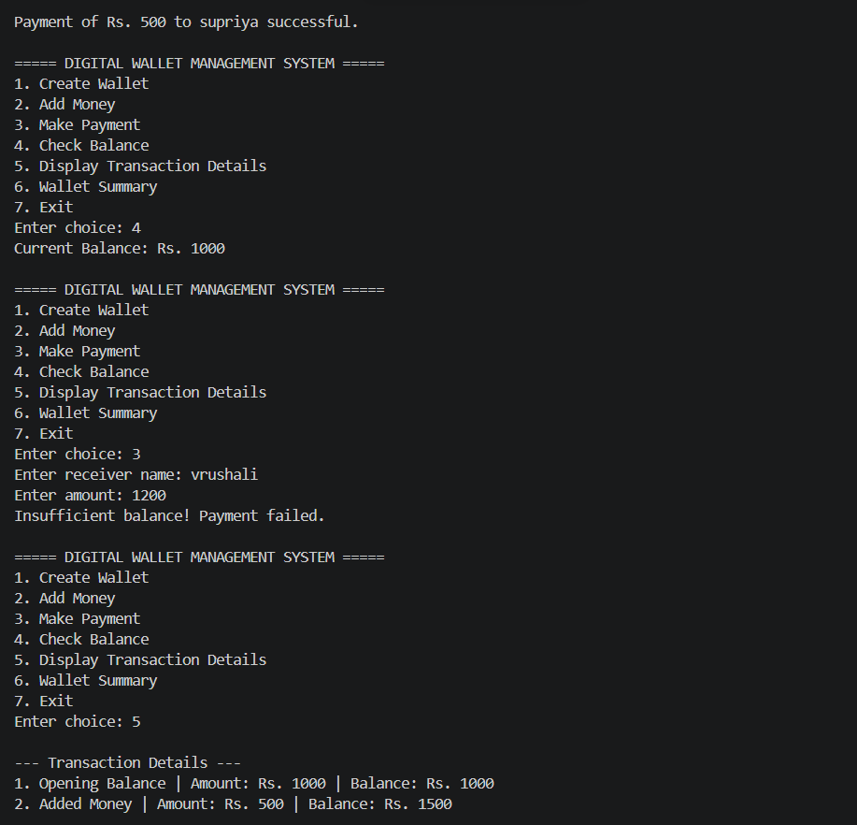
Figure 2: Payment success, balance check, insufficient balance and transaction history
The payment of Rs. 500 succeeds and the balance shows Rs. 1000. A second payment of Rs. 1200 to "vrushali" fails with the message "Insufficient balance! Payment failed." Option 5 then starts displaying the transaction details.
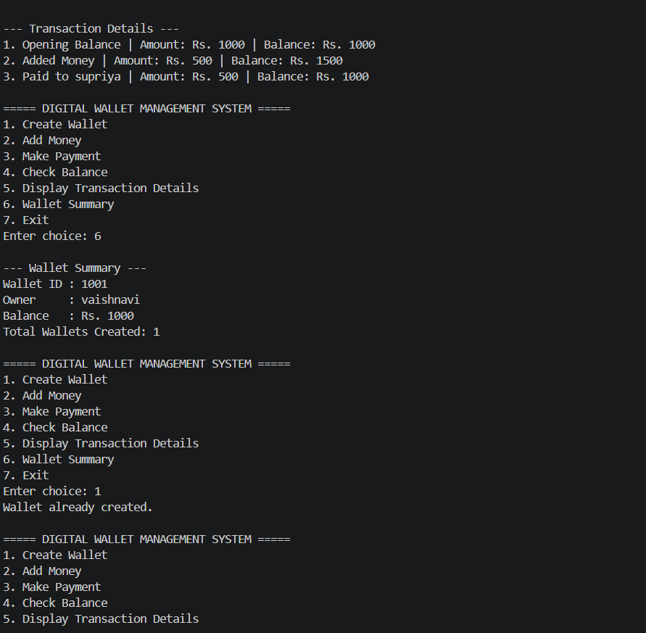
Figure 3: Complete transaction details and wallet summary
The history lists the opening balance, the added money and the payment to "supriya" with the running balance. The summary shows Wallet ID 1001, owner vaishnavi, balance Rs. 1000 and one wallet created. Trying to create another wallet gives "Wallet already created."
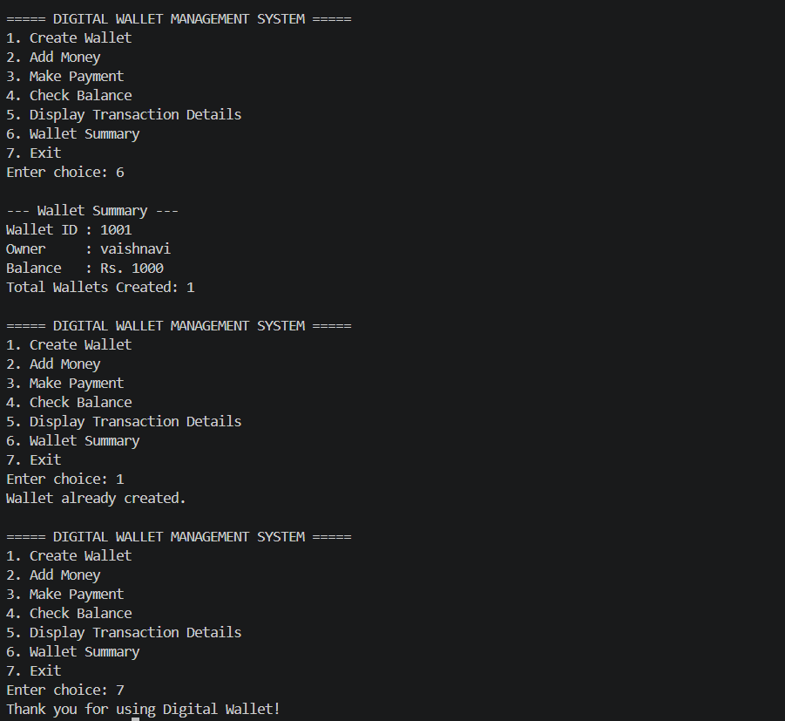
Figure 4: Wallet summary, duplicate wallet check and exit
The wallet summary is displayed again and choosing option 1 once more confirms that only one wallet is allowed at a time. Option 7 ends the program with the message "Thank you for using Digital Wallet!"

Output 2: Premium Wallet
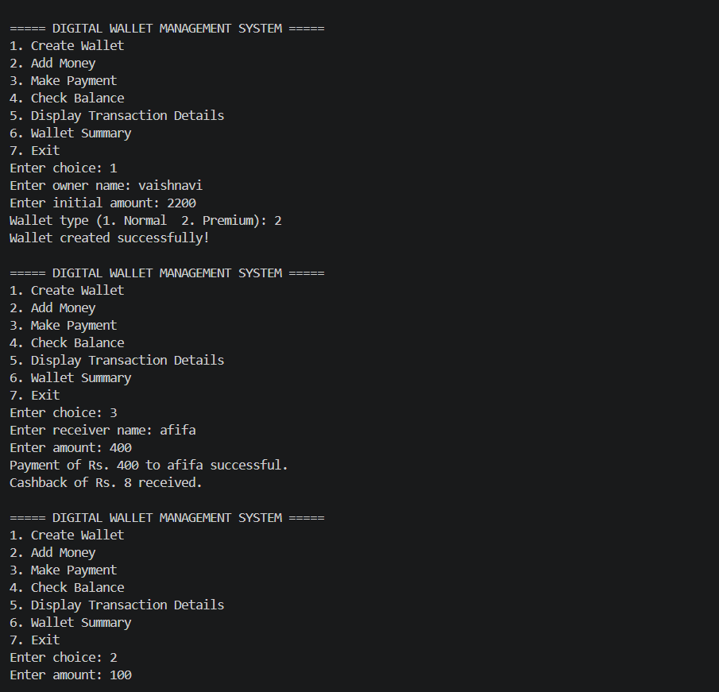
Figure 5: Creating a Premium wallet and making a payment with cashback
A Premium wallet (type 2) is created for "vaishnavi" with Rs. 2200. A payment of Rs. 400 to "afifa" succeeds and the message "Cashback of Rs. 8 received." appears, which is 2% of Rs. 400. The user then chooses to add Rs. 100.
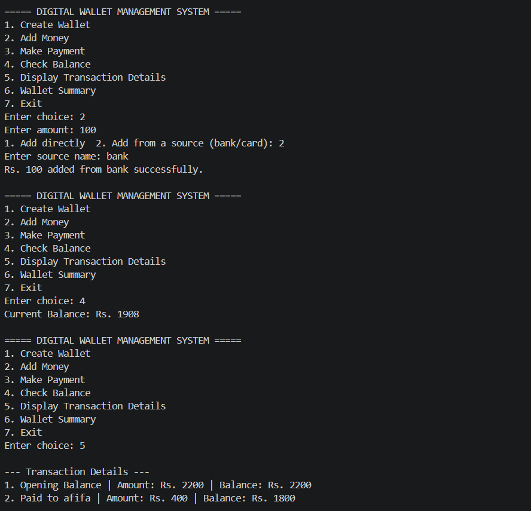
Figure 6: Adding money from a bank, updated balance and transaction history
Rs. 100 is added from the source "bank". The balance is now Rs. 1908 (2200 - 400 + 8 + 100). Option 5 begins listing the transaction history.
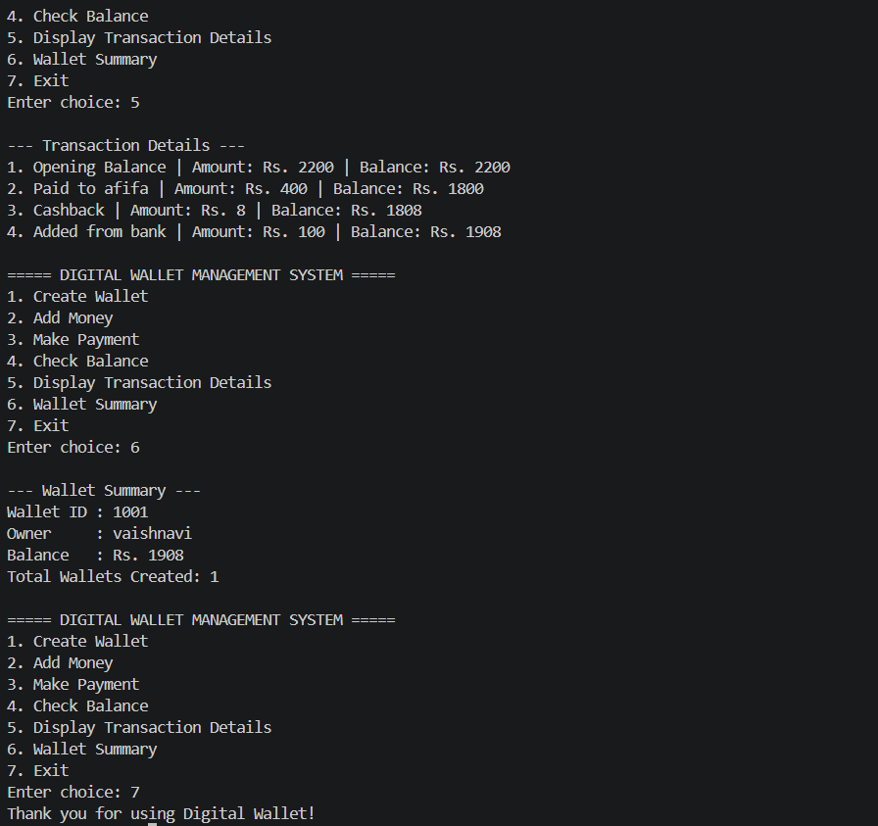
Figure 7: Premium wallet transaction details, summary and exit
The history shows the opening balance, the payment to afifa, a separate "Cashback" entry of Rs. 8 (balance Rs. 1808) and the amount added from the bank (balance Rs. 1908). The summary confirms the final balance of Rs. 1908, and the program exits normally.

6. Conclusion
- The project successfully demonstrates Object-Oriented Programming concepts in a real-world application.
- The Premium wallet shows inheritance and polymorphism clearly through the overridden makePayment() function and the 2% cashback.
- The menu-driven design makes the program simple and user-friendly.
- The project improved our understanding of C++, problem solving and debugging.
- Future scope: file handling for permanent storage of wallet data.
- Future scope: PIN / password security for wallet access.
- Future scope: support for multiple wallets and users.
- Future scope: GUI and database integration for a complete payment application.

