A

Project Report

On

Website For Smartphone company

Submitted

To

**SOLAPUR UNIVERSITY, SOLAPUR**

IN PARTIAL FULFILLMENT OF THE

REQUIREMENT OF

BACHELOR OF COMPUTER APPLICATION

BY

**Vrushali Vikas Valsangkar(3055)**

And

**Priya Santosh Yadav (3058)**

Through

THE PRINCIPAL

HIRACHAND NEMCHAND COLLEGE OF COMMERCE,

SOLAPUR

2024-2025

REPORT SUBMITTED

TO

SOLAPUR UNIVERSITY, SOLAPUR

IN PARTIAL FULFILLMENT OF THE

REQUIREMENT OF

BACHELOR OF COMPUTER APPLICATION

TITLE

**Website For smartphone company**

BY

**Vrushali Vikas Valsangkar (3055)**

And

**Priya Santosh Yadav (3058)**

THE PRINCIPAL

HIRACHAND NEMCHAND COLLEGE OF COMMERCE,

SOLAPUR

2020-21

EXTERNAL EXAMINAR PRINCIPAL

**CERTIFICATE**

**This is to certify that work on the Project Report entitled**

**“ Website for smartphone company” in partial fulfillment of the requirement for**

**the award of BACHELOR OF COMPUTER APPLICATION**

**(B.C.A.)**

**to the Solapur University, Solapur has been carried**

**out under my guidance.**

**To the best of my knowledge and belief the matter presented in**

**this report has not been submitted earlier.**

**Signature of the Guide**

**Date: Signature of the Guide**

**Name :**

**DECLARATION**

**To,**

**The Principal**

**H. N. College Of Commerce**

**Solapur.**

**Dear Sir,**

**I the undersigned hereby declare that Project entitled**

**“Website For Smartphone Company” written and submitted under the guidance of**

**“Mr. Manure sir” is my original work. The empirical**

**findings in this report are based on the data collected by**

**myself. While preparing this report, I have not copied from**

**any other report.**

**We understand that any such copying is liable to be punished**

**in a way the university authorities may deem fit.**

**Date : Signature Of the student**

**Vrushali Vikas Valsangkar (3055)**

**Priya Santosh Yadav (3058)**

**Acknowledgement**

**Before embarking into a detailed explanation of our project**

**on “Website For Smartphone Company” at Our College. We would like to say a few**

**words about the people who helped us to make this project**

**what it is today. We are extremely grateful for the necessary information,**

**support and guidance provided by our principal Dr.S.K.Shah Sir, H.O.D. Dr Pravin bajaj sir and also our lab assistant Tamboli Sir & Dhumal Sir with whom we had several conversations about present system we also want to thank our project guide Mr. Manure sir who gave us a proper guidance for making our project.**

**We are grateful to all of them for their constant**

**encouragement and guidance throughout this project.**

**INDEX**

|  |  |  |
| --- | --- | --- |
| **Chapter**  **no.** | **Particulars** | **Page**  **Number** |
| **1** | **Introduction** | **7** |
| **1.1** | **Introduction to organization** | **7** |
| **1.2** | **Introduction to existing system** | **8** |
| **1.3** | **Objective of proposed system** | **9** |
| **1.4** | **Scope of proposed system** | **10** |
| **1.5** | **Limitations of proposed system** | **11** |
| **2** | **Data Requirement Analysis** | **12** |
| **2.1** | **Fact finding technique** | **12** |
| **2.2** | **Feasibility study** | **13** |
| **2.2.1** | **Technical feasibility** | **13** |
| **2.2.2** | **Economical feasibility** | **13** |
| **2.2.3** | **Operational feasibility** | **14** |
| **2.3** | **Website & hardware requirement** | **15** |
| **2.4** | **Context level** | **16** |
| **2.5** | **Data Flow Diagram** | **17** |
| **2.6** | **Entity Relationship Diagram** | **18** |
| **2.7** | **Data Dictionary** | **19** |
| **2.8** | **Table Design** | **20** |
| **3** | **System Design** | **23** |
| **3.1** | **Site map** | **23** |
| **3.2** | **Screen Layouts** | **24** |
| **3.3** | **Coding** | **28** |
| **4** | **System testing** | **35** |
| **4.1** | **Program Specification & validation** | **35** |
| **4.2** | **Types of testing** | **36** |
| **5** | **Implementation** | **37** |
| **5.1** | **User manual** | **37** |
| **6** | **Conclusion and suggestion** | **38** |
| **6.1** | **Conclusion** | **38** |
| **6.2** | **Enhancement suggestion** | **39** |
| **7** | **Bibliography** | **40** |
| **7.1** | **References** | **40** |

**1.2 Introduction to Existing System**

**In the early days of smartphone eCommerce, several pioneering websites played a crucial role in shaping how we buy and sell mobile devices.**

**Sites like Amazon and eBay were among the first to offer a wide range of smartphones, allowing consumers to compare models, read reviews, and make purchases online.**

**These early eCommerce platforms laid the groundwork for the sophisticated and user-friendly shopping experiences we have today.**

**Exploring these earlier websites provides insight into how the smartphone market has evolved and highlights the key milestones in the development of online shopping for mobile technology.**

**1.3 Objective of proposed systemTop of Form**

**While many existing smartphone eCommerce websites have helped shape online shopping, they often have limitations like outdated designs, confusing navigation, and poor customer support.**

**These issues can make it hard for users to find the right smartphone or get help when needed.**

**In contrast, our smartphone eCommerce website offers a modern, easy-to-use interface with personalized recommendations and up-to-date information.**

**We focus on making the shopping experience smooth and enjoyable, with better customer support and features that simplify finding and buying the perfect smartphone.**

* **User-Friendly Interface:** Create an intuitive and easy-to-navigate design that enhances the shopping experience for users of all skill levels.
* **Personalized Recommendations**: Implement algorithms to offer tailored smartphone suggestions based on user preferences, browsing history, and past purchases.
* **Real-Time Updates:** Ensure that product information, availability, and pricing are always current to provide users with accurate and up-to-date details.
* **One-Click Payment:** Provide a streamlined one-click payment option for returning customers to simplify the checkout process and enhance convenience.

**Top of Form**

**1.4 Scope of proposed system**

**Bottom of Form**

**The proposed eCommerce website for smartphones aims to deliver a user-friendly shopping experience with an intuitive interface, real-time product updates, and secure payment options.**

**It will feature advanced search tools, personalized recommendations, and responsive customer support, all while ensuring a smooth checkout process and global accessibility.**

**1.4 Limitations of proposed system**

**The proposed eCommerce website may face limitations such as technical challenges with integration and scalability, as well as potential issues with real-time updates.**

**Ongoing maintenance will be required to address these challenges and ensure a smooth user experience.**

**Top of Form**

**2.DATA REQUIREMENT ANALYSIS**

**2.1 Fact Finding technique**

**Fact finding technique is the system of methods used as an activity or study  and actually this is decided by the organization. The techniques that we have used  are,**

* **We conducted interviews with stakeholders to understand business goals and objectives.**
* **We performed user interviews to gather insights into customer needs and preferences.**
* **We distributed surveys and questionnaires to collect broader data on user buying behaviours and preferences.**
* **We observed user behaviour through website analytics and studied competitor sites.**
* **We developed prototypes to test designs and gather early user feedback.**
* **We conducted use case analysis to define how users will interact with the site and identify necessary features.**
* **We carried out a SWOT analysis to evaluate strengths, weaknesses, opportunities, and threats for the project.**

**2.2 Feasibility study**

**After doing the project Lap-Mart System, study and analyzing all the**

**existing or required functionalities of the system, the next task is to do the**

**feasibility study for the project. All projects are feasible - given unlimited**

**resources and infinite time.**

**Feasibility study includes consideration of all the possible ways to provide**

**a solution to the given problem. The proposed solution should satisfy all the user**

**requirements and should be flexible enough so that future changes can be easily**

**done based on the future upcoming requirements.**

**2.2.1 Technical feasibility**

**This included the study of function, performance and constraints that may affect the ability to achieve an acceptable system. For this feasibility study, we studied complete functionality to be provided in the system, as described in the System Requirement Specification (SRS), and checked if everything was possible using different type of frontend platforms.**

**2.2.2 Economical feasibility**

**This is a very important aspect to be considered while developing a project.**

**We decided the technology based on minimum possible cost factor.**

**• All hardware and website cost has to be borne by the organization.**

**• Overall, we have estimated that the benefits the organization is going to**

**receive from the proposed system millinery, the initial costs and the later**

**on.**

**2.2.3 Operational feasibility**

**No doubt the proposed system is fully GUI based that is very user friendly and all inputs to be taken all self-explanatory even to a layman. Besides, a proper training has been conducted to let know the essence of the system to the users so that they feel comfortable with new system. As far our study is concerned the clients are comfortable and happy as the system has cut down their loads and doing.**

**2.3 Website and Hardware requirement**

**The following website and hardware are required for my application:**

**Minimum Hardware:**

**• Any Web-Enabled Device.**

**Minimum Website:**

**• Web Browser.**

**Other Requirement:**

**• Internet connection is a must.**

**2.4 Context Level**

Login/register

View phones

Admin

User

Bo Boo Book phones login

Booking details

Phone details

Make payment

Order confirmed

Bottom of Form

**2.5 Data Flow Diagram**

Admin

**3.2 Screen Layout**

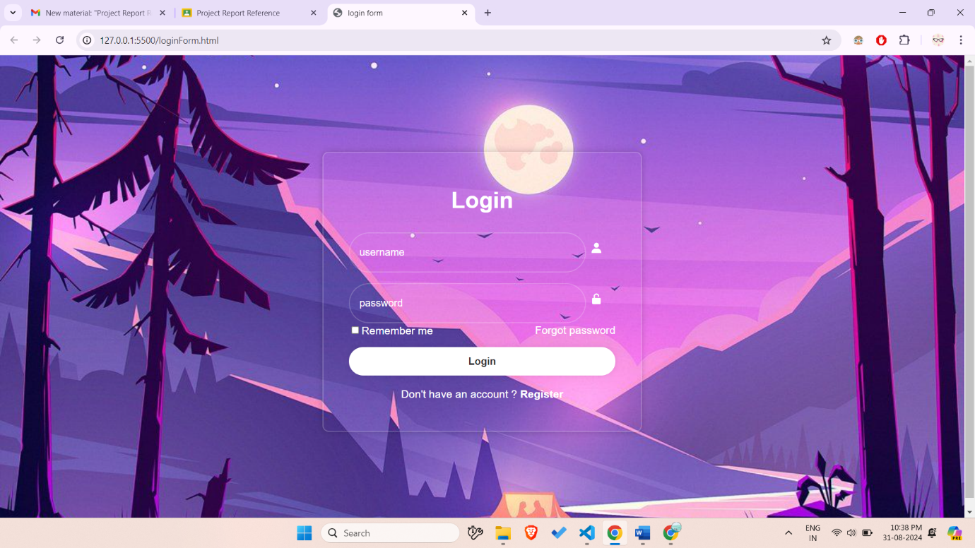

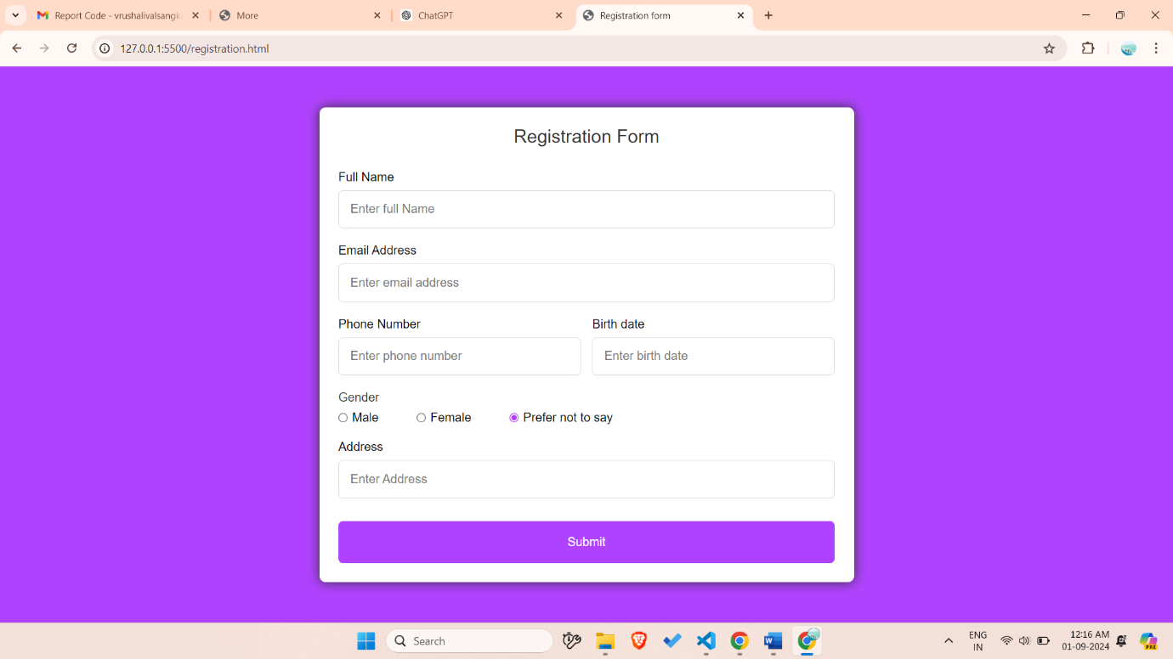

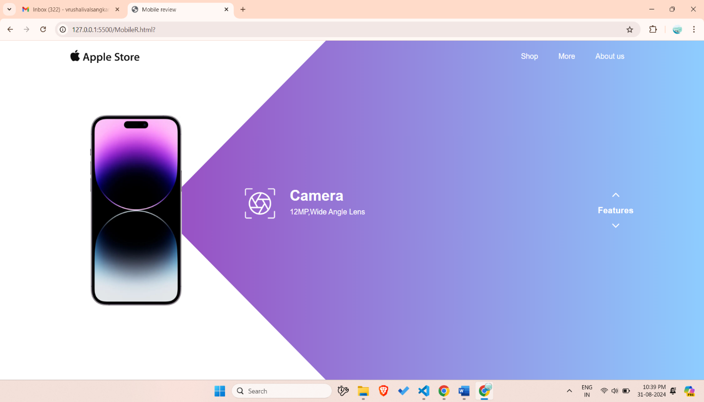

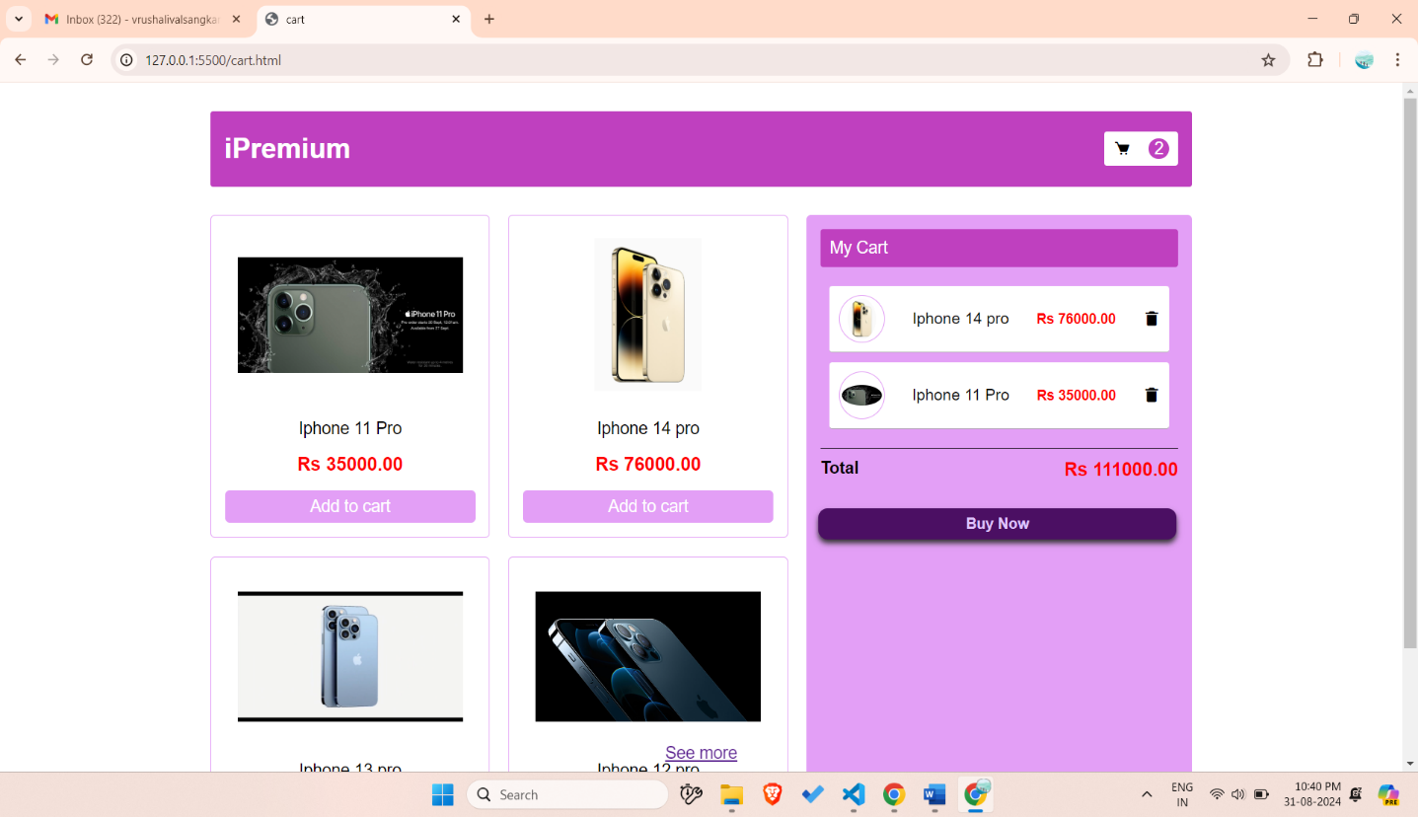

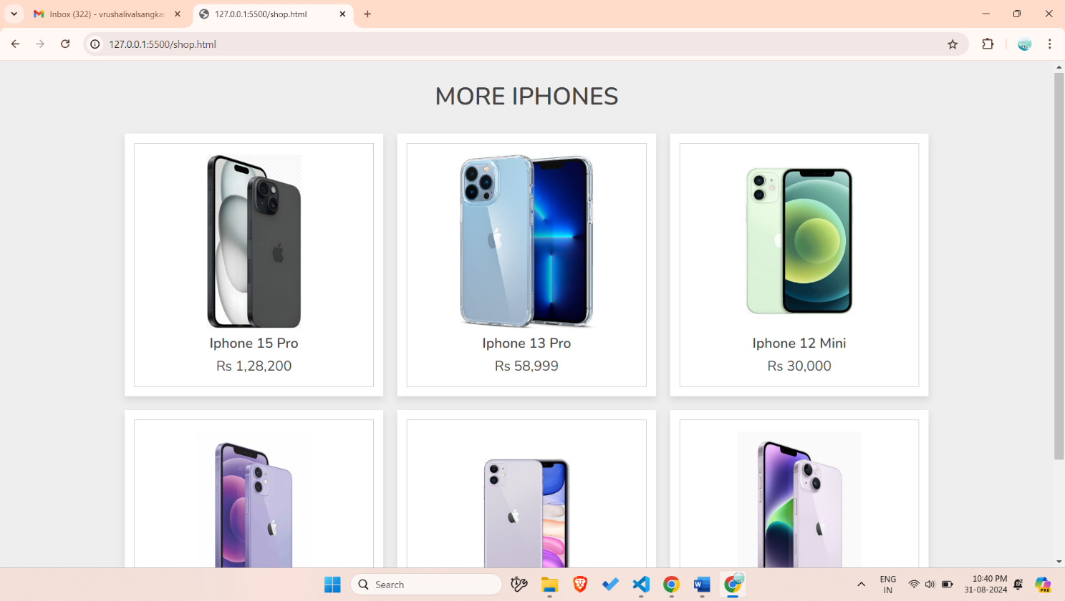

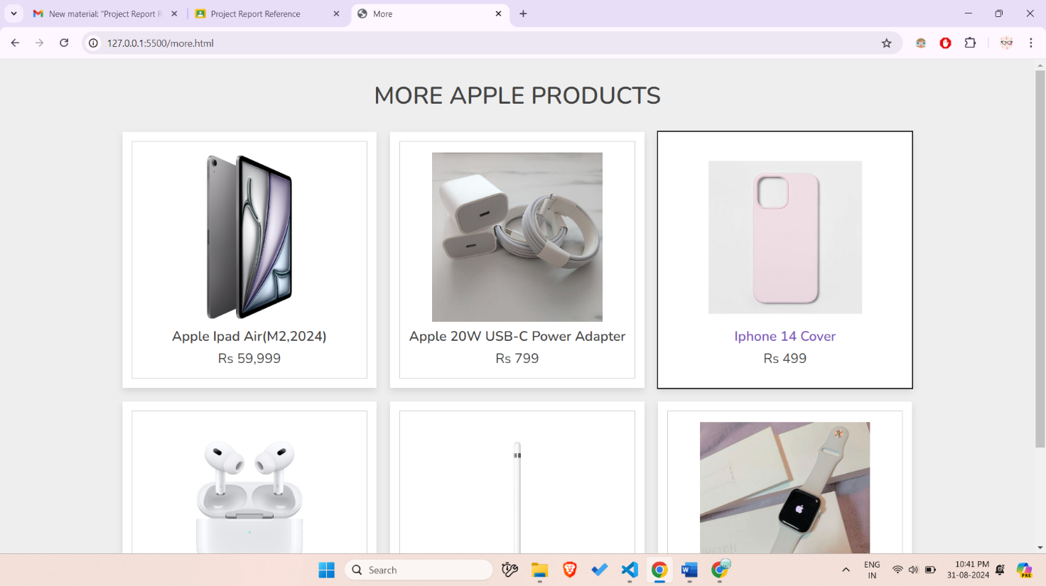

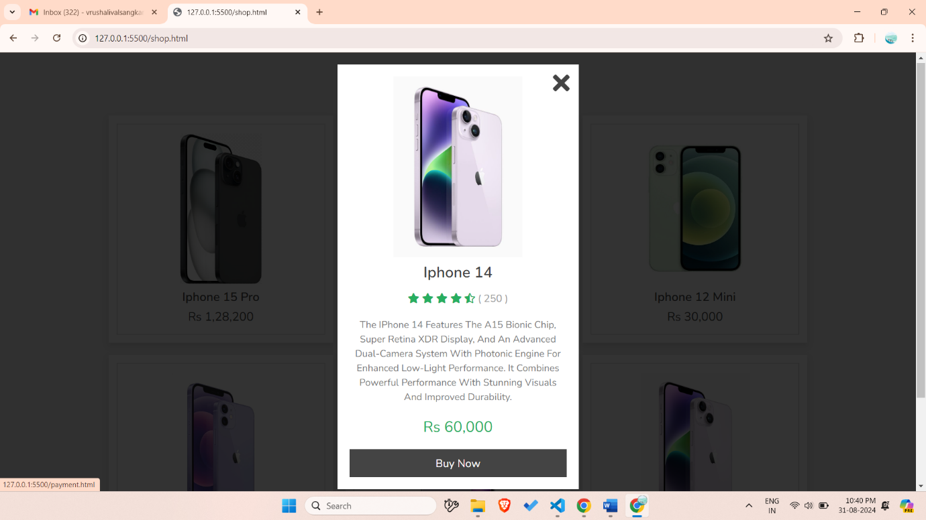

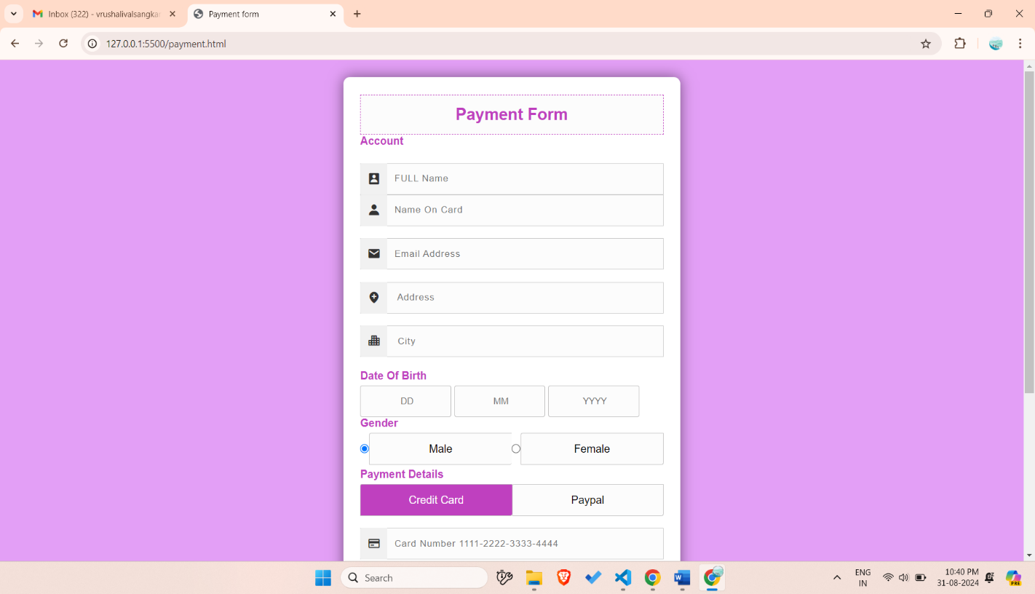

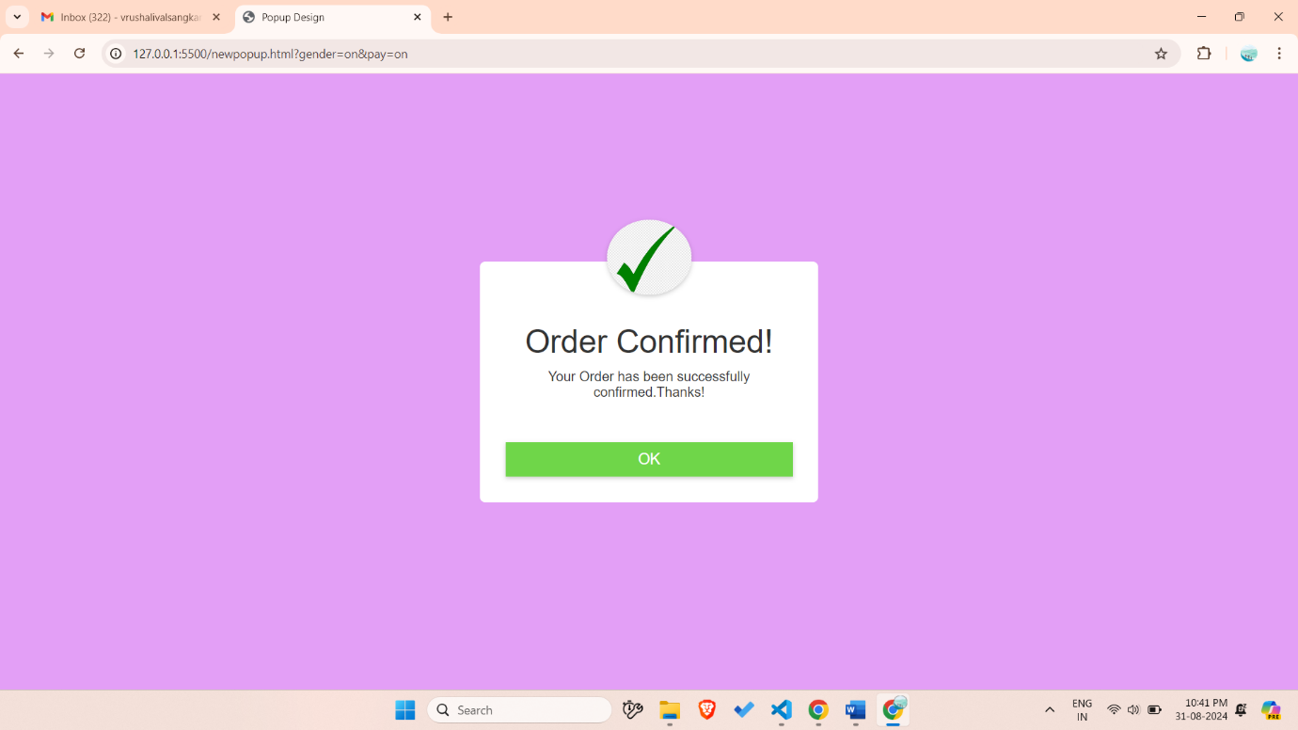

**3.3 Coding**

**Login form:**

<!DOCTYPE html>

<head>

<title>login form</title>

<link rel ="stylesheet" href="LoginStyle.css">

<link href='https://unpkg.com/boxicons@2.1.4/css/boxicons.min.css' rel='stylesheet'>

</head>

<body>

<div class="wrapper">

<form action="MobileR.html">

<h1>Login</h1>

<div class="input-box">

<input type="text" placeholder="username"

required>

<i class='bx bxs-user'></i>

</div>

<div class = "input-box">

<input type="password" placeholder="password"

required>

<i class='bx bxs-lock-open-alt' ></i>

</div>

<div class="remember-forgot">

<lable><input type="checkbox">Remember me</lable>

<a href="#">Forgot password</a>

</div>

<button type="submit" class="btn" onClick="onclk()"> Login</button>

<script>

function onclk(){

document.location.href="MobileR.html";

}

</script>

<div class="register-link">

<p>Don't have an account ? <a href="registration.html">Register</a></p>

</form>

<div>

**Home page:**

<!DOCTYPE html>

<html lang="en">

<head>

   <meta charset="UTF-8">

   <meta http-equiv="X-UA-Compatible" content="IE=edge">

   <meta name="viewport" content="width=device-width, initial-scale=1.0">

   <!-- font awesome cdn link  -->

   <link rel="stylesheet" href="https://cdnjs.cloudflare.com/ajax/libs/font-awesome/5.15.4/css/all.min.css">

   <!-- custom css file link  -->

   <link rel="stylesheet" href="shop.css">

   <!-- custom js file link  -->

   <script src="shop.js" defer></script>

</head>

<body>

<div class="container">

   <h3 class="title"> More iphones</h3>

   <div class="products-container">

      <div class="product" data-name="p-1">

         <img src="pic1.jpg" alt="">

         <h3>iphone 15 pro</h3>

         <div class="price">Rs 1,28,200</div>

      </div>

      <div class="product" data-name="p-2">

         <img src="pic2.jpg" alt="">

         <h3>iphone 13 pro</h3>

         <div class="price">Rs 58,999</div>

      </div>

      <div class="product" data-name="p-3">

         <img src="pic3.jpg" alt="">

         <h3>iphone 12 mini</h3>

         <div class="price">Rs 30,000 </div>

      </div>

      <div class="product" data-name="p-4">

         <img src="pic4.jpg" alt="">

         <h3>iphone 12</h3>

         <div class="price">Rs 38,000</div>

      </div>

      <div class="product" data-name="p-5">

         <img src="pic5.jpg" alt="">

         <h3>iphone 11</h3>

         <div class="price">Rs 23,000</div>

      </div>

      <div class="product" data-name="p-6">

         <img src="pic7.jpg" alt="">

         <h3>iphone 14</h3>

         <div class="price">Rs 60,000</div>

      </div>

   </div>

</div>

<div class="products-preview">

   <div class="preview" data-target="p-1">

      <i class="fas fa-times"></i>

      <img src="pic1.jpg" alt="">

      <h3>latest iphone 15 pro</h3>

      <div class="stars">

         <i class="fas fa-star"></i>

         <i class="fas fa-star"></i>

         <i class="fas fa-star"></i>

         <i class="fas fa-star"></i>

         <i class="fas fa-star-half-alt"></i>

         <span>( 250 )</span>

      </div>

      <p>The iPhone 15 Pro boasts a sleek titanium design, A17 Pro chip, advanced triple-camera system with ProRAW,

         5G connectivity, and USB-C charging.

        It's a powerhouse in performance and photography, perfect for tech enthusiasts.</p>

      <div class="price">Rs 1,28,200</div>

      <div class="buttons">

         <a href="Payment.html" class="buy">buy now</a>

      </div>

   </div>

   <div class="preview" data-target="p-2">

      <i class="fas fa-times"></i>

      <img src="pic2.jpg" alt="">

      <h3>iphone 13 pro</h3>

      <div class="stars">

         <i class="fas fa-star"></i>

         <i class="fas fa-star"></i>

         <i class="fas fa-star"></i>

         <i class="fas fa-star"></i>

         <i class="fas fa-star-half-alt"></i>

         <span>( 250 )</span>

      </div>

      <p>The iPhone 13 Pro features a sleek design, A15 Bionic chip, Super Retina XDR display with ProMotion,

         and a versatile triple-camera system with Night mode.

         It's built for speed, clarity, and pro-level photography.</p>

      <div class="price">Rs 58,999</div>

      <div class="buttons">

         <a href="Payment.html" class="buy">buy now</a>

      </div>

   </div>

   <div class="preview" data-target="p-3">

      <i class="fas fa-times"></i>

      <img src="pic3.jpg" alt="">

      <h3>iphone 12 mini</h3>

      <div class="stars">

         <i class="fas fa-star"></i>

         <i class="fas fa-star"></i>

         <i class="fas fa-star"></i>

         <i class="fas fa-star"></i>

         <i class="fas fa-star-half-alt"></i>

         <span>( 250 )</span>

      </div>

      <p>The iPhone 12 mini offers a compact design, A14 Bionic chip, Super Retina XDR display, and 5G connectivity. It’s powerful,

         pocket-sized, and perfect for those who want top-tier performance in a smaller form factor.</p>

      <div class="price">Rs 30,000</div>

      <div class="buttons">

         <a href="Payment.html" class="buy">buy now</a>

      </div>

   </div>

   <div class="preview" data-target="p-4">

      <i class="fas fa-times"></i>

      <img src="pic4.jpg" alt="">

      <h3>iphone 12</h3>

      <div class="stars">

         <i class="fas fa-star"></i>

         <i class="fas fa-star"></i>

         <i class="fas fa-star"></i>

         <i class="fas fa-star"></i>

         <i class="fas fa-star-half-alt"></i>

         <span>( 250 )</span>

      </div>

      <p>The iPhone 12 features a sleek design, A14 Bionic chip, Super Retina XDR display, and 5G connectivity. It delivers powerful performance,

        stunning visuals, and advanced dual-camera system in a durable, lightweight build.</p>

      <div class="price">Rs 38,000</div>

      <div class="buttons">

         <a href="Payment.html" class="buy">buy now</a>

      </div>

   </div>

   <div class="preview" data-target="p-5">

      <i class="fas fa-times"></i>

      <img src="pic5.jpg" alt="">

      <h3>iphone 11</h3>

      <div class="stars">

         <i class="fas fa-star"></i>

         <i class="fas fa-star"></i>

         <i class="fas fa-star"></i>

         <i class="fas fa-star"></i>

         <i class="fas fa-star-half-alt"></i>

         <span>( 250 )</span>

      </div>

      <p>The iPhone 11 offers a powerful A13 Bionic chip, Liquid Retina HD display,

        and a dual-camera system with Night mode. It provides impressive performance,

         vibrant visuals, and excellent camera capabilities, all in a durable design.

      </p>

      <div class="price">Rs 23,000</div>

      <div class="buttons">

         <a href="Payment.html" class="buy">buy now</a>

    </div>

   </div>

   <div class="preview" data-target="p-6">

      <i class="fas fa-times"></i>

      <img src="pic6.jpg" alt="">

      <h3>iphone 14</h3>

      <div class="stars">

         <i class="fas fa-star"></i>

         <i class="fas fa-star"></i>

         <i class="fas fa-star"></i>

         <i class="fas fa-star"></i>

         <i class="fas fa-star-half-alt"></i>

         <span>( 250 )</span>

      </div>

      <p>The iPhone 14 features the A15 Bionic chip, Super Retina XDR display,

        and an advanced dual-camera system with Photonic Engine for enhanced low-light performance.

         It combines powerful performance with stunning visuals and improved durability.</p>

      <div class="price">Rs 60,000</div>

      <div class="buttons">

         <a href="Payment.html" class="buy">buy now</a>

      </div>

   </div>

</div>

</body>

</html>

<!Doctype html>

<html>

<head>

    <title>cart</title>

<link rel="stylesheet"href="cart.css"> </head>

<link href='https://unpkg.com/boxicons@2.1.4/css/boxicons.min.css' rel='stylesheet'>

</head>

<body>

<div class="header">

<p class="logo">iPremium</p>

<div class="cart"><i class='bx bxs-cart'></i><p id="count">0</p>

</div>

</div>

<div class="container">

<div id="root"></div>

<div class="sidebar">

<div class="head">

<p>My Cart</p></div>

<div id="cartItem">Your cart is empty</div>

<div class="foot">

<h3>Total</h3>

<h2 id="total">Rs 0.00</h2>

</div>

<a href="Payment.html">

<button class="buy">Buy Now</button>

</a>

</div>

<script src = "cart.js"> </script>

</body>

<div class="more">

    <a href="shop.html">See more</a>

</div>

</html>

<!DOCTYPE html>

<html lang="en">

<head>

    <meta charset="UTF-8">

    <meta name="viewport" content="width=device-width, initial-scale=1.0">

    <title>Payment form</title>

    <link rel="stylesheet"href="Paystyle.css">

    <link rel="stylesheet" href='https://unpkg.com/boxicons@2.1.4/css/boxicons.min.css' >

</head>

<body>

    <div class="wrapper">

        <h2>Payment Form</h2>

        <form action="Thankuh.html">

            <!--Account Information Start-->

        <h4>Account</h4>

        <div class="input_group"></div>

        <div class="input_box">

            <input type="text" placeholder="FULL Name" class="name">

            <i class='bx bxs-user-rectangle' ></i>

        </div>

        <div class="input_box">

            <input type="text" placeholder="Name On Card"class="name">

            <i class='bx bxs-user' ></i>

        </div>

        <div class="input_group"></div>

        <div class="input_box">

            <input type="email" placeholder="Email Address" class="name">

            <i class='bx bxs-envelope'></i>

        </div>

    <div class="input_group"></div>

        <div class="input_box">

            <input type="text" placeholder=" Address"class="name">

            <i class='bx bxs-location-plus' ></i>

              </div>

    <div class="input_group"></div>

        <div class="input_box">

            <input type="text" placeholder=" City" class="name">

            <i class='bx bxs-city'></i>

              </div>

    <div class="input_group"></div>

        <div class="input_box">

            <h4>Date Of Birth</h4>

            <input type="text" placeholder=" DD"  class="dob">

            <input type="text" placeholder=" MM" class="dob">

            <input type="text" placeholder=" YYYY"class="dob">

              </div>

              <div class="input_box">

                <h4>Gender</h4>

                <div class="gender">

                  <input type="radio" name="gender"  id="b1" checked>

                  <label for="b1">Male</label>

                  <input type="radio" name="gender" id="b2">

                  <label for="b2">Female</label>

           </div>

           </div>

    <div class="input_group">

        <div class="input_box">

            <h4>Payment Details</h4>

            <input type="radio" name="pay"class="radio" id="bc1" checked>

            <label for="bc1"><span>

                <i></i>Credit Card

            </span></label>

                    <input type="radio" name="pay"class="radio" id="bc2">

                    <label for="bc2"><span>

                        <i></i>Paypal

                    </span></label>

        </div>

    </div>

    <div class="input_group">

        <div class="input_box">

            <input type="tel"class="name"placeholder="Card Number 1111-2222-3333-4444">

            <i class='bx bx-credit-card'></i>

        </div>

    </div>

    <div class="input_group">

        <div class="input_box">

            <input type="tel"class="name"placeholder="Card CVC 632">

            <i class='bx bxs-user' ></i>

        </div>

    </div>

    <div class="input_group">

        <div class="input_box">

            <input type="number"class="name"placeholder="Exp Month">

            <i class='bx bx-calendar'></i>

        </div>

    </div>

    <div class="input_group">

        <div class="input_box">

            <input type="number"class="name"placeholder="Exp Year">

            <i class='bx bx-calendar-alt'></i>

        </div>

    </div>

    <div class="input_group">

        <div class="input_box">

            <input type="number"class="name"placeholder="Enter Amount">

            <i class='bx bx-money'></i>

        </div>

    </div>

    <div class="input_group">

        <div class="input_box">

        <button type="submit">Pay Now</button>

        </div>

    </div>

        </form>

    </div>

</body>

</html>

<!DOCTYPE html>

<html lang="en">

<head>

    <meta charset="UTF-8">

    <meta name="viewport" content="width=device-width, initial-scale=1.0">

    <title>Popup Design</title>

    <link rel ="stylesheet" href="Popstyle.css">

</head>

<body>

    <div class="container">

    <button type="submit" class="btn" onclick="openPopup()">Confirm Payment</button>

    <div class="popup" id="popup">

        <img src="tick.png">

        <h2>Order Confirmed!</h2>

        <p>Your Order has been successfully confirmed.Thanks!</p>

        <button type="button" onclick="closePopup()">OK</button>

    </div>

</div>

<script>

    let popup = document.getElementById("popup");

    function openPopup(){

      popup.classList.add("open-popup");

    }

    function closePopup(){

      popup.classList.remove("open-popup");

    }

</script>

</body>

</html>

**4.SYSTEM TESTING**

**4.1 Program Specification & Validation**

* **User Registrations and login**

Validation**:**

• All fields must be filled.

• Username and password should be valid

**4.2 Types of Testing**

* Functional Testing: We verified that all key features, such as adding items to the cart, and the checkout process, functioned as intended.
* Usability Testing: We tested the site to ensure it was user-friendly and that navigating through it was smooth and intuitive for our customers.
* Performance Testing: We checked how the site performed under different loads, including peak traffic times, to ensure it could handle high volumes of users and transactions.

**5.IMPLEMENTATION**

**5.1 User Manual**

Step 1: Open Web browser

Step 2: Open the Website.

Step 3: Login if you are existing user else register

Step 4: Browse through features of latest phone

Step 5: Click on shop and browse through products

Step 5: Click on add to cart

Step 6: Click on Buy now

Step 7: Fill the payment form

Step 8: Click on confirm Order

**6.CONCLUSION AND SUGGESTIONS**

**6.1 Conclusion**

Our website was designed for smartphones to meet the growing demand for mobile shopping. With a responsive design, it ensures a smooth, user-friendly experience for browsing and purchasing on the go.

**6.2 Enhancement Suggestion**

• The application can be enlarged by using front end frameworks and

Backend databases for better scaling.

• The reports can be improved.

**7.BIBLIOGRAPHY**

**7.1 References**

* <https://search.google.com/test/mobile-friendly>
* <https://www.w3schools.com/html/html_responsive.asp>
* <https://developer.mozilla.org/en-US/docs/Learn/CSS/CSS_layout/Responsive_Design>
* <https://www.smashingmagazine.com/2018/05/mobile-ecommerce-design/>
* <https://alistapart.com/article/designing-for-mobile-first/>