## START K8S CLUSTER

1. Start the master and worked nodes in the VM manager

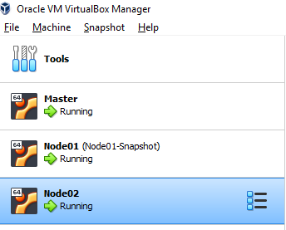

1. SSH into **each** VM and execute the following command (as admin)

sudo swapoff –a

Credentials

Master: master/root

Node01: node01/root

Node02: node02/root

1. Go to master ssh session and use this command to check that the cluster is up:

kubectl get nodes

The result should “Ready” status for master node and two worker nodes.

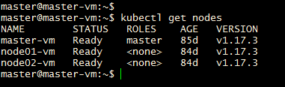

## CONFIGURE KUBECTL ON WINDOWS VM (Developer Environment)

1. On the master node get the token of the cluster admin using the commands below. Save the token.

sudo kubectl create serviceaccount k8sadmin -n kube-system

sudo kubectl create clusterrolebinding k8sadmin --clusterrole=cluster-admin --serviceaccount=kube-system:k8sadmin

sudo kubectl -n kube-system describe secret $(sudo kubectl -n kube-system get secret | (grep k8sadmin || echo "$_") | awk '{print $1}') | grep token: | awk '{print $2}'

1. Save the attached config file in USER_HOME/.kube (if .kube is not created, use the window commands prompt to create one using mkdir .kube)



1. Open the config file and
   1. Replace the placeholder in clusters[0].cluster.server to IP address of master node.
   2. Replace placeholder in Users[0].user.token with the token saved in step 1.
2. Test the kubectl on windows VM now.

kubectl get nodes

