1. Screenshot of Tableau Data Source view showing Tables and Joins from Contoso DW

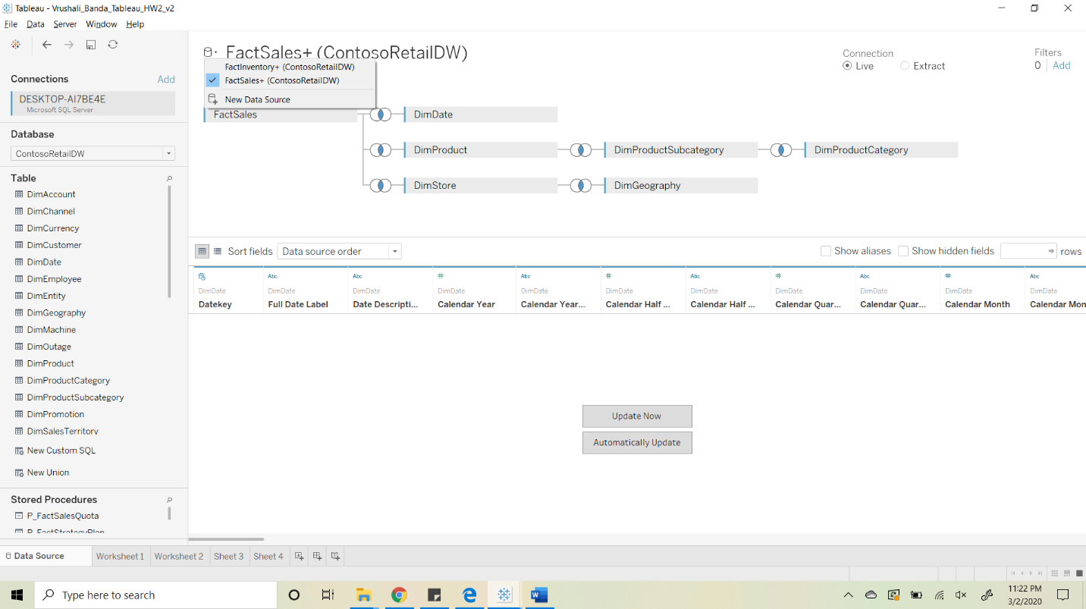

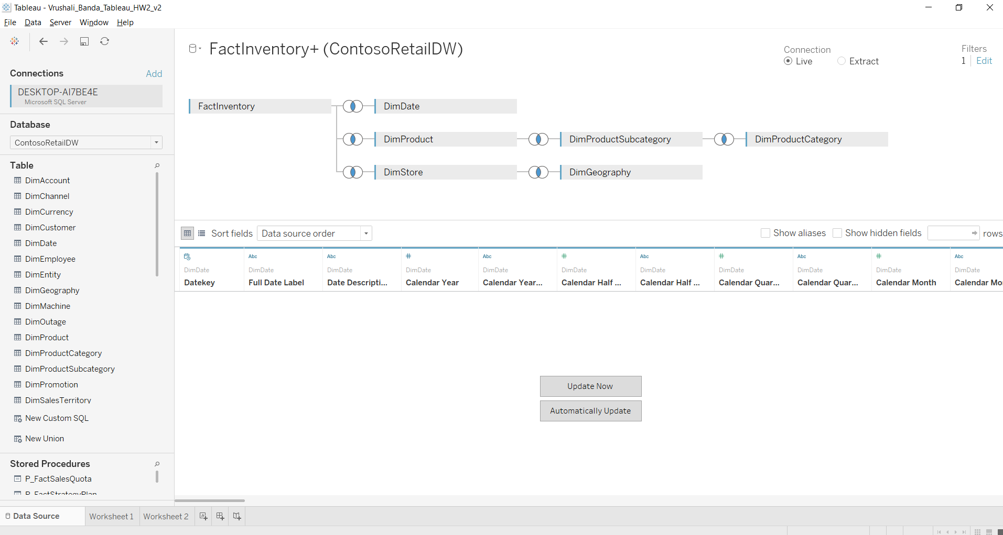

1. Screenshot of Worksheet 1 with Category as Rows and Months of 2009 as Columns. The Inventory on Last Day of Period and Sales numbers should be readable.

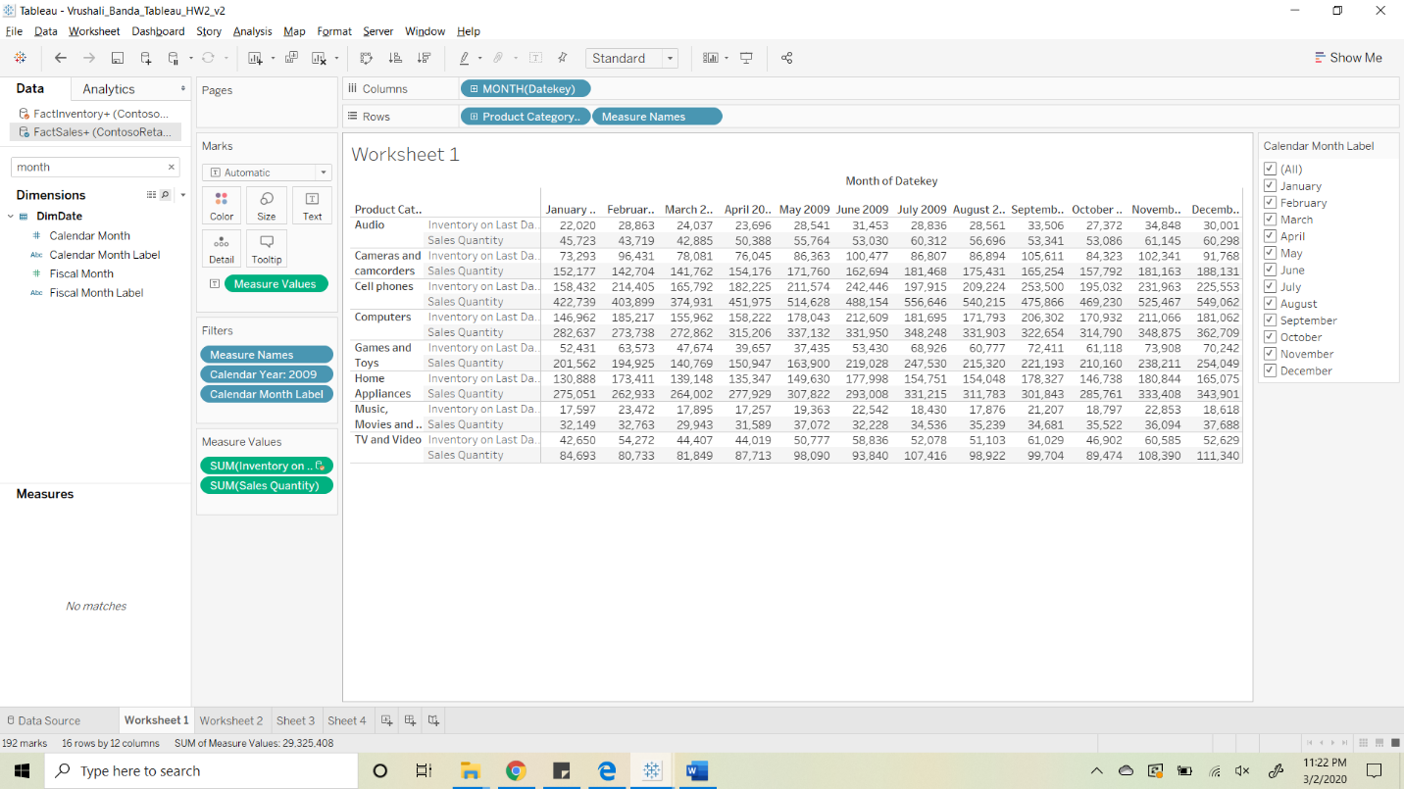

1. Submit Screenshot of Worksheet 2 with Line graphs of Stock to Sales ratio for each Category

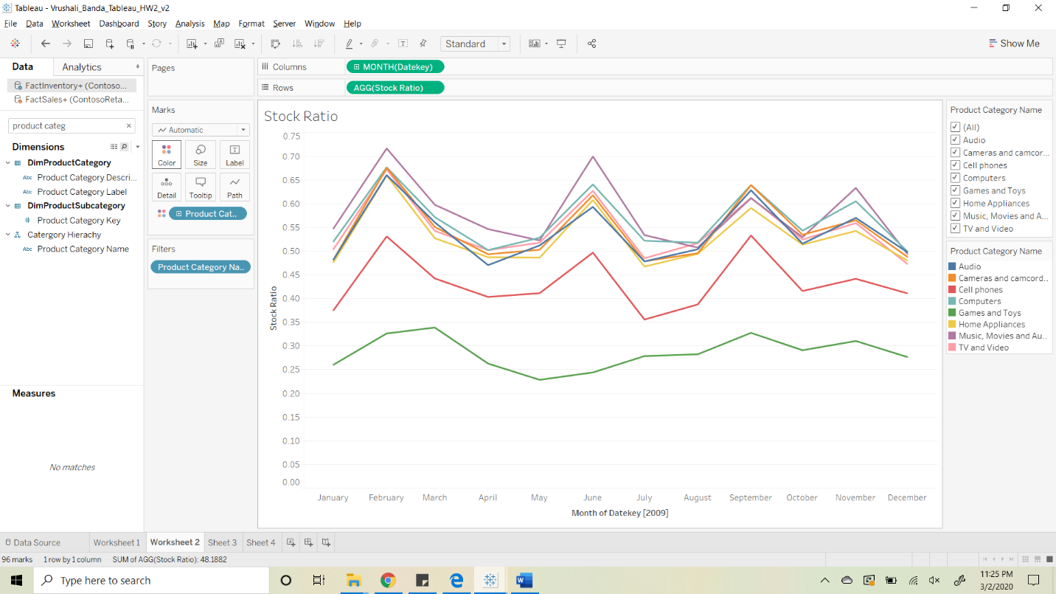

1. Submit brief summary of analysis in item 3

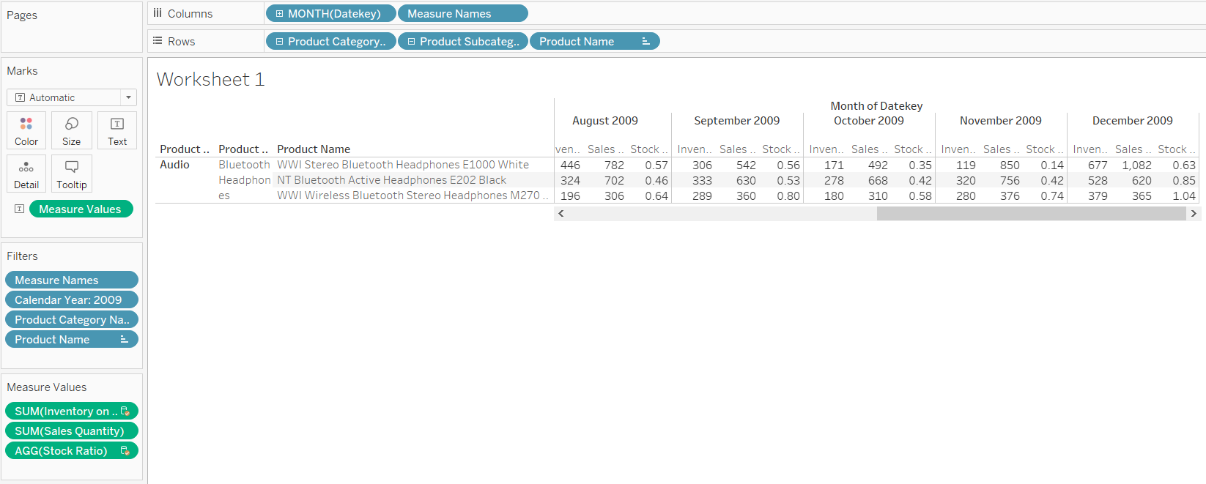

There are many products that are deviating from the expected trend of increase in stock ratio between October – November and a decrease in November December period. Here are the three examples that I would like to highlight.

Case i) WWI Stereo Bluetooth Headphones E1000 White (Let’s call it P1)

P1 has the highest inventory on the last day of December. Its stock ratio was 0.35 in October 2009, reduced to 0.14 in November when it was expected to increase and then increased again in December to 0.63, deviating significantly from the expected behavior. While sales increased, the ratio was high mainly due to huge inventory at the end of the period.

Case ii) NT Bluetooth Active Headphones E202 Black (P2)

P2 had a Stock Ratio of 0.42 in October, remained flat in November in spite of increase in sales by 13.2% and the inventory increased by the same rate. The Stock Ratio then doubled to 0.85 in December due to increase in inventory and a drop in sales. This behavior of flat followed by increasing trend in the last two months is a significant deviation from the expected behavior.

Case iii) WWI Wireless Bluetooth Stereo Headphones M270 Black (P3)

P3 had an increasing trend in Stock Ratio between the October to December, where it went from 0.58 to 0.74 and then to 1.04 at the end of December 2009. This was driven by flat sales, but increasing inventory levels, suggesting that the demand was not appropriately understood by the planners. This is also a significant deviation from the expected trend in Stock Ratio.