**MINI-PROJECT**

**SE COMPUTER ENGINNERING**

**sem-IV**

**DATABASE**

**MANAGEMENT**

**SYSTEM**

**HOTEL**

**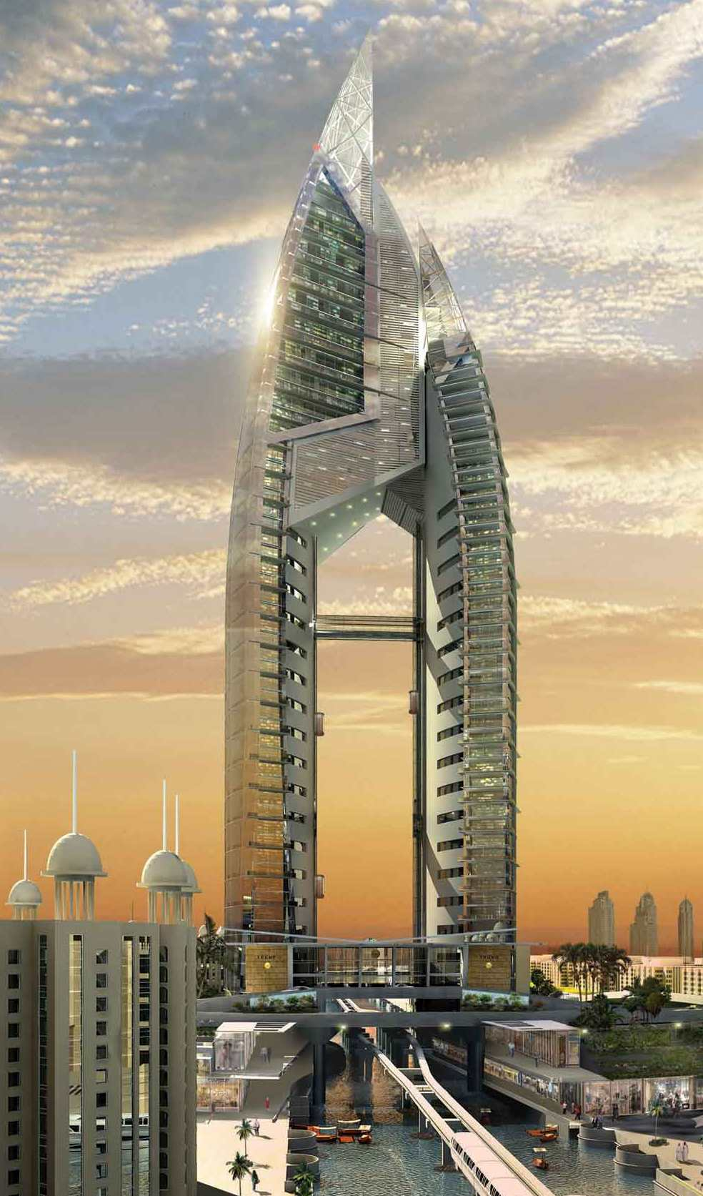MANAGEMENT**

**SYSTEM**

**GROUP MEMBERS**:

* **VRUSHAL RAUT**
* **JAYENDRA SHIRSAT**
* **ROHIT THAPAR**
* **YOGESH SALIAN**

**DESCRIPTION:**

The Hotel Management System is the project about to add the customer records of hotel customer with their personal details like Name,Address and Phone number in SQL database with VB6.0 front end.

Separate record system for SINGLE person and COUPLES with automatically calculate rent with respect to class chosen by customer and day of living in hotel.

Tabular viewing of record of all inserted records. And editing is major feature to edit data directly in table of database

**TECHNOLOGY USED:**

**FRONT END:**

**BACK END:**



**FORMS:**

**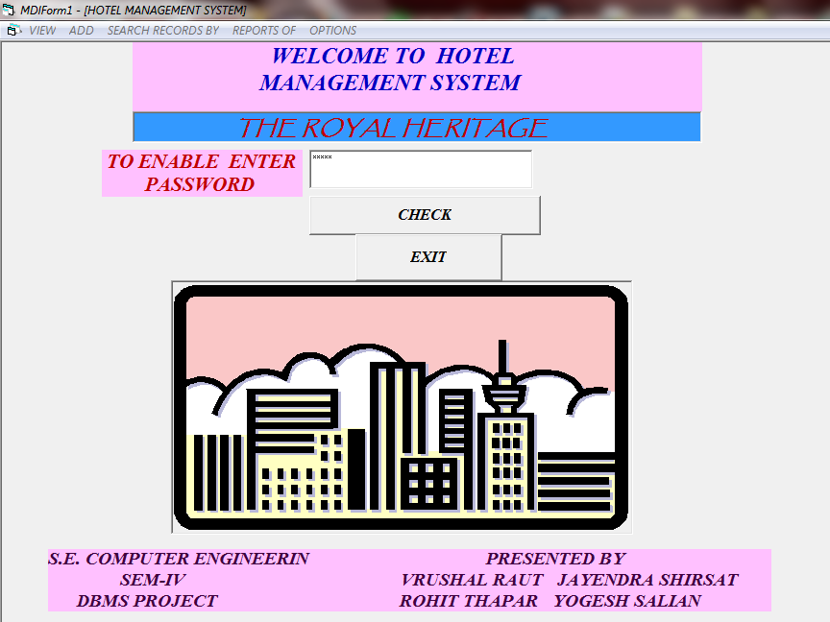FORM 1**

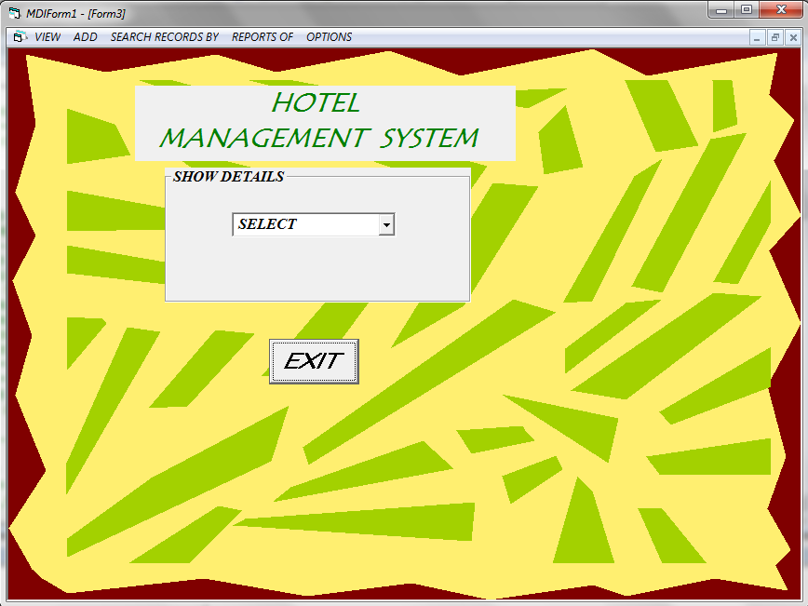**FORM 2**

**FORM 3**

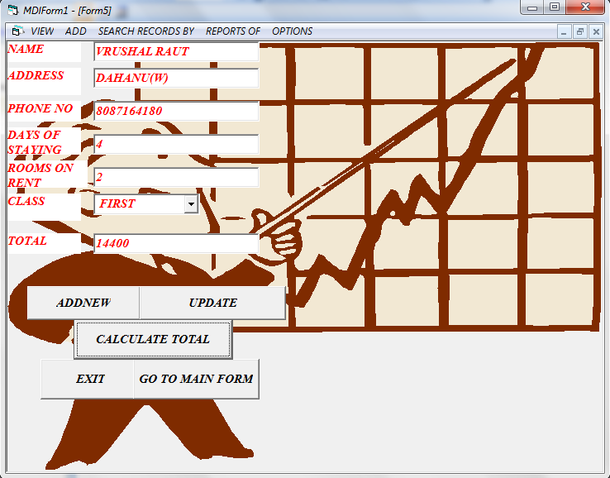

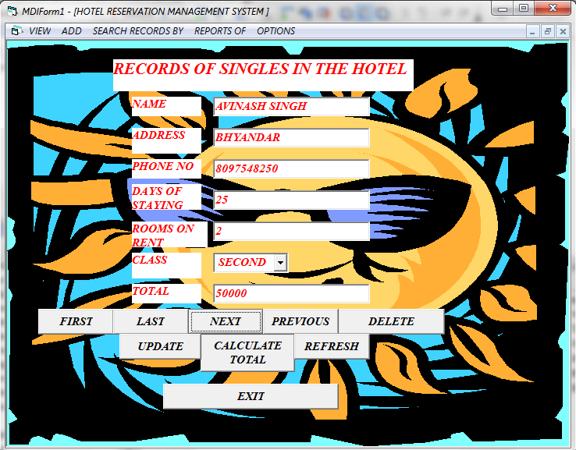

**FORM 4**

**FORM**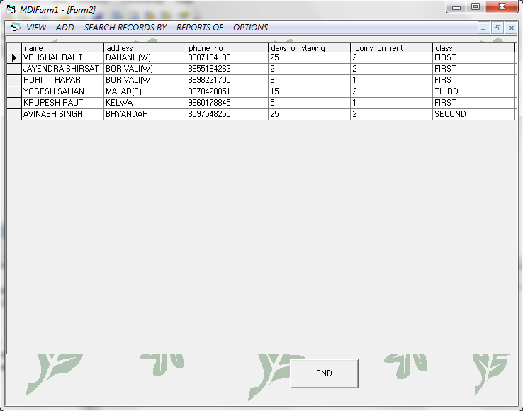 **5**

**FORM 6**

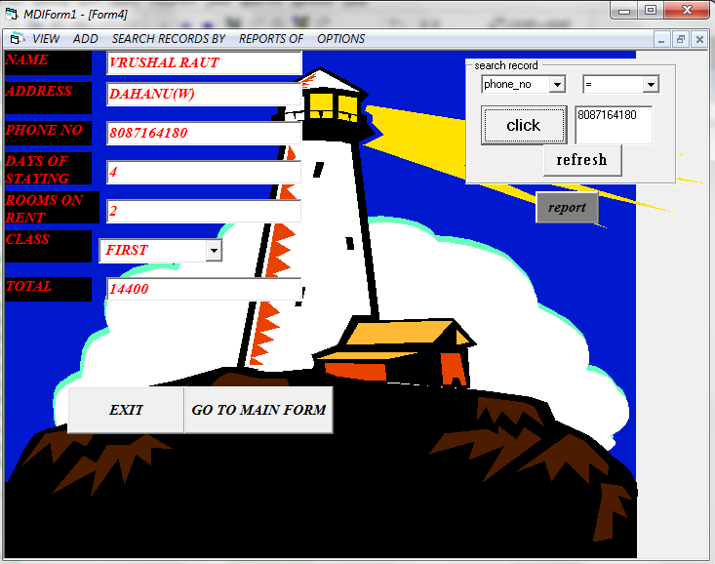

**SQL Queries:**

**CREATE TABLE HOTEL**

create table HOTEL(name varchar(25),address varchar(25),phone\_no varchar(25),days\_of\_staying varchar(25),rooms\_on\_rent varchar(25),class varchar(25),total varchar(25))

select\*from HOTEL

C:\Users\vrushal\Pictures\2011-05-22 IMAGES_FINEPIX\DBMS\New Picture (6).bmp

**INSERT DATA**

**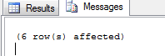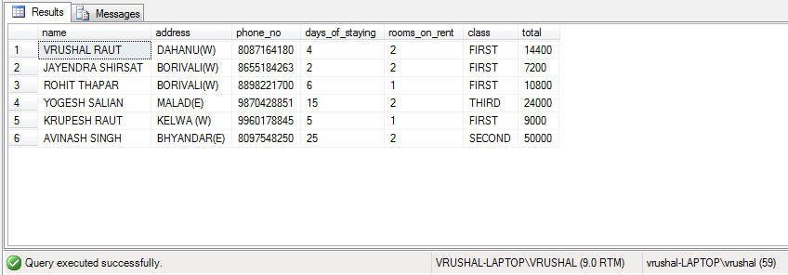**

**UPDATE DATA**

UPDATE HOTEL SET address='DAHANU' WHERE address='DAHANU(W)'

**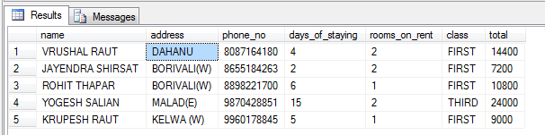**

**C:\Users\vrushal\Pictures\2011-05-22 IMAGES_FINEPIX\DBMS\New Picture (14).bmp**

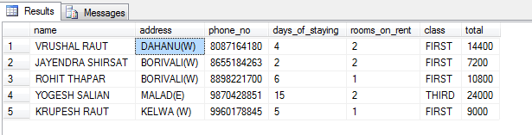

**DELETE DATA**

DELETE FROM HOTEL WHERE phone\_no=8097548250

DELETE TOP(1) FROM HOTEL WHERE name='AVINASH SINGH';



C:\Users\vrushal\Pictures\2011-05-22 IMAGES_FINEPIX\DBMS\New Picture (10).bmp

