# DBMS - Mini Project

# Title of the Project – CharterGhar(House Rental Management System)

Submitted By: Vrushank G

SRN : PES1UG20CS516

V Semester

Section : I

# Short Description and Scope of the Project

* House management has become important factor in modern society hence the need to have a house rental management system
* Charter-Ghar is a House rental management website where house owners, agents and tenants can exchange information effectively and inexpensively.
* Provides user-friendly interface, satisfying the needs of the consumers.
* Employs a new strategy that facilitates easy management of rental houses.

**Scope:**

The project scope defines the description of the work that is required in delivering the rental house management system.

The following are the scopes of work during the course of the project:

* Study and understand the requirement of this project
* ER diagram and relational schema
* A minimalistic UI/front-end
* Creating and populating the database
* Using the SQL queries and show the reflections in the front-end developed

**Modules Used:**

* Owner: Displays the details of the Houses he/she owns for rent.
* Tenant: Searched the best suited house for the living and makes contract with the owner once he/she buys/rents the house.
* Contract: Stores the details of Tenant renting the house belonging to respective Owner.
* Payment: Payment window for making multiple payments for a contract

**ER Diagram**

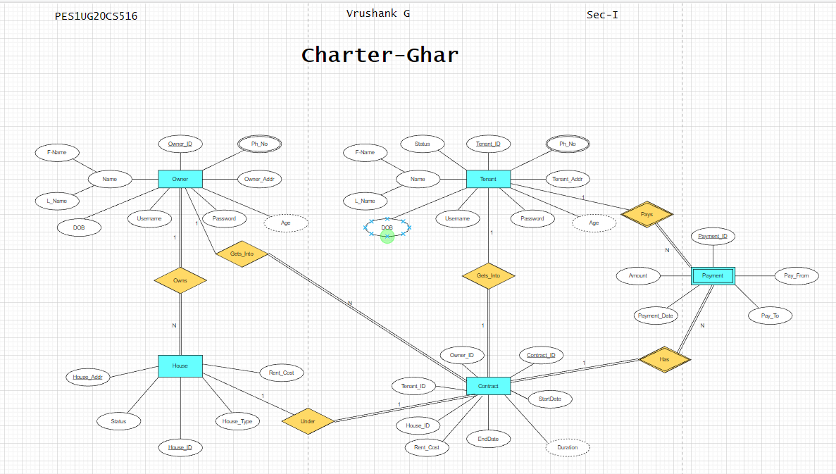

# Relational Schema

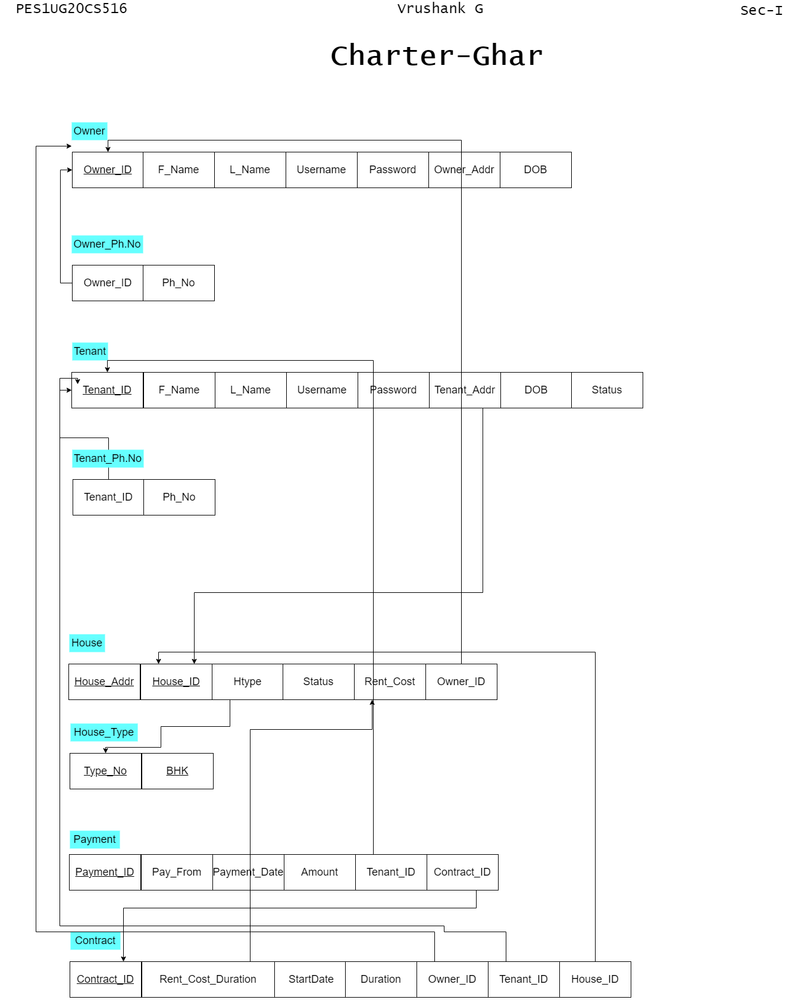

**DDL statements - Building the database**

--Owner Table

CREATE TABLE IF NOT EXISTS Owner(

    Owner_ID int(6) auto_increment,

    primary key(Owner_ID),

    F_Name varchar(10) not null,

    L_Name varchar(10) not null,

    Username varchar(10) not null unique,

    Password varchar(10) not null,

    Owner_Addr varchar(50) unique,

    DOB date

);

alter table Owner auto_increment=100000;

--Owner_Ph.No

CREATE TABLE IF NOT EXISTS Owner_Ph(

    Owner_ID int(6),

    constraint fk_owner_id foreign key(Owner_ID) REFERENCES Owner(Owner_ID),

    Ph_No char(10) not null

);

alter table Owner_Ph add constraint check_ph check(char_length(Ph_No)=10);

--Tenant

CREATE TABLE IF NOT EXISTS Tenant(

    Tenant_ID int(6) auto_increment,

    primary key(Tenant_ID),

    F_Name varchar(10) not null,

    L_Name varchar(10) not null,

    Username varchar(10) not null unique,

    Password varchar(10) not null,

    Tenant_Addr varchar(50) default NULL,

    -- constraint fk_tenant_addr foreign key(Tenant_Addr) REFERENCES House(House_Addr),

    DOB date,

    Status boolean default false

);

alter table Tenant auto_increment=300000;

--Tenant_Ph.No

CREATE TABLE IF NOT EXISTS Tenant_Ph(

    Tenant_ID int(6),

    constraint fk_tenant_id foreign key(Tenant_ID) REFERENCES Tenant(Tenant_ID),

    Ph_No char(10) not null

);

alter table Tenant_Ph add constraint check_ph check(char_length(Ph_No)=10);

--House_type

CREATE TABLE IF NOT EXISTS House_Type(

    Type_No int(2),

    BHK varchar(6),

    primary key(Type_No,BHK)

);

--House

CREATE TABLE IF NOT EXISTS House(

    House_ID int auto_increment,

    House_Addr varchar(50),

    primary key(House_ID,House_Addr),

    Htype int(2),

    constraint fk_house_type foreign key(Htype) REFERENCES House_type(Type_No),

    Rent_Cost int(10) not null,

    Owner_ID int(6),

    constraint fk_owner_id2 foreign key(Owner_ID) REFERENCES Owner(Owner_ID)

);

alter table House auto_increment=200000;

--Contract

CREATE TABLE IF NOT EXISTS Contract(

    Contract_ID int(6) auto_increment,

    primary key(Contract_ID),

    Start_Date date,

    Duration int(2) not null default 1,

    Rent_Cost_Duration int(10),

    -- constraint fk_rent_cost foreign key(Rent_Cost_Duration) references House(Rent_Cost),

    Owner_ID int(6),

    constraint fk_owner_id3 foreign key(Owner_ID) REFERENCES Owner(Owner_ID),

    Tenant_ID int(6),

    constraint fk_tenant_id2 foreign key(Tenant_ID) REFERENCES Tenant(Tenant_ID),

    House_ID int(6),

    constraint fk_house_id foreign key(House_ID) REFERENCES House(House_ID)

);

alter table Contract auto_increment=400000;

--Payment

CREATE TABLE IF NOT EXISTS Payment(

    Payment_ID int auto_increment,

    primary key(Payment_ID),

    Pay_From varchar(20) not null,

    Payment_Date date,

    Amount int(10) not null,

    Tenant_ID int(6),

    constraint fk_tenant_id3 foreign key(Tenant_ID) REFERENCES Tenant(Tenant_ID),

    Contract_ID int(6),

    constraint fk_contract_id foreign key(Contract_ID) REFERENCES Contract(Contract_ID)

);

alter table Payment auto_increment=500000;

# Populating the Database

--Owner

insert INTO Owner(F_Name,L_Name,username,password,Owner_Addr,DOB) VALUES("Vrushank","G","vrush41","12345","2nd cross,millerpet,bellary",'2002-08-12');

insert INTO Owner(F_Name,L_Name,username,password,Owner_Addr,DOB) VALUES("Hemanth","N","hemanth28","23456","4th cross,gauribidanur,chikkaballapur",'2002-01-28');

insert INTO Owner(F_Name,L_Name,username,password,Owner_Addr,DOB) VALUES("Dhanush","M D","mdebro","34567","2nd cross,puttur,mangaluru",'2002-06-01');

insert INTO Owner(F_Name,L_Name,username,password,Owner_Addr,DOB) VALUES("Srinivas","Y","vasu03","45678","3rd cross,rr nagar,bengaluru",'2002-03-27');

insert INTO Owner(F_Name,L_Name,username,password,Owner_Addr,DOB) VALUES("Om","Prasad","om123","56789","2nd cross,jaynagar,bengaluru",'2002-05-10');

--Owner_Ph

insert INTO Owner_Ph(Owner_ID,Ph_No) VALUES(100000,(9876929479));

insert INTO Owner_Ph(Owner_ID,Ph_No) VALUES(100001,(6968456239));

insert INTO Owner_Ph(Owner_ID,Ph_No) VALUES(100002,(9087565642));

insert INTO Owner_Ph(Owner_ID,Ph_No) VALUES(100003,(9980674554));

insert INTO Owner_Ph(Owner_ID,Ph_No) VALUES(100004,(9780678543));

--Tenant

insert INTO Tenant(F_Name,L_Name,Username,Password,Tenant_Addr,DOB) VALUES("Sathvik","A","stvk64","09875","guntur",'2002-04-03');

insert INTO Tenant(F_Name,L_Name,Username,Password,Tenant_Addr,DOB) VALUES("Teja","Kanala","tsreddy43","98735","kurnool",'2002-07-21');

insert INTO Tenant(F_Name,L_Name,Username,Password,Tenant_Addr,DOB) VALUES("Soumith","B","soumpi23","56780","bellary",'2002-01-23');

insert INTO Tenant(F_Name,L_Name,Username,Password,Tenant_Addr,DOB) VALUES("Prathap","P","ptp45","12988","hindupur",'2002-07-09');

insert INTO Tenant(F_Name,L_Name,Username,Password,Tenant_Addr,DOB) VALUES("Nayan","K","nyn987","09876","rajaji nagar,bengaluru",'2002-04-03');

--Tenant_Ph

insert INTO Tenant_Ph(Tenant_ID,Ph_No) VALUES(300000,(9067825372));

insert INTO Tenant_Ph(Tenant_ID,Ph_No) VALUES(300001,(6273682936));

insert INTO Tenant_Ph(Tenant_ID,Ph_No) VALUES(300002,(9808577578));

insert INTO Tenant_Ph(Tenant_ID,Ph_No) VALUES(300003,(9768457902));

insert INTO Tenant_Ph(Tenant_ID,Ph_No) VALUES(300020,(6363787893));

--House_Type

insert INTO House_Type(Type_No,BHK) VALUES(1,"1 BHK");

insert INTO House_Type(Type_No,BHK) VALUES(2,"2 BHK");

insert INTO House_Type(Type_No,BHK) VALUES(3,"3 BHK");

insert INTO House_Type(Type_No,BHK) VALUES(4,"4 BHK");

insert INTO House_Type(Type_No,BHK) VALUES(5,"5 BHK");

--House

INSERT INTO House(House_Addr,Htype,Rent_Cost,Owner_ID) VALUES("Bellary",3,10000,100000);

INSERT INTO House(House_Addr,Htype,Rent_Cost,Owner_ID) VALUES("gauribidanur",2,8000,100001);

INSERT INTO House(House_Addr,Htype,Rent_Cost,Owner_ID) VALUES("puttur",1,7000,100002);

INSERT INTO House(House_Addr,Htype,Rent_Cost,Owner_ID) VALUES("rr nagar",5,15000,100003);

INSERT INTO House(House_Addr,Htype,Rent_Cost,Owner_ID) VALUES("jaynagar",4,20000,100004);

**Join Queries**

Showcase at least 4 join queries

Write the query in English Language, Show the equivalent SQL statement and also a screenshot of the query and the results

Select * from Owner inner JOIN Owner_Ph on Owner.Owner_ID=Owner_Ph.Owner_ID;

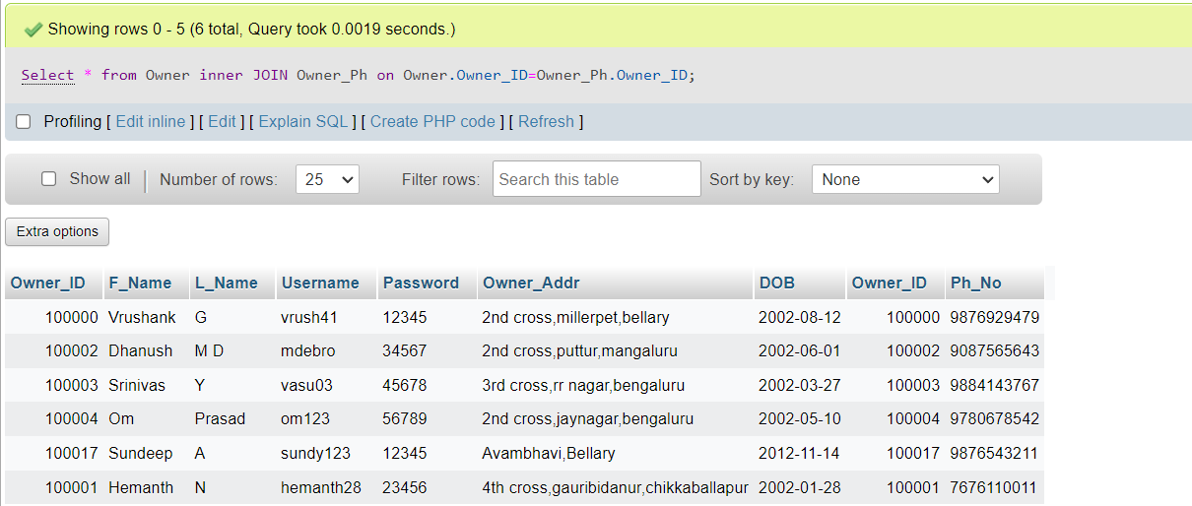

Select * from Tenant inner JOIN Tenant_Ph on Tenant.Tenant_ID=Tenant_Ph.Tenant_ID;

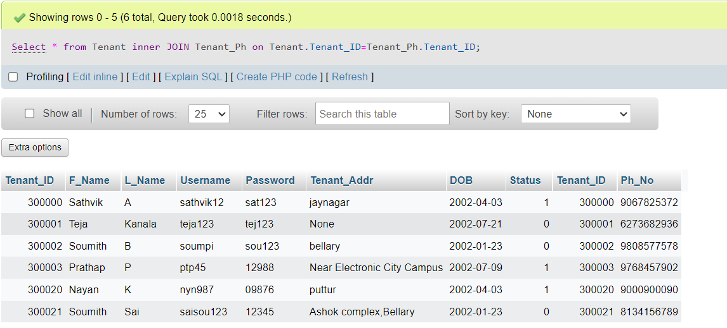

Select * from House inner JOIN House_Type on House_Type.Type_No=House.Htype;

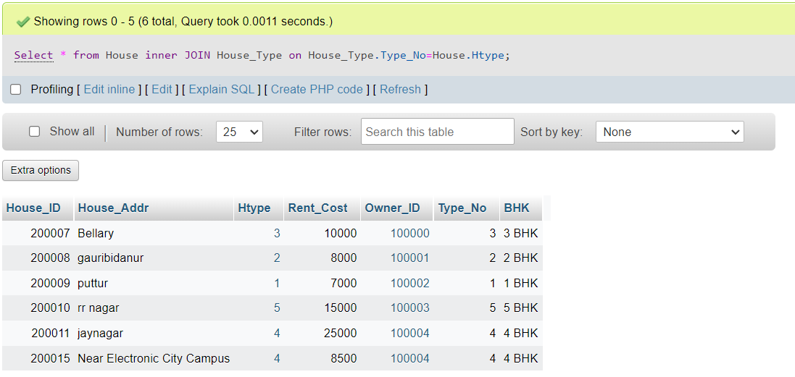

select Payment_ID,Contract.Contract_ID from Contract inner join Payment on Contract.Contract_ID=Payment.Contract_ID;

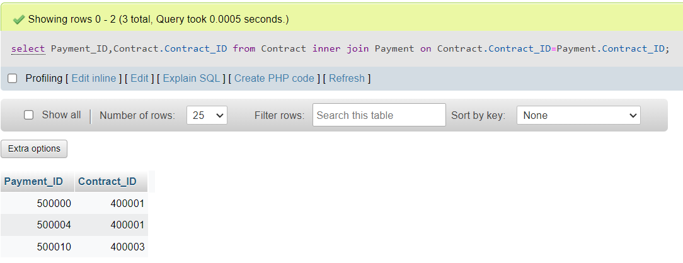

# Aggregate Functions

Showcase at least 4 Aggregate function queries

Write the query in English Language, Show the equivalent SQL statement and also a screenshot of the query and the results

select count(Payment_ID),Contract.Contract_ID from Contract inner join Payment on Contract.Contract_ID=Payment.Contract_ID group by Contract_ID;

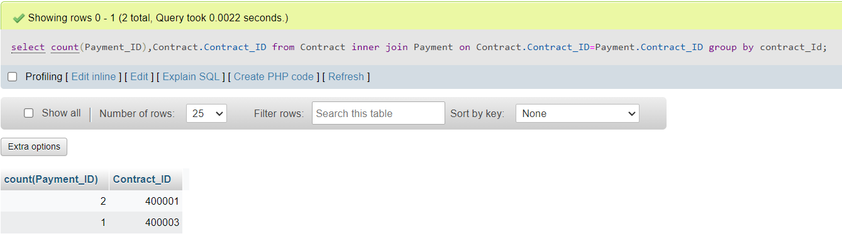

SELECT sum(payment.Amount),Contract.Contract_ID from Contract inner join Payment on Contract.Contract_ID=Payment.Contract_ID group by contract_Id;

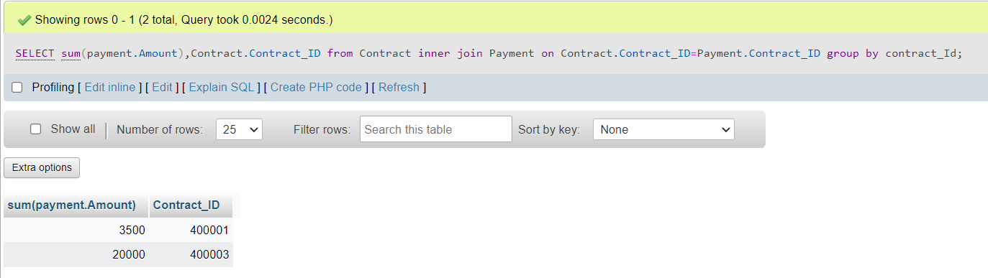

SELECT AVG(Rent_Cost) from house;

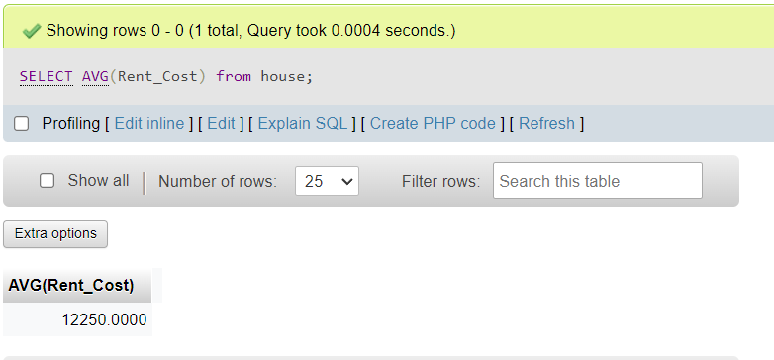

Select Contract.Contract_ID,Contract.Start_Date,Contract.Duration,Contract.Rent_Cost_Duration,Contract.Owner_ID,Contract.Tenant_ID,Contract.House_ID,count(Payment.Payment_ID),sum(Payment.Amount),rent_remain(sum(Payment.Amount),Rent_Cost_Duration) from Contract inner join Payment on Contract.Contract_ID=Payment.Contract_ID group by Contract_ID;

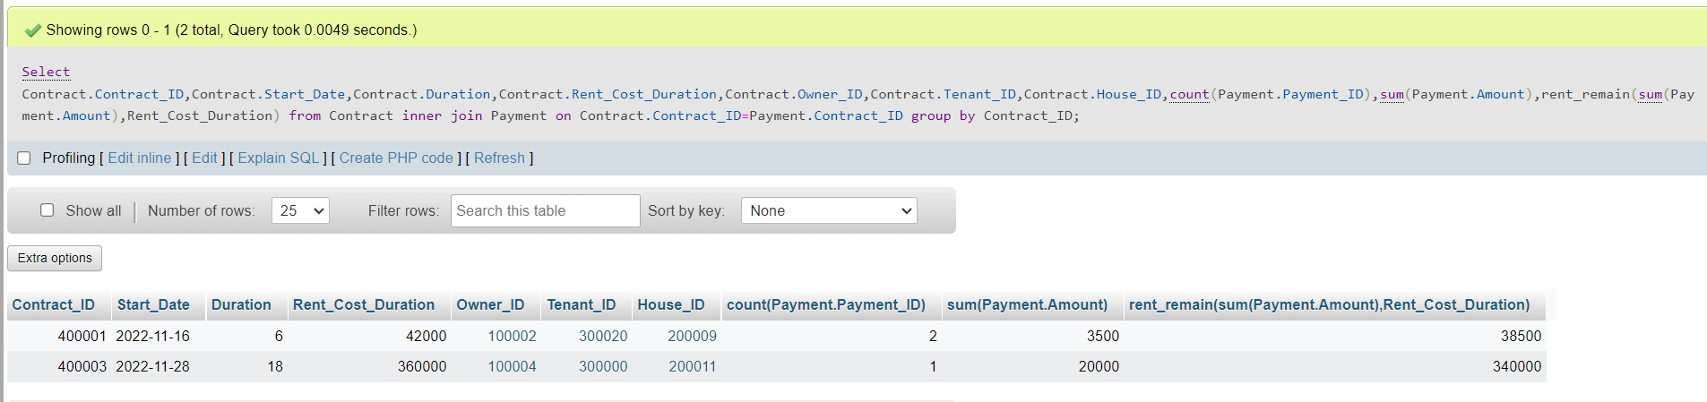

# Set Operations

Showcase at least 4 Set Operations queries

Write the query in English Language, Show the equivalent SQL statement and also a screenshot of the query and the results

SELECT * FROM house where (Rent_Cost > 10000) UNION Select * from house where (Rent_Cost<8000);

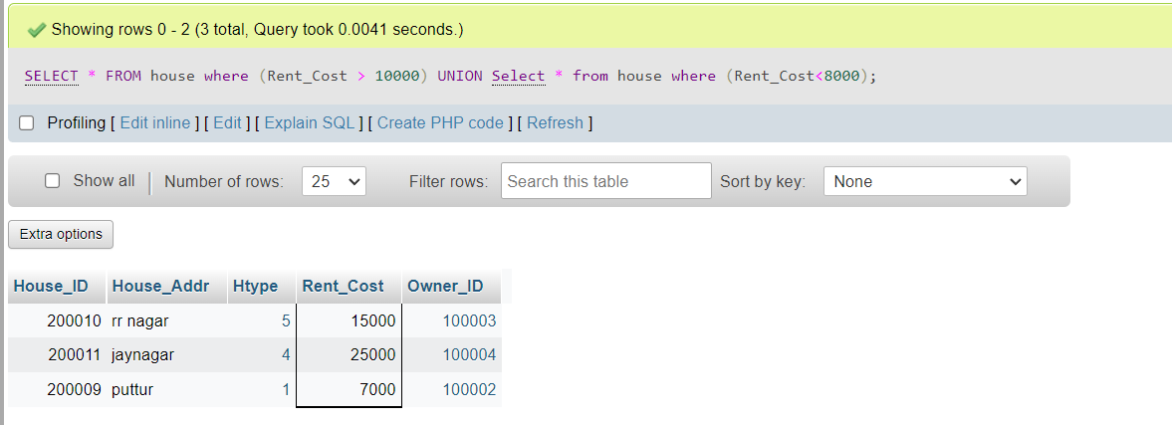

SELECT * FROM owner where (DOB ='2002-05-13') UNION Select * from owner where (DOB ='2002-01-28');

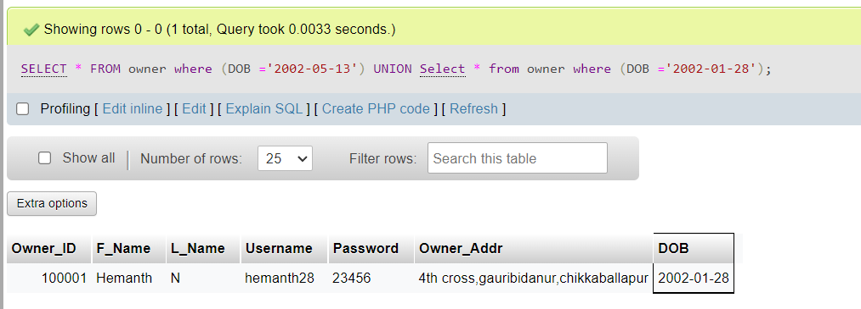

SELECT * FROM contract where (Start_Date>'2016-04-12') INTERSECT SELECT * from contract where (Duration = 9);

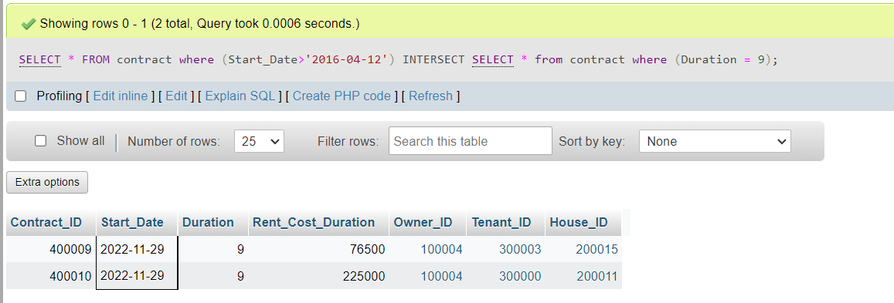

SELECT * FROM contract where (Start_Date = '2022-11-16') INTERSECT Select * from contract where (Duration<7);

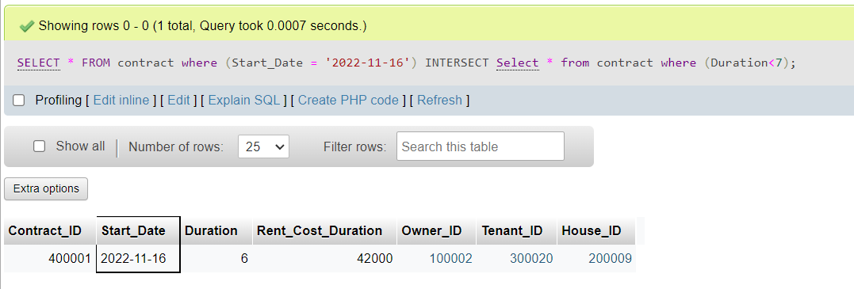

# Functions and Procedures

Create a Function and Procedure. State the objective of the function / Procedure. Run and display the results.

Functions:

DELIMITER $

CREATE FUNCTION rent_remain(Amount double,Total double)

  RETURNS double

   DETERMINISTIC

    BEGIN

        return Total-Amount;

    END $

delimiter ;

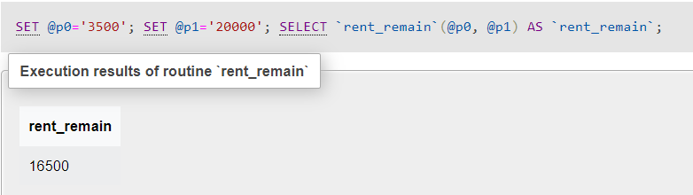

DELIMITER $

CREATE FUNCTION totalrent(duration int,Total double)

  RETURNS double

   DETERMINISTIC

    BEGIN

        return duration*Total;

    END $

delimiter ;

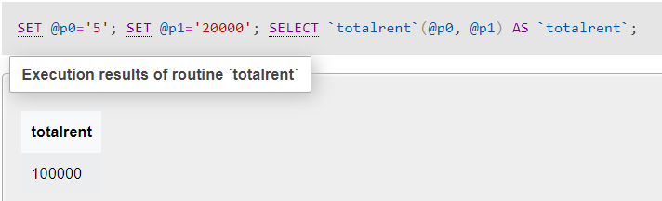

Procedures:

delimiter $

create Procedure end_date_calc(IN start_date date,IN duration int, OUT end_date date)

begin

    select date_add(`start_date`, INTERVAL `duration` MONTH) into end_date;

end $

delimiter ;

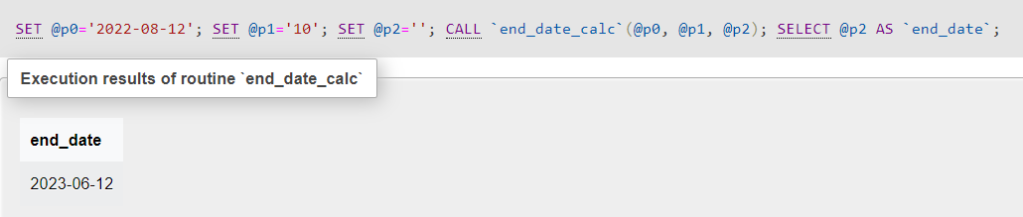

create Procedure age_dob(IN dob date, OUT age int)

begin

    SELECT DATE_FORMAT(FROM_DAYS(DATEDIFF(NOW(), dob)), '%Y') + 0 AS age

into age;

end $

delimiter ;

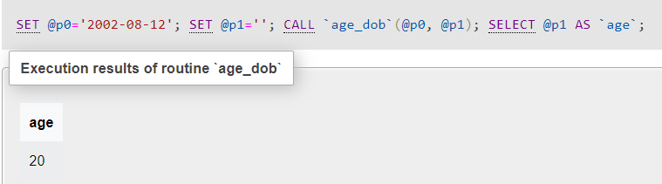

# Triggers and Cursors

Create a Trigger and a Cursor. State the objective. Run and display the results.

**Cursor**:

For creating a backup:

DELIMITER $$

CREATE PROCEDURE backup_member()

BEGIN

DECLARE done INT DEFAULT 0;

DECLARE Owner_ID INTEGER;

DECLARE Start_Date DATE;

DECLARE cur CURSOR FOR SELECT Owner_ID,start_date FROM contract ;

DECLARE CONTINUE HANDLER FOR NOT FOUND SET done = 1;

OPEN cur;

label: LOOP

FETCH cur INTO Owner_ID,Start_Date;

INSERT INTO backup VALUES(Owner_ID,Start_Date);

IF done = 1 THEN LEAVE label;

END IF;

END LOOP;

CLOSE cur;

END$$

DELIMITER ;

--Creating backup table:

CREATE TABLE backup(Owner_ID int,Start_Date DATE);

-- CALL THE PROCEDURE:

CALL backup_member();

--SHOW THE Backup TABLE created due to this cursor :

SELECT * FROM backup;

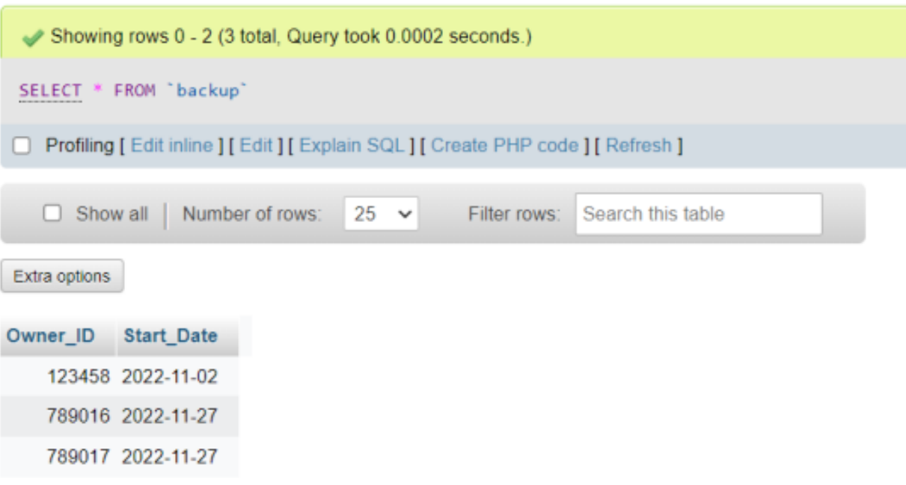

**Trigger:**

c.execute(" drop trigger if exists amount_exceed")

        qrystr = ("""  delimiter // \n"

                "  CREATE TRIGGER mytrigger BEFORE INSERT ON  Payment FOR EACH ROW \n"

                "  BEGIN \n"

                "   IF (select sum(Amount) from Payment group by Contract_ID={}) > {} THEN \n"

                "      SIGNAL SQLSTATE '45000' SET message_text="Amount can't exceed total Rent Cost";\n"

                "   END IF;\n"

                "  END;//\n"

                "  delimiter ; \n""".format(Contract_ID,totalrent))

        c.execute(qrystr)

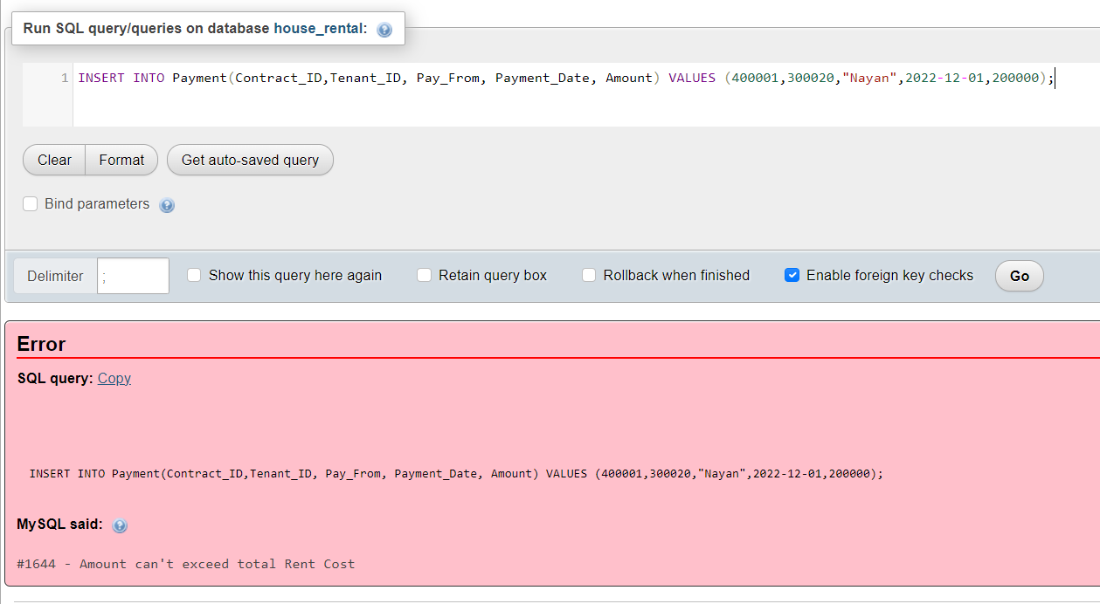

# Developing a Frontend

The frontend should support

1. Addition, Modification and Deletion of records from any chosen table

**FrontEnd**

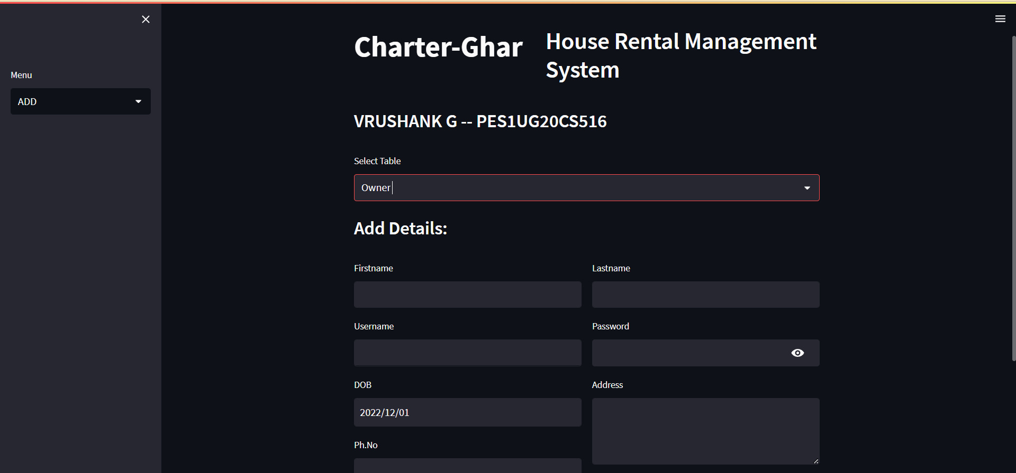

**Addition**

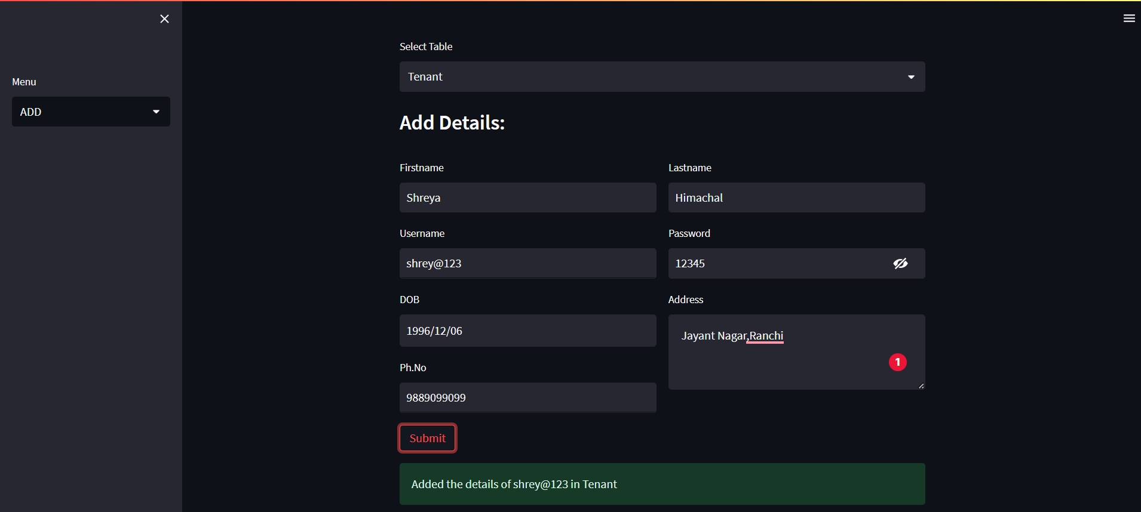

**Reading**

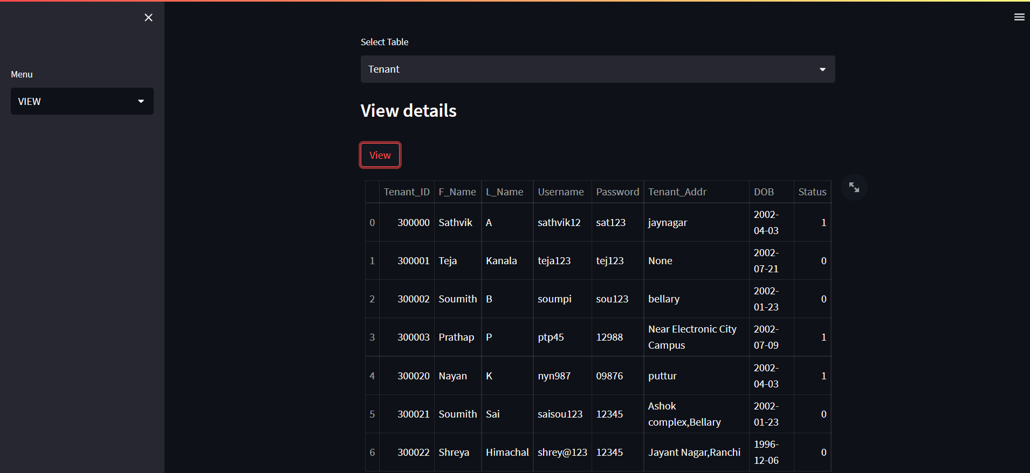

**Updation**

Before Update:

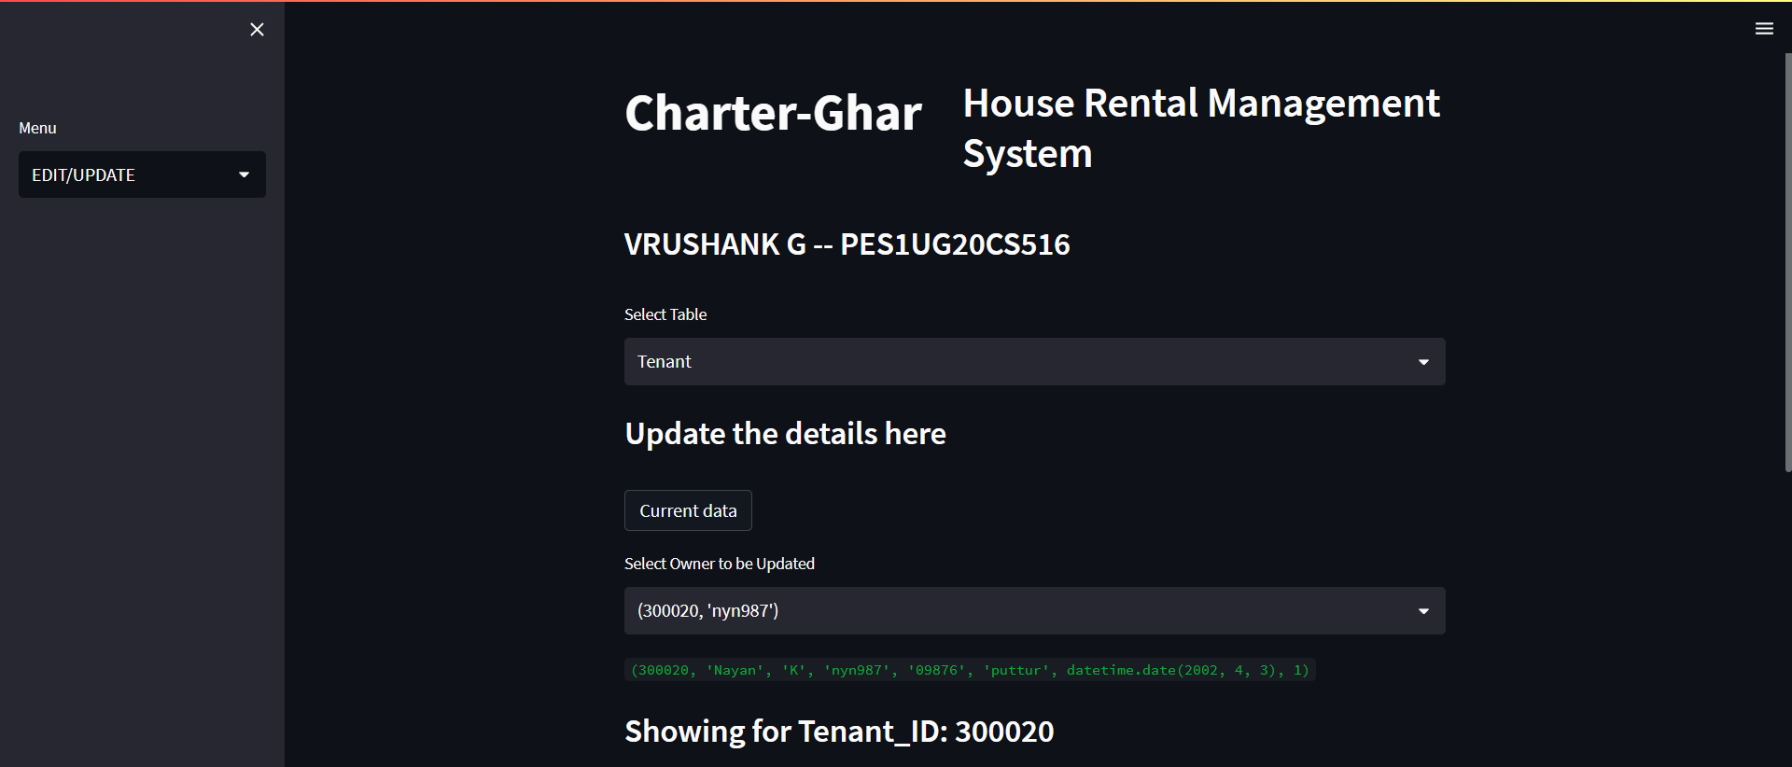

After Update:

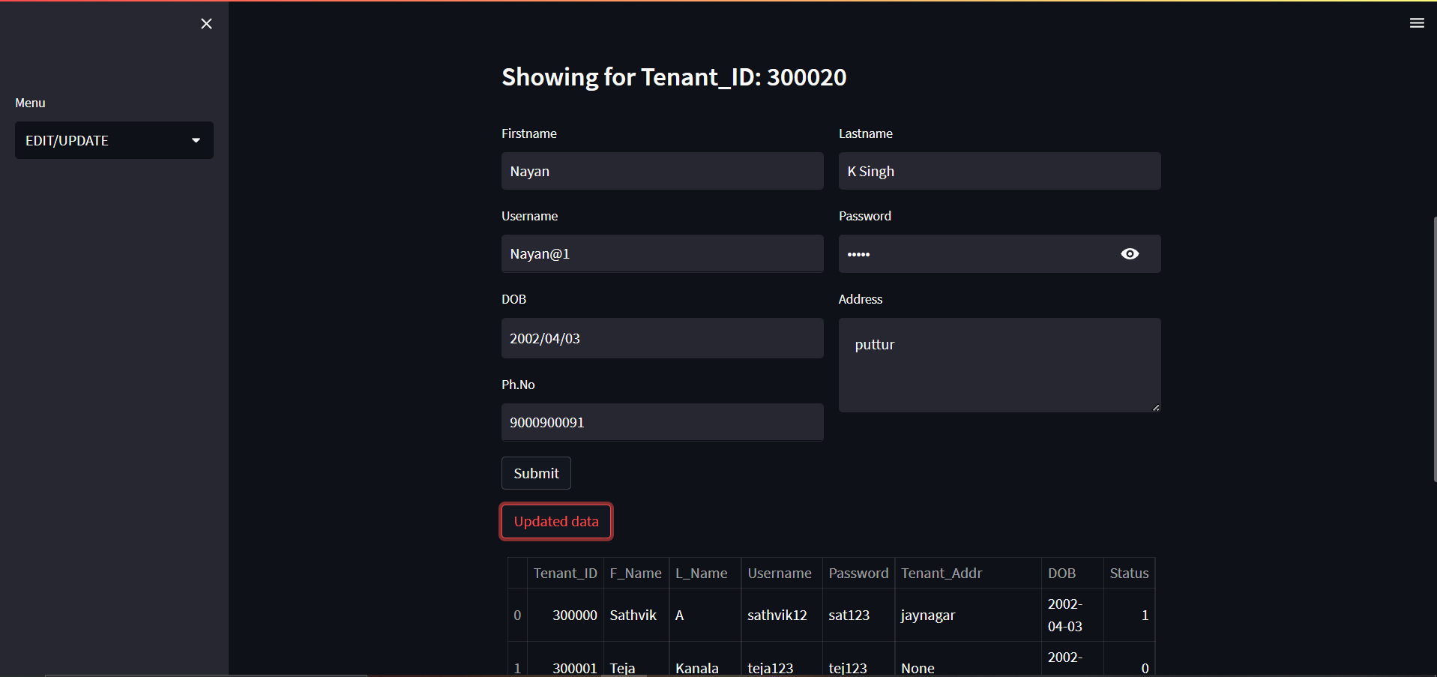

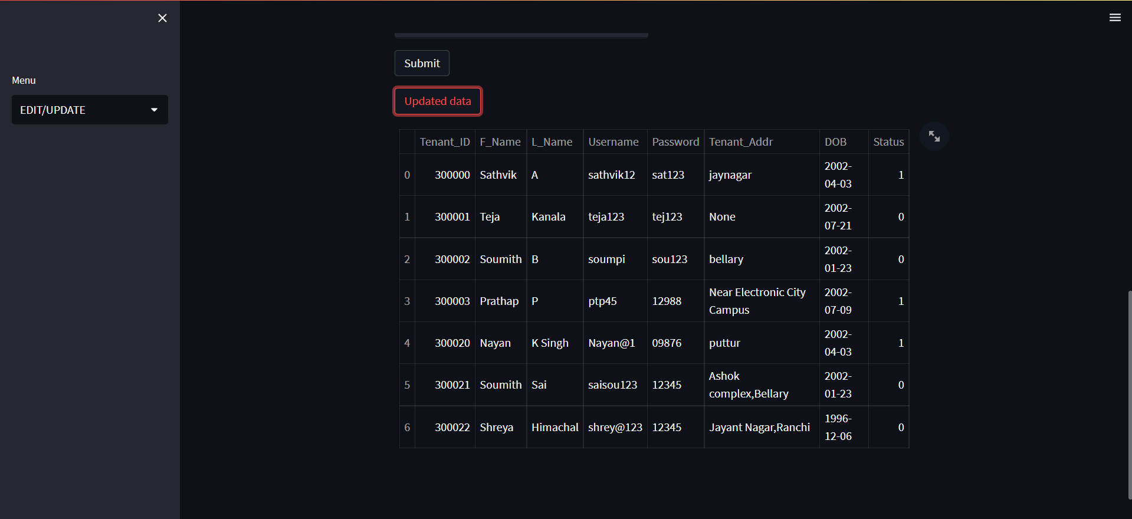

**Deletion:**

Before deletion:

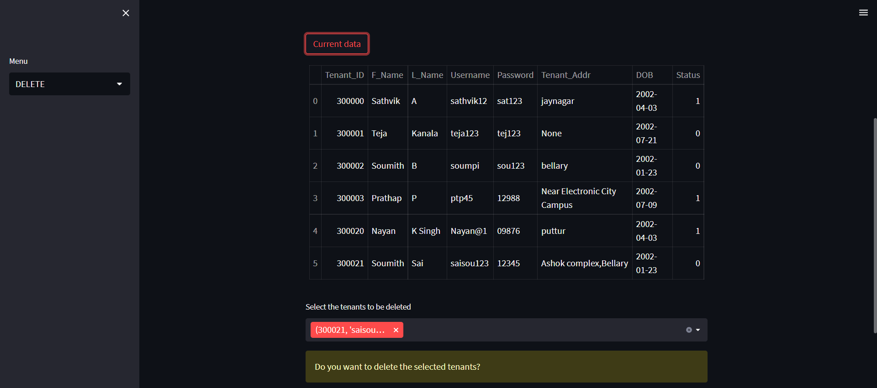

After deletion:

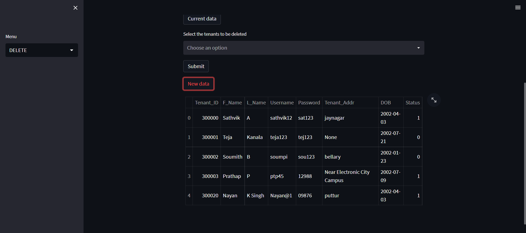

**Other Functional Features**

Get a new Contract:

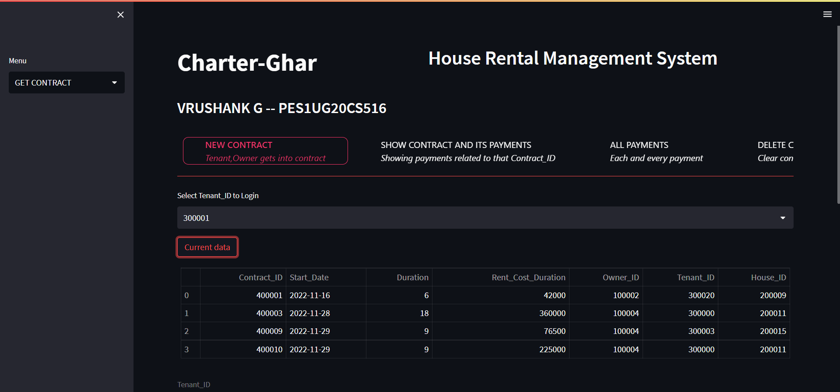

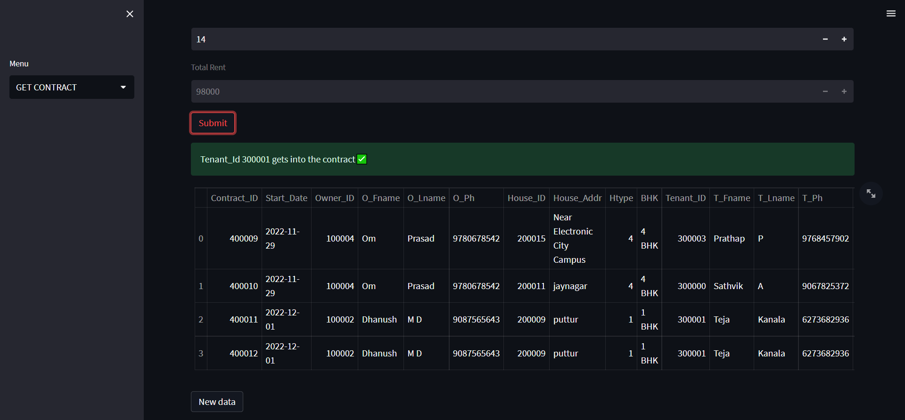

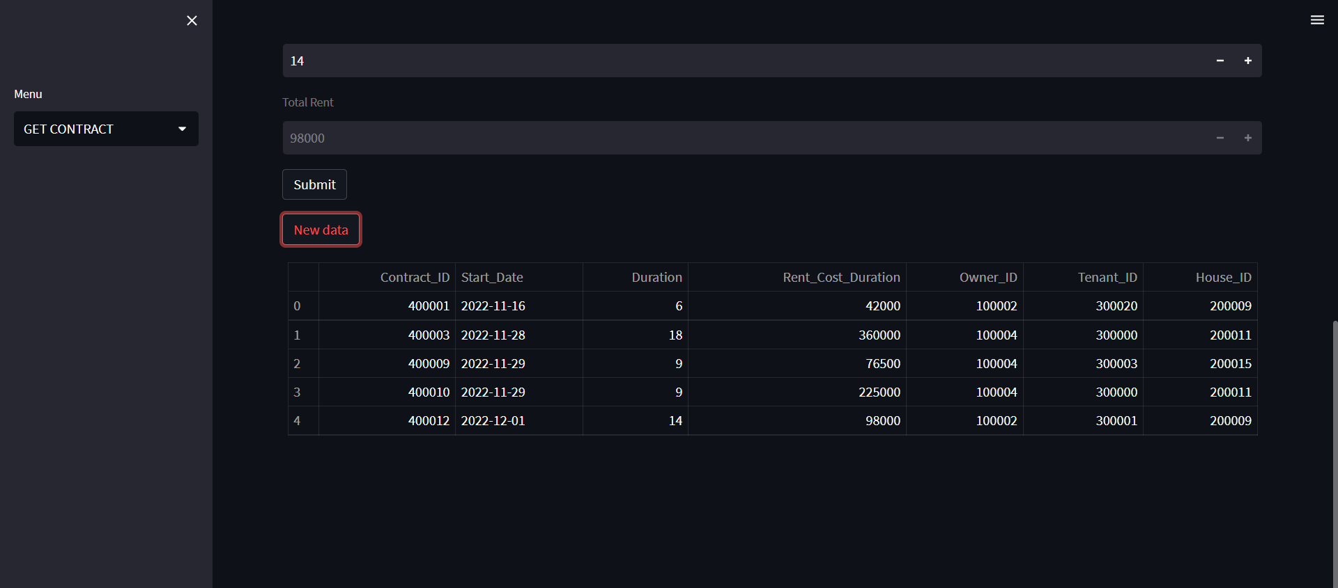

Show Contract and Payment details of that contract

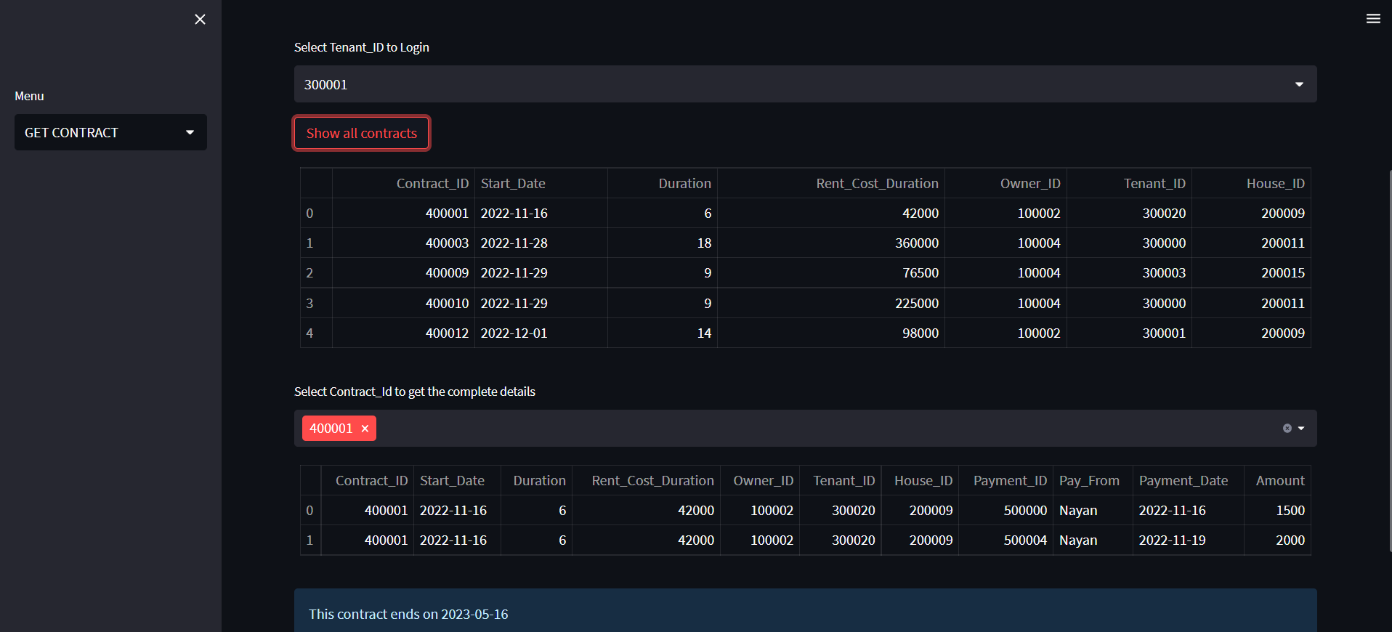

All payments

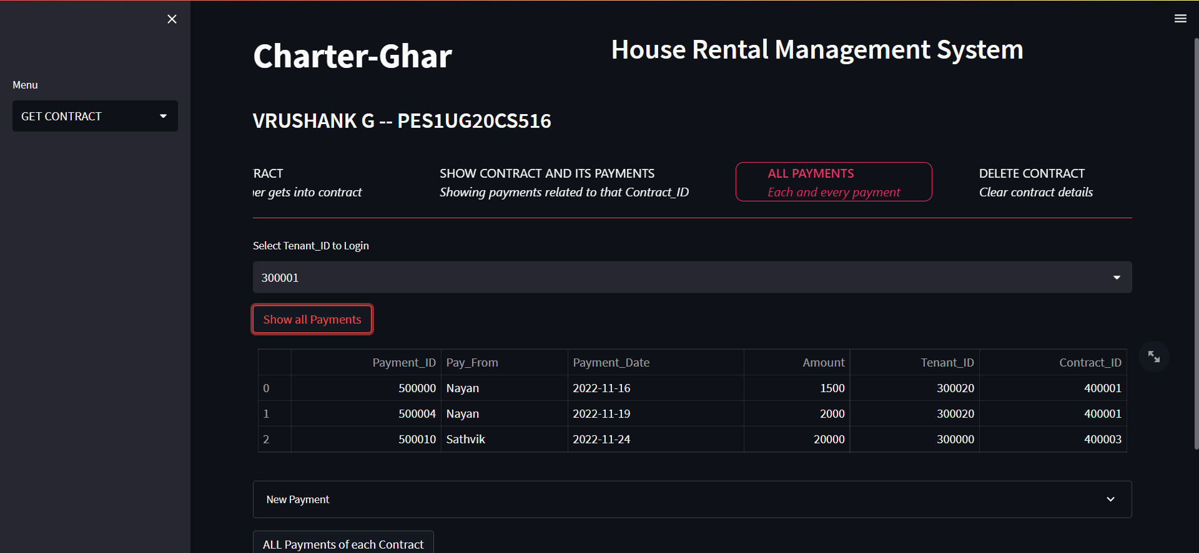

Delete Contract and related Payments

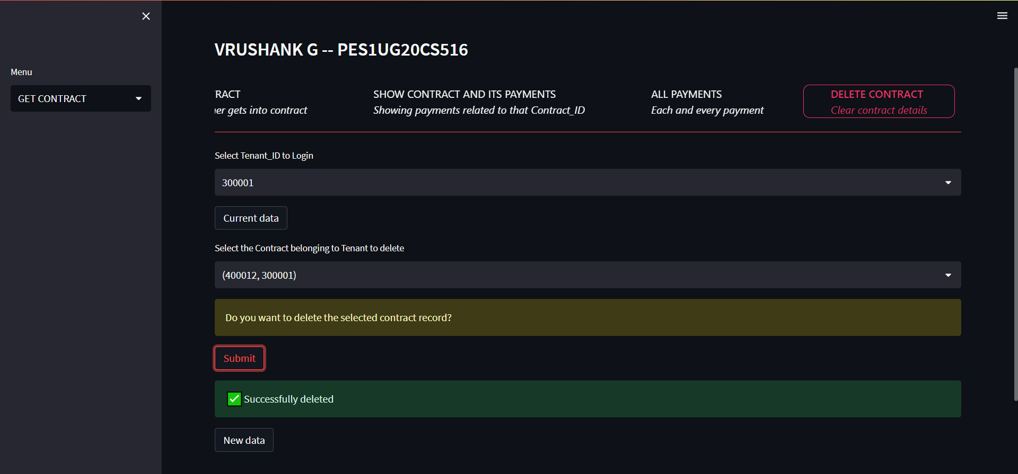

1. There should be an window to accept and run any SQL statement and display the result

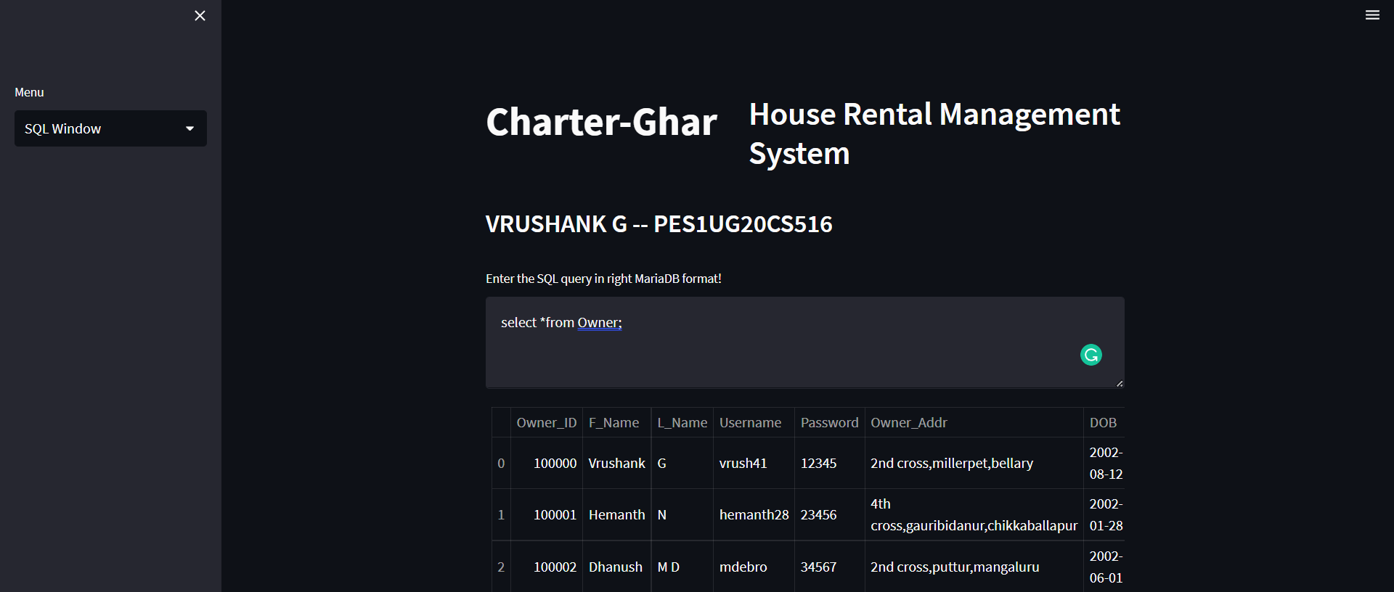

3.Modification suggested:

Trigger to display all the Contract details including Tenant details,House details,Owner details

Clearly after inserting into contract table

