DBMS-LAB1

# SRN: PES1UG20CS516 SEC:’I’

# NAME: VRUSHANK G

Entity Diagram:

1(a).

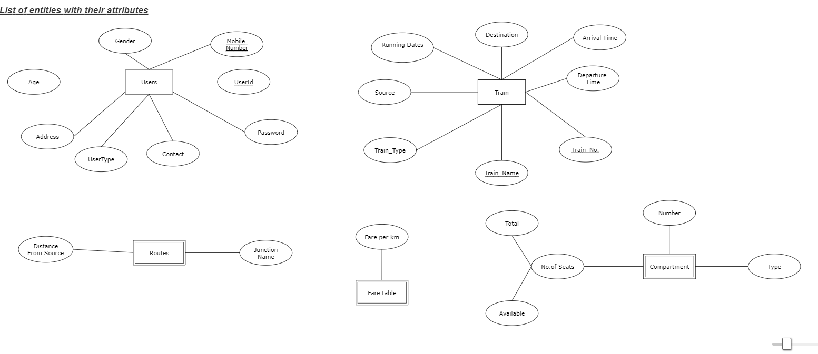

1(b).

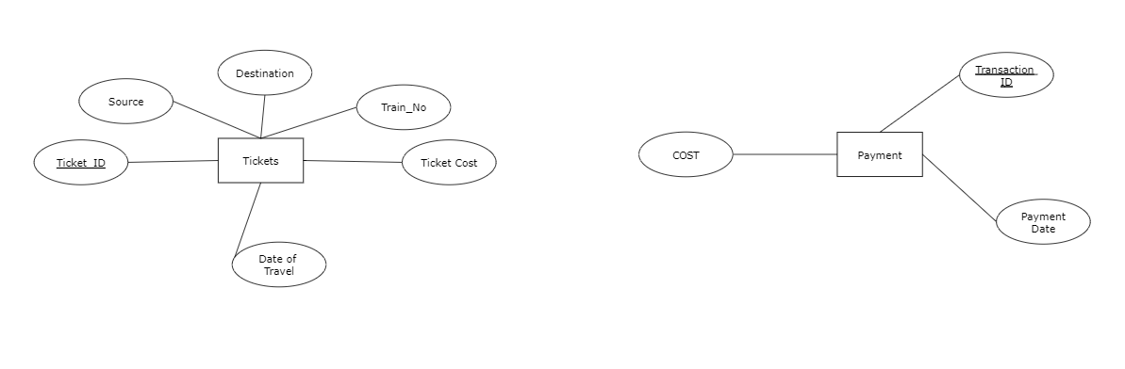

Relationships:

2(a):

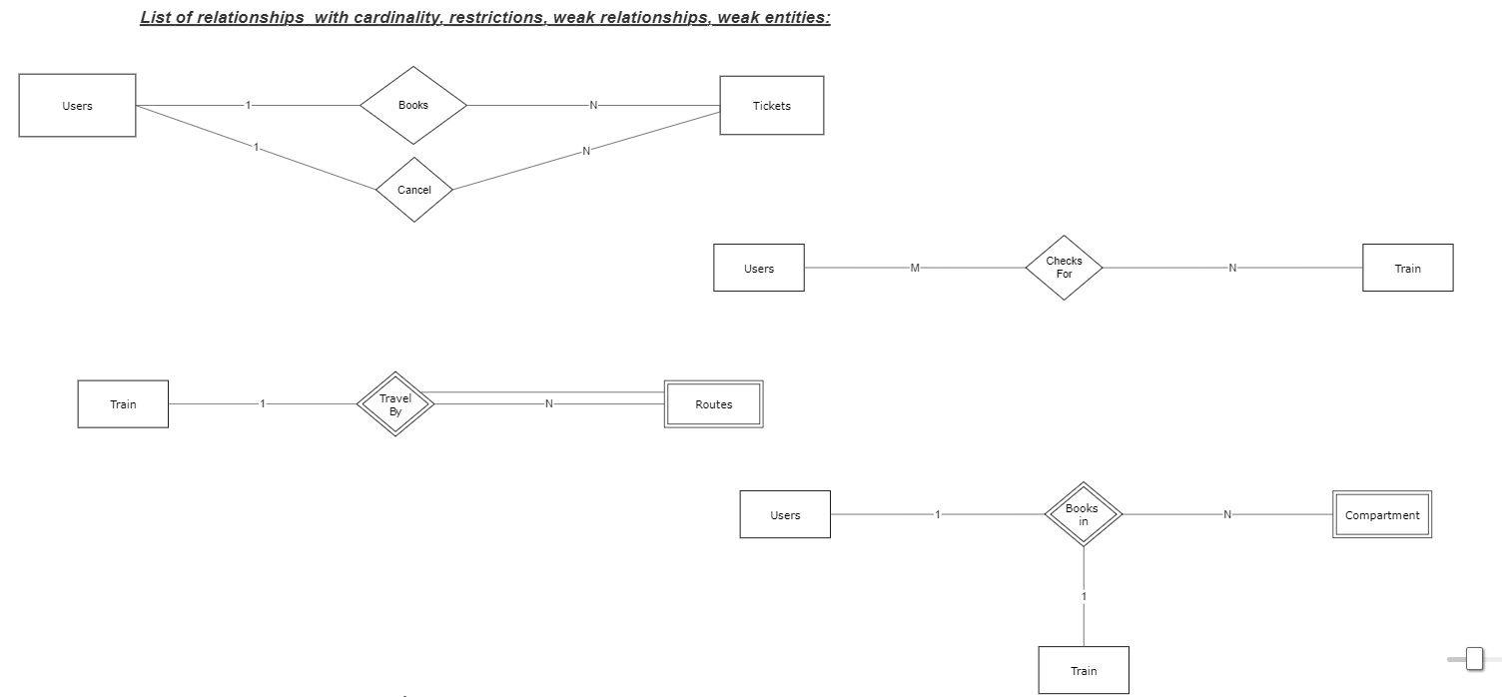

2(b):

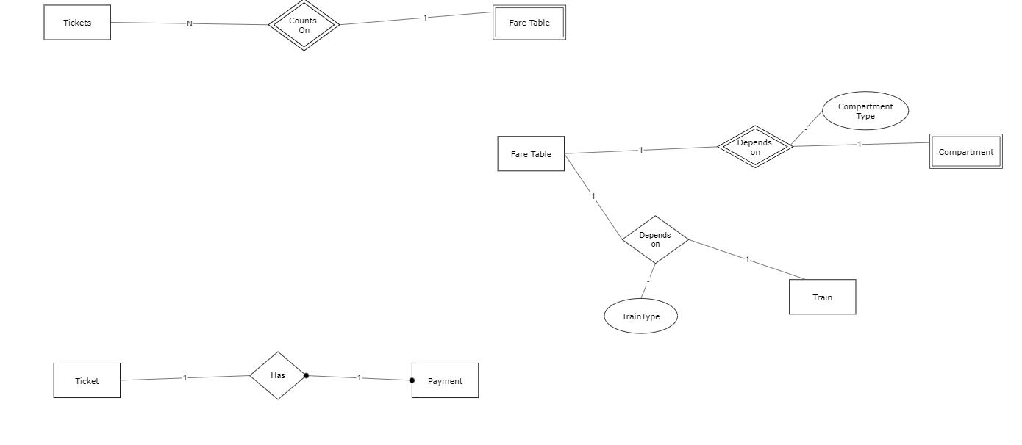

ER Diagram:

