Lab 10 -Connecting a Python Application to a MySQL Database

## Screenshot of database with the table - ‘train’ before populating it.

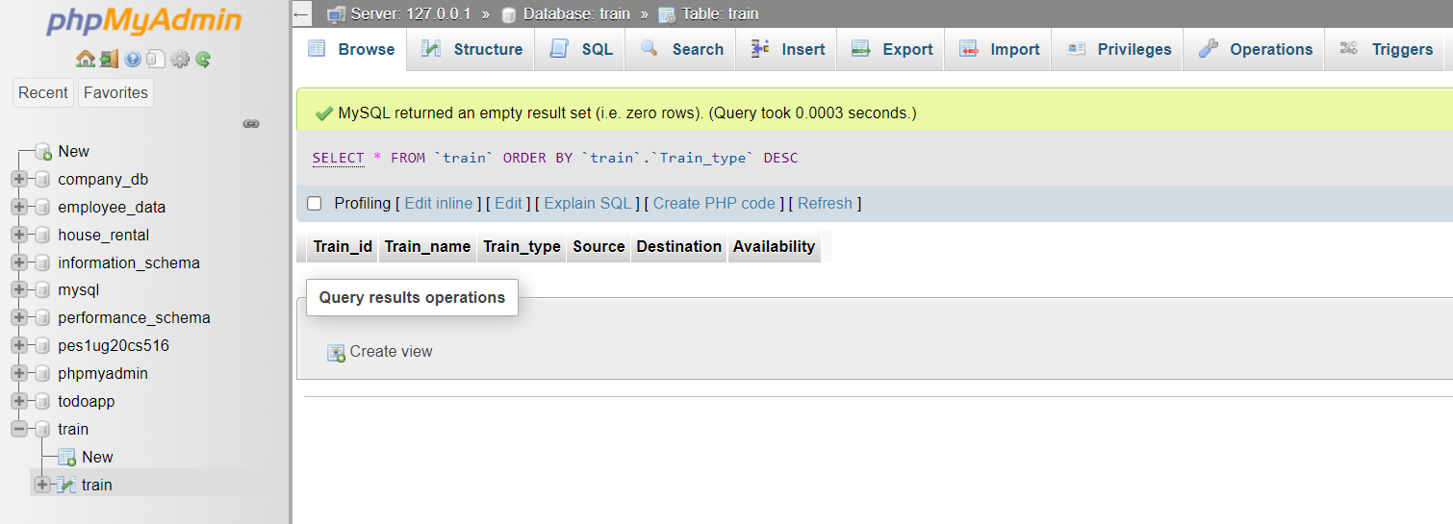

## Screenshot of the User Interface.

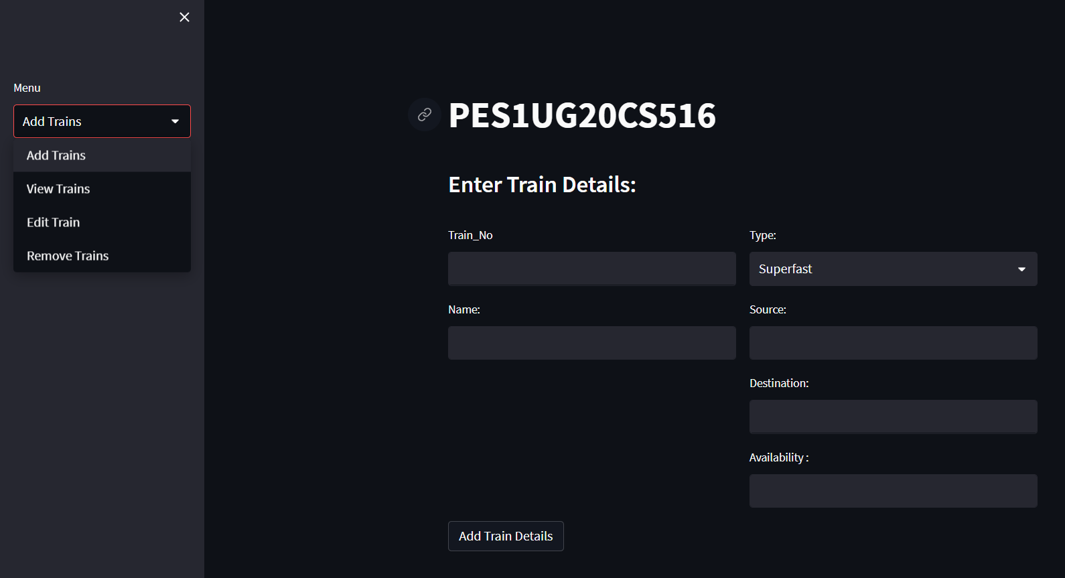

## Screenshot of the 3 records in the train table from MySQL WorkBench.

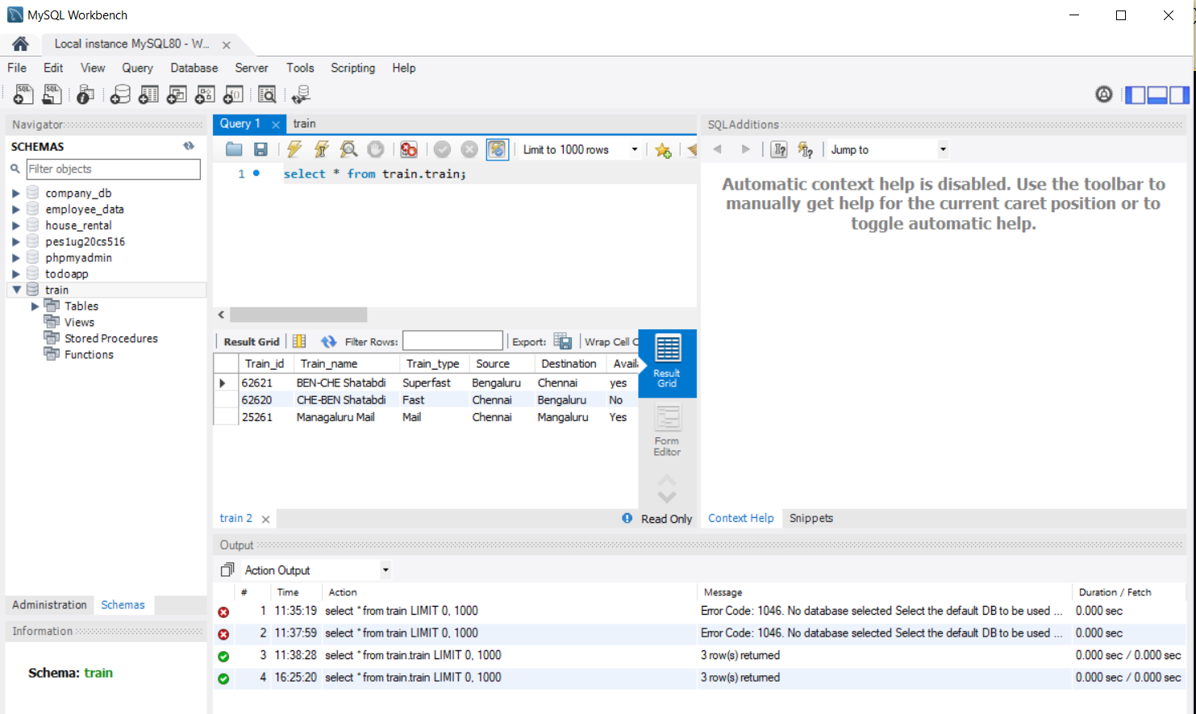

## Screenshot of the same 3 records visualised in the User Interface.

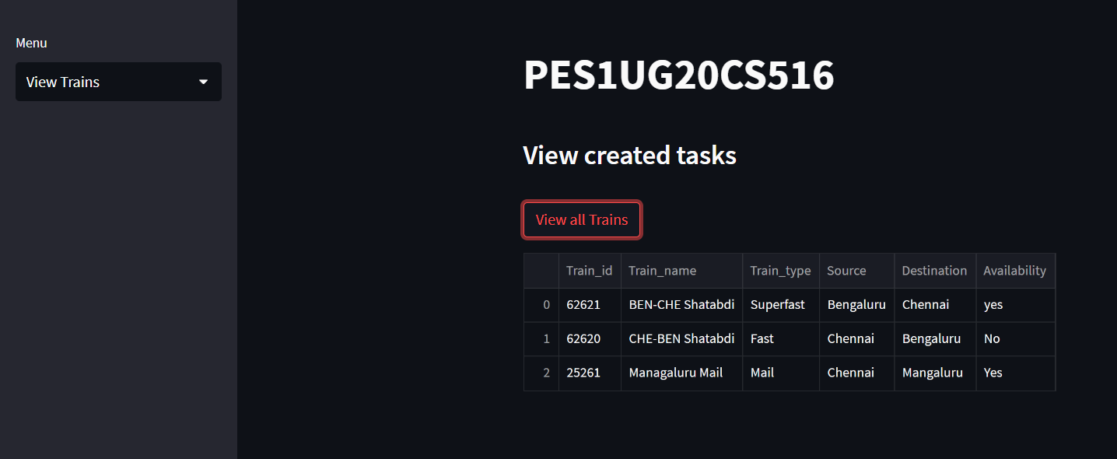

## Screenshot of Updated Train_No 62620 in the User-Interface.

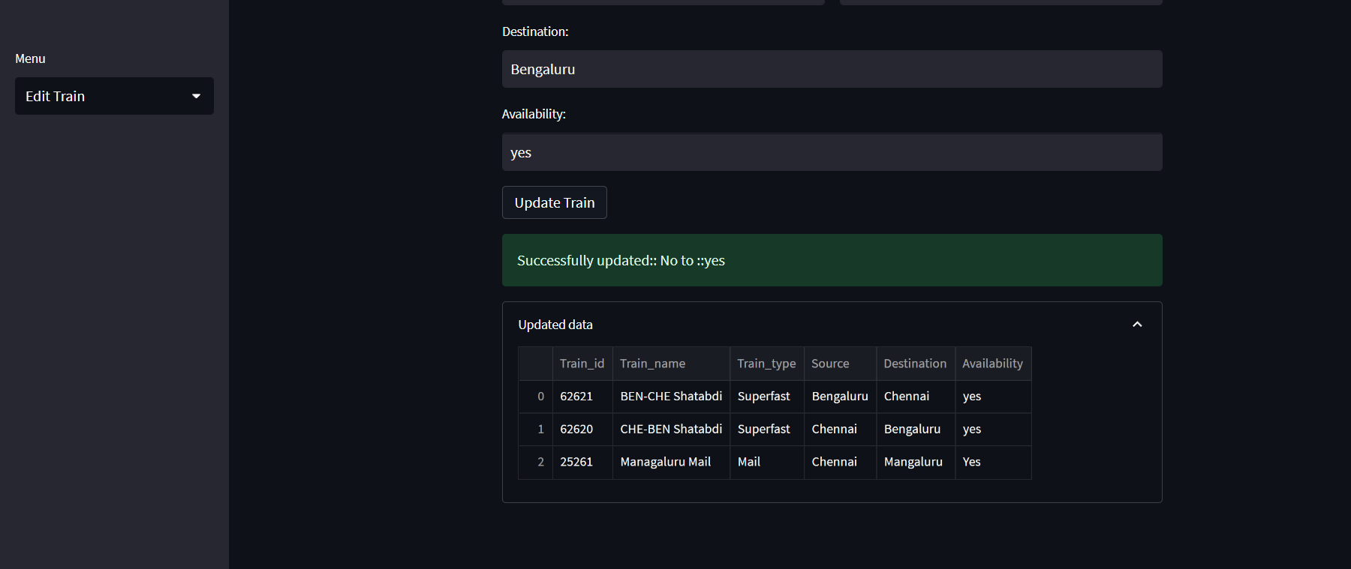

## Screenshot of User-Interface after the Train_No 25261 has been deleted.

