Create new Database:

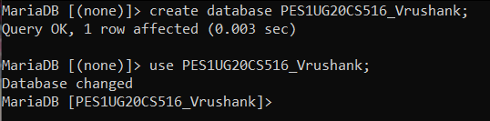

Create Table Train:

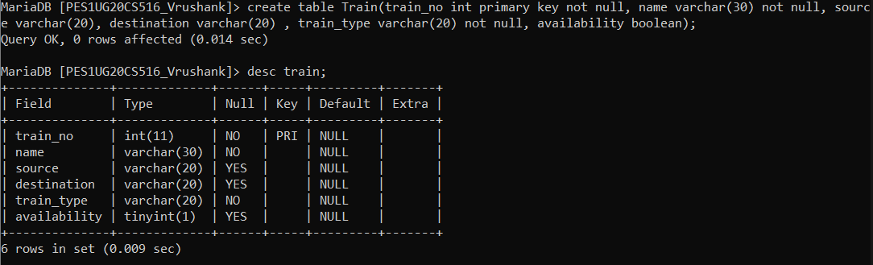

Create Table Compartment:  
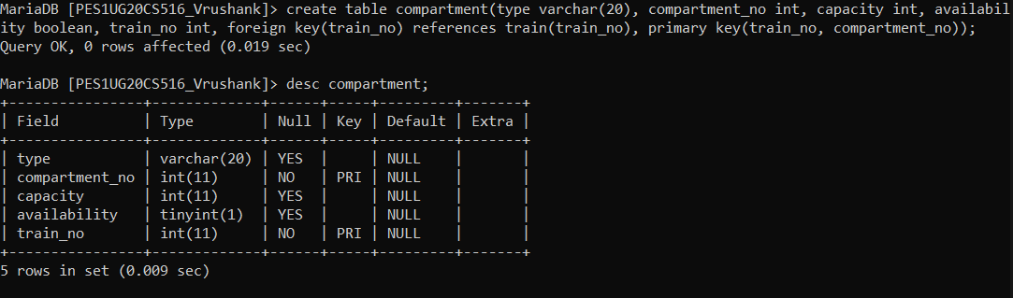

Alter Table Compartment add default availability to true:

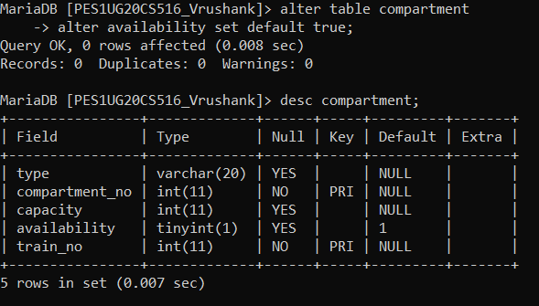

Create Table Route Info:

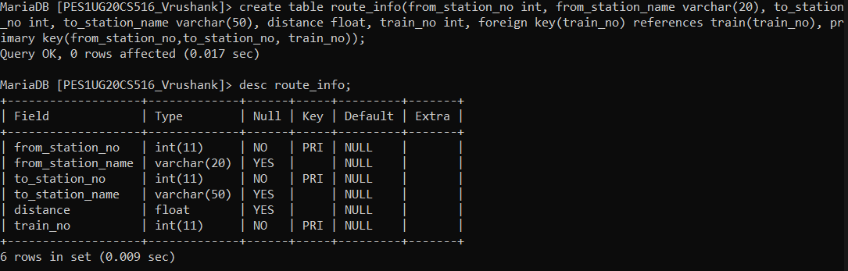

Create Table User:

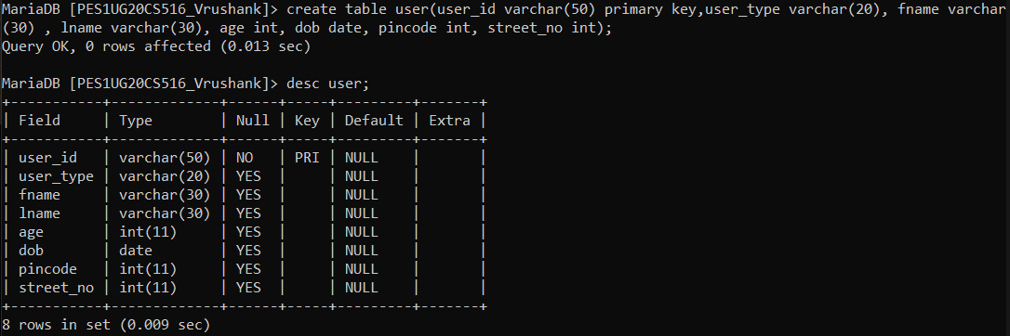

Create Table User Train:  
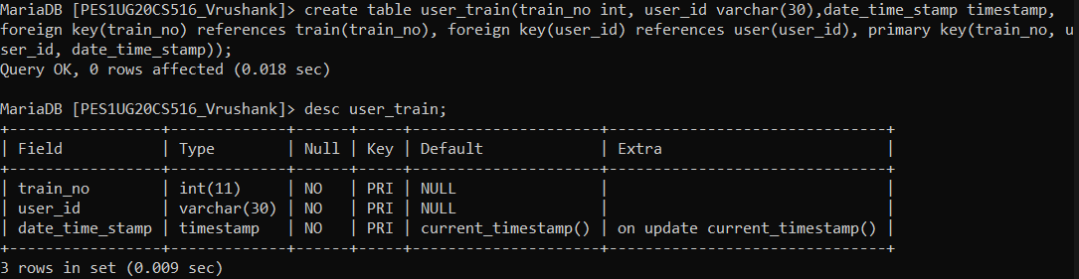

Create Table User Phone:  
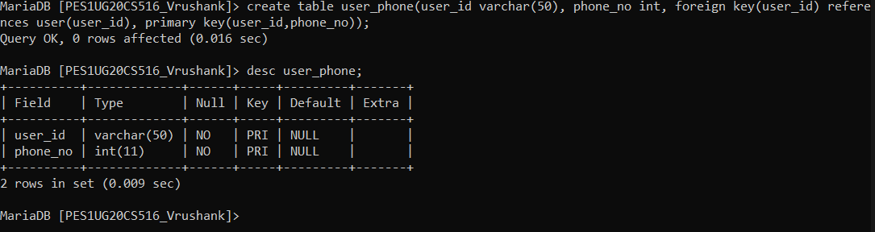

Create Table Ticket:  
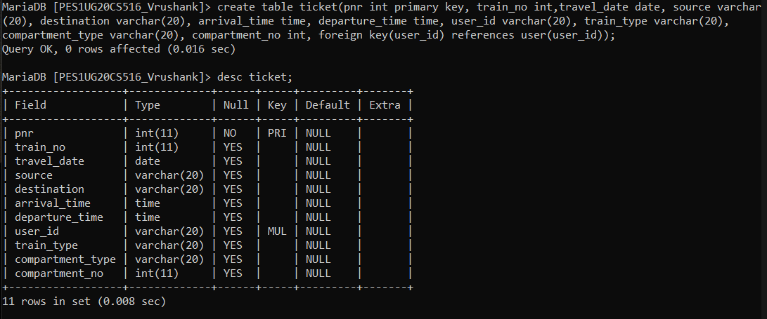

Create Table Payment Info:  
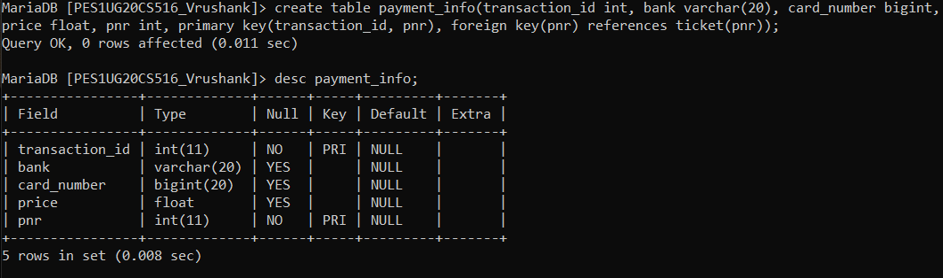

Create Table Ticket Passenger:

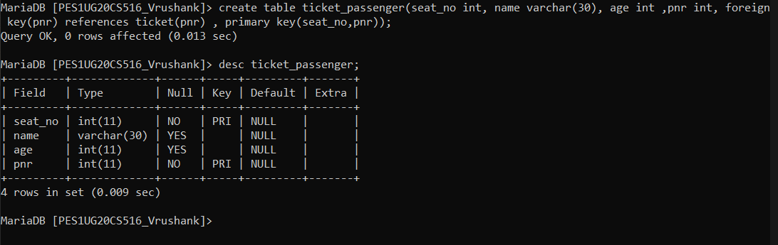

Create Table Fare Info:

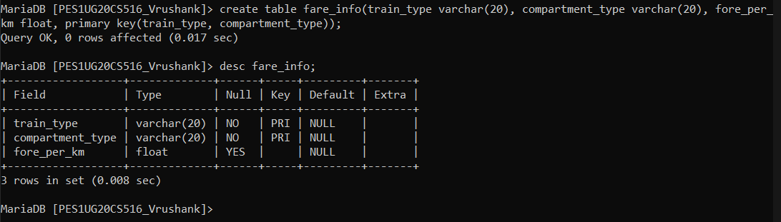

Create add check constraint for age > 5 in user table:

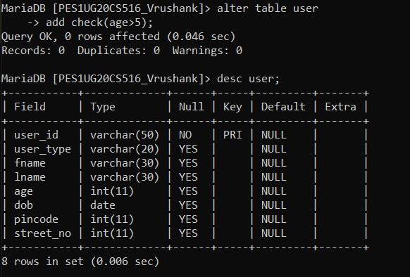

Rename Table:

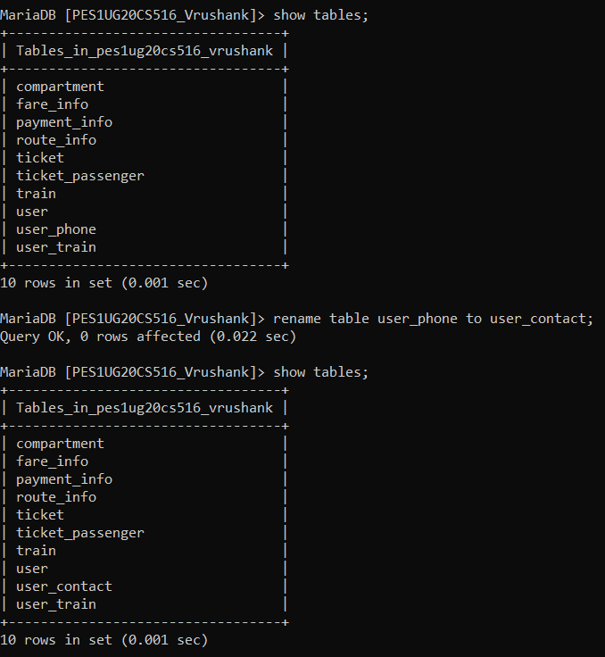

Insert values into table:  
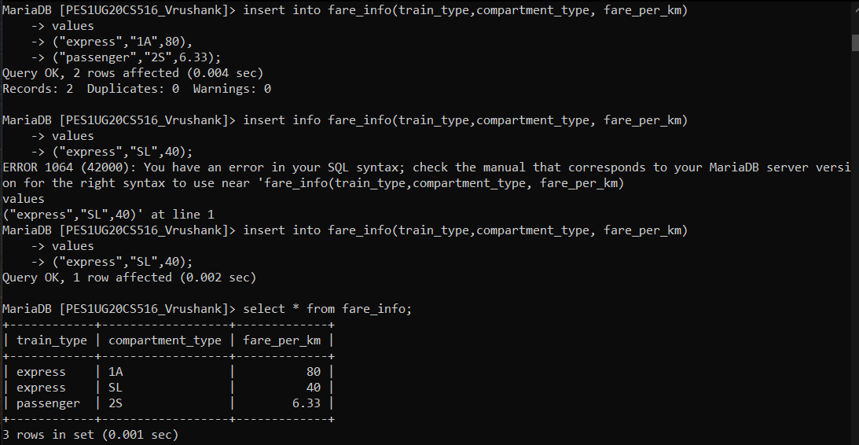

Create view:  
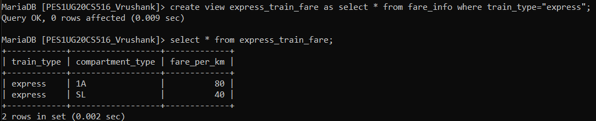

Drop view:

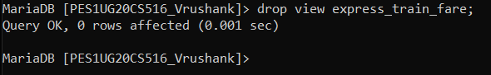

Truncate Table:  
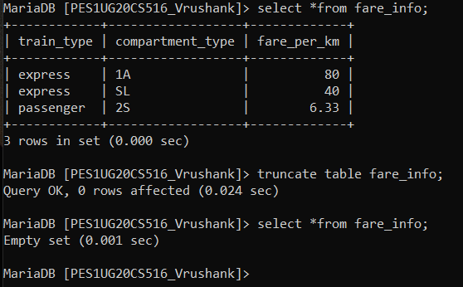

Drop table

