# Task-I: Use INSERT/SELECT/UPDATE queries for the following tasks:

## 1. Insert the shared data into the respective tables using appropriate insert query.

## • Show the usage of INSERT and LOAD DATA INFILE commands explicitly

## 

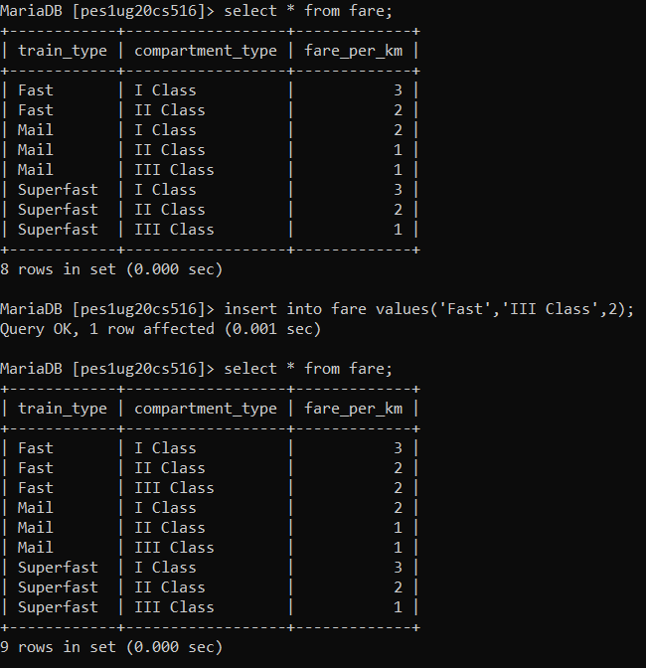

## 2. Calculate and update age attribute in User Table.

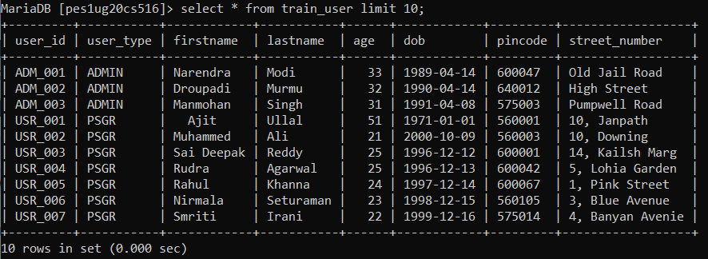

## 3. Display all the route information whose distance falls in a range from 70 to 150 km.

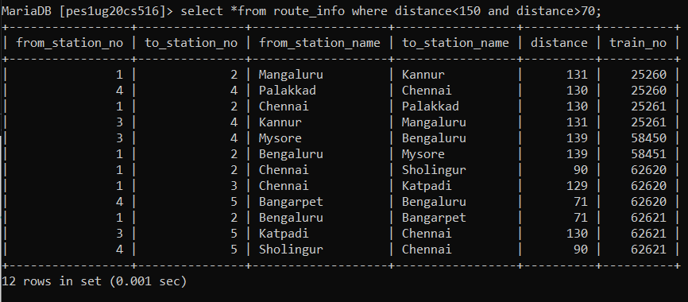

## 4. Display the train route information which are run between Chennai and Sholingur

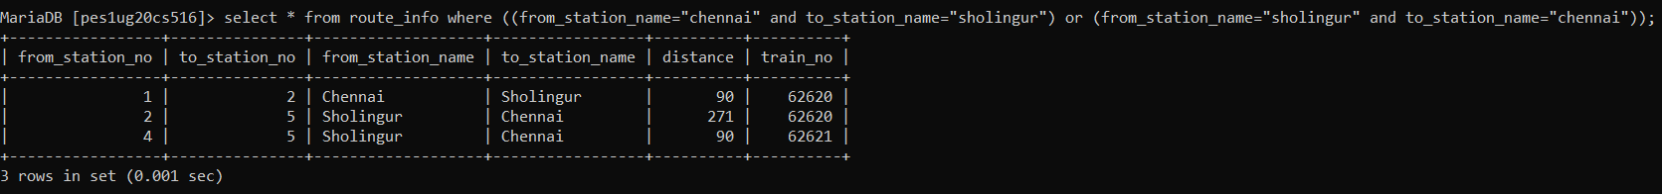

## 5. Display the train details whose type is not mail.

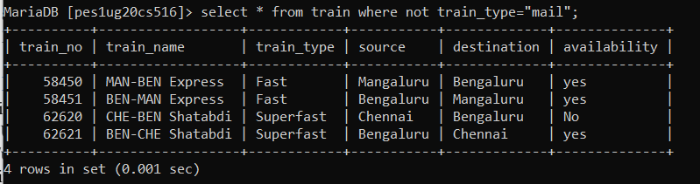

## 6. Display the train name which goes to Chennai from Bengaluru.

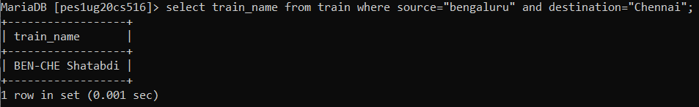

## 7. Display the list of trains starting from Chennai after 8:00.

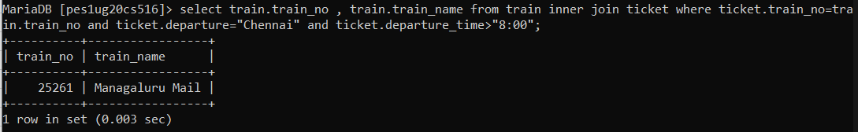

## 8. Display the list of users who are born between 1980 to 1990.

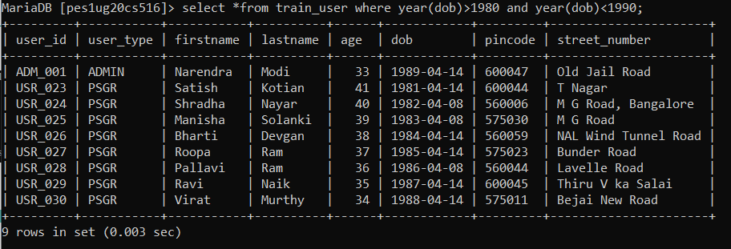

## 9. Display the train users whose name starts with the letter ‘S’

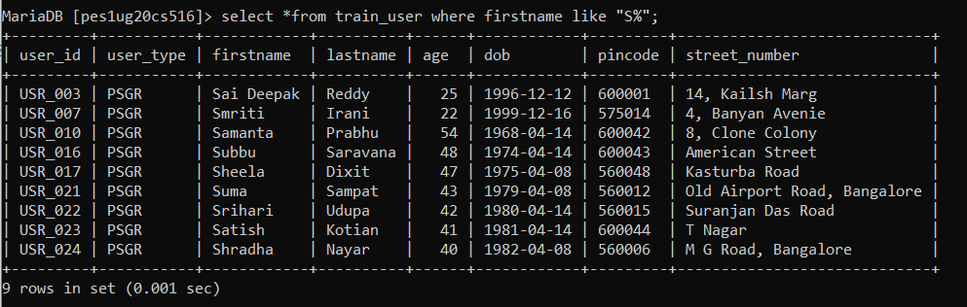

## 10. Find the availability of I Class compartment of the train number 62621

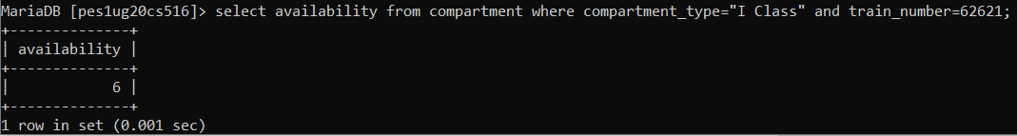

## 11. Find the PNR and Transaction ID of the users who made payment via Union Bank.

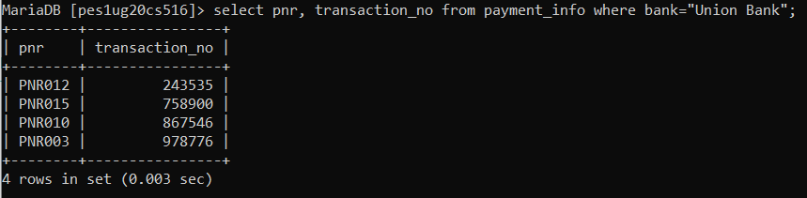

# Task-II: Use DCL and TCL statements for the following:

## Grant privileges on different tables to users and observe the effect.



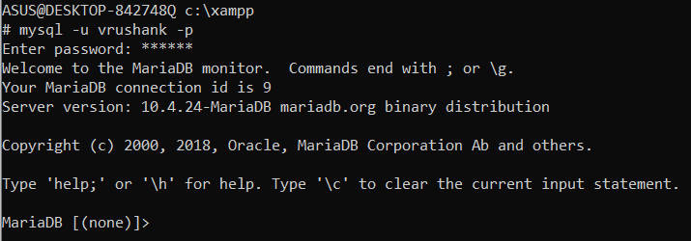







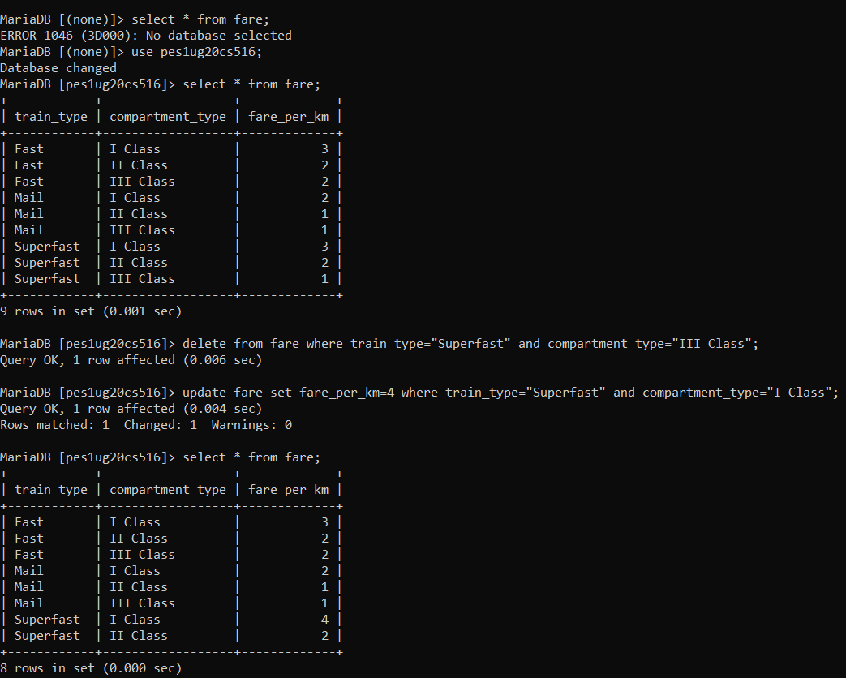

## Revoke UPDATE & DELETE privileges on any tables and observe the effect if any deletion/ updation is performed.



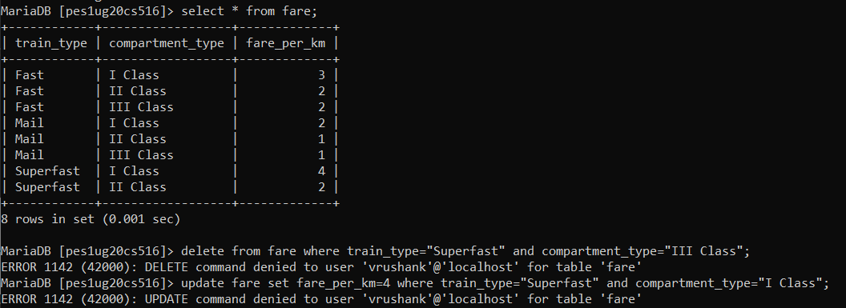

## Create different save points and perform some insert/update/delete operations. Observe the effect of commit & rollback operations and release any created savepoints.

Task-2_3.sql file:

START TRANSACTION;

SAVEPOINT S1;

UPDATE ticket_passenger

SET

    seat_no = "S01-29",

    name = "vrushank",

    age = 19

WHERE pnr = "PNR015";

(SELECT * FROM ticket_passenger ORDER BY pnr DESC limit 5) ORDER BY pnr ASC;

SAVEPOINT S2;

INSERT INTO ticket_passenger

VALUES

(

    "S01-30",

    "Y Srinivas",

    20,

    "PNR020"

);

(SELECT * FROM ticket_passenger ORDER BY pnr DESC limit 5) ORDER BY pnr ASC;

ROLLBACK TO S2;

(SELECT * FROM ticket_passenger ORDER BY pnr DESC limit 5) ORDER BY pnr ASC;

ROLLBACK TO S1;

(SELECT * FROM ticket_passenger ORDER BY pnr DESC limit 5) ORDER BY pnr ASC;

