# Task-II: Use DCL and TCL statements for the following:

## Grant privileges on different tables to users and observe the effect.



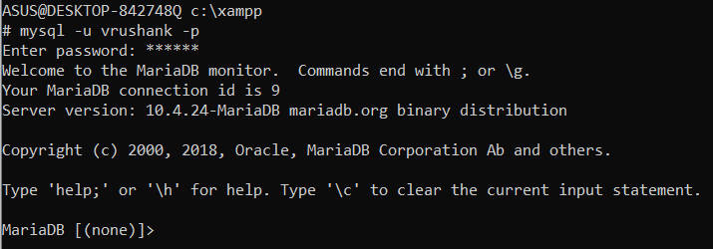







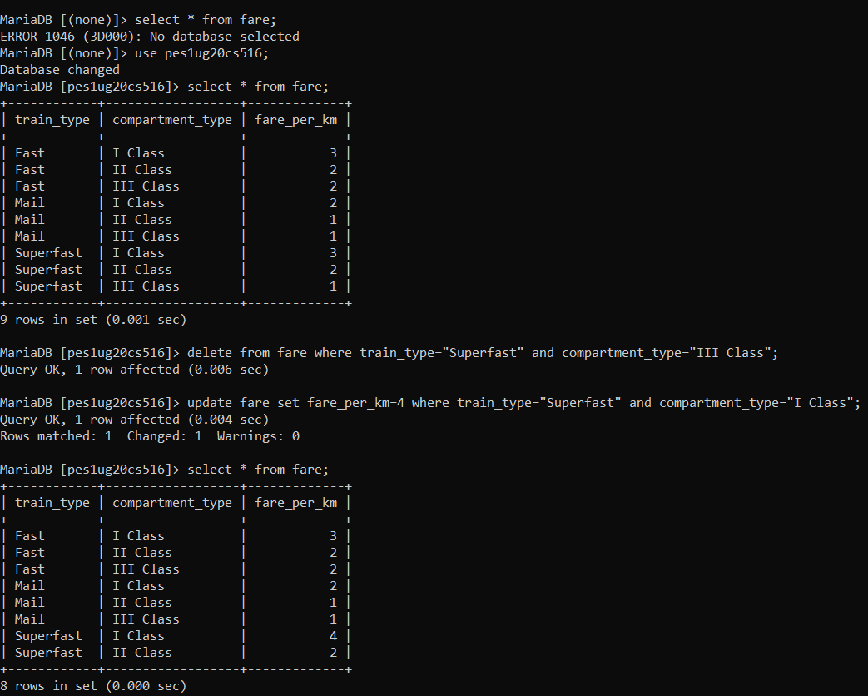

## Revoke UPDATE & DELETE privileges on any tables and observe the effect if any deletion/ updation is performed.



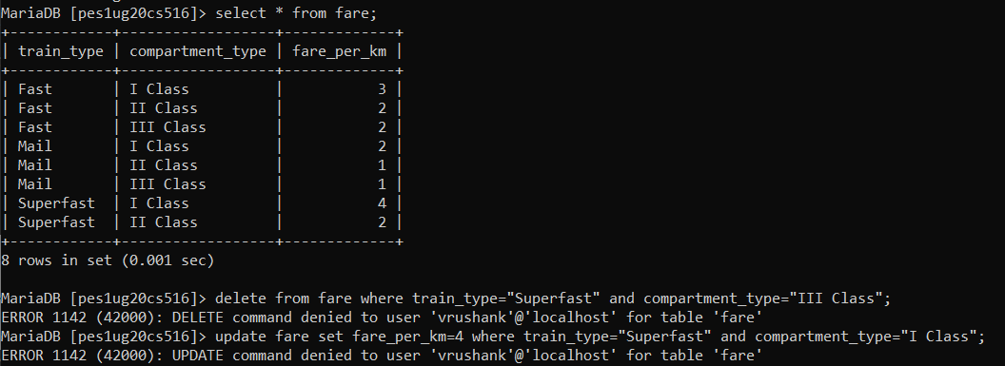

## Create different save points and perform some insert/update/delete operations. Observe the effect of commit & rollback operations and release any created savepoints.

Task-2_3.sql file:

START TRANSACTION;

SAVEPOINT S1;

UPDATE ticket_passenger

SET

    seat_no = "S01-29",

    name = "vrushank",

    age = 19

WHERE pnr = "PNR015";

(SELECT * FROM ticket_passenger ORDER BY pnr DESC limit 5) ORDER BY pnr ASC;

SAVEPOINT S2;

INSERT INTO ticket_passenger

VALUES

(

    "S01-30",

    "Y Srinivas",

    20,

    "PNR020"

);

(SELECT * FROM ticket_passenger ORDER BY pnr DESC limit 5) ORDER BY pnr ASC;

ROLLBACK TO S2;

(SELECT * FROM ticket_passenger ORDER BY pnr DESC limit 5) ORDER BY pnr ASC;

ROLLBACK TO S1;

(SELECT * FROM ticket_passenger ORDER BY pnr DESC limit 5) ORDER BY pnr ASC;

