**Lab 5 - SQL – Joins: Inner, Outer; Sub queries: Correlated and Uncorrelated**

## 1.Update price of the ticket.

## a. Create a view compute_price as below

## CREATE VIEW compute_price AS

## SELECT Ticket.PNR, Ticket.Train_No, Ticket.Departure, Ticket.Arrival,

## Route_Info.Distance, Fare.fare_per_km

## FROM Ticket, Route_Info, Fare

## WHERE (Ticket.Train_No = Route_Info.Train_No AND

## Ticket.Departure = Route_Info.From_Station_Name AND

## Ticket.Arrival = Route_Info.To_Station_Name AND

## Fare.Train_Type=Ticket.Train_Type AND

## Fare.Compartment_Type =Ticket.Compartment_type);

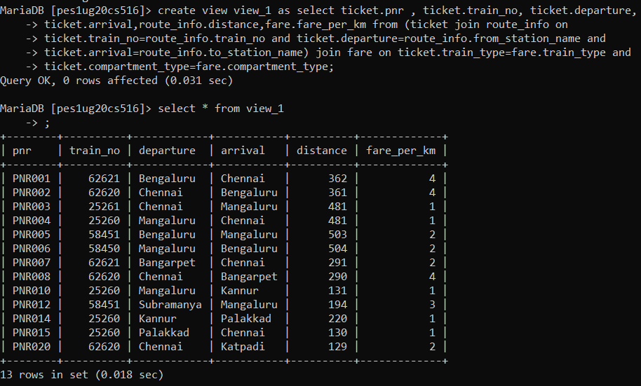

## b. Create a View passenger_num

## CREATE VIEW passenger_num AS select PNR, count(PNR) as numbers from Ticket_Passenger group by PNR;

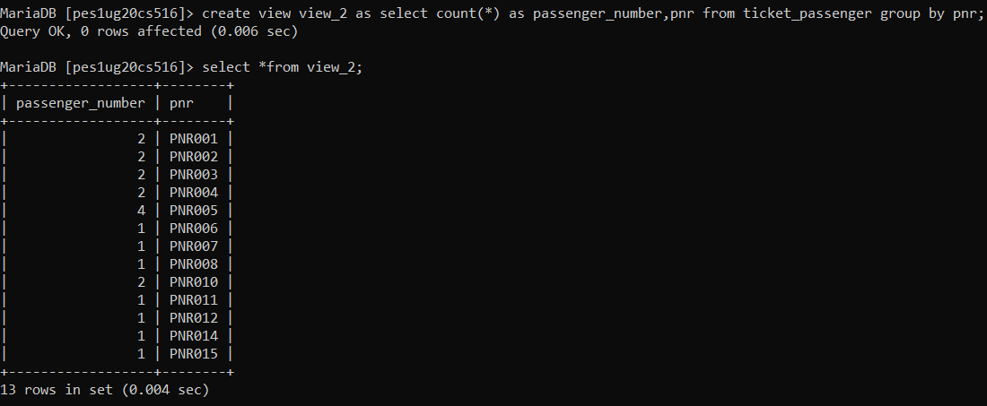

## c. Update Payment_info.price as below

## UPDATE Payment_Info AS p INNER JOIN compute_price AS cs ON p.PNR =

## cs.PNR INNER JOIN passenger_num AS pn ON cs.PNR = pn.PNR SET p.Price =

## cs.Distance * cs.Fare_Per_KM * pn.numbers;

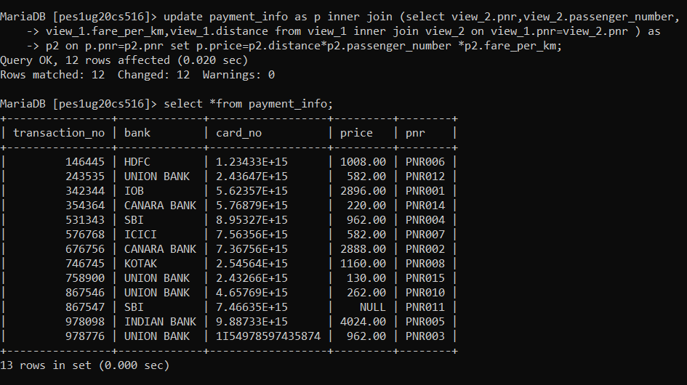

## NATURAL JOIN

## 2. Retrieve the all stations along route of the Trains along with the distance between the stations

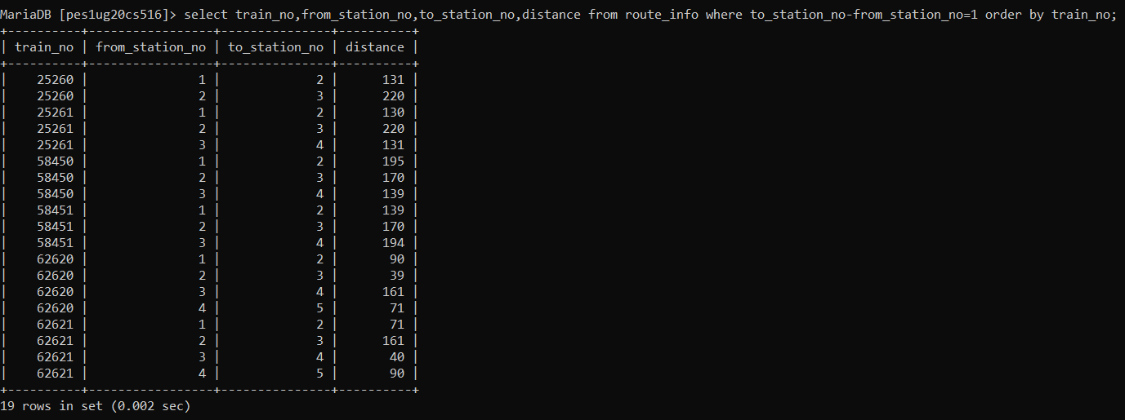

## INNER JOIN (equijoin)

## 3.Retrieve the Train no of train which is leaving Bengaluru and arriving at Chennai with compartments availability greater than 10.

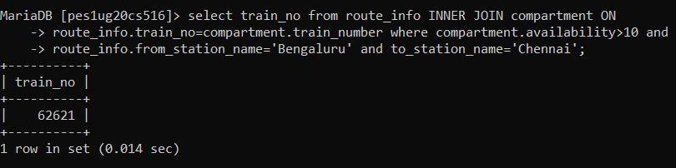

## 4.Retrieve first and last name of users who have booked a ticket with price greater than 500

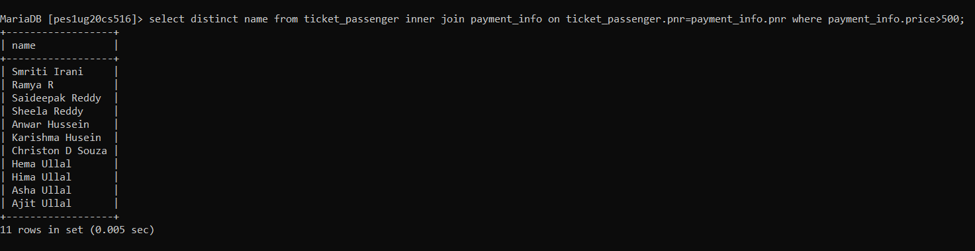

## LEFT OUTER JOIN

## 5. Retrieve the first name, last name, DOB and ticket PNR if they’ve bought it for all users.

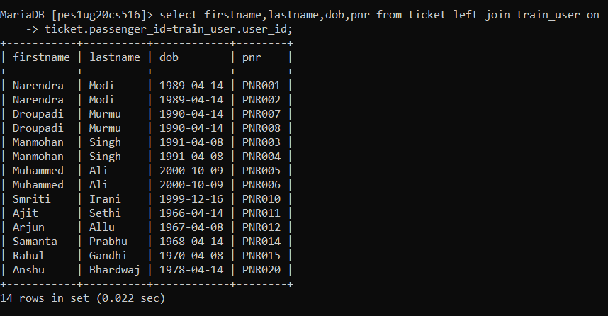

## 6. Retrieve the first name, last name, of the Users who have not bought a ticket.

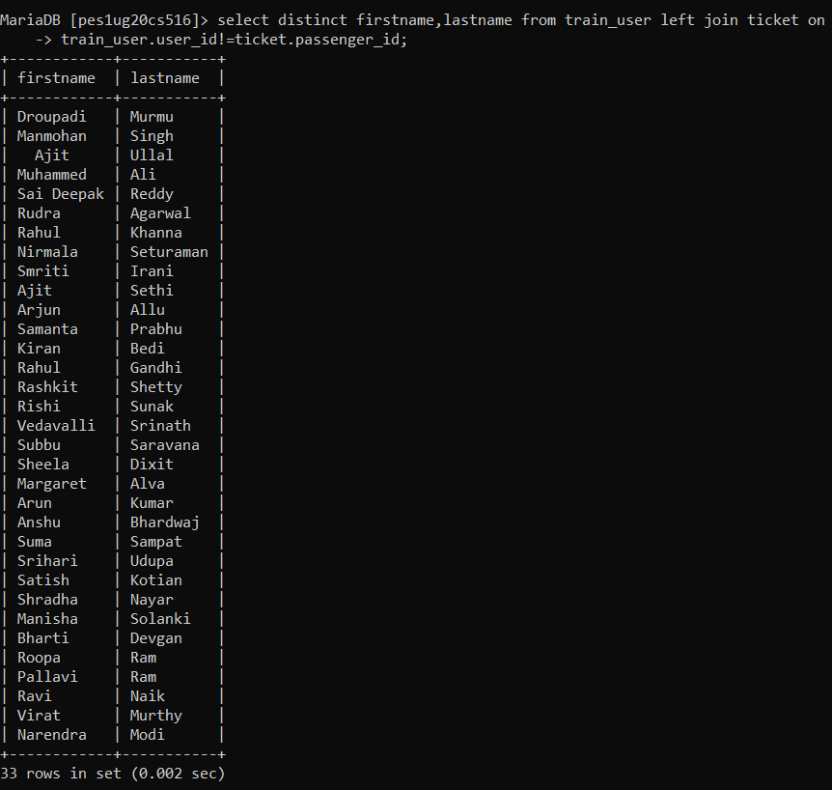

## RIGHT OUTER JOIN

## 7. Retrieve the ticket PNR, Train number, travel date and along with all users first name and last name.

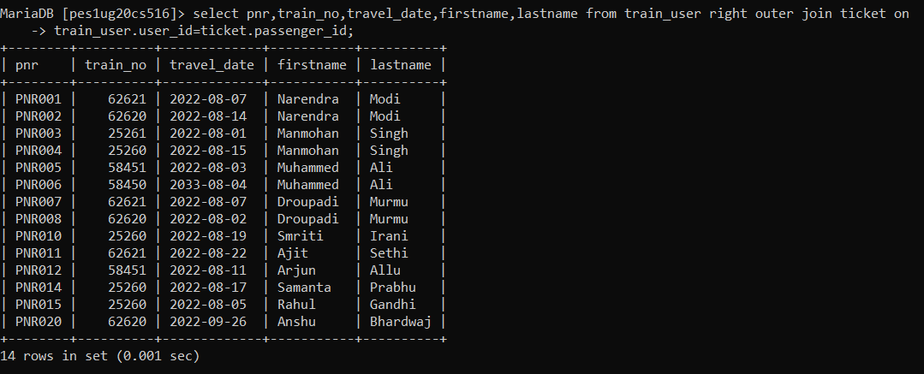

## 8. Retrieve the user id if they’ve travelled in a train along with train id and name of all trains.

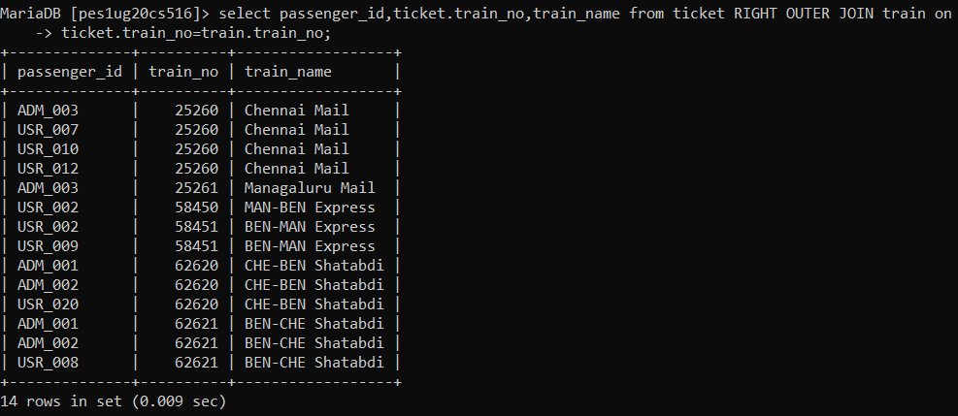

## NESTED QUERIES

## 9. Retrieve the train no and name of trains whose destination is not Mangaluru and distance is not less than 100km and departure time is not 8:30:00 PM. (Correlated)

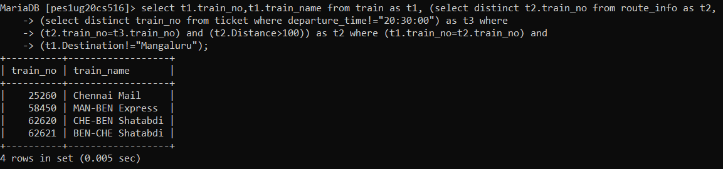

## 10. Retrieve the User ID who has spent more than the average ticket price. (Uncorrelated)

