Lab 6 – Aggregate Function

## 1. Find the average distance between subsequent stations for every train

## 

## 2. Find the average distance between subsequent stations for every train and display them in descending order of distance

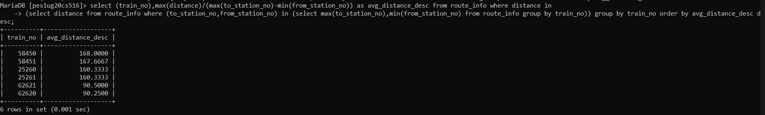

## 3. Display the list of train numbers and the total distance travelled by each in descending order of the distance travelled

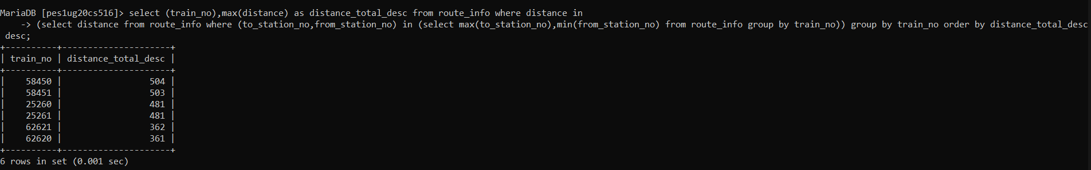

## 4. List those trains that have maximum and minimum number compartments and also display number of compartments they have. (2 queries one to find max and other to find min)

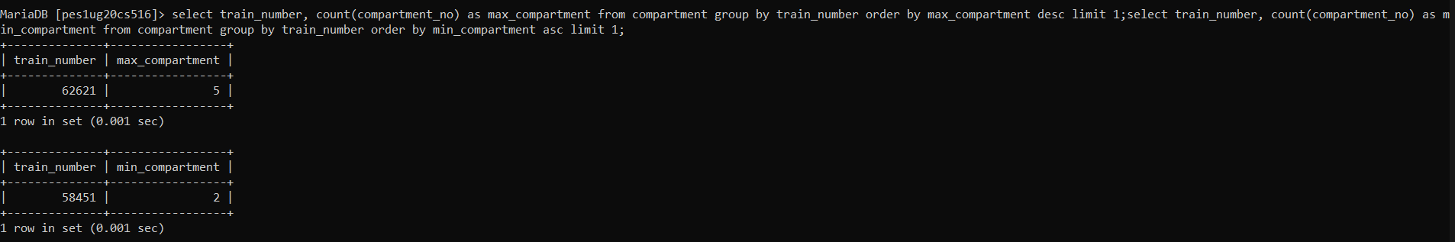

## 5. Display the number of phone numbers corresponding to the user_id(s) ADM_001,USR_006, USR_010

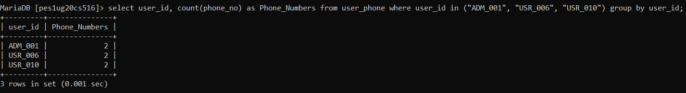

## 6. Find the average fare per km for each train type specified and display the train type and corresponding average fare per km as ‘Avg_Fare’ in decreasing order of Avg_Fare.

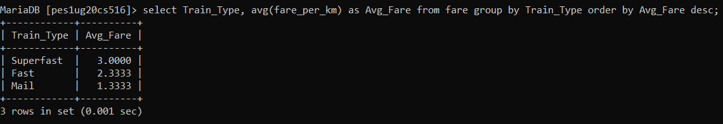

## 7. Retrieve all details of the oldest passenger.

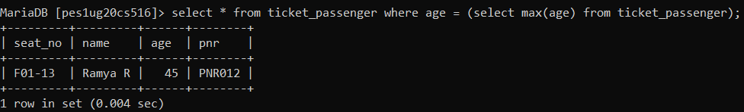

## 8. Count the number of passengers whose name consists of ‘Ullal’. (Hint: Use the LIKE operator)

