Lab 7 – UNION, INTERSECTION, MINUS operators

## 1. Find the list of passengers (user_id, user_type First name and

## last name) who have travelled from Bengaluru to Chennai during

## the month of Oct 2021 and Aug 2022

select tu.user_id,tu.user_type,tu.firstname,tu.lastname from train_user as tu,ticket as ti where tu.user_id = ti.passenger_id and ti.departure='Bengaluru' and ti.arrival='Chennai' and ti.travel_date<'2021-11-1' UNION select tu.user_id,tu.user_type,tu.firstname,tu.lastname from train_user as tu,ticket as ti where tu.user_id = ti.passenger_id and ti.departure='Bengaluru' and ti.arrival='Chennai' and ti.travel_date>'2022-07-31';

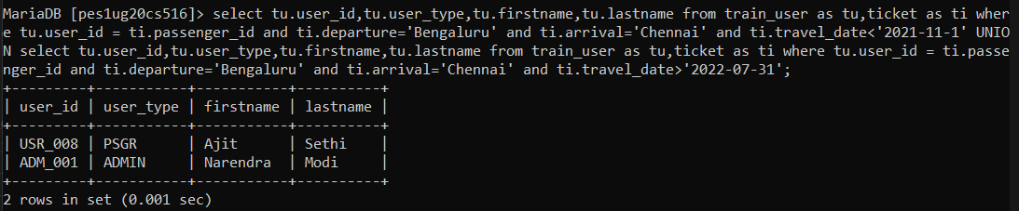

## 2. Find the list of passengers (user_id, user_type First name and

## last name) who have travelled from Bengaluru to Chennai during

## the month of Oct 2021 and also during Aug 2022

select tu.user_id,tu.user_type,tu.firstname,tu.lastname from train_user as tu,ticket as ti where tu.user_id = ti.passenger_id and ti.departure='Bengaluru' and ti.arrival='Chennai' and (ti.travel_date<'2021-11-1' and ti.travel_date>'2021-09-30') INTERSECT select tu.user_id,tu.user_type,tu.firstname,tu.lastname from train_user as tu,ticket as ti where tu.user_id = ti.passenger_id and ti.departure='Bengaluru' and ti.arrival='Chennai' and (ti.travel_date>'2022-07-31' and ti.travel_date<'2022-09-01');

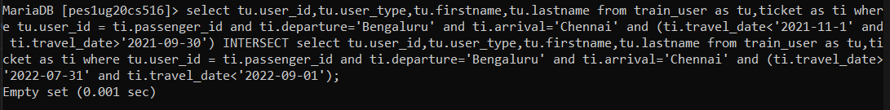

## 3. Find the list of passengers (user_id, user_type First name and

## last name) who have travelled from Bengaluru to Chennai during

## the month of Aug 2022 and not in Oct 2021

select tu.user_id,tu.user_type,tu.firstname,tu.lastname from train_user as tu,ticket as ti where tu.user_id = ti.passenger_id and ti.departure='Bengaluru' and ti.arrival='Chennai' and not(ti.travel_date<'2021-11-1' and ti.travel_date>'2021-09-30') union (select tu.user_id,tu.user_type,tu.firstname,tu.lastname from train_user as tu,ticket as ti where tu.user_id = ti.passenger_id and ti.departure='Bengaluru' and ti.arrival='Chennai' and (ti.travel_date>'2022-07-31' and ti.travel_date<'2022-09-01'));

## 

## 4. Find the list of passengers (user_id, user_type, First name and

## last name) who have travelled from Bengaluru to Chennai and

## returned to Bengaluru within a week.

select tu.user_id, tu.user_type,tu.firstname, tu.lastname  from ticket as t, train_user as tu where t.passenger_id = tu.user_id and t.Departure = 'Bengaluru' and t.Arrival = 'Chennai' and exists(select pnr from ticket as ti where t.passenger_id = ti.passenger_id and ti.Departure = 'Chennai' and ti.Arrival = 'Bengaluru' and (DATEDIFF(ti.travel_date,t.travel_date) BETWEEN 0 and 7));

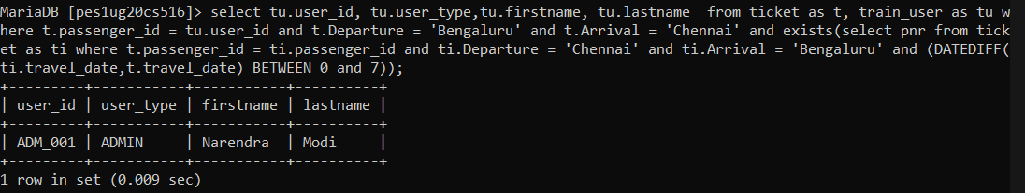

## 5. Find the list of passengers (user_id, user_type, first name and

## last name) who have travelled from Bengaluru to Chennai and did

## not return to Bengaluru (in other words, only one way travel

## from Bengaluru to Chennai)

select tu.user_id, tu.user_type,tu.firstname, tu.lastname  from ticket as t, train_user as tu where t.passenger_id = tu.user_id and t.Departure = 'Bengaluru' and t.Arrival = 'Chennai' and not exists(select pnr from ticket as ti where t.passenger_id = ti.passenger_id and ti.Departure = 'Chennai' and ti.Arrival = 'Bengaluru');

