Lab 8 – Creating Functions and Stored Procedures

## 1.Write a function to find the number of tickets booked by a customer. If no of tickets is more than 3 for the current month then display error message as “cannot purchase tickets current limit is over”.

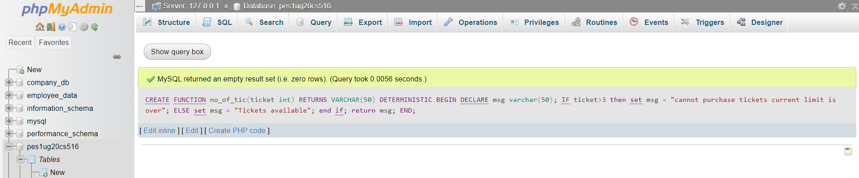

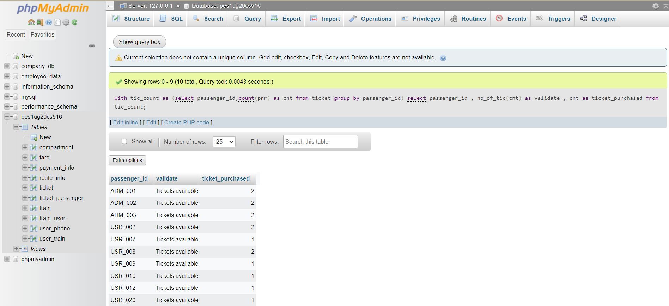

## 2. Write a stored procedure to calculate the age of the customer when the date of birth is given. Update the column named age in the customer table.

