Lab 8 – Creating Triggers

## 1.Write a trigger on insert to compartment table when a new compartment gets added to a train and make sure that total number of compartments available in the train does not exceed more than 4.

DELIMITER $$

CREATE TRIGGER compartment_no_check BEFORE INSERT on compartment for each row

BEGIN

IF (SELECT count(compartment_no) FROM compartment WHERE train_number=NEW.train_number)>=4 THEN

SIGNAL SQLSTATE '45000' SET message_text="Cannot add more than 4 compartments to a train";

END IF;

END $$

DELIMITER ;

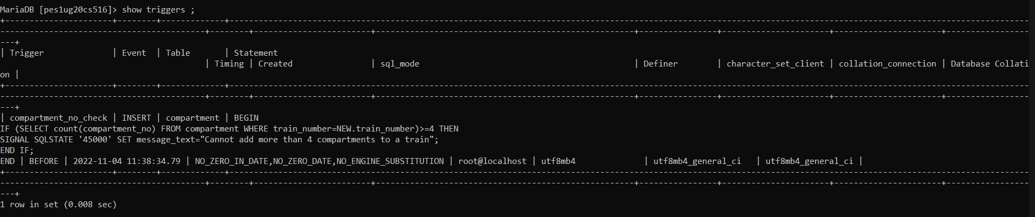

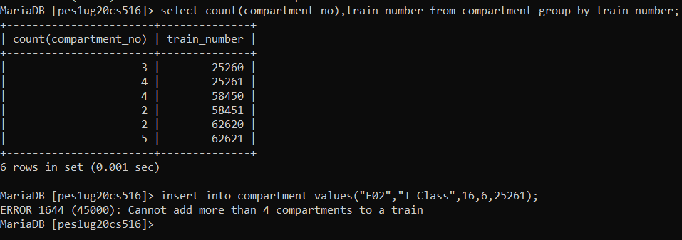

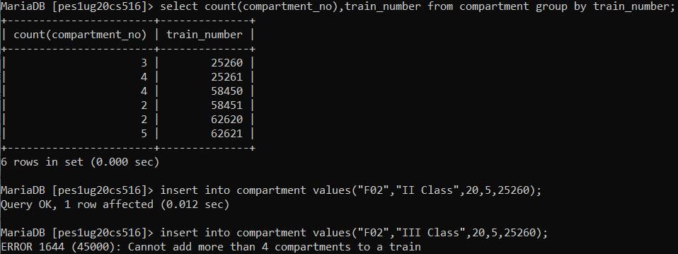

## 2. Create a new table called 'backup' in the railway reservation database with all the attributes of ticket, ticket passenger and paymentinfo.

## You are supposed to initiate a 'deletetrigger' whenever a ticket record is deleted from ticket table.

## This deletetrigger has to Fetch the data to be deleted from all the three tables( ticket, ticket passenger and paymentinfo) with the given ticket info and add the same into backup table. After that, deletion of ticket record should be allowed.

