## Lab Quiz

### Creation and population of PES1UG20CS516_LabQuiz database

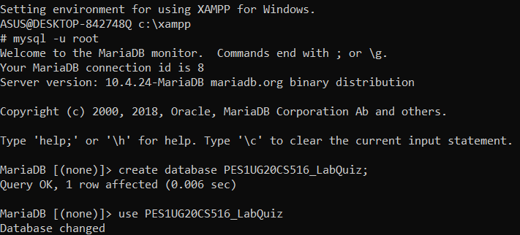



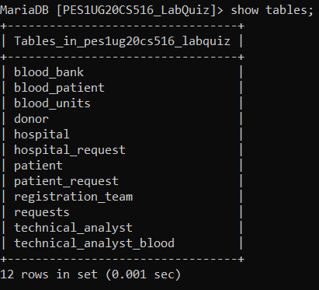

## SET No 2:

## 4. List the name and IDs of the patients who did not get the exact blood group as their own. Also display the blood group of blood unit and their actual blood group

SELECT patient.patient_name, patient.patient_id, requests.blood_group AS bloodgroup_unit , patient.blood_group AS actual_bloodgroup

FROM patient

INNER JOIN patient_request

ON patient.patient_id = patient_request.patient_id

INNER JOIN requests

ON patient_request.request_id = requests.request_id

WHERE patient.blood_group != requests.blood_group;

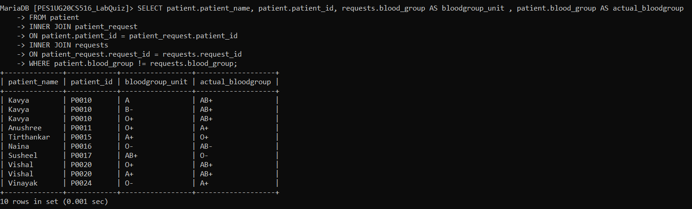

## 5. Write a query to display the number of donors and the number of request for particular blood groups in the ascending order of requests

SELECT * FROM

(SELECT blood_group, COUNT(d_id) AS no_of_donors

FROM donor

GROUP BY blood_group) AS t1

NATURAL JOIN

(SELECT blood_group, COUNT(request_id) AS no_of_requests

FROM requests

GROUP BY blood_group) AS t2

ORDER BY no_of_requests;

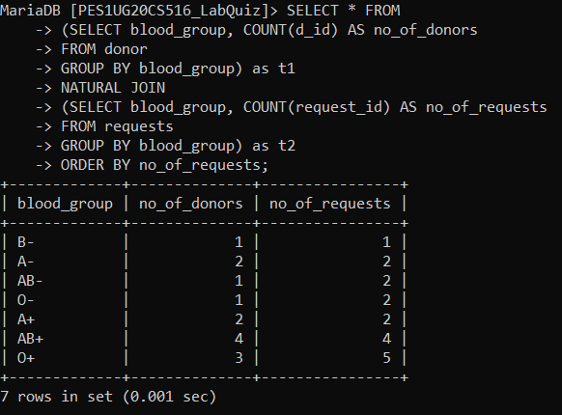

## 6. Write a function to set the health status of a donor. If the donor has some associated disease set health status to ‘Fair’, otherwise to ‘Good’

DELIMITER $$

CREATE OR REPLACE FUNCTION health_status(disease VARCHAR(50))

RETURNS VARCHAR(10)

DETERMINISTIC

BEGIN

    DECLARE SET_MSG VARCHAR(10);

    IF disease = "NIL" OR disease = "Nil" THEN

    SET SET_MSG ="Good";

    ELSE

    SET SET_MSG ="Fair";

    END IF;

    RETURN SET_MSG;

END; $$

DELIMITER ;

SELECT d_id, d_name, d_surname, d_disease, health_status(d_disease) as health_status FROM donor;

