MPCA LAB WEEK5

NAME: Vrushank G

SECTION:”I”

SRN:PES1UG20CS516

1. **Write a program to find the largest number in a given Array of Integers.**

Code:

.DATA

A:.WORD 1,2,3,5,4

B:.WORD

.TEXT

LDR R0,=A

LDR R1,[R0]

MOV R4,#0

LDR R5,=B

LOOP:LDR R2,[R0,#4]!

ADD R4,R4,#1

CMP R2,R1

MOVPL R1,R2

CMP R4,#4

BNE LOOP

STR R1,[R5]

SWI 0X011

**OUTPUT**

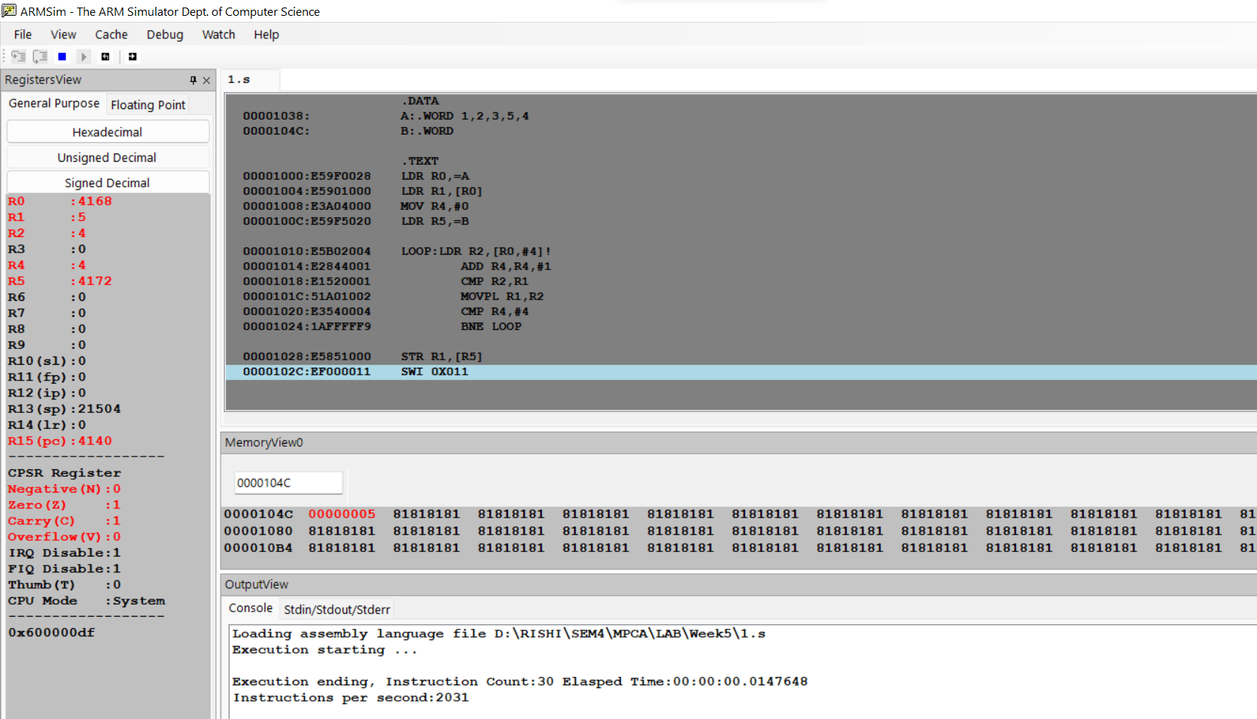

1. **Write a program to move the Contents 45 words from one block to another block in reverse order use Load/store multiple Register instruction at a rate of 36 byte.[ can use any of LDMIA,STMIA**

,LDMIB,STMIB,LDMDA,STMDA,LDMDB,STMDB]

CODE:

OUTPUT SCREENSHOT