MPCA WEEK5 LAB

Name:Vrushank G

Section:”I”

SRN:PES1UG20CS516

1. Write a program in ARM7TDMI-ISA to multiply 2 matrices of order3.

i.e., implement c[i][j]=c[i][j] + a[i][j] x b[i][j].

a. Use MLA instruction

b. Use MUL instruction

a.

**=>CODE:**

.DATA

A: .WORD 1,2,3,4,5,6,7,8,9

B: .WORD 9,8,7,6,5,4,3,2,1

C: .WORD 0,0,0,0,0,0,0,0,0

.TEXT

LDR R0,=A

LDR R1,=B

LDR R2,=C

MOV R12,#0

MOV R3,#0

MOV R4,#0

MOV R5,#0

MOV R8,#3

L1: MUL R6,R3,R8

    ADD R6,R6,R4

    MUL R7,R4,R8

    ADD R7,R7,R5

    LDR R10,[R0,R6,LSL #2]

    LDR R11,[R1,R7,LSL #2]

    MUL R7,R10,R11

    ADD R12,R12,R7

    ADD R4,R4,#1

    CMP R4,#3

    BNE L1

    MUL R9,R3,R8

    ADD R9,R9,R5

    STR R12,[R2,R9,LSL #2]

    MOV R4,#0

    MOV R12,#0

    ADD R5,R5,#1

    CMP R5,#3

    BNE L1

MOV R5,#0

ADD R3,R3,#1

CMP R3,#3

BNE L1

SWI 0X011

**=>Output:**

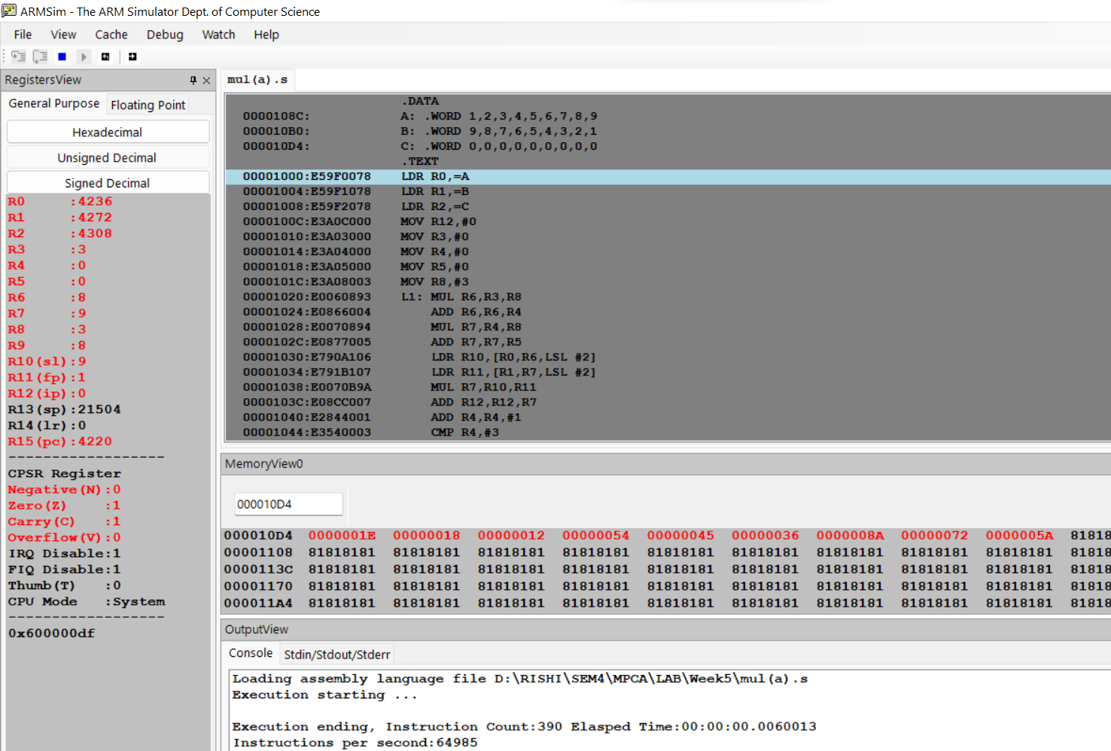

b.

**=>CODE:**

.DATA

A: .WORD 1,2,3,4,5,6,7,8,9

B: .WORD 9,8,7,6,5,4,3,2,1

C: .WORD 0,0,0,0,0,0,0,0,0

.TEXT

LDR R0,=A

LDR R1,=B

LDR R2,=C

MOV R12,#0

MOV R3,#0

MOV R4,#0

MOV R5,#0

MOV R8,#3

L1:

    MLA R6,R3,R8,R4

    MLA R7,R4,R8,R5

    LDR R10,[R0,R6,LSL #2]

    LDR R11,[R1,R7,LSL #2]

    MLA R12,R10,R11,R12

    ADD R4,R4,#1

    CMP R4,#3

    BNE L1

    MLA R9,R3,R8,R5

    STR R12,[R2,R9,LSL #2]

    MOV R4,#0

    MOV R12,#0

    ADD R5,R5,#1

    CMP R5,#3

    BNE L1

    MOV R5,#0

    ADD R3,R3,#1

    CMP R3,#3

    BNE L1

SWI 0X11

**=>Output:**

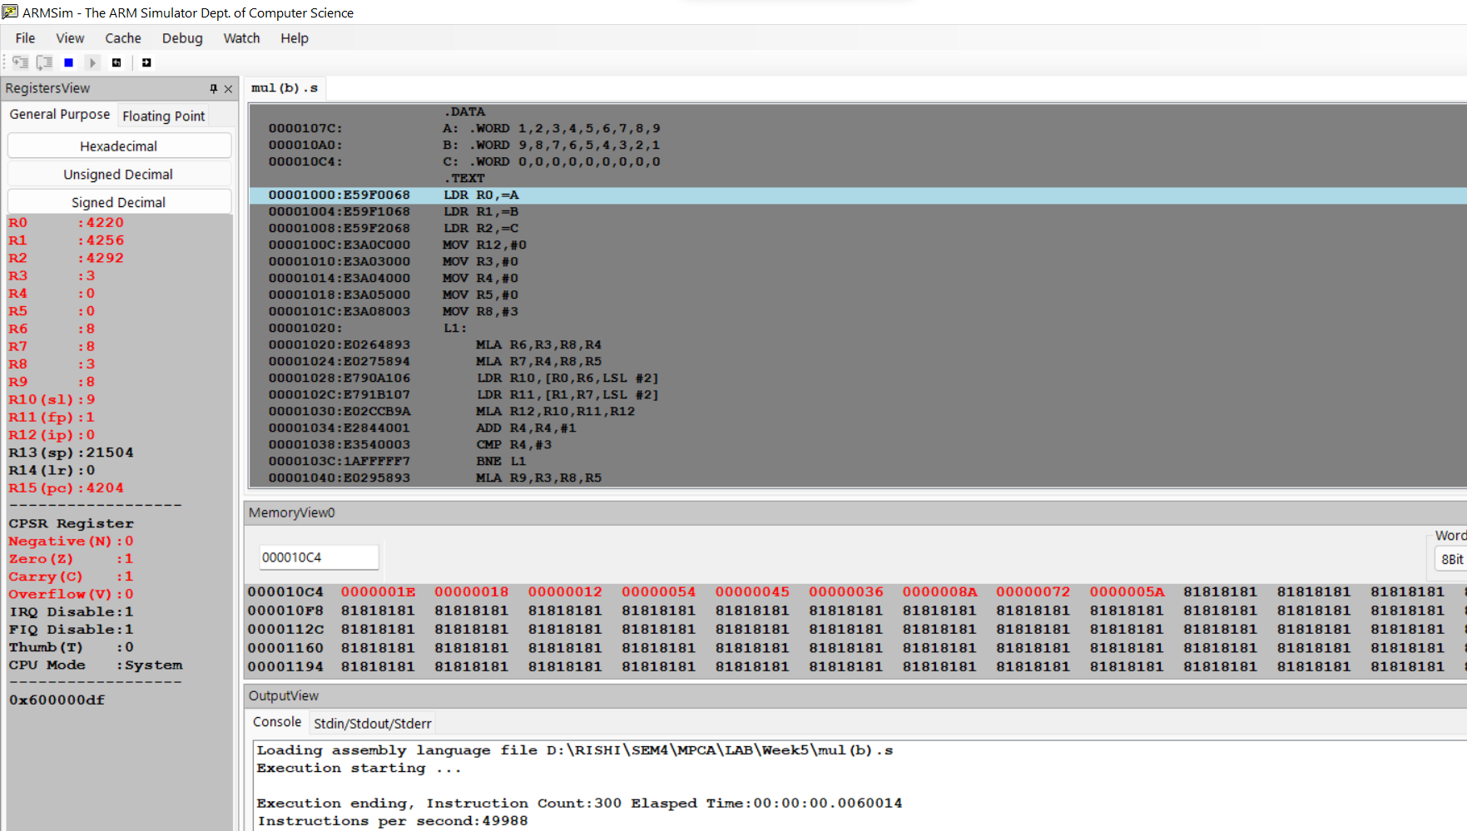

2. Write a program in ARM7TDMI-ISA to find the NORM of a square matrix of

order n

**=>CODE:**

.DATA

A: .WORD 1,2,7,6,9,5,4,3,8

SUM: .WORD

.TEXT

LDR R0,=A

LDR R9,=SUM

MOV R1,#0

MOV R2,#0

MOV R3,#3

MOV R4,#0

MOV R8,#0

LOOP:MLA R5,R3,R1,R2

    MOV R5,R5,LSL #2

    LDR R6,[R0,R5]

    ADD R4,R4,R6

    ADD R2,R2,#1

    CMP R2,#3

    BNE LOOP

    CMP R4,R8

    MOVGT R8,R4

    ADD R1,R1,#1

    MOV R2,#0

    MOV R4,#0

    CMP R1,#3

    BNE LOOP

    STR R8,[R9]

SWI 0X011

**=>Output:**

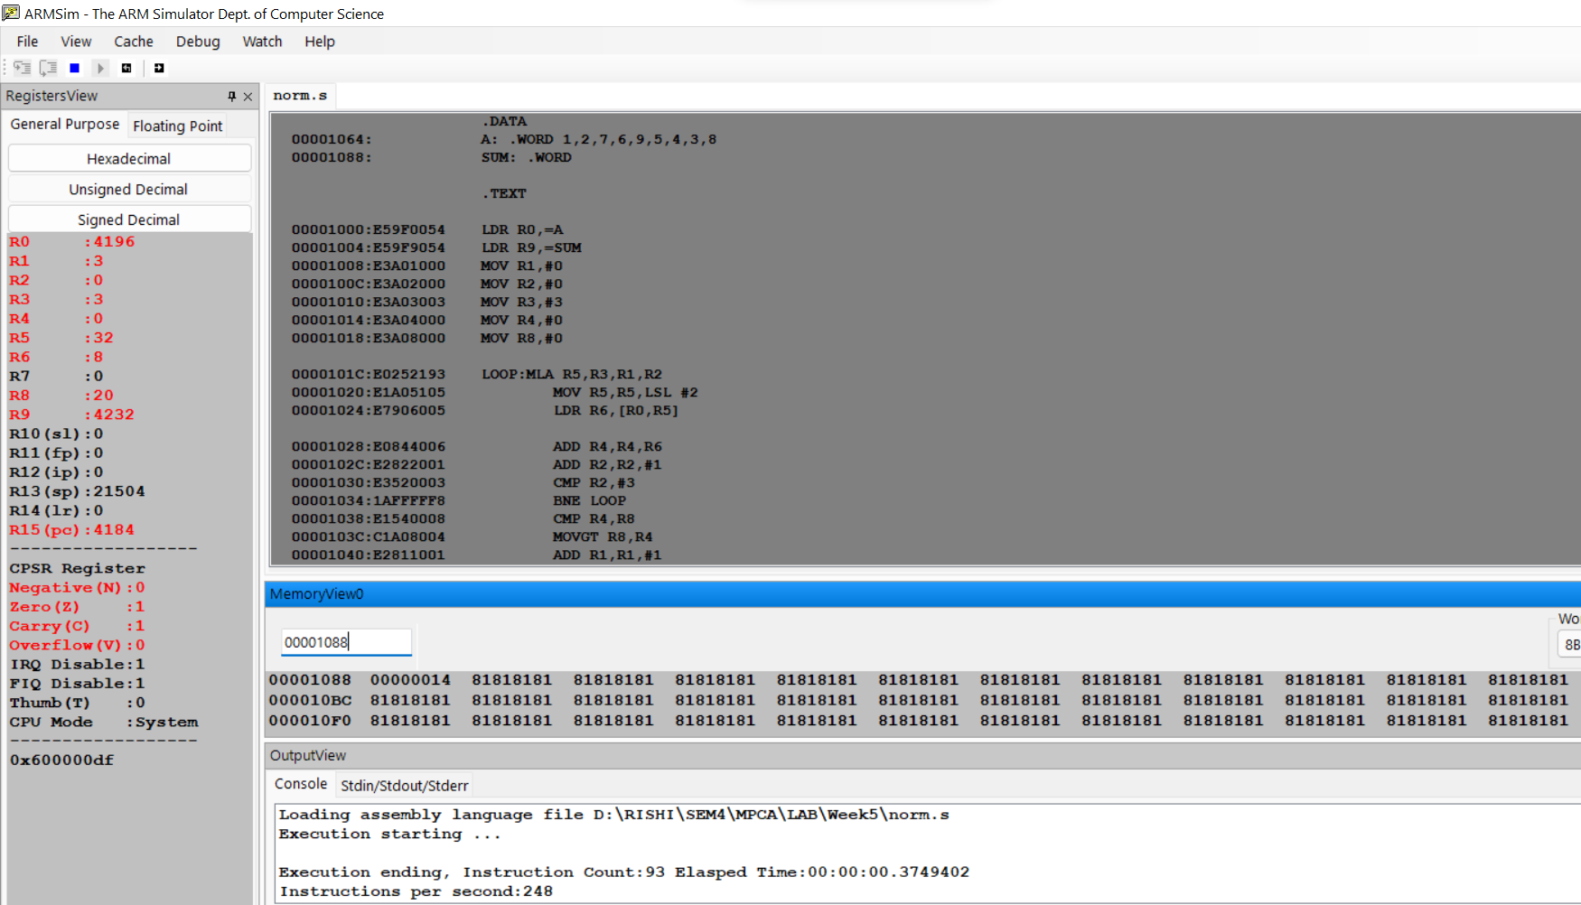

3. Write a program in ARM7TDMI-ISA to find the ROWSUM of a matrix.

**=>CODE:**

.DATA

A: .WORD 1,2,3,4,5,6,7,8,9

SUM: .WORD 0,0,0

.TEXT

LDR R0,=A

LDR R9,=SUM

MOV R1,#0

MOV R2,#0

MOV R3,#3

MOV R4,#0

LOOP:MLA R5,R3,R1,R2

    MOV R5,R5,LSL #2

    LDR R6,[R0,R5]

    ADD R4,R4,R6

    ADD R2,R2,#1

    CMP R2,#3

    BNE LOOP

    STR R4,[R9],#4

    ADD R1,R1,#1

    MOV R2,#0

    MOV R4,#0

    CMP R1,#3

    BNE LOOP

SWI 0X011

**=>Output:**

