MPCA WEEK6 LAB

Name:Vrushank G

Section:”I”

SRN:PES1UG20CS516

1. Write a program in ARM7TDMI-ISA to find the sum of all the digits in an

32bit number.

**=>CODE:**

.DATA

A: .WORD 32

.TEXT

LDR R0,=A

MOV R1,#15

LDR R2,[R0]

MOV R3,#8

LOOP: ANDS R4,R1,R2

    ADDS R5,R5,R4

    MOV R2, R2,LSR #4

    SUB R3,R3,#1

    CMP R3,#0

    BNE LOOP

SWI 0X011

**=>Output:**

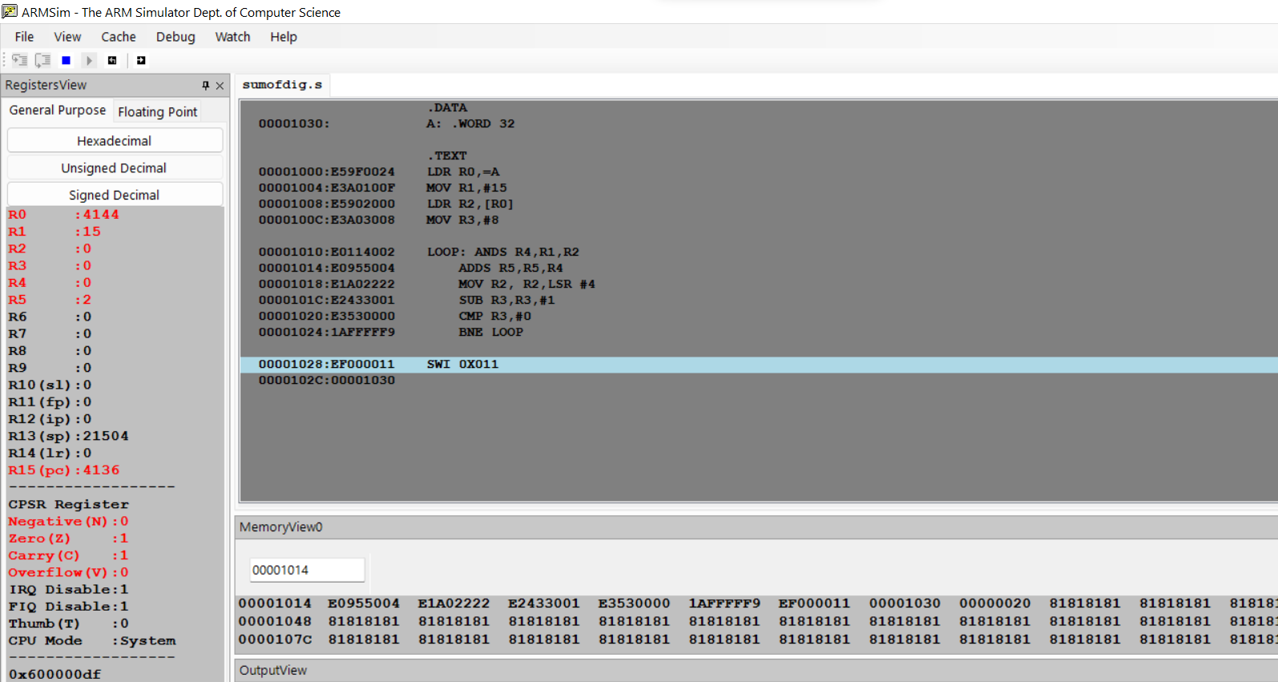

2. Write a program in ARM7TDMI-ISA to find the number of occurrences of a

given character in a string.

Example: Given string : My name is Bond.

Character : ‘n’.

Expected Output : Display 2 in a register.

**=>CODE:**

.DATA

A: .ASCII "SHASHA ON THE SEA SHORE"

B: .ASCII "S"

.TEXT

LDR R0,=A

LDR R1,=B

MOV R4,#0

MOV R9,#0

LOOP: LDRB R2,[R0],#1

    LDRB R3,[R1]

    CMP R2,R3

    BEQ LOOP1

    ADD R9,R9,#1

    CMP R9,#20

    BNE LOOP

LOOP1: ADD R4,R4,#1

       BAL LOOP

SWI 0X011

**=>Output:**

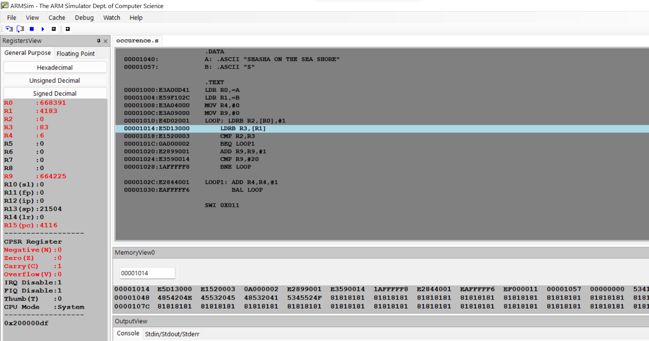

Here 4 times “S” is repeated.

R4 contains 4 occurences of ‘S’ in the sentence.