MPCA LAB WEEK 7

**NAME: Y SRINIVAS SECTION:I SRN:PES1UG20CS517**

# #STRING MOVING

.text

mov r0, #25 ;r0 = x mov r1, #4 ;r1 = y mov r7, #0

ldr r8, =num ldr r8, [r8] ldr r2, =str

loop: swi 0x204 ;display a string on screen, address should be in r2 reg

bl sum cmp r0, #0

subne r0, r0, #1 swieq 0x11

b loop

sum:

cmp r7, r8 addne r7, r7, #1 bne sum

swi 0x206 ;Clear one line in the display on the LCD screen.r0-line no(y) mov r7, #0

mov pc, lr

.data

str: .asciz "HELLO WORLD" num: .word 128000

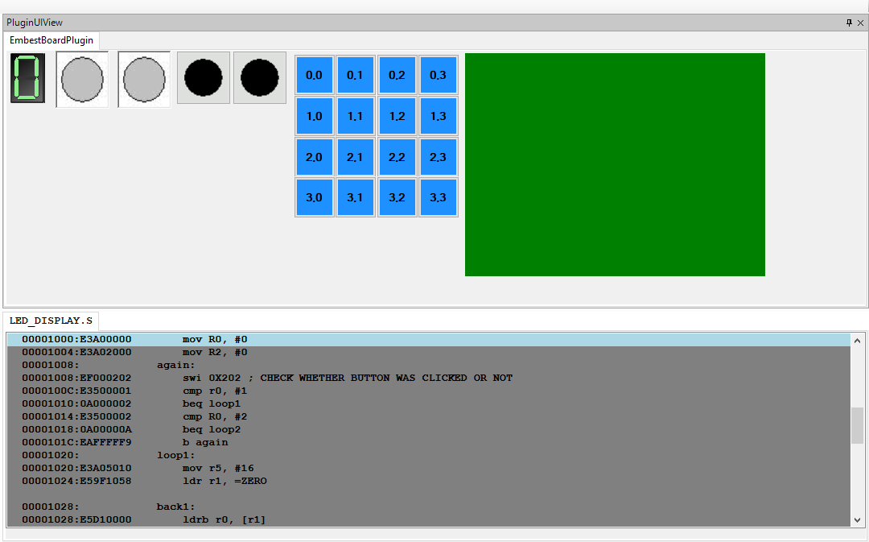

# #LED BULBS

.TEXT

MOV R0, #0 LOOP:

SWI 0X201 ADD R0, R0, #1

MOV R4, #64000 DELAY:

SUB R4, R4, #1 CMP R4, #0 BNE DELAY

CMP R0, #3 BLE LOOP

SWI 0X001

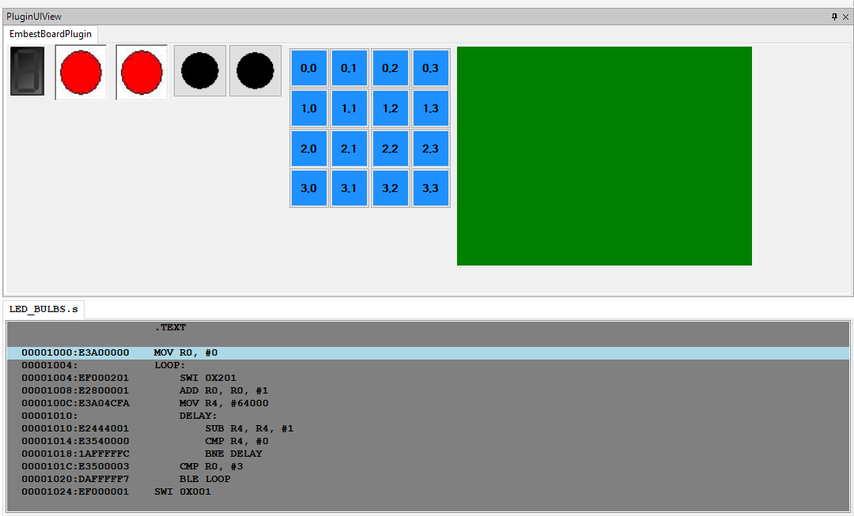

# #LED DISPLAY

.DATA

ZERO: .BYTE 0B11101101 ONE: .BYTE 0B01100000 TWO: .BYTE 0B11001110 THREE: .BYTE 0B11101010 FOUR: .BYTE 0B01100011 FIVE: .BYTE 0B10101011 SIX: .BYTE 0B10101111 SEVEN: .BYTE 0B11100000 EIGHT: .BYTE 0B11101111 NINE: .BYTE 0B11101011

A: .byte 0b11100111 B: .byte 0b00101111 C: .byte 0b10001101 D: .byte 0b01101110 E: .byte 0b10001111 F: .byte 0b10000111

.TEXT

; PROGRAM TO DISPLAY 0 TO F AND F TO 0

begin:

mov R0, #0

mov R2, #0 again:

swi 0X202 ; CHECK WHETHER BUTTON WAS CLICKED OR NOT

cmp r0, #1 beq loop1 cmp R0, #2 beq loop2 b again

loop1:

mov r5, #16 ldr r1, =ZERO

back1:

ldrb r0, [r1]

swi 0x200 ; Set 8 segment display to light up bl delay

add r1,r1,#1 sub r5, r5,#1 cmp r5, #0 bne back1

b again loop2:

mov r5,#16 ldr r1,=F

back2:

ldrb r0, [r1]

swi 0x200 ; Set 8 segment ; display to light up bl delay

sub r1,r1,#1 sub r5, r5,#1 cmp r5, #0 bne back2

b again

delay:

mov r4, #64000 loop3:

sub r4, r4, #1 cmp r4, #0 bge loop3 mov pc, lr

