**SOFTWARE ENGINEERING**

**1. Synopsis/Project Proposal**

=>**Project Title** : Real-Time Chat Application using SocketIO

=>Team Members :

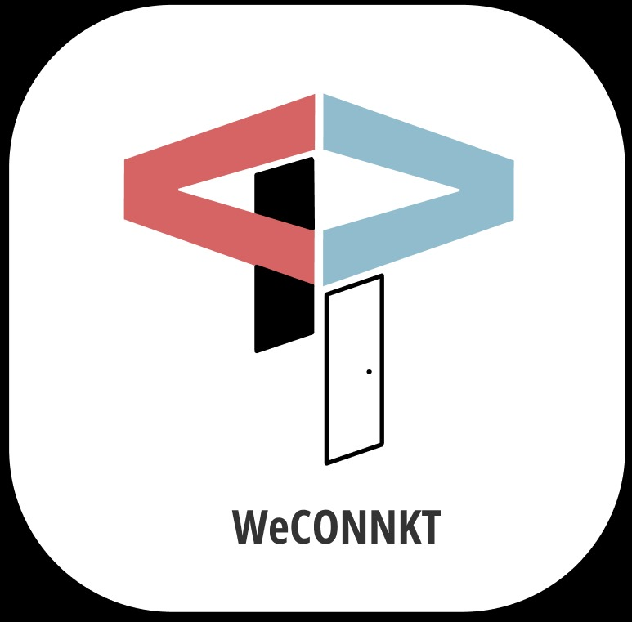

* Y Srinivas: PES1UG20CS517
* Vrushank G: PES1UG20CS516
* Akash S: PES1UG20CS534
* Venkatesh BR : PES1UG20CS494

**2. Proposed Project Description**

People around the world are used to chatting online about everything, including discussing the latest episode with a friend, organizing a team-building meeting, or asking your favourite coffee shop’s chatbot about new flavours.

Numbers and statistics are also on the side of chat apps. The overwhelming majority of studies show that instant messaging is becoming more and more popular among users worldwide.

We will be using express to build the web server that Socket.IO will work with. Any other node-server-side framework or even node HTTP server can be used. Express JS makes it easy to define routes and other things. Socket.IO enables real-time bidirectional event-based communication. It works on browser, focusing equally on reliability and speed. Socket.IO is built on top of the WebSockets API (Client side) and Node.js. It is one of the most depended upon library on **npm** (Node Package Manager) . The chat server’s resources can include a REST API, a WebSocket server, MongoDB Atlas for media storage and cloud platform, etc.

**3.Plan of work and product ownership:**

* *“****Who should do what*** *“*. *?*
* Developing front end website architecture and designing user interactions on web pages - VENAKTESH BR
* Developing back-end website applications and seeing through a project from conception to finished product-SRINIVAS Y
* Specialize in developing and maintaining the server and the technical side of website development Creating servers and databases for functionality*-*AKASH S
* Ensuring responsiveness of applications, working alongside graphic designers for web design features-VRUSHANK G
* **Functionality: ( Chat Features )**



* Simple Login
* Cloud storage
* Dark and light modes
* Message broadcasting
* Sharing of media files
* Cross-platform solution
* User settings
* Profile customization