ASSIGNMENT – 7.1
Name : k.vrushikesh
HT No : 2303A52218
Task Description #1 (Syntax Errors – Missing Parentheses in PrintStatement)
Task: Provide a Python snippet with a missing parenthesis in a print
statement (e.g., print "Hello"). Use AI to detect and fix the syntaxerror.
# Bug: Missing parentheses in print statement
def greet():
print "Hello, AI Debugging Lab!"
greet()
Requirements:
• Run the given code to observe the error.
• Apply AI suggestions to correct the syntax.
• Use at least 3 assert test cases to confirm the corrected codeworks.
Expected Output #1:
• Corrected code with proper syntax and AI explanation.
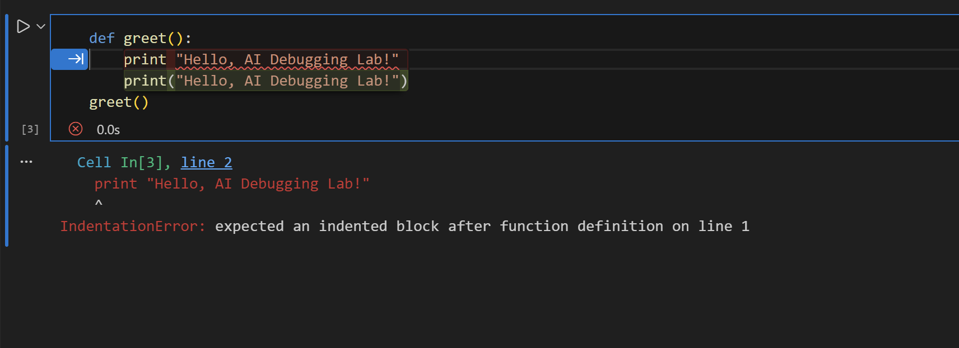
Explanation :The given code gives a SyntaxError because in Python 3, print must use parentheses.
So print "Hello" should be corrected to print("Hello, AI Debugging Lab!").
After fixing, we can verify the function using assert test cases to ensure it runs correctly.
This confirms the syntax issue is solved and the output is printed properly.

Task Description #2 (Incorrect condition in an If Statement)
Task: Supply a function where an if-condition mistakenly uses =instead of ==. Let AI identify and fix the issue.
# Bug: Using assignment (=) instead of comparison (==)
def check_number(n):
if n = 10:
return "Ten"
else:
return "Not Ten"
Requirements:
• Ask AI to explain why this causes a bug.
• Correct the code and verify with 3 assert test cases.
Expected Output #2:
• Corrected code using == with explanation and successful test
execution.
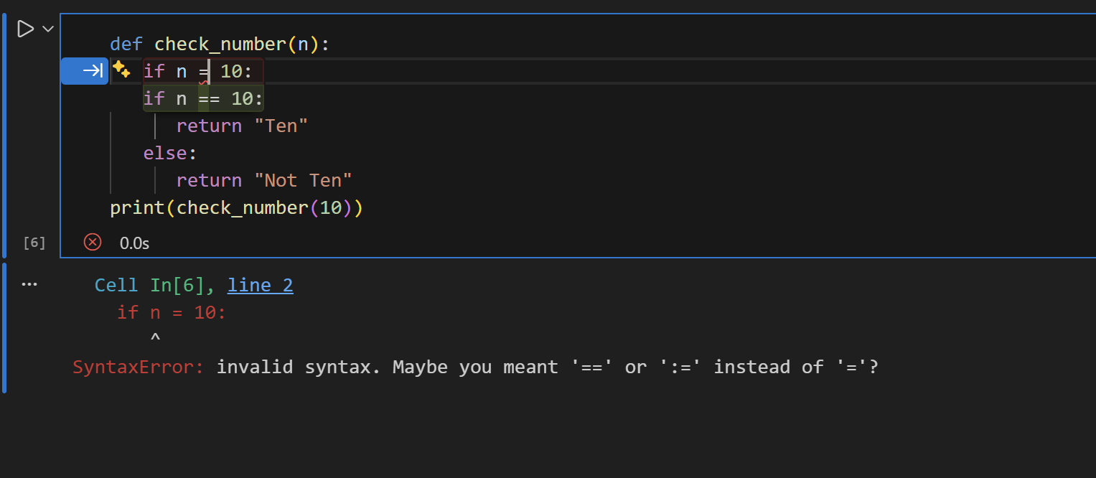
Explanation :This code causes an error because = is used for assignment, not for comparison inside an if statement.
In conditions, we must use == to check equality, so if n == 10: is correct.
After fixing, the function will properly return "Ten" when the number is 10.
We can confirm the corrected code works by running 3 assert test cases successfully.

Task Description #3 (Runtime Error – File Not Found)
Task: Provide code that attempts to open a non-existent file andcrashes. Use AI to apply safe error handling.
# Bug: Program crashes if file is missing
def read_file(filename):
with open(filename, 'r') as f:
return f.read()
print(read_file("nonexistent.txt"))
Requirements:
• Implement a try-except block suggested by AI.
• Add a user-friendly error message.
• Test with at least 3 scenarios: file exists, file missing, invalidpath.
Expected Output #3:
• Safe file handling with exception management.
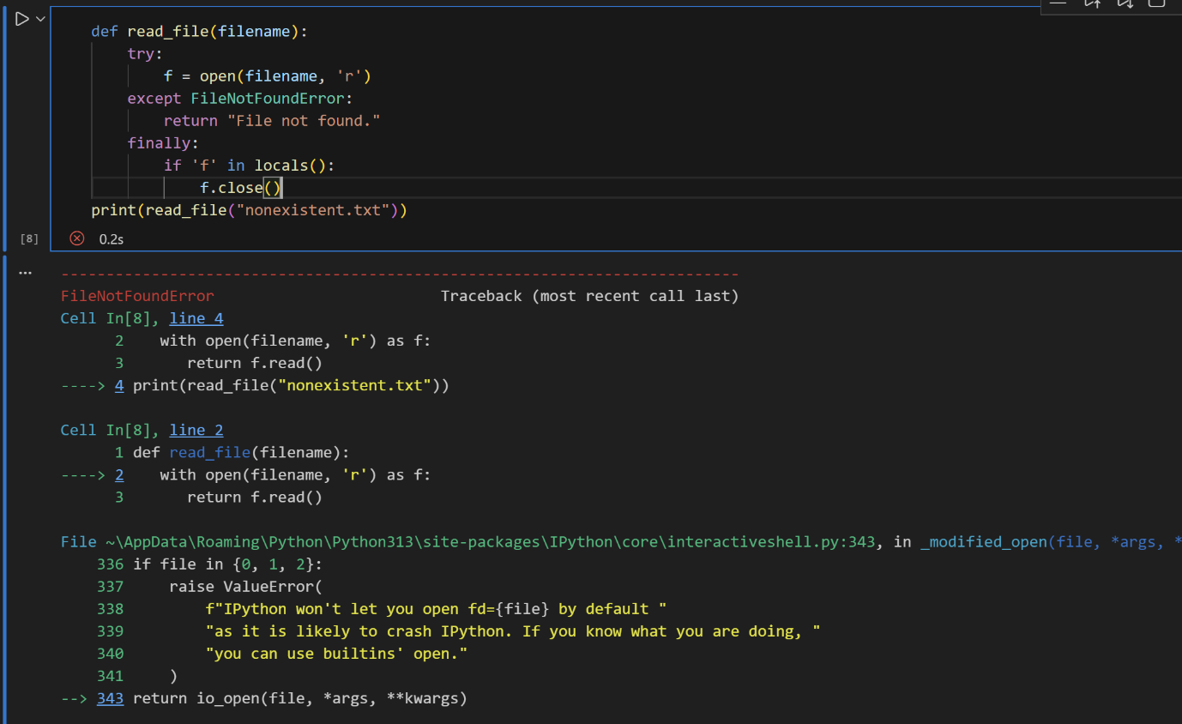
Explanation :This code crashes because it tries to open a file that does not exist, causing a FileNotFoundError at runtime.
AI suggests using a try-except block to safely handle missing files instead of stopping the program.
After adding error handling, the function can return a user-friendly message when the file is missing.
We can test it in 3 cases: file exists, file missing, and invalid path to ensure it works safely.

Task Description #4 (Calling a Non-Existent Method)
Task: Give a class where a non-existent method is called (e.g.,obj.undefined_method()). Use AI to debug and fix.
# Bug: Calling an undefined method
class Car:
def start(self):
return "Car started"
my_car = Car()
print(my_car.drive()) # drive() is not defined
Requirements:
• Students must analyze whether to define the missing method
or correct the method call.
• Use 3 assert tests to confirm the corrected class works.
Expected Output #4:
• Corrected class with clear AI explanation.
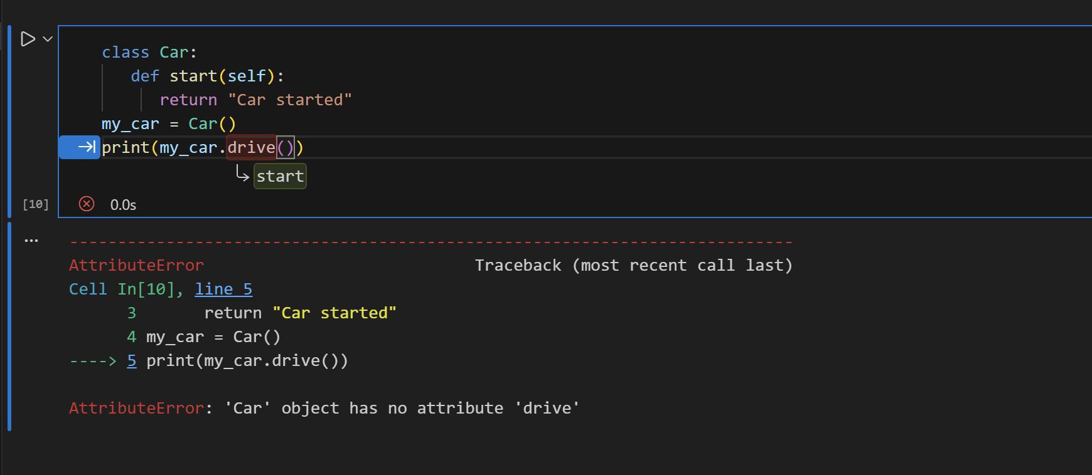
Explanation :This code gives an AttributeError because the method drive() is called, but it is not defined inside the Car class.
AI suggests either adding a drive() method or changing the call to the existing start() method.
After fixing, the class will work correctly without calling an undefined method.
We can confirm the correction using 3 assert test cases to ensure expected outputs.

Task Description #5 (TypeError – Mixing Strings and Integers inAddition)
Task: Provide code that adds an integer and string ("5" + 2) causinga TypeError. Use AI to resolve the bug.
# Bug: TypeError due to mixing string and integer
def add_five(value):
return value + 5
print(add_five("10"))
Requirements:
• Ask AI for two solutions: type casting and string
concatenation.
• Validate with 3 assert test cases.
Expected Output #5:
• Corrected code that runs successfully for multiple inputs.
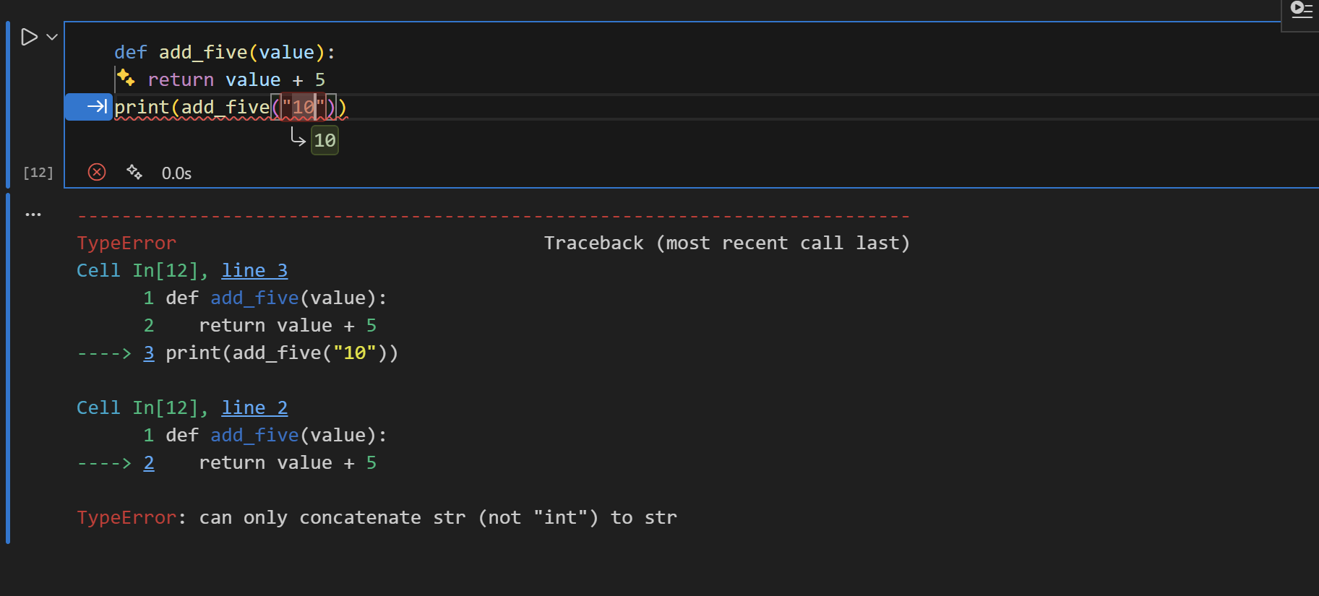
Explanation :This code raises a TypeError because Python cannot add a string ("10") and an integer (5) directly.
AI suggests two fixes: type casting the string to an integer (int(value) + 5) or using string concatenation (value + "5").
After applying either fix, the function works correctly for valid inputs.
We can verify this by running 3 assert test cases for both solutions successfully.

